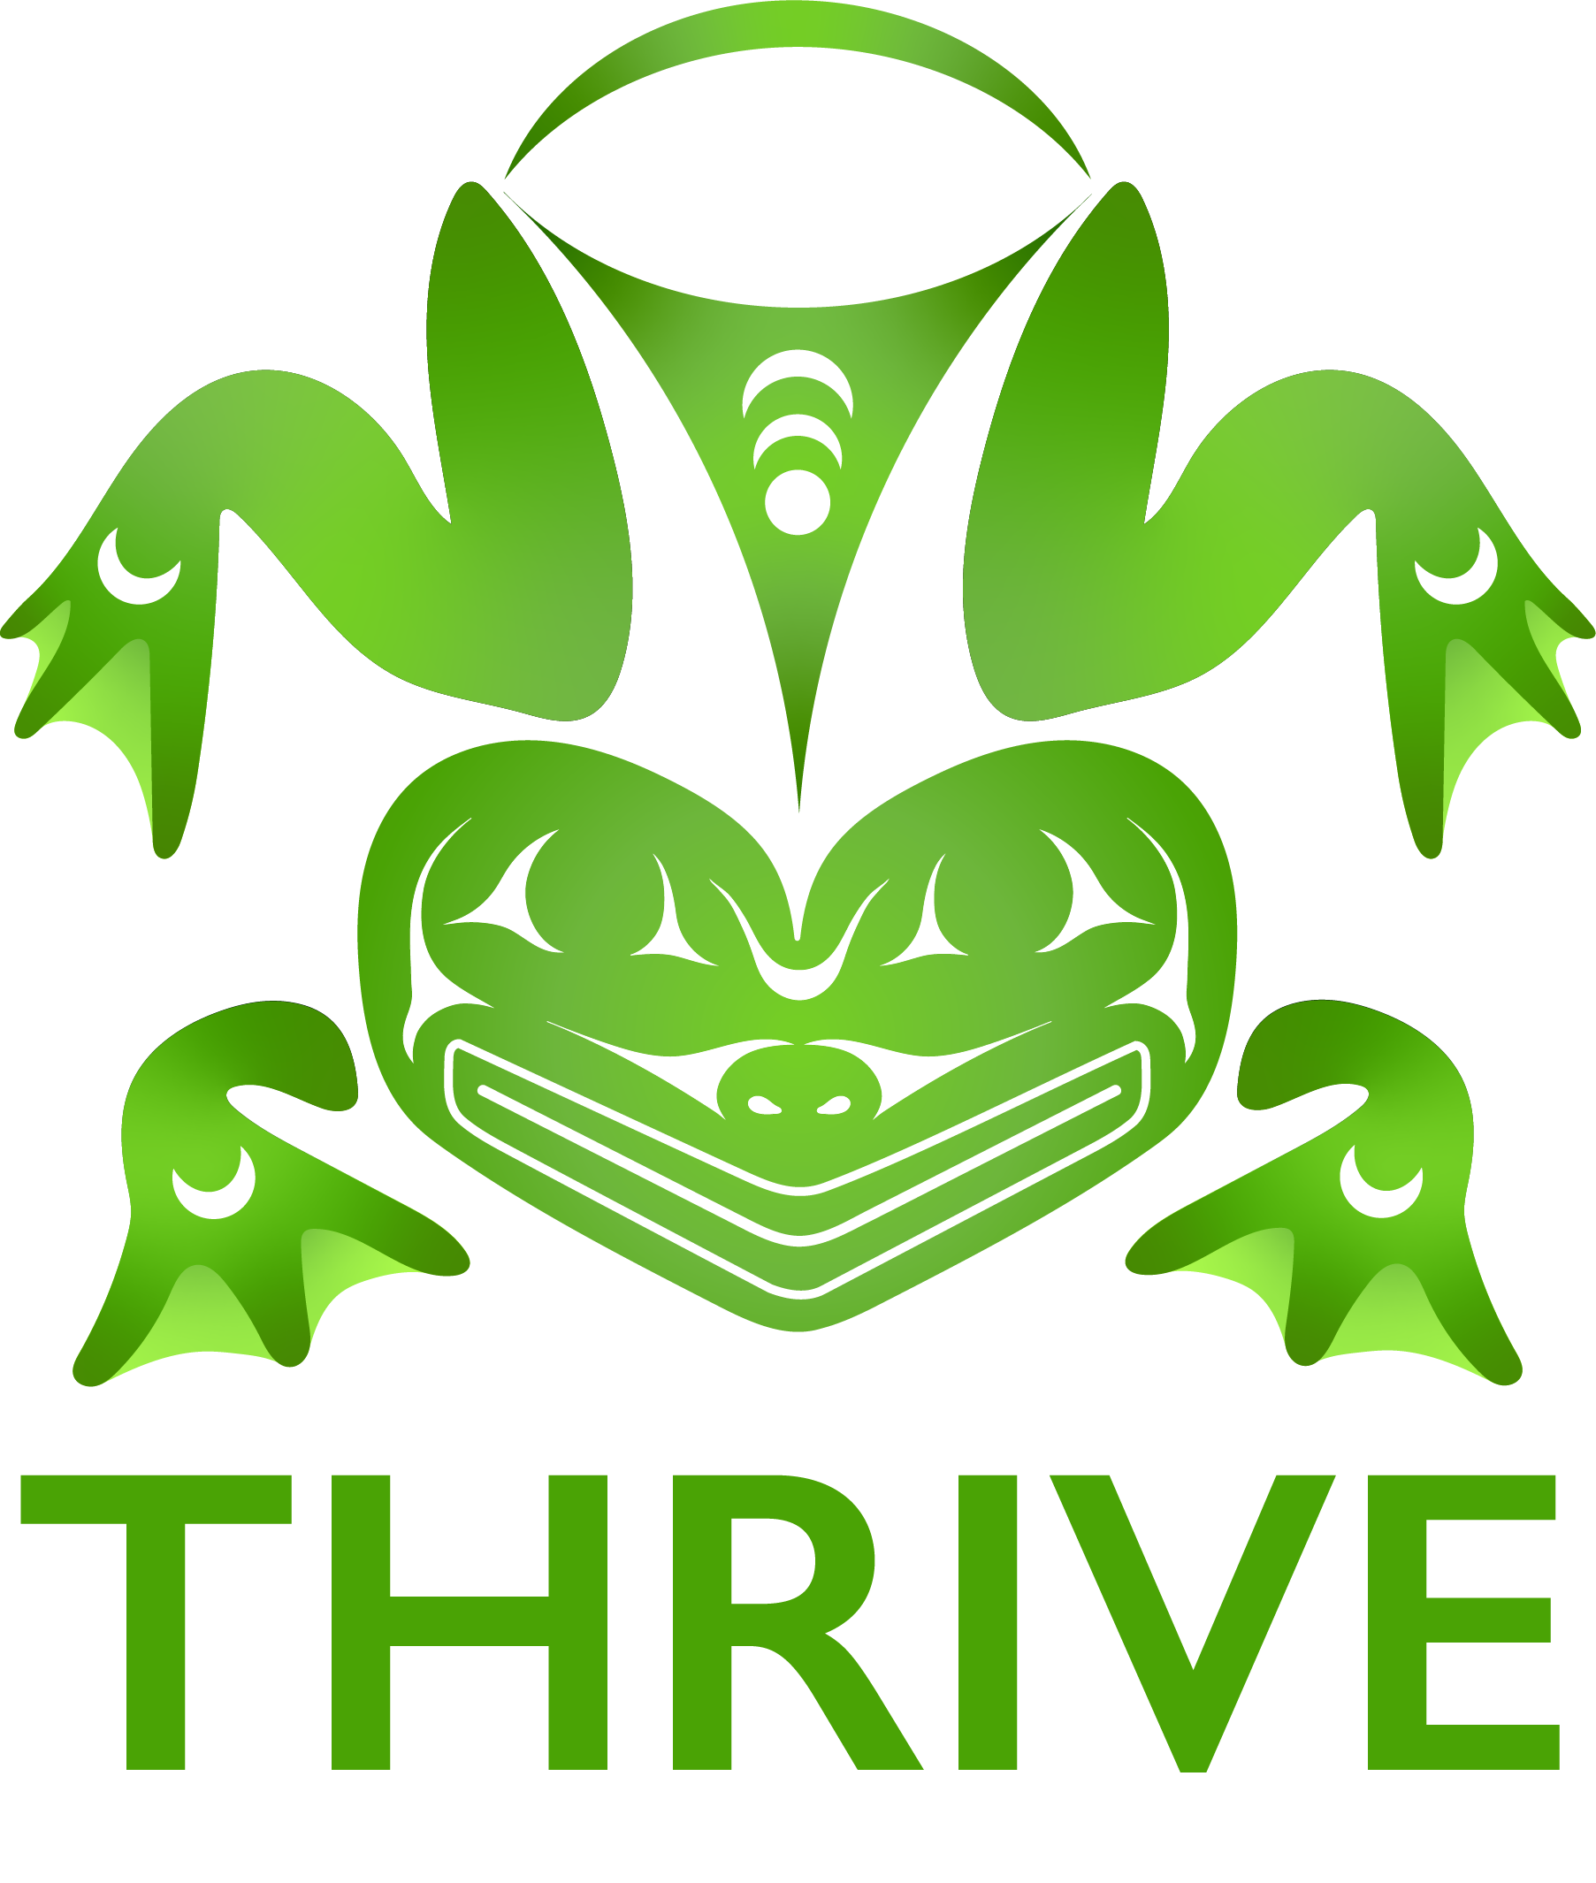
PARENT LETTER & PERMISSION SLIP
The 2025 THRIVE Conference will be at the Native American Student and Community Center on Portland State University’s campus in Portland, OR from June 23 - June 27, 2025. The conference is open to Native youth ages 13-19.
The conference is being hosted by THRIVE, the suicide prevention program at the Northwest Portland Area Indian Health Board (NPAIHB) with funding from grants received from the Substance Abuse and Mental Health Services Administration and Centers for Disease Control and Prevention.
At the conference, participants will learn about the signs of suicide, the impacts of drug and alcohol misuse, how to be a resource for friends and family, and much more. Sessions will incorporate American Indian/Alaska Native culture, traditional learning strategies, and skill-building activities that educate youth about healthy behaviors. Participants will also learn to positively express their emotions and feelings about these challenging topics through interactive, educational workshop tracks. Workshops are Beats, Lyrics and Leaders (25 youth), Medicine and Movement (15 youth), Wellness Workshop (15 youth), and Keep Tobacco Sacred (by invitation only, 10 youth). Please register your youth with their preferred workshop and we will try to give youth their first or second choice. The workshops are briefly described below:
- Beats Lyrics Leaders - Explore your way through cultures and heritage with music! BLL offers a hands-on approach to learning as they teach each participant the ins and outs of beat making, lyric/songwriting, and recording. **Limit is 25 youth, and they will travel off-site for some activities.
- Wellness Workshop- centered on relationship building, goal setting, and holistic self-care, while creating vision boards and blending cultural teachings, movement, and mindfulness practices. Participants also explore ways to confront fear in today’s society, all while engaging in contemporary appliqué work.
**Limit is 15 Youth
- Medicine and Movement- Join the We R Native and THRIVE team as we blend traditional activities and cultural teachings with different ways to improve your leadership skills and overall mental health. Workshop participants will be active all week as they learn how to tie their own hand drums and participate in traditional games while enjoying the outdoors. Youth will also have an opportunity to work with a variety of plant medicines and utilize them in different workshop activities. For this workshop, please be sure the youth have appropriate athletic clothing and shoes. **Limit is 15 youth, and they will travel off-site for some activities.
- Keep Tobacco Sacred- This Workshop equips youth with the knowledge and skills to use photography as a tool for social change and community empowerment. It's a youth will document their experiences with commercial tobacco through photography, discuss the images collectively, and use them to share their stories and advocate for positive change. *This is by invitation only and the limit is 10 Youth. Please do not register for this workshop unless you have already received the invitation.

Registration for the conference is FREE! While the conference is free (including lunch Monday–Thursday), travel to and from the conference, breakfasts and dinners, and lodging are the responsibilities of the youth, families, &/or Tribe. Each group of youth that attends must be accompanied by at least 1 chaperone from their community for up to 4 youth. Adults 18+ (including participants) must complete and pass a background check (paid for by NPAIHB) - or - submit a letter from your Tribe or Organization which states that you have completed and passed a background check within the last two years.
The THRIVE Conference will follow local mandates in regard to COVID-19. As of April 1, 2025, there is no planned mask or COVID-19 vaccine mandate in place; masks and vaccination status will be optional during the THRIVE conference. If your teen tests positive for COVID-19 during or up to 5 days after the conference, is highly encouraged to immediately contact Krystie Holder, 503-422-5450 for contact tracing purposes. Names will remain confidential. KN95 masks, hand sanitizer, and hand washing facilities will be provided at the conference.
Parent/guardian written permission and the youth’s signatures are both required before they can attend. If you have no objections to the following statements, please sign and return the attached permission slip. It will remain on file throughout the conference.

Permission Slip and Participant Contract
Please read then sign and return THE next page

2025 THRIVE Conference
June 23 – June 27, 2025

Teen Rules & Expectations:
- I will not leave the assigned program area at any time, without permission of my chaperone and my workshop facilitator. I will stay for the duration of the conference unless negotiated with the conference staff.
- I will observe established hours set forth by the conference agenda and my chaperone.
- I will not bring or use commercial tobacco, nicotine products, alcohol, drugs (except those prescribed by my doctor), fireworks, firearms, pocket knives, or weapons of any kind. If I see anyone breaking this rule I will report it immediately. If this expectation is not followed, the participant may not attend the remainder of the conference.
- I understand that public displays of affection can be distracting to the group, and it is not appropriate and I will refrain from them.
- I will dress appropriately to the occasion. My language will be appropriate and respectful of others.
- I will be responsible for all my personal property.
- I will respect other’s personal property and personal space.
- I understand that bullying, belittling, disrespecting and putting down others is not allowed at any time. If this expectation is not followed, the participant may not attend the remainder of the conference.
- I will use personal electronics including cell phones at appropriate times and be respectful of conference workshops, speakers, and activities.
- As a conference participant, I give permission to projects at the Northwest Portland Area Indian Health Board (NPAIHB), NPAIHB partner organizations, and any of the facilitating entities to use my image (photographs, videos, audio) and any quotes I may provide for positive program publicity and other educational purposes. I understand that these may be used in the newspaper, TV and radio announcements, reports/publications, and educational films.
- As a conference participant, I give permission to projects at the Northwest Portland Area Indian Health Board (NPAIHB), NPAIHB partner organizations, and any of the facilitating entities to transport me if needed for the workshop I have signed up for. Any travel will be on public transportation or in an insured vehicle with background-checked adults/ workshop facilitators. If a workshop requires vehicle travel, it has been identified in the above workshop description.

-----------------------------------------------Please sign and return next page-------------------------------------------------------------

Permission Slip and Participant Contract
2025 THRIVE Conference hosted by the Northwest Portland Area Indian Health Board
June 23 – June 27, 2025

- Participant Name: ________________________________________________________________________

- Attending with which group/Tribe/Organization: ________________________________________________

- Please list any allergies. Include medicine, food, etc.: _____________________________________________

- Other Health Concerns: _______________________________________________________________________

- In case of an emergency, I give permission for my child to receive medical treatment.

In case of such an emergency, please contact: ___________________________ Phone:_________________

- Adults 18+ must complete and pass a background check (paid for by NPAIHB) - or - submit a letter from your organization that states that you have completed and passed a background check.

Please check the boxes if they apply:

My child is in foster care I do not permit my child to be filmed or photographed.

I do not permit my child to complete a needs assessment survey about their knowledge of 988 services. This survey is anonymous and voluntary. Please see the information about the survey on the following page.

I do not permit my child to travel off-premises with workshop facilitators, by selecting this I also acknowledge my child is not signed up for a workshop that is identified above as having off-site travel.

I certify to the best of my knowledge and belief that all of my statements and answers are true, correct, complete, and made in good faith. Please complete the following and sign. For parent/guardian:

I, ________________________________ , give my permission for the teen listed above to participate in the
Print Name (Parent/ Legal Guardian)

2025 THRIVE Conference in Portland, Oregon.

Parent/Guardian Signature _______________________________________________ Date: _____________________

For the teen:

I, the teen listed above, agree to the participant contract during the THRIVE Conference and agree to participate in the 2025 THRIVE Conference in Portland, Oregon.

Teen Signature _______________________________________________ Date: _____________________

If at any time, you have any questions, concerns or comments, please contact Krystie Holder at kholder@npaihb.org. Please return the signature page by June 9, 2025 via email to thrive@npaihb.org, if we do not have signed forms when the conference begins the youth may not be able to participate.

Tribal 988 Needs Assessment – Youth Survey Information
As part of the NPAIHB’s 988 Project, we want to understand the needs of Native people and communities in Idaho, Oregon, and Washington.
- Youth participation in this survey will help us better serve Native youth in the PNW.
- There are 11 questions, and it should take 3-5 minutes to fill out.
- This survey is voluntary: youth do not have to fill this out or you can stop or not answer a question at any time.
- This survey is anonymous. Responses are sent encrypted to an online database that does not collect name, email, location, phone number, or other information about you. The database is accessible only to our evaluation partner (NPC Research) in Portland, Oregon.
  - They will summarize the survey responses like this: “50% of the youth live in Washington state.
- Risks: Some people feel uncomfortable taking surveys. Some people may feel uncomfortable taking this survey because it asks questions related to mental health crises and use of a crisis line.
- Benefits: There are no direct benefits from taking this survey. However, youth answers will help us improve services to Native youth like them in the future.
- Questions: These survey questions have been reviewed by the Portland Area Indian Health Services’ Institutional Review Board (PAIRB), a tribal committee that is responsible for protecting the rights and welfare of research participants and tribal members. If you have any concerns about your rights as a participant, please contact the PAIRB Coordinator, Clarice Charging (phone: 503-416-3256 or email: PAIRB@Ihs.gov). The IRB Chair, Dr. Ryan G. Pett, can be contacted directly by phone at: 509-865-1728.

