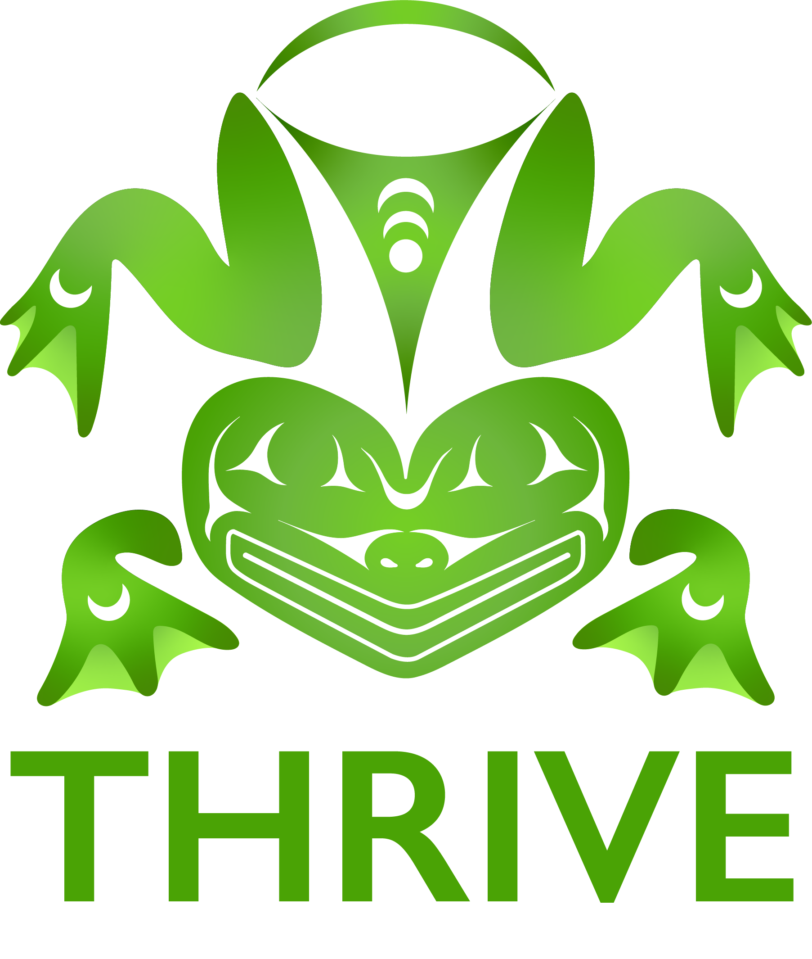
VOLUNTEER/STAFF/Chaperone Consent Form
THRIVE Conference | June 23 – June 27, 2025

Please read the following carefully before you sign:
- I give permission to projects at the Northwest Portland Area Indian Health Board (NPAIHB), NPAIHB partner organizations, and any of the facilitating entities to use my image (photographs, videos, audio) and any quotes I may provide for positive program publicity and other educational purposes. I understand that these may be used in the newspaper, TV, and radio announcements, reports/publications, and educational films.
- I agree to be drug and alcohol-free throughout the entire conference. If I use tobacco, I will only smoke in designated smoking areas that are not in view of any youth participants and only during appropriate break times. If these rules are not followed, I understand that I will be asked to leave.
- If I am a chaperone, I agree to be present and take part in the entire conference, this is Monday June 23 at 8:30AM until Friday June 27 at 1:00PM, and to assist the youth participants when needed. Content from the THRIVE Conference builds day-by-day, and youth must attend every day of the conference to fully benefit from their workshops and lessons. I understand that I am ultimately the person responsible for the youth I brought to the Conference although I may assist with the chaperoning of youth from other areas as well.
- The THRIVE Conference will follow local mandates regarding COVID-19. As of April 1, 2024, there is no planned mask or COVID-19 vaccine mandate in place so those will be optional during the THRIVE conference. If I or one of my youth participants tests positive for COVID-19 during or after the conference, it is highly encouraged to immediately contact Krystie Holder at 503-422-5450 for contact tracing purposes. Names will remain confidential. KN95 masks, hand sanitizer, and hand washing facilities will be provided at the conference.
- I will use appropriate language and model honorable behavior, such as respect, integrity, honesty, timeliness, and excellence. Profanity, discriminatory, or sexualized language, or jokes are inappropriate when working with youth, regardless of whether it occurs face-to-face or by any other means.
- I understand that staff/volunteers/chaperones must take particular care when touching youth. Most adults understand the difference between appropriate physical contact such as a handshake or pat on the back and contact that is sexual or disrespectful. Staff/volunteers/chaperones also must be cognizant of how any physical contact may be perceived.
- I understand that interactions with youth must both be appropriate and appear appropriate. It is expected that volunteer interactions with teens are always appropriate and professional. It is expected that adults will not act as a teens’ counselor or advisor unless authorized or licensed to do so.
- I understand that staff/volunteers/chaperones are responsible for the quality of interactions. Youth often find it difficult to state discomfort or objections. Staff/volunteers/chaperones must be especially sensitive to physical and verbal cues that youth provide.
- I agree to try my best to keep youth respectful of conference schedules, attendees, & facilities. Bullying is NOT allowed.
- If I am a chaperone, I agree to escort youth if they choose to be part of activities around the downtown Portland area during the evening hours.
- I understand that the ratio of chaperones to youth must be 1:5 or less.
- I understand that Conference staff from the NPAIHB, PSU-NASCC, and any facilitators are not responsible for lost youth or youth that choose to stray from the conference facilities.
- I understand that attendance tracking is an important step in ensuring the safety of all conference participants. I will not bring any unregistered guests unless I receive written approval from the THRIVE Project. I will contact Krystie Holder at kholder@npiahb.org as soon as possible if I wish to bring an unregistered guest.

- Adults 18+ (including participants) must complete and pass a background check (paid for by NPAIHB) - or - submit a letter from your organization which states that you have completed and passed a background check within the last two years. Please provide your full legal name and email address below and HireRight will send you an email with “Northwest Portland Area Indian Health Board Background Verification Request” in the subject line. Click the link in the email and submit the information requested to HireRight as soon as possible. NPAIHB will not be able to allow any adults in the conference who have not completed and passed the background check. Results are usually sent to the NPAIHB 3-5 days after the adult completes the submission to HireRight but may take up to two weeks.

I certify to the best of my knowledge and belief that all my statements and answers are true, correct, complete, and made in good faith.

Signature: _______________________________________________________ Date: ____________________________
Printed Legal Name:__________________________________ Email Address: ___________________________________
Attending with which group/tribe/Organization: __________________________________________________________
Please send completed forms to THRIVE staff by email to THRIVE@npaihb.org before June 9, 2025. A physical signature is preferred; electronic signatures are only allowed if they are Adobe-certified electronic e-signatures. If you have any questions or concerns regarding this consent form, please contact Krystie Holder at kholder@npaihb.org or (503) 422-5450.

