NW NARCH Research support fellowship program | 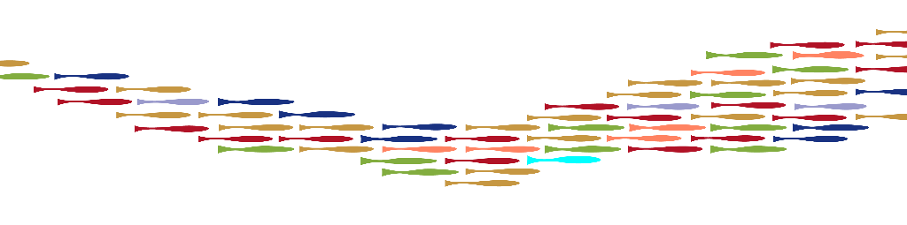UNDERGRADUATE STUDENTS  Application
The overall goal of the NW Native American Research Center for Health (NARCH) Research Support Fellowship is to increase the number of well-trained AI/AN researchers who are prepared to conduct population health sciences research in diverse settings. We will support undergraduate AI/AN students interested in population science careers as they undertake and complete mentored research projects. Fellows will have many opportunities to increase research competencies by attending skill-building courses in our Summer Research Training Institute, participating in regularly scheduled Zoom and web-based seminars, attending in-person workshops, through near-peer mentorship, and by attending national, regional, and local research conferences. Financial support is awarded on an hourly basis ($20/hour; 10 hours per week; up to $7,200) for research completed.

Applicant Information
Last Name |  |  | Click or tap here to enter text. |  |  |  |  |  | First | Click or tap here to enter text. |  |  |  |  |  | Date |  |  | Click or tap here to enter text.
Street Address |  |  |  | Click or tap here to enter text. |  |  |  |  |  |  |  |  |  |  |  | Apartment/Unit # |  |  |  | Click or tap here to enter text.
City |  | Click or tap here to enter text. |  |  |  |  |  |  | State | Click or tap here to enter text. |  |  |  |  |  | ZIP |  | Click or tap here to enter text.
Phone |  | Click or tap here to enter text. |  |  |  |  |  |  | E-mail Address |  |  | Click or tap here to enter text.

Education
Undergraduate Institution(s) |  |  |  |  |  | Degree(s) |  |  |  |  |  |  |  | Degree Date(s)
Click or tap here to enter text. |  |  |  |  |  | Click or tap here to enter text. |  |  |  |  |  |  |  | Click or tap here to enter text.
Click or tap here to enter text. |  |  |  |  |  | Click or tap here to enter text. |  |  |  |  |  |  |  | Click or tap here to enter text.
Graduate Institution(s)
Click or tap here to enter text. |  |  |  |  |  | Click or tap here to enter text. |  |  |  |  |  |  |  | Click or tap here to enter text.
Click or tap here to enter text. |  |  |  |  |  | Click or tap here to enter text. |  |  |  |  |  |  |  | Click or tap here to enter text.
Click or tap here to enter text. |  |  |  |  |  | Click or tap here to enter text. |  |  |  |  |  |  |  | Click or tap here to enter text.

Tribal Affiliation
Click or tap here to enter text.
Click or tap here to enter text.

Previous Professional Position(s) (If applicable)
1. Click or tap here to enter text.
2. Click or tap here to enter text.

Current Professional PositioN (If applicable)
Title |  |  |  |  | Click or tap here to enter text.
Organization |  |  |  |  | Click or tap here to enter text.
Street Address |  |  |  |  | Click or tap here to enter text.
City | Click or tap here to enter text. |  |  |  |  |  | State | Click or tap here to enter text. |  |  |  |  |  |  | ZIP |  | Click or tap here to enter text.
Phone | Click or tap here to enter text. |  |  |  |  |  |  |  |  |  | E-mail |  | Click or tap here to enter text.

Briefly describe your Career Goals (Field will expand as you type.)
Click or tap here to enter text.

Please submit completed application packet to Ashley Thomas (athomas@npaihb.org)
Application packet should include the following:
- Completed application form
- Certificate of Indian Blood (CIB) (We recognize not all Tribes have this document)
- A cover letter describing your research
- Name and contact information of your academic mentor
- Letter of recommendation (at least one from a professor, academic advisor, or other faculty member who knows you)
- A copy of your transcripts

Contact:
Ashley Thomas, MPH
Sr. Program Manager
NW NARCH
athomas@npaihb.org

