REPRINT: Suicide Prevention Materials for Indian Country
Feel free to print and disseminate #WeNeedYouHere and 988 Suicide & Crisis Lifeline materials from the Northwest Portland Area Indian Health Board (NPAIHB), from your local printers!
For the print campaign materials, you can reach out to the same company the NPAIHB used for printing, AlphaGraphics Portland Downtown and they ship anywhere. The contact information is 503-248-0666 or email them at us243@alphagraphics.com and visit https://www.alphagraphics.com/us-oregon-portland-us243.
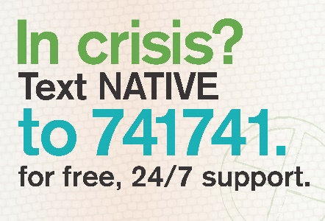
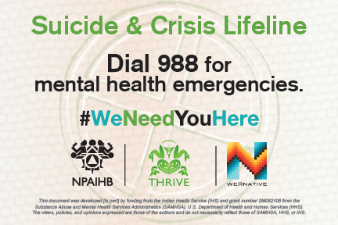
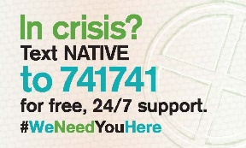
Business card front (left), back (below)
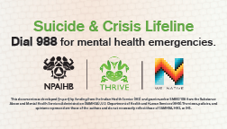

Postcard front (above) Postcard back (above)
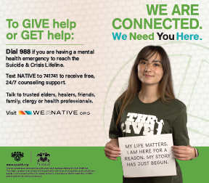
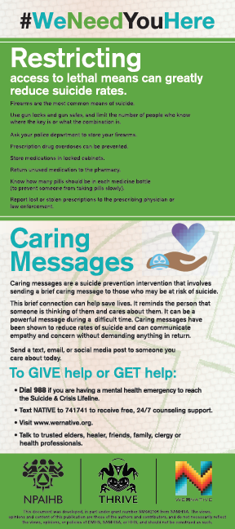
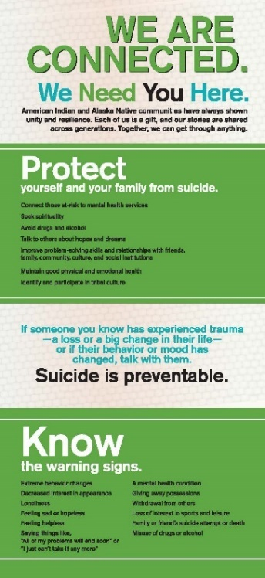

Tipcard front (right), back (right & below)

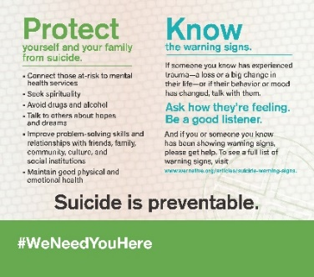
Rackcard front & back (both left)

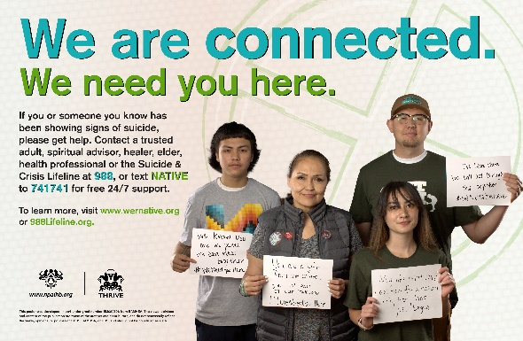
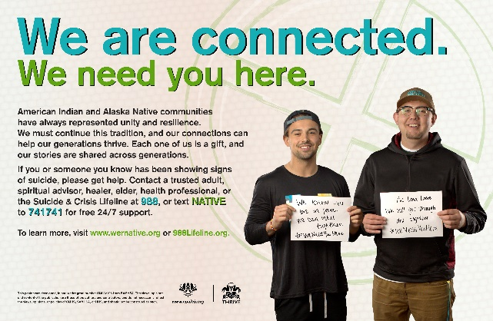

Poster option 1 (above) Poster option 2 (above)
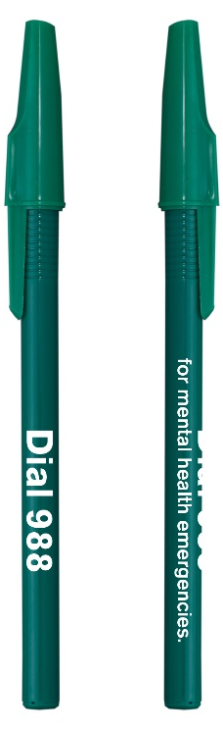
Educational materials can include:
988 Suicide & Crisis Lifeline Lip Balm (not pictured)

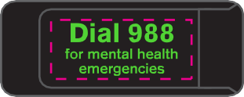
988 Suicide & Crisis Lifeline camera cover (no red) 988 Suicide & Crisis Lifeline pens

988 Suicide & Crisis Lifeline pop-socket 988 Suicide & Crisis Lifeline stickers & magnets
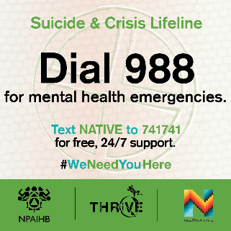

For more information or to request more materials please contact THRIVE staff at the NPAIHB:
Northwest Portland Area
Indian Health Board
503-416-3284
ccaughlan@npaihb.org or amartinez@npaihb.org

