Native Boost Social Media Toolkit
Image 1:

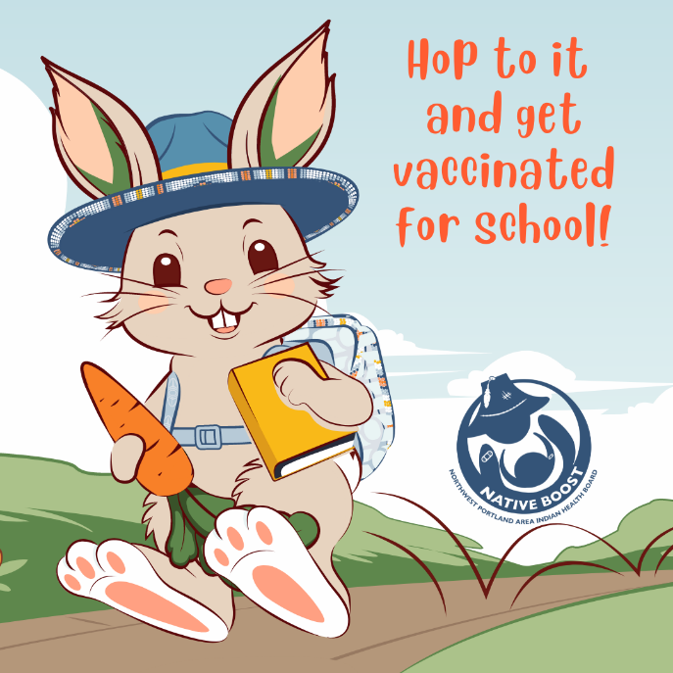

Proposed Text: Make sure your littles hop into school with their backpack and up to date vaccines, 🐰✏️ Being up to date on vaccines contributes to a positive school experience by reducing sick days and trips to the clinic. Learn more at: www.NPAIHB.org/Native-Boost. #HoppinIntoSchool #NativeBoost

Image 2:
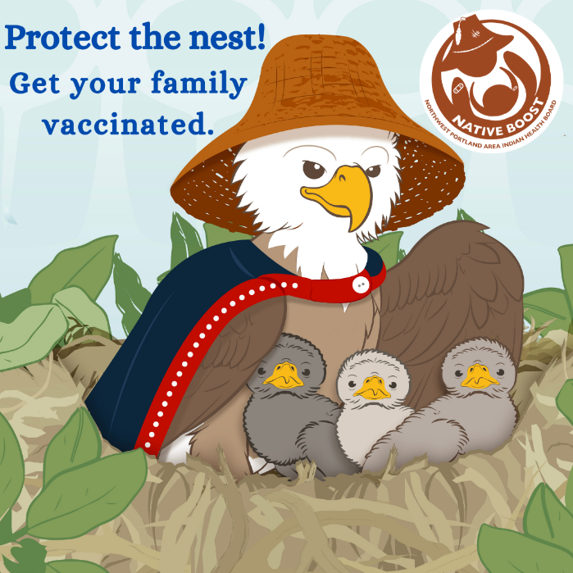

Proposed Text: As a parent, you understand the importance of protecting your precious eaglets. Shield them from illness by making sure that they are up to date on their vaccines. 🐦💪 Learn more at: www.NPAIHB.org/Native-Boost. #ProtectingTheNest #ProtectingOurFlock #NativeBoost

Image 3:
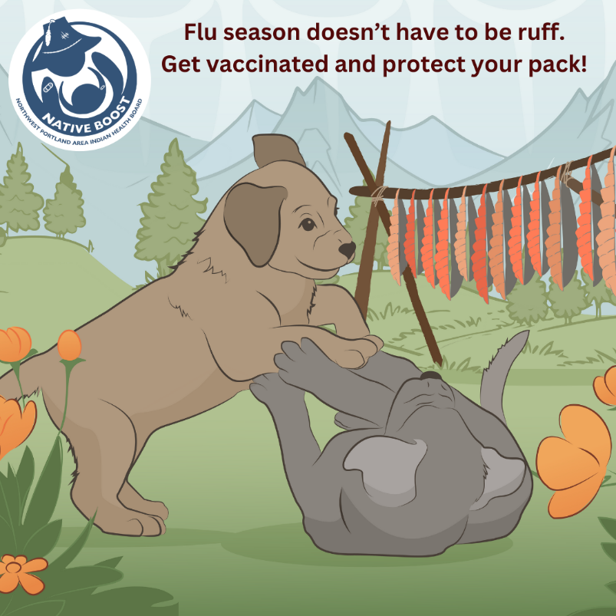
Proposed Text: Flu season doesn’t have to be ruff for your littles! 🐾 So, make sure you and your pups get vaccinated annually. Learn more at: www.NPAIHB.org/Native-Boost. #PawsibilitiesWithVaccines #NativeBoost

Image 4:
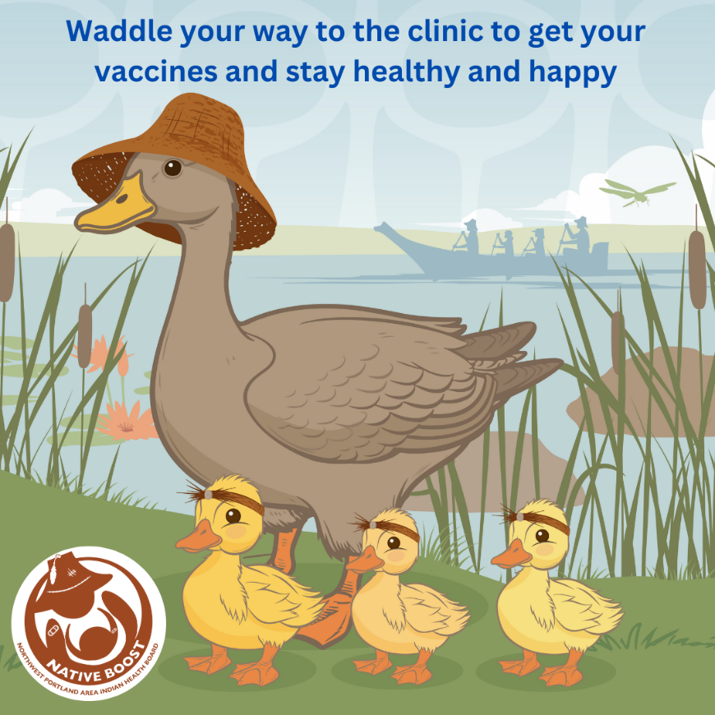

Proposed Text: Shield your little ducklings from serious illness! 🦆 Waddle your way to the clinic and learn what all the quack is about vaccines. Learn more at: www.NPAIHB.org/Native-Boost. #ProtectiveFeathers #HealthyFlock #NativeBoost

Image 5:
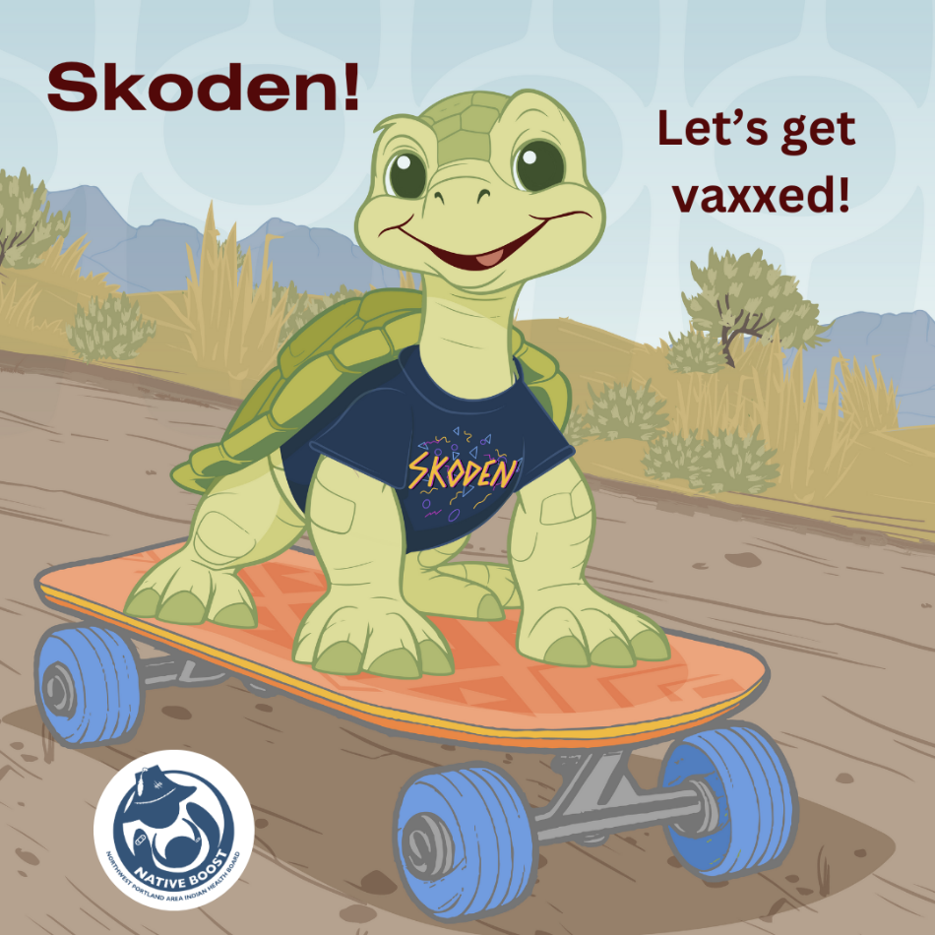

Proposed Text: Don’t let illness slow their roll! Ensure your littles can stay on the move by getting them vaccinated. 🐢💨 🛼 For more info, visit: www.NPAIHB.org/Native-Boost. #ProtectingOurShells #NativeBoost

Image 6:
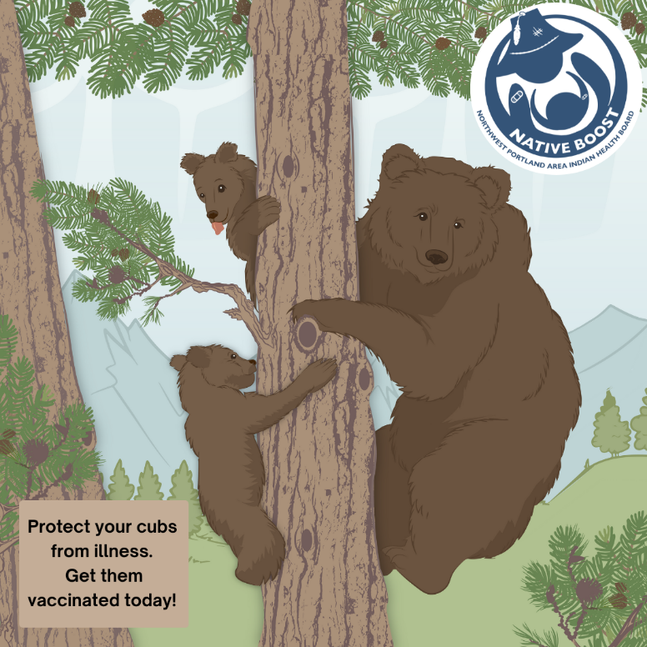

Proposed Text: Make flu season bearable for your cubs. 🐻 Protect your littles with an annual flu vaccine so they don’t have to miss school or other fun events. Visit www.NPAIHB.org/Native-Boost to learn more. #FluFighters #ProtectingOurCubs #NativeBoost

Image 7:
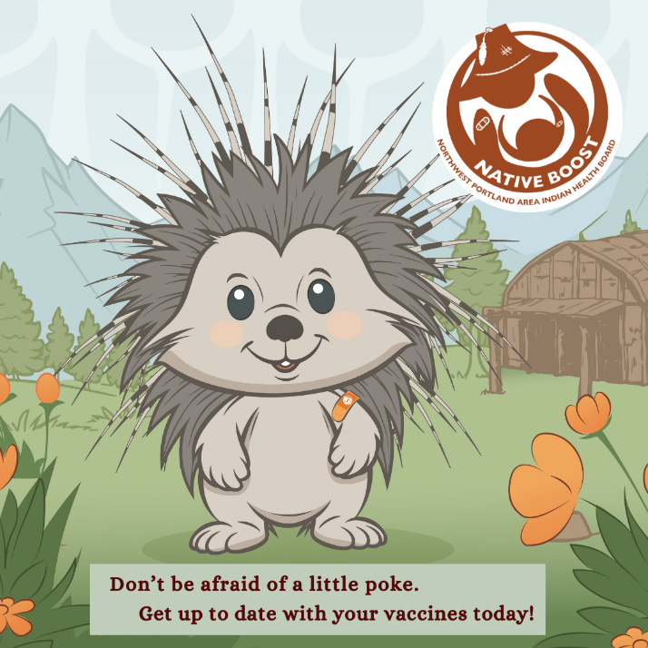

Proposed Text: This porcupine isn’t scared to get poked. 🦔 Get yourself and your child vaccinated to stay healthy and reduce sick days and last-minute trips to the clinic. Learn more by visiting: www.NPAIHB.org/Native-Boost. #VaccineWarrior #NativeBoost

Image 8:
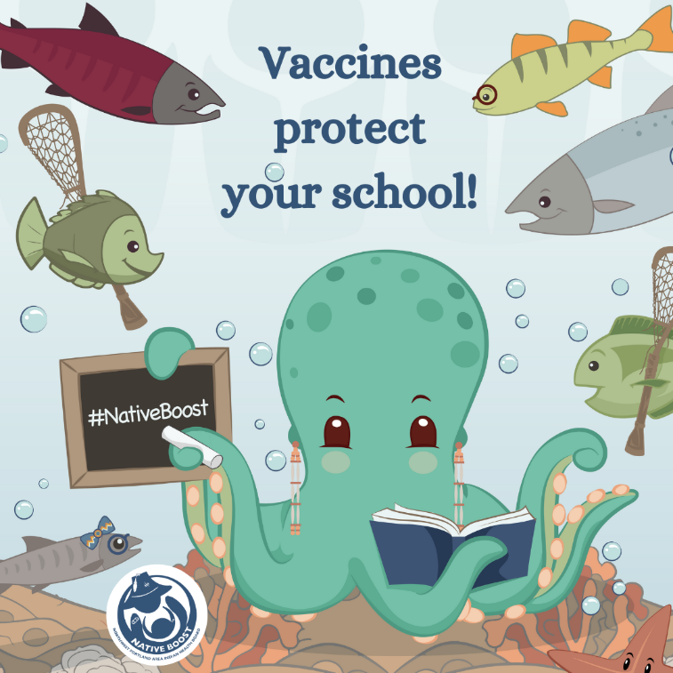

Proposed Text: When each little fish is vaccinated, the whole school is protected! 🐙 Let your littles swim freely without the fear of serious illness. Learn more at: www.NPAIHB.org/Native-Boost. #HealthyLittleFish #NativeBoost

Image 9:

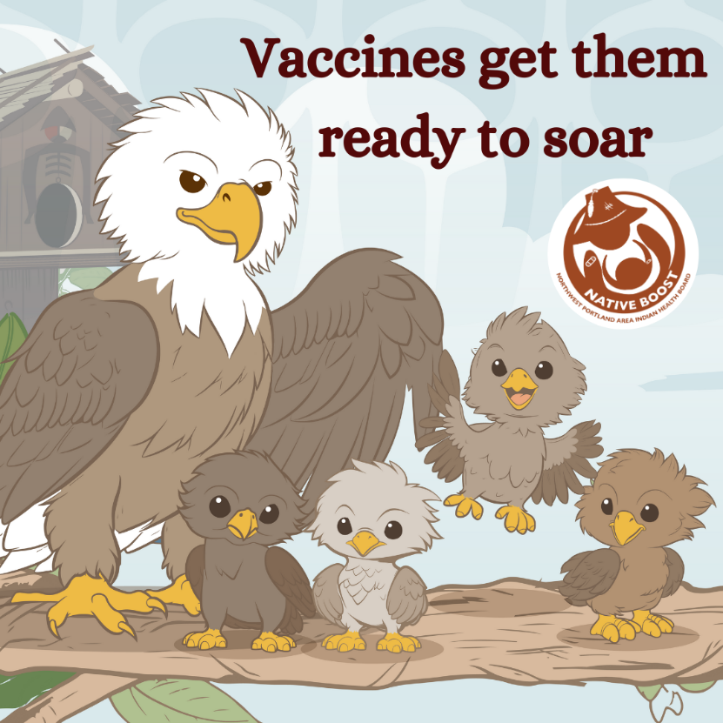

Proposed Text: Class is in session! 🎓 Are your kids ready to soar? Keep them healthy by making sure they are up to date on their vaccines. Learn more at www.NPAIHB.org/Native-Boost. #FlyLikeAnEagle #NativeBoost

Image 10:
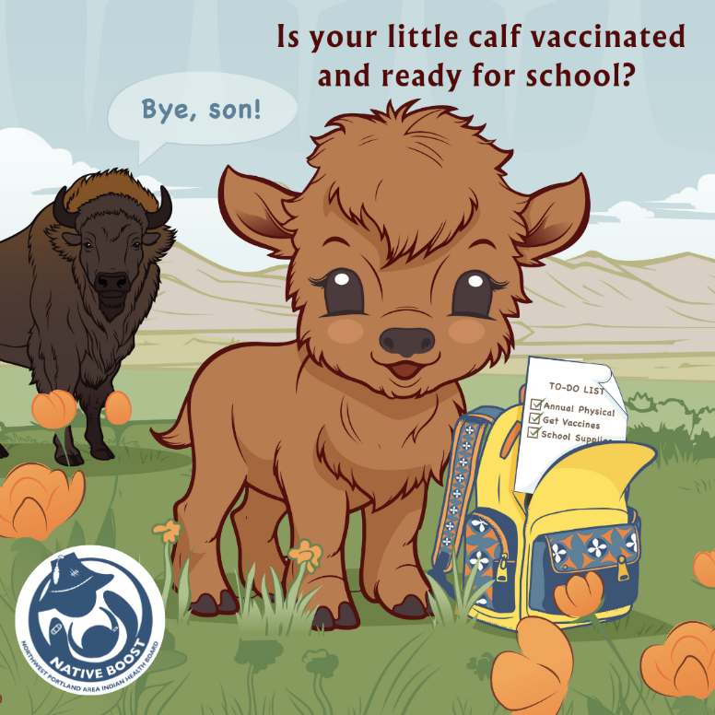

Proposed Text: Part of getting your calf ready for school includes checking that they are up to date on their vaccines! Give your littles the best start! 📚 For more information on vaccinations for kids, visit: www.NPAIHB.org/Native-Boost #BackToSchoolProtection #NativeBoost

