Making Quick Orders
Quick orders are made on the Order Entry Configuration Menu, using option MNU Order Menu Management
Figure 1: Order Entry Configuration screen
At the “Select Order Entry Configuration Option” prompt type MNU and press the Enter key.
Figure 2: Order Menu Management screen
Usually the option used for making quick orders and menus is MNU Enter/Edit Order Menus. Other options can also be accessed while in the Order Menu Management screen (MNU).
At the “Select Order Menu Management Option” prompt type MNU and press the Enter key.

Naming Conventions
Naming conventions allow each site to follow standard rules in making quick orders.
While not required, it makes quick order maintenance much easier, especially if a CAC leaves for another position or moves to another facility.

Naming Convention for Quick Orders
Start each quick order with the following naming convention. The names used are the package assigned names given to an individual package, plus the letter Z which means it was locally created.
ORZ | Nursing text quick orders.
ORGXZ | Generic Text quick orders
LRZ | Laboratory quick orders
RAZ | Radiology quick orders
PSOZ | Outpatient medication quick orders
PSJZ | Inpatient medication quick orders
PSJIZ | IV quick orders
GMRCZ | Consult quick orders
ORZM | Order menus

Naming Conventions for Order Sets
When making order sets, you can either use ORZSET for order sets mixing data elements, or use LRZSET, RAZSET, etc. for a set of orders from one package.

Create a New Menu
After typing MNU (Create/Modify Order Menus), type in the new menu name at the “MENU” prompt. Insert your last name to create the sample menu. The new menu should be called ORZM YOURLASTNAME SAMPLE MENU. In the example below, the new menu name is ORZM HAGER SAMPLE. (Note: in the Training data base we insert YOURNAME to allow multiple users to work in the same system. Do not add YOURNAME if you are working on your sites production data base)
Select Order Menu Management Option: MNU Create/Modify Order MenusSelect ORDER MENU: ORZM HAGER SAMPLE
Are you adding 'ORZM HAGER SAMPLE' as a new ORDER DIALOG? No//YES
Do you wish to copy an existing menu? YES// N
DISPLAY TEXT: Sample Menu
DESCRIPTION:
No existing text
Edit? NO//
COLUMN WIDTH: 40
MNEMONIC WIDTH: 3
PATH SWITCH: y YES
ENTRY ACTION:
Figure 3: Example of new menu creation
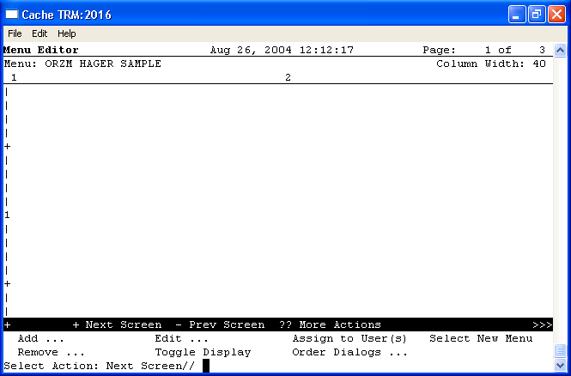
Figure 4: Menu Editor for ORZM HAGER SAMPLE
The screenshot above shows the empty, new menu that was created called ORZM HAGER SAMPLE. Options at the bottom of the screen give the user the ability to customize the menu.
At the “Select Action” prompt, type Order Dialogs.
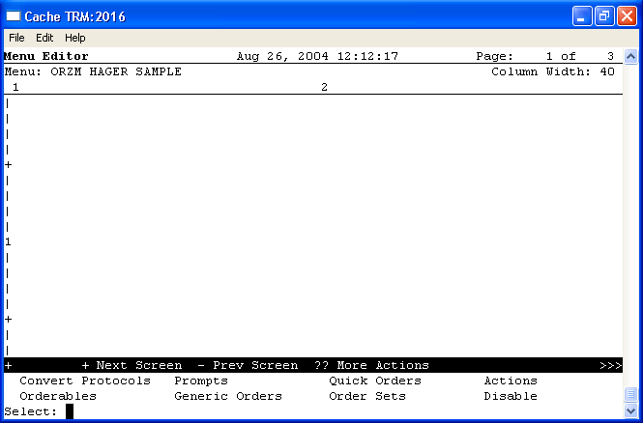
Figure 5: Menu Editor showing “Select” prompt
At the “Select” prompt type Quick Orders.

Laboratory Quick Orders
Using your name, make a quick order named, LRZ YOURNAME GLUCOSE. In the following example, the user’s responses are shown in bold type.
Select QUICK ORDER NAME: LRZ HAGER GLUCOSE
Are you adding 'LRZ HAGER GLUCOSE' as a new ORDER DIALOG? No// Y (Yes)
TYPE OF QUICK ORDER: LABORATORY
NAME: LRZ HAGER GLUCOSE//
DISPLAY TEXT: Glucose
VERIFY ORDER: y YES
DESCRIPTION:
No existing text
Edit? NO//
ENTRY ACTION:
Lab Test: GLUCOSE
1 GLUCOSE
2 GLUCOSE (CSF)
3 GLUCOSE (FASTING)
4 GLUCOSE (FLUID)
5 GLUCOSE (URINE)
Press <RETURN> to see more, '^' to exit this list, OR
CHOOSE 1-5: 1 GLUCOSE
SEND TO LAB - Means the patient is ambulatory and will be sent to the
Laboratory draw room to have blood drawn.
WARD COLLECT - Means that either the physician or a nurse will be collecting
the sample on the ward.
LAB BLOOD TEAM - Means the phlebotomist from Lab will draw the blood on the
ward. This method is limited to laboratory defined collection times.
SP Send patient to lab
WC Ward collect & deliver
LC Lab blood team
Collected By: SP
Collection Sample: BLOOD//
Collection Date/Time: Today (Aug 26, 2004)
How often: ONCE ONCE
-----------------------------------------------------------------------------
Lab Test: GLUCOSE
Collected By: Sent patient to lab
Collection Sample: BLOOD
Specimen: BLOOD
Collection Date/Time: TODAY
How often: ONCE
(P)lace, (E)dit, or (C)ancel this quick order? PLACE//<enter>
Auto-accept this order? NO// <enter>
Figure 6: Example of a quick order
Make two more lab quick orders, exactly the same way, called LRZ YOURNAME HGBAIC and LRZ YOURNAME CBC.

Radiology Quick Order
Using your name, make a quick order named, RAZ YOURNAME KNEE. In the following example, the user’s responses are shown in bold type.
Select QUICK ORDER NAME: RAZ HAGER KNEE
Are you adding 'RAZ HAGER KNEE' as a new ORDER DIALOG? No// Y (Yes)
TYPE OF QUICK ORDER: IMAGING
NAME: RAZ HAGER KNEE//
DISPLAY TEXT: Knee Xray
VERIFY ORDER: y YES
DESCRIPTION:
No existing text
Edit? NO//
Select one of the following imaging types:
ANGIO/NEURO/INTERVENTIONAL
GENERAL RADIOLOGY
ULTRASOUND
Select IMAGING TYPE: GENERAL RADIOLOGY
Figure 7: Example of a radiology quick order
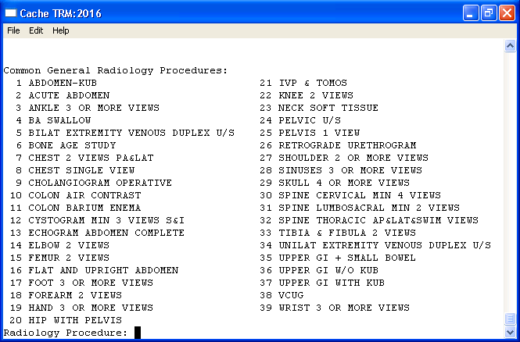
Figure 8: Top 40 list of radiology procedures
The top 40 list will display. Choose from this list or select any active radiology procedure.
Radiology Procedure: 22 KNEE 2 VIEWS
Procedure Modifier:
History and Reason for Exam:
No existing text
Edit? No// (No)
Category: OUTPATIENT
Is this patient scheduled for pre-op? NO// <enter>
Date Desired: TODAY// <enter>
Mode of Transport: AMBULATORY
Is patient on isolation procedures? N
Urgency: ROUTINE// <enter>
-----------------------------------------------------------------------------
Radiology Procedure: KNEE 2 VIEWS
Category: OUTPATIENT
Date Desired: TODAY
Mode of Transport: AMBULATORY
Isolation Procedures: NO
Urgency: ROUTINE
Submit request to: X-RAY
-----------------------------------------------------------------------------
(P)lace, (E)dit, or (C)ancel this quick order? PLACE// <enter>
Auto-accept this order? NO// <enter>
Figure 9: Example of user choosing a radiology procedure

Outpatient Medication Quick Order
Using your name, make a quick order named, PSOZ YOURNAME AMOXICILLIN 500MG Q8H 10DAYS. In the following example, the user’s responses are shown in bold type.
Select QUICK ORDER NAME: PSOZ HAGER AMOXICILLIN 500MG Q8H 10DAYS
Are you adding 'PSJZ HAGER AMOXICILLIN 500MG Q8H 10DAYS' as
a new ORDER DIALOG? No// Y (Yes)
TYPE OF QUICK ORDER: OUTPATIENT MEDICATIONS
NAME: PSOZ HAGER AMOXICILLIN 500MG Q8H 10DAYS Replace
DISPLAY TEXT: Amoxicillin 500mg Q8H for 10days
VERIFY ORDER: y YES
DESCRIPTION:
No existing text
Edit? NO//
ENTRY ACTION:
Medication: AMOXIC
1 AMOXICILLIN CAP,ORAL
2 AMOXICILLIN PWDR,RENST-ORAL
3 AMOXICILLIN/CLAVULANATE PWDR,RENST-ORAL
4 AMOXICILLIN/CLAVULANATE TAB
CHOOSE 1-4: 1 AMOXICILLIN CAP,ORAL
Complex dose? NO//
Complex dose? NO//
Choose from (or enter another):
1 250MG $0.003
2 500MG $0.005
3 1000MG $0.01
Dose: 2 500MG $0.005
Route: ORAL MOUTH//
Schedule: Q8H EVERY 8 HOURS
21 CAPSULES PER BOTTLE
Days Supply: 10
Quantity (CAP): 30
Refills (0-11): 0
Pick Up: Window
Priority: ROUTINE// <enter>
Comments:
No existing text
Edit? No// (No)
-----------------------------------------------------------------------------
Medication: AMOXICILLIN CAP,ORAL 500 MG
Instructions: 500 MG ORAL Q8H
Days Supply: 10
Quantity (CAP): 30
Refills (0-11): 0
Pick Up: WINDOW
Priority: ROUTINE
-----------------------------------------------------------------------------
(P)lace, (E)dit, or (C)ancel this quick order? PLACE// <enter>
Auto-accept this order? NO// <enter>
Figure 10: Example of medication quick order

Nursing Text Order
Press the Enter key to go back to the menu. At the “Select” prompt type Order Dialog, and at the following prompt type Orderables to create the orderable item to make a nursing text order.
For standard packages, orderables are created by the package.
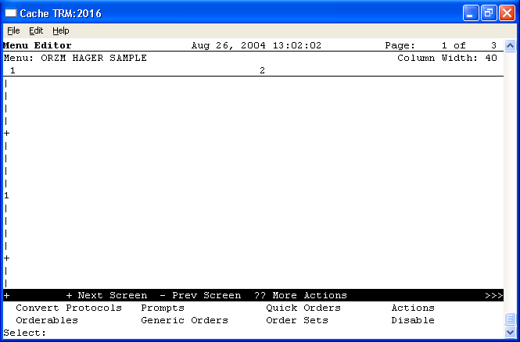
Figure 11: Creation of a new orderable
Using your name, make an orderable named YOURNAME DRESSING CHANGE and a quick order named, ORZ YOURNAME DRESSING CHANGE. In the following example, the user’s responses are shown in bold type.
CHOOSE 1-2: 2 Orderables
Type of Orderable: NURSING
Select ORDERABLE ITEMS: HAGER DRESSING CHANGE
Are you adding 'HAGER DRESSING CHANGE' as a new ORDERABLE ITEMS (the 2868TH)? No// Y (Yes)
NAME: HAGER DRESSING CHANGE//
Select QUICK ORDER NAME: ORZ HAGER DRESSING CHANGE
Are you adding 'ORZ HAGER DRESSING CHANGE' as a new ORDER DIALOG? No// Y (Yes)
TYPE OF QUICK ORDER: NURSING
NAME: ORZ HAGER DRESSING CHANGE//
DISPLAY TEXT: Dressing Change as Indicated
VERIFY ORDER: y YES
DESCRIPTION:
No existing text
Edit? NO//
Patient Care: HAGER DRESSING CHANGE
Instructions: Change Dressing as Indicated
Start Date/Time: NOW// today (AUG 26, 2004)
Stop Date/Time: t+2 (AUG 28, 2004)
-----------------------------------------------------------------------------
Patient Care: DRESSING CHANGE
Instructions: Change Dressing as Indicated
Start Date/Time: TODAY
Stop Date/Time: 2 DAYS FROM TODAY
-----------------------------------------------------------------------------
(P)lace, (E)dit, or (C)ancel this quick order? PLACE// <enter>
Auto-accept this order? NO// <enter>
Figure 12: Example of dressing change quick order

Order Set
From the menu, at the “Select” prompt type Order Dialogs, and at the following prompt type Order Sets.
Using your name, make a quick order named, LRZSET YOURNAME DIABETIC. In the following example, the user’s responses are shown in bold type.
Select ORDER SET NAME: LRZSET HAGER DIABETIC
Are you adding 'LRZSET HAGER DIABETIC' as
a new ORDER DIALOG? No// Y (Yes)
Do you wish to copy an existing order set? YES// NO
NAME: LRZSET HAGER DIABETIC Replace
DISPLAY TEXT: Diabetic Lab Tests
DESCRIPTION:
No existing text
Edit? NO//
ENTRY ACTION:
EXIT ACTION:
Select COMPONENT SEQUENCE#: 1
SEQUENCE: 1//
ITEM: LRZ HAGER GLUCOSE
Select COMPONENT SEQUENCE#: 2
SEQUENCE: 2//
ITEM: LRZ HAGER HGBAIC

Adding Items to the Menu
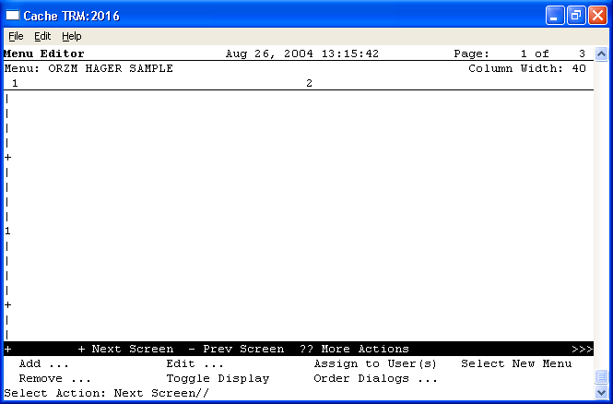
Figure 13: Adding newly created items to the menu
At the “Select Action” prompt type Add. This option will add the newly created items.
Add: TEXT Text or Header
DISPLAY TEXT: LAB
ROW: 1
COLUMN: 1
HEADER: NO// YES
DISPLAY TEXT: RADIOLOGY
ROW: 8
COLUMN: 1
HEADER: NO// YES
DISPLAY TEXT: MEDICATIONS
ROW: 1
COLUMN: 2
HEADER: NO// YES
DISPLAY TEXT: NURSING
ROW: 10
COLUMN: 2
HEADER: NO// YES
Figure 14: Example of using the Add option
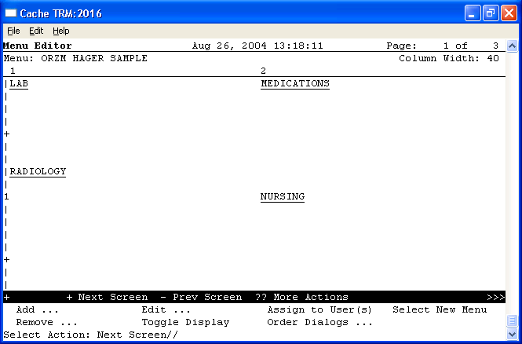
Figure 15: Example of empty headers in the ORZM HAGER SAMPLE menu
The headers on this screen should be empty until items are added. Use the Toggle Display option to ensure that nothing displays under the headers because the headers are not associated with any real items.
At the “Select Action” prompt, type Add to add the newly created items.
ITEM: LRZ CBC OUTPT
ROW: 2
COLUMN: 1
DISPLAY TEXT:
MNEMONIC: 1
ITEM: LRZ GLUCOSE TODAY
ROW: 3
COLUMN: 1
DISPLAY TEXT:
MNEMONIC: 2
ITEM: LRZ HGBAIC OUTPT
ROW: 4
COLUMN: 1
DISPLAY TEXT:
MNEMONIC: 3
ITEM: LRZSET HAGER DIABETIC
ROW: 5
COLUMN: 1
DISPLAY TEXT:
MNEMONIC: 4
ITEM: RAZ HAGER KNEE
ROW: 11
COLUMN: 1
DISPLAY TEXT:
MNEMONIC: 10
ITEM: PSOZ AMOXICIILIN 500MG BID
ROW: 2
COLUMN: 2
DISPLAY TEXT:
MNEMONIC: 20
ITEM: ORZ HAGER DRESSING CHANGE
ROW: 11
COLUMN: 2
DISPLAY TEXT:
MNEMONIC: 30
Figure 16: Example of adding to the menu ORZM HAGER SAMPLE
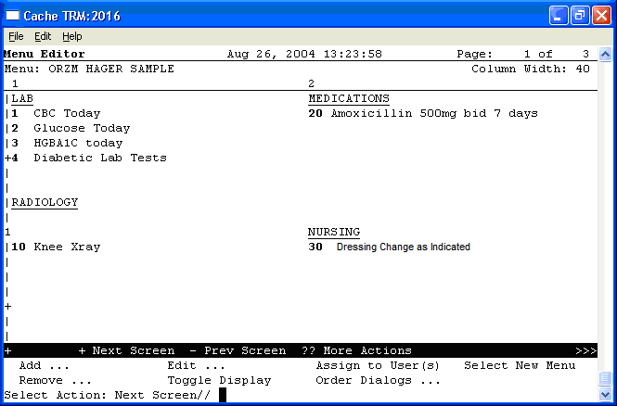
Figure 17: Example of headers that are populated with data
At the “Select Action” prompt type Toggle Display to view the official names of the items.
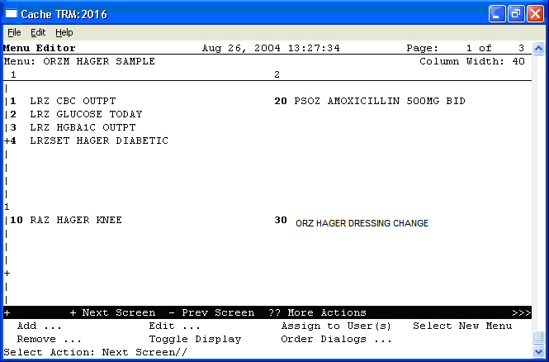
Figure 18: Example of menu after user toggles display

Add This Menu to the EHR
At the “Select Order Menu Management Option” prompt type PAR (Menu Parameters) and press the Enter key.
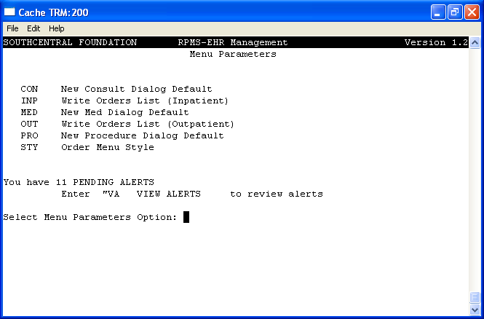
Figure 19: Example of Menu Parameters menu options
At the “Select Order Menu Parameters Option” prompt type OUT (Write Orders List) and press the Enter key.
Next, type 8 System DEMO.MEDSPHERE.COM
----- Setting Menu for Write Orders List for System: DEMO.MEDSPHERE.COM -----
Order Dialog: ORZM MAIN MENU//
Figure 20: Example of system display after user types 8 at the prompt

