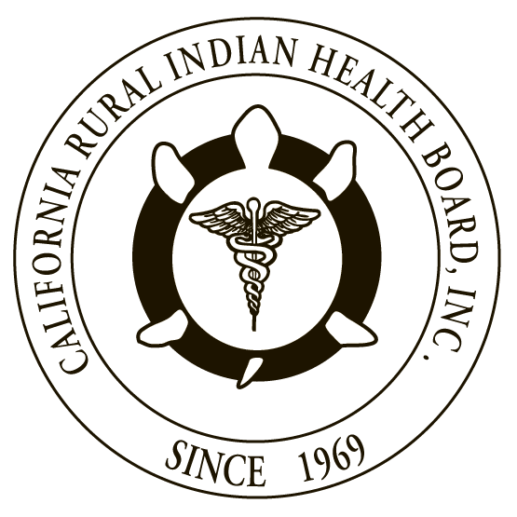
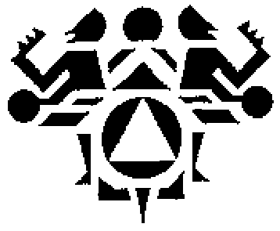

RESOLUTION # 17-04-07 RESOLUTION #
NORTHWEST PORTLAND AREA CALIFORNIA RURAL INDIAN
INDIAN HEALTH BOARD HEALTH BOARD

JOINT RESOLUTION
Recommendations to Congress to Fully Fund the Indian Health Service

WHEREAS, the Northwest Portland Area Indian Health Board (NPAIHB) is a Tribal organization under P.L. 93-638 that represents 43 federally-recognized Indian Tribes in Oregon, Washington, and Idaho and is dedicated to assisting and promoting the health needs and concerns of American Indian/Alaska Native (AI/AN) people in the Northwest; AND

WHEREAS, the California Rural Indian Health Board, Inc. (CRIHB), founded in 1969 for the purpose of bringing back health services to Indians of California, is a Tribal organization in accordance with P.L. 93-638 and is a statewide Tribal health organization representing 33 Federally recognized tribes in 14 counties through its membership of 12 Tribal Health Programs throughout California’s Indian Country; AND

WHEREAS, the NPAIHB and CRIHB are dedicated to assisting and promoting the health needs and concerns of AI/AN people; AND

WHEREAS, the primary goal of the NPAIHB and CRIHB is to improve the health and quality of life of its member Tribes; AND

WHEREAS, the Indian Health Service (IHS) is significantly underfunded compared to other federal health agencies. For example, in 2015, IHS expended only $3,136 per AI/AN patient, while the national average spending per user was $8,517 -- an astonishing 63 percent difference; AND

WHEREAS, IHS funding is in fulfillment of the federal government’s trust responsibility assumed through a series of treaties with Tribes, exchanging compensation and benefits for Tribal land and peace. The Snyder Act of 1921 (25 U.S.C. § 13) legislatively affirmed this trust responsibility; AND

WHEREAS, for AI/ANs, the federal budget is not just a fiscal document, but also a moral and ethical commitment that reflects the extent to which the United States honors its promises of justice, health, and prosperity to AI/AN people; AND

WHEREAS, health funding for Indian Country has been hurt by sequestration and government shutdown in the past. In FY 2013, sequestration cuts devastated Tribal communities throughout the United States. In a health care delivery system that has been chronically underfunded for decades, this was disastrous for clinics across Indian Country.

THEREFORE BE IT RESOLVED, that CRIHB and NPAIHB urge the U.S. Congress to fully fund the IHS at $32 billion annually as fulfillment of the federal trust responsibility.

BE IT FURTHER RESOLVED, that CRIHB and NPAIHB urge the U.S. Congress to permanently, fully exempt the IHS from sequestration.

BE IT FURTHER RESOLVED, that CRIHB and NPAIHB urge the U.S. Congress to require the IHS to provide a detailed breakdown of how spending is allocated at the national and Area level to Congress and Tribes each year.

BE IT FINALLY RESOLVED, that CRIHB and NPAIHB urge the U.S. Congress to make IHS funding mandatory, no longer subject to the constraints of the annual discretionary appropriations process.

CERTIFICATION

The foregoing joint resolution was adopted at a duly called regular joint meeting of the Board of Directors of Northwest Portland Area Indian Health Board and California Rural Indian Health Board (NPAIHB vote __ For and _ Against and _ Abstain; CRIHB vote __ For and _ Against and _ Abstain) held this day of July 2017 in Canyonville, Oregon and shall remain in full force and effect until rescinded.

NORTHWEST PORTLAND AREA CALIFORNIA RURAL
INDIAN HEALTH BOARD INDIAN HEALTH BOARD
2121 SW Broadway, Suite 300 4400 Auburn Blvd, 2nd Floor
Portland, OR 97201 Sacramento, CA 95841
(503) 228-4185 (916) 929-9761

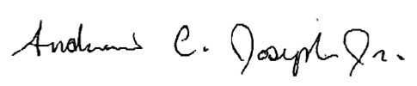
_________________________ __________________________
Chairperson of the Board Chairperson of the Board

_________________________ __________________________
Attest Attest

