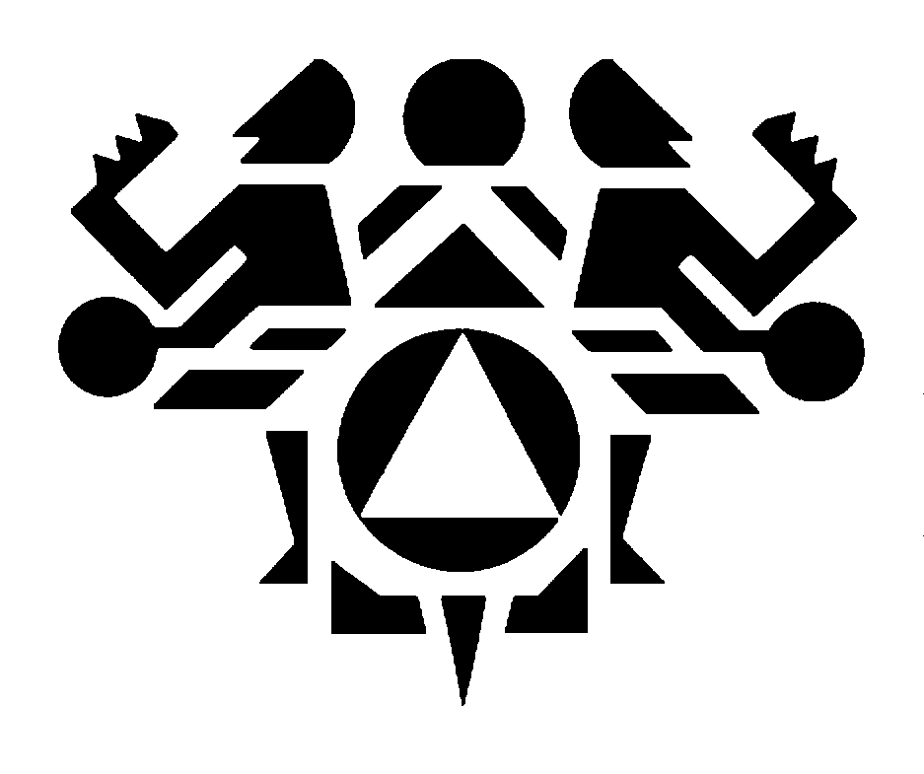

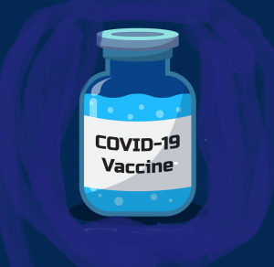

**Covid-19 vaccine update**

A vaccine for Covid-19 is in the news now and sometimes it is difficult to figure out what is fact and what is speculation or rumor. The Northwest Portland Area Indian Health Board and [**your tribe’s name here]** want to make sure you have the right information.

**Making the vaccine**

Right now the US government is supporting the development of eight different Covid-19 vaccines and four of those are in *clinical trials*. A clinical trial is when a new treatment, like a vaccine, is tested by volunteers to determine if it is safe and effective.

Clinical trials have three main phases.

* In Phase I, a small group of healthy people, around 20-100, will receive the vaccine primarily to test its safety.
* In Phase II, a few hundred people receive the vaccine to primarily test its effectiveness. These people are more representative of the people most susceptible to Covid-19.
* In Phase III, vaccines are tested on thousands of people from the general population to further test safety and effectiveness and to look for reactions.

The four vaccines in clinical trials now are all in Phase III trials. Three of the trials will enroll approximately 30,000 people each and the fourth will enroll up to 60,000 people. Both healthy people and people at higher risk of contracting Covid-19 are included in these trials.

Many of us ask, why are there so many vaccines being tested for one illness? One reason is to increase the opportunity for successful vaccines. It is also because there are many different types of people in the United States and in Indian Country. The four vaccines in Phase III clinical trials may each be more effective with specific groups of people, for example, elders. The 120,000 people currently taking part in the trials will allow researchers to test the vaccines on people of many different heritages, ages, and body types – to determine which works best for which group.

**Are tribes being consulted in the process?**

Yes, very much. Tribes and the Indian Health Service (IHS) are being consulted in the planning process in many ways and senior members of the Indian Health Service have been loaned to [*Operation Warp Speed*](https://www.cdc.gov/vaccines/imz-managers/downloads/COVID-19-Vaccination-Program-Interim_Playbook.pdf), the federal government program developing the vaccines.

Tribes have also been included in the vaccine trials, *if they choose.* The Navajo Nation has chosen to participate in one Phase III trial and the Lummi and Nooksack Nations are considering joining another trial set to begin this winter. Tribal participation in vaccine trials may help understand which vaccines being developed are most effective for tribal populations.

Distribution of the vaccines has also included tribal input to make sure the people who need the vaccines the most are being prioritized. Other government agencies, such as the Centers for Disease Control and Prevention (CDC), are also actively consulting with the tribes. Besides federally-recognized tribes, plans also are underway for the distribution of vaccines to tribal health facilities, including urban facilities, and non-federally recognized tribes that are not officially connected to IHS.

**When will the vaccine be ready?**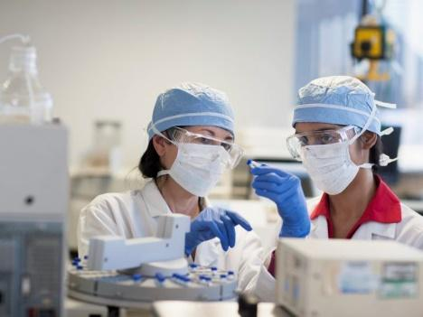

Limited doses of the vaccine may be available by the end of 2020. Most people involved with the production do not expect the vaccine sooner than this. Once available, the distribution of the vaccines will likely be in three stages. The distribution may look like this:

* Stage 1, projected for the winter of 2021, because of limited availability, the vaccines will be given to the people who need them the most, such as health care workers, elders, and medically vulnerable people.
* Stage 2, in the spring of 2021, with more production, the vaccine will go to the critical populations who were not vaccinated in Stage 1 and then to the general population.
* Stage 3, in the summer of 2021, it is expected there will be enough vaccines for the entire United States population. Distribution is also reviewed at this stage to make sure that populations or communities with low coverage have access to the vaccines.

*NOTE*: Plans for distribution may change depending on the development of the vaccine.

**How do we know it is safe?**

Safety and effectiveness are the primary goals of any clinical trial. At any phase, a vaccine trial may be halted if there are reports of unwanted or harmful reactions and only resumed if it is deemed safe to continue. Besides the normal safety measures in any trial, there are several more things being done now that will help make this vaccine safe. These include:

* The 120,000 people participating in these Covid-19 trials is **3 to 10 times** more than would normally take part in a Phase III trial. This allows researchers to be confident in determining the safety and effectiveness of each vaccine candidate. 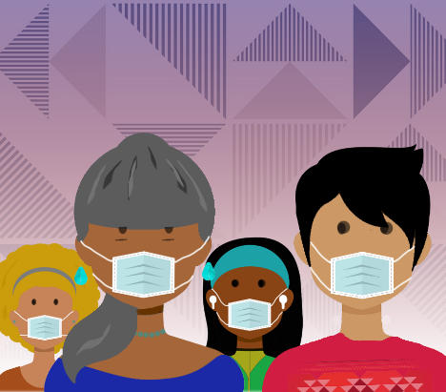
* Drug companies making the vaccines have pledged that they will not submit candidates to the Food and Drug Administration (FDA) for review until they have been shown to be safe and effective in the clinical trials.
* Washington, Oregon, Nevada, and California are joining together to independently review the safety and effectiveness of Covid-19 vaccines after approval by the FDA, adding another layer of expert review to build confidence in the vaccine.

Participation by indigenous and people of color along with the elderly and people with underlying conditions is being prioritized in the trials because these people have been the hardest hit by Covid-19. One of the vaccine candidates reports that 37% of the participants in its trial are people of color. The knowledge gained from their participation will help make the vaccine safe and effective for these populations.

Finally, participants are being monitored after they receive the vaccines to make sure that any problems are detected before the vaccines are distributed to the public. Safety efforts will also continue while and after the vaccine is distributed to the American public. to the *Vaccine Adverse Event Reporting System* (VAERS) at the CDC will be notified of any reported problems for follow up to determine if they are because of the vaccine.

Just like a flu vaccine, it is possible you may have minor side effects from the Covid-19 vaccine. Rear Admiral Francis Frazier, IHS Vaccine Task Force Lead, reports that the most common side effects reported by people in the trials are tiredness, muscle aches, and headaches.

**How do we know the vaccine will be distributed fairly?**

Detailed planning is going into the fair and equitable distribution of the vaccines on federal, state, local, and tribal levels. The CDC is working directly with the IHS and other tribal organizations and its guiding principles in the manufacturing and distribution of the vaccine, [*Safety, Inclusion, Efficient Distribution, and Flexibility*](https://www.cdc.gov/vaccines/acip/meetings/downloads/slides-2020-08/COVID-08-Dooling.pdf)*,* are viewed through a lens of equity.

The CDC will oversee the vaccine distribution process. On October 1, 2020, the Northwest Portland Area Indian Health Board and other tribal organizations made recommendations to federal partners on the distribution and administration of the vaccine. Tribal nations will choose if they want to receive the vaccine from the IHS or through their local health jurisdictions.

Once they choose how they want to receive the vaccines, tribal organizations and governments will independently develop their own distribution and administration plans for their communities. Most are developing those plans now based on tribal priorities.

**Will the Covid-19 vaccine be free?**

The vaccine will be available to the American people at no cost from the federal government but some healthcare providers might charge for the cost of administering of the vaccine.

**Resources:**

For more information about the vaccines being developed for Covid-19 and how they will be distributed, please see:

* [IHS COVID-19 Pandemic Vaccine Draft Plan](https://www.ihs.gov/sites/coronavirus/themes/responsive2017/display_objects/documents/IHS_COVID-19_Pandemic_Vaccine_Plan.pdf)
* [Tribal Communities and the CDC](https://www.cdc.gov/coronavirus/2019-ncov/community/tribal/index.html)
* [Vaccine Safety](https://www.cdc.gov/vaccinesafety/ensuringsafety/history/index.html)
* [Washington Covid-19 Vaccination Plan](https://www.doh.wa.gov/Portals/1/Documents/1600/coronavirus/WA-COVID-19-Vaccination-Plan.pdf)
* [Oregon Covid-19 Vaccination Plan](https://www.oregon.gov/oha/covid19/Documents/COVID-19-Vaccination-Plan-Oregon.pdf)
* [Idaho Covid-19 Vaccination Plan](https://coronavirus.idaho.gov/wp-content/uploads/2020/10/Idaho_COVID-19-Interim-Vaccination-Plan-V2-10-19-2020.pdf)

