IMPROVING INDOOR AIR QUALITY TO REDUCE THE TRANSMISSION OF COVID-19

COVID-19 spreads from person-to-person through respiratory droplets when an infected person coughs, sneezes, or talks. These droplets can be transported in the air and dispersed throughout a room, making improving indoor air quality an important component to a comprehensive COVID-19 prevention and mitigation plan in buildings and homes. Strategies to improve indoor air quality include:

VENTILATION
Increase air ventilation by bringing in more fresh, outdoor air to dilute and/or displace any present airborne viruses. This may include opening windows and doors, holding meeting or classes outdoors, and/or adjusting air circulating functions to increase fresh air intake on the heating, ventilation, and air conditioning (HVAC) system.

FILTRATION
Increase the level of the HVAC air filter to MERV 13 or higher or the highest level the system can handle. Sometimes increasing the efficiency of the filter can impact airflow; make sure there is sufficient airflow with any increased filtration. Ensure the filter is the right size and fits properly. Ensure the filter is maintained or replaced according to manufacturers’ directions.

SUPPLEMENTATION
Depending on the layout of the building, supplemental air quality devices may be useful in improving indoor air quality. You might consider portable air cleaners or purifiers, UV germicidal irradiation (UGVI) or air sanitizers.

EVALUATION
Work with certified professionals to evaluate the HVAC system for airflow efficiency and fresh air intake. Carbon dioxide (CO2) levels and/or indoor humidity measurements can help assess air quality and airflow. Ideal indoor relative humidity levels should be between 40-60%; ideal CO2 level indoors is 600 ppm, do not exceed 800 ppm.

AIR CLEANER PURCHASING GUIDELINES & CONSIDERATIONS

Air cleaners or purifiers can be very effective at improving air quality when used properly. There are hundreds of brands and models on the market that vary widely in cost and efficacy. This information is designed to help facilities research, select and purchase air purifiers.

TRUE HEPA vs. MEDICAL GRADE HEPA
There are not different kinds of HEPA filters, since they all meet the same standard, but there are different levels of efficiency. There are 6 different types, A-F, that range in efficiency from 99.97%-99.999%. Most medical grade HEPA filters filter at the highest levels and may be labeled as Ultra-High Capacity HEPA or ULPA.

FUNCTION & FILTER
Air cleaners serve different purposes. Consider what contaminants you need to filter- wildfire smoke, viruses, bacteria, pollen, animal dander, molds, dust, or volatile organic compounds (VOCs) or other gases. Most units filter for particles or gases; although you can find units that will filter for both.

An air cleaner equipped with a “true” High Efficiency Particulate Air or HEPA filter is recommended. True HEPA filters are tested to remove 99.97% of particles, 0.3 microns in size. Particles that are larger or smaller are trapped with higher efficiency. These are the most efficient for filtering a variety of contaminants including wildfire and tobacco smoke as well as most viruses. True HEPA filters are tested and certified to meet the highest standard in air purification. Units labeled as “HEPA-type”, “HEPA-like”, “99% HEPA” do not meet the standard. Typically, air purifiers have at least 2 stages of filtration for particles, a prefilter for larger particles and a HEPA one for smaller ones.

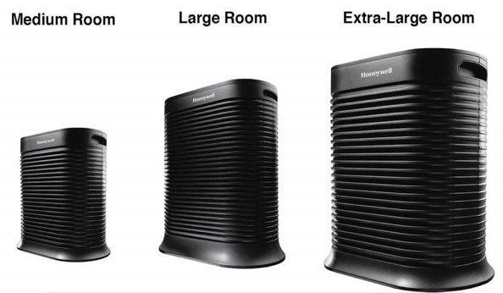
SIZE
Air cleaners are designed to work in rooms, not entire buildings. Consider the size of the room in which the air purifier will be used and purchase a unit that is designed for that size room. Units should very clearly state what size room they are designed for. If you buy a unit that is too small for the room, it will not provide the level of clean air intended. Harvard University and CU Boulder developed a resource for calculating size of air cleaner for classrooms (see link below).

Some units are rated by their Clean Air Delivery Rate (CADR). The CADR is designed to help consumers
select an air cleaner based off the size of the area it will be used in. The higher the CADR, the more particles it will remove and the larger the area it can be used in. The CADR may also indicate the size of particles that can be effectively filtered- with a higher CADR unit being able to filter smaller particles.

CARE & MAINTENANCE
Follow the manufacturer directions when it comes to maintenance and cleaning to ensure units function and last as expected. Most manufacturers recommend checking filters every six months and replacing them annually, but some last as long as 5 years!

AVOID OZONE GENERATING UNITS
Ozone is a lung irritant and strictly regulated pollutant. Never use any ozone generators in occupied spaces. Some units that contain electrostatic precipitators, ionizers, UV lights without adequate lamp coatings and plasma cleaners may emit some ozone gases. The California Air Resources Board maintains a list of units that emit no or very little ozone (see link below). Contact the manufacturer if you are unsure whether a unit you are considering emits ozone.

Resources & References:
EPA. (2020). Air Cleaners & Air Filters in the Home. https://www.epa.gov/indoor-air-quality-iaq/air-cleaners-and-air-filters-home-0
California Air Resources Board. https://ww2.arb.ca.gov/our-work/programs/air-cleaners-ozone-products/california-certified-air-cleaning-devices
National Air Filtration Association. (2020). “How many Types of HEPA Filters Are There?. https://www.nafahq.org/how-many-types-of-hepa-filters-are-there/
ASHRAE (2020). COVID-19 Technical Resources. https://www.ashrae.org/technical-resources/resources
Harvard T.H. Chan School of Public Health Healthy Buildings program. (2020). Healthy Schools: Risk Reduction Strategies for Reopening Schools. https://schools.forhealth.org/wp-content/uploads/sites/19/2020/06/Harvard-Healthy-Buildings-Program-Schools-For-Health-Reopening-Covid19-June2020.pdf
Harvard T.H. Chan School of Public Health & Colorado University Boulder. (2020). Portable Air Cleaner Calculator for Schools. https://docs.google.com/spreadsheets/d/1NEhk1IEdbEi_b3wa6gI_zNs8uBJjlSS-86d4b7bW098/edit#gid=1882881703

