SECTION I: Adding a user

Adding user Check list:
- Add using AVA IHS provider/person add/edit menu option
- Edit User, User management menu option
  - Make sure to give them the correct person class according to their credentials:
Reference site, https://npiregistry.cms.hhs.gov/
- Add Keys
  - Reference document, Excel Sheet “Copy of user template”
- according to their duties, assign to mail groups, I added some groups but this list is not all inclusive
  - RCIS Staff need to be added to:
BMC IHS ALERT - A Bulletin is sent when a IHS Type Referral is entered
BMC INHOUSE ALERT - A Bulletin is sent when a INHOUSE Type Referral is entered
BMC OTHER ALERT - A Bulletin is sent when a OTHER Type Referral is entered

  - CAC staff to:
PXRM ERROR – receive mail man messages with reminder errors

TIU CACS – This cross-reference identifies the people who should receive
informational bulletins concerning the implementation of the Text
Integration Utilities (TIU) Package.

DGPF Local Flag (if your site created a local mail group, use that local group instead)

  - HIM staff to:
TIU MIS ALERTS - This mail group is for the purpose of receiving problem alerts for
TIU. These alerts should be for problems in TIU Notes that are caused by
a system bug. It is meant as a management tool - not an alert system for
the end user.This mail group is for the purpose of receiving problem
alerts for TIU. These alerts should be for problems in TIU Notes that are
caused by a system bug. It is meant as a management tool - not an alert
system for the end user.

BEHOCCD HIMS TOC - HIMs people who should get an alert when a new TOC document is generated

DGPF Local Flag (if your site created a local mail group, use that local group instead)

  - Pharmacy staff:
GMRA MARK CHART -
GMRA P&T COMMITTEE FDA
GMRA REQUEST NEW REACTANT
GMRA VERIFY DRUG ALLERGY
GMRA VERIFY FOOD ALLERGY

  - BCMA Coordinators staff to:
BCMA ISSUES - This is a mail group for BCMA issues
Will be used in BCMA Site Parameters set-up

***may be other mail groups that I am not aware of, consult RPMS package manuals and installation notes****
- Setup Electronic Signature
- For clinician that have schedule clinics, create clinic in scheduling package
- Behavior health providers, add them to the “update those allowed to see all records”
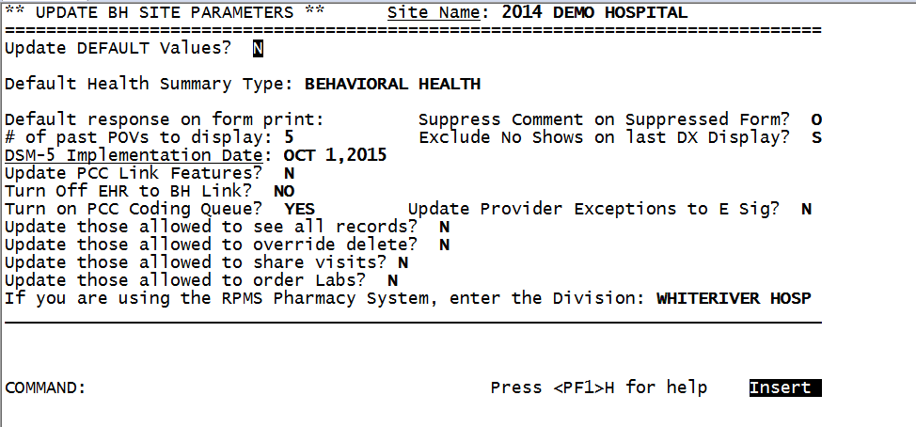
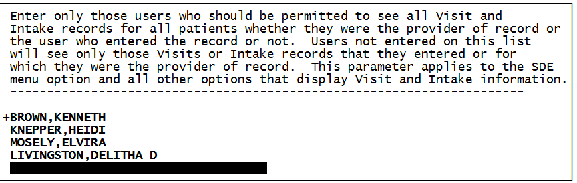

- For sites that assign patient to providers and use the PCP Team setup, go into the Primary Care Provider add this provider to the team

- Give them a TIU user class according to their credentials

- If the provider is an in-house referral service, assign them to the correct consult team

STEP 1: Adding User as a Provider (use PER Add/Edit New Persons if they do not perform patient care)

Select User Management Option: AVA

Select IHS Provider/Person Add/Edit Option: PRV

ADD/EDIT PROVIDERS

Use this option to add new providers to your system OR to edit those already in the system. You do NOT need to enter the provider as a person first. Just use this option.

Enter NEW PERSON's name (Family,Given Middle Suffix): DEMO,PHX-AO DOCTOR P
DD PHYSICIAN

NAME: DEMO,PHX-AO DOCTOR//
INITIAL: PDD//
SEX: MALE//
DOB: AUG 15,1975//
TITLE: PHYSICIAN//
SSN: 321551199//
SERVICE/SECTION: MEDICAL STAFF//
STREET ADDRESS 1: (Facility’s address)
STREET ADDRESS 2:
STREET ADDRESS 3:
CITY: PHOENIX
STATE: AZ ARIZONA AZ
ZIP CODE: 85004
PHONE (HOME):
OFFICE PHONE:
FAX NUMBER:
EMAIL ADDRESS: DEMO.DOCTOR@PHX.AO
PROVIDER CLASS: MD
(Use the following site to determine the PROVIDER CLASS and CODE)
http://www.ihs.gov/scb/index.cfm?module=W_PROVIDER_DISC&option=list&num=50&newquery=1
1 MD
2 MDA MEDICAL ASSISTANT
CHOOSE 1-2: 1 MD
AFFILIATION: IHS IHS
CODE: 00
IHS LOCAL CODE:
MEDICARE PROVIDER NUMBER: (The facility’s #)
MEDICAID PROVIDER NUMBER: (The facility’s #)
UPIN NUMBER:
AUTHORIZED TO WRITE MED ORDERS: Y YES
DEA#: ?? (All providers should have a DEA number)
Enter the DEA number 2 letters 7 numbers (optional 2-character extension).
Enter the DEA number as two upper case letters followed by 7 digits
e.g. AA1234567. Each provider must have a unique number.
A suffix of up to two alphanumeric characters may be appended (optional).
DEA EXPIRATION DATE:
***if user does not have a DEA and they are prescribing providers, you will need to go into fileman, new person file and enter a VA#, using this format (Initials followed by last 4 of social, example EM5558)
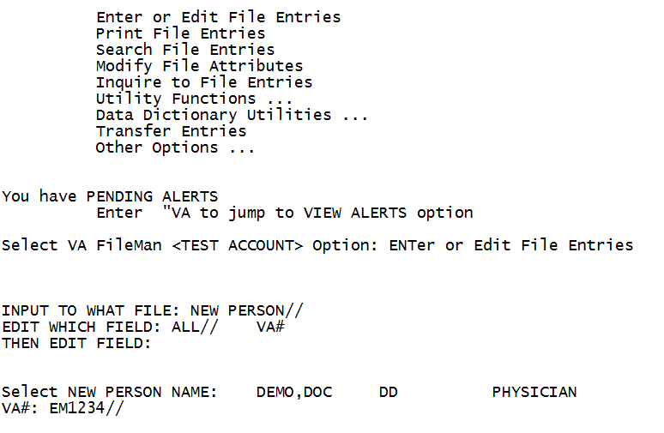
SPI: ***IF your site is an e-RX site, add the SPI# here plus add your facility, or clinic, or pharmacy fax number***
PROVIDER TYPE: FULL FULL TIME
REQUIRES COSIGNER:
USUAL COSIGNER:
REMARKS:
Select STATE OF LICENSEURE: AZ ARIZONA AZ
Are you adding 'ARIZONA' as a new STATE OF LICENSURE (the 1ST for this PROVIDE
R)? No// Y (Yes)
LICENSE NUMBER: A13254Z

Disabled pending intial upload.

Press RETURN to continue:

****add menus, fileman access code, person class and other important data****

Select IHS Kernel Option: USRM
Select User Management Option: EDIT an existing user

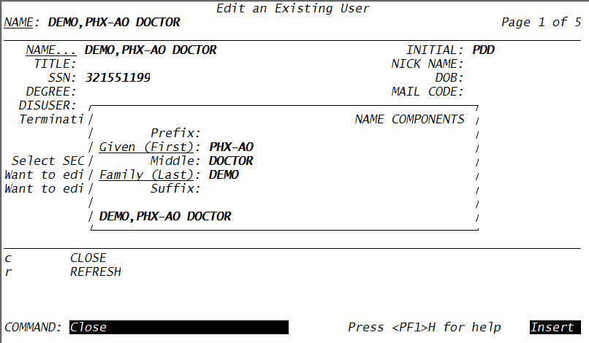

COMMAND: C

STEP 2. Adding Additional Information

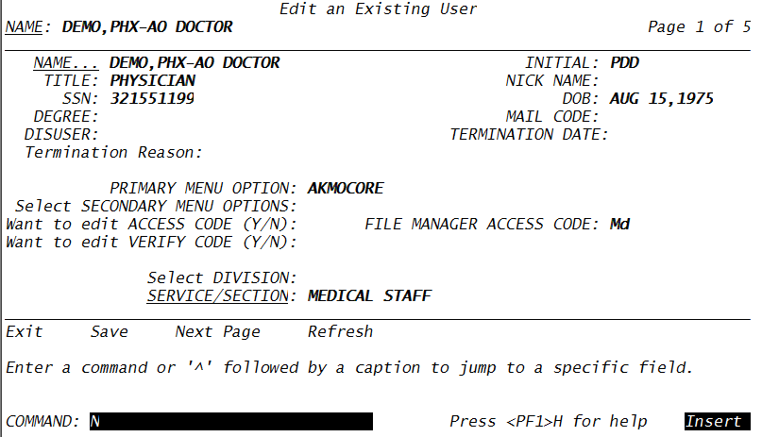

COMMAND: N

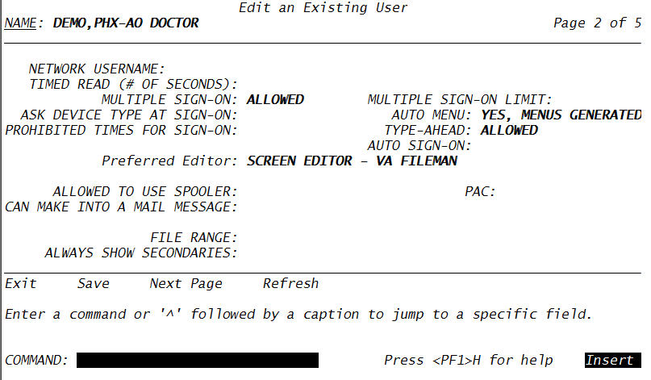

COMMAND: N
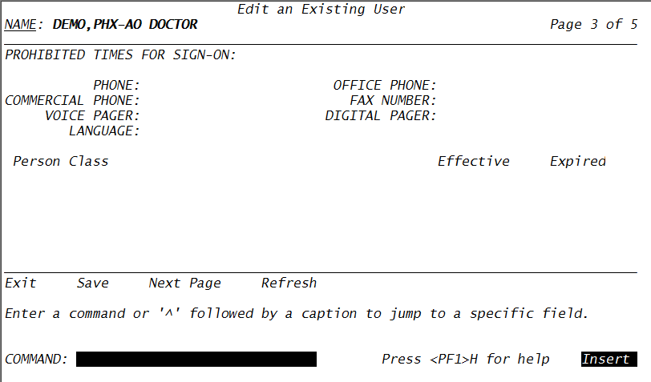

Person Class: using the providers NPI got to https://nppes.cms.hhs.gov/NPPESRegistry/NPIRegistryHome.do to get the Person Class.

COMMAND: N

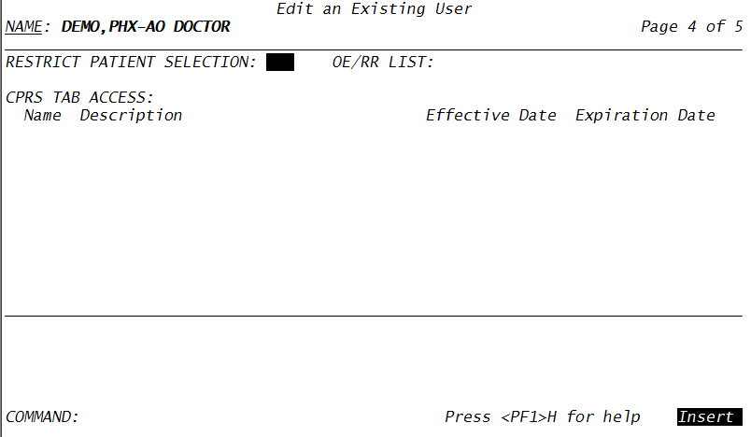
COMMAND: N
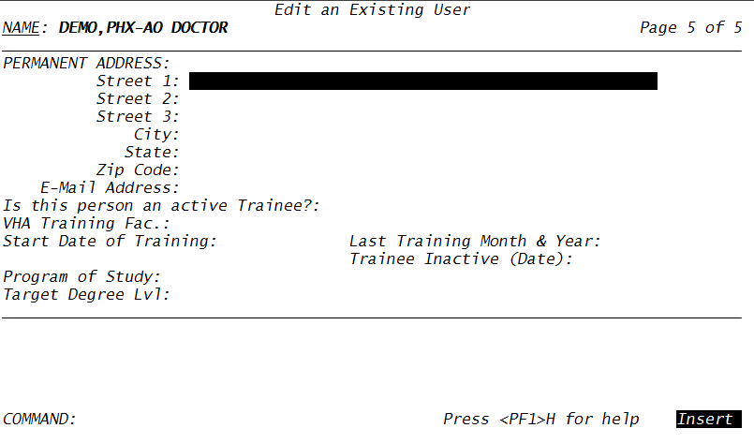

Type an S then an E to save and exist.

Enter a command or '^' followed by a caption to jump to a specific field.

STEP 3. Grant Access by Profile
If you have created clean user templates, clone the new user against that user otherwise add security manually via
KEYS Key Management ...
***use the excel sheet attach for guidance on keys***
Select User Management Option: Grant Access by Profile

Batch Entry of New Persons
--------------------------
****for the script use the demo doc below or clone using a user on your database****
Please select a person to copy from
Template PERSON: DEMO,HOPI DOC HD PHYSICIAN

Is this the person whose data you want cloned? Y

You may enter a date, when the users that are being created/updated will no longer have access to the system.
Enter (optional) TERMINATION DATE:

Batch Entry of New Persons
--------------------------

Clone of: DEMO,HOPI DOC
Enter NEW PERSON's name (Family,Given Middle Suffix): DEMO,PHX-AO DOCTOR P
DD PHYSICIAN
DEMO,PHX-AO DOCTOR is an existing user. Do you want to include? YES
Clear out KEYS, FILES, SECONDARY MENUS first? YES
Do You Want To Clone PERSON CLASS? NO (Should always answer NO)

Next!
Enter NEW PERSON's name (Family,Given Middle Suffix):

Where do you want to print the COMPUTER ACCOUNT NOTIFICATION LETTERS?
DEVICE: HOME//

CONVERTING DEMO,PHX-AO DOCTOR'S ACCOUNT OVER

One moment please...
USER ACCOUNT NOTIFICATION

2014 DEMO HOSPITAL
40 NORTH CENTRAL AVE
SUITE 605
PHOENIX, AZ 85340

PHX-AO DOCTOR DEMO
MEDICAL STAFF (MD)

---
CONVERTING DEMO,PHX-AO DOCTOR'S ACCOUNT OVER

A user account has been created in your name to enable you to access on-line clinical and/or administrative data required to perform your duties as an employee of Indian Health Service. Please read the enclosed NEW USER INFORMATION before you attempt your first log-on to the system. Questions about access should be referred to the AIS Application Coordinator in your service, your facility Information Security Officer (ISO), or your IRM Service.

Your Computer Access Coordinator is:
MOSELY,ELVIRA
345
338-3785
Your Facility Information Security Officer:
Elvira Mosely
Your Alternate Information Security Officer:
---
Access Code: OQMN316
Verify Code: 9734PLK}

COMPUTER ACCOUNT ACCESS POLICY

INDIAN HEALTH SERVICE
2014 DEMO HOSPITAL

PHX-AO DOCTOR DEMO
MEDICAL STAFF (MD)

As an authorized user of IHS RPMS/EHR SYSTEM and having access to data stored in them, I will be given sufficient access to perform my assigned duties. I will use this access ONLY for its intended purpose and understand the following policies that apply to IHS data and computer systems policies:

I agree to safeguard all passwords (e.g., Access/Verify codes, electronic signature codes) assigned to me and am strictly prohibited from disclosing these codes to anyone including family, friends, fellow workers, supervisor(s), and subordinates for ANY reason.

I understand that I may be held accountable for all entries/changes made to any government information system using my passwords.

I am aware of the regulations and facility information system security policies designed to ensure the confidentiality of all sensitive information. I am aware that information about patients or employees is confidential and protected from unauthorized disclosure by law. I understand that my obligation to protect IHS information does not end with either the termination of my access to this facility's systems or with the termination of my government employment.

I will exercise common sense and good judgment in the use of electronic mail. I understand that electronic mail is not inherently confidential and I have no expectation of privacy in using it. I understand that technical or administrative problems may create situations which requires viewing of my messages. I also understand that facility management officials may authorize access to my electronic mail messages whenever there is a legitimate purpose for such access.

I understand that a violation of this notice constitutes disregard of a local and/or IHS policy and will result in appropriate disciplinary action as defined in IHS employee conduct Regulations as well as suspension/termination of access privileges.

I affirm with my signature that I have read, understand, and agree to fulfill the provisions of this User Access notice.

Signature:________________________
PHX-AO DOCTOR DEMO MEDICAL STAFF MD
RETURN THIS FORM TO: IRMS - NEW ACCTS (xxx/xxx)

STEP 4. Adding a TIU User’s Class

Follow this menu path: TIUM > TMM > UCM > UCM2
Select USER: DEMO,PHX-AO

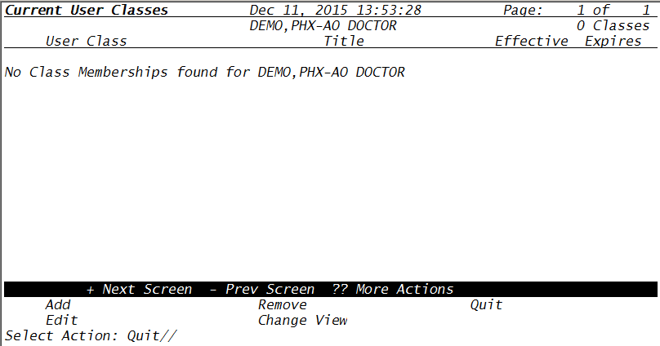
Select Action: Quit// ADD
Select USER CLASS: PHYSICIAN
1 PHYSICIAN
2 PHYSICIAN ASSISTANT
CHOOSE 1-2: 2
EFFECTIVE DATE: T-1
EXPIRATION DATE:
TITLE:
Select Another USER CLASS:

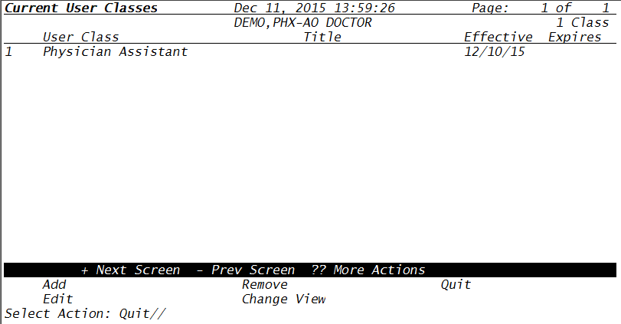
Step 7: Create Clinic, Add to mail group, add to EHR Consult teams, add provider Primary Care Team.
***following through step 7 depends on the provider’s credetials and duties****
Step 6 Assist user with electronic signature

Have the user sign into RPMS and assist them with their electronic signature block and other credentials
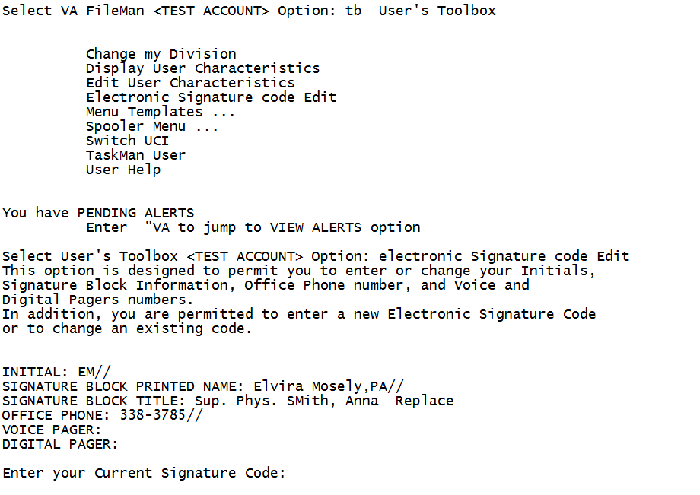
Assist them with electronic signature, they can created the signature in EHR or in RPMS.
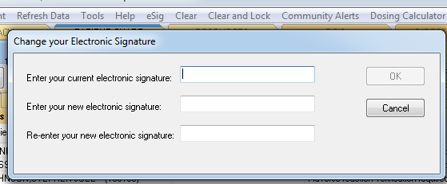

Finally have that provider sign into EHR. Assess whether the provider can:

- Create a visit
- Add themselves to the provider box
- Enter health factor, exam, pov, etc
- Can they order
- Do they get prompted for electronic signature
- Can they add a note
- Assist with creating top note title list
- Assist with creating lab flowsheets or report flowsheet

SECTION II: Inactivating a provider

Removing user check-list:
- Assign a surrogate
- Take away RPMS access
- De-activate provider
- DE-activate clinic (if any)
- Remove from mail groups and consult teams
- PCP – Assign patient to new team or provider.
- Review provider’s deficiencies and assign as appropriately

STEP 1: Take away access to RPMS

usrm User Management
Select User Management Option: edit an Existing User
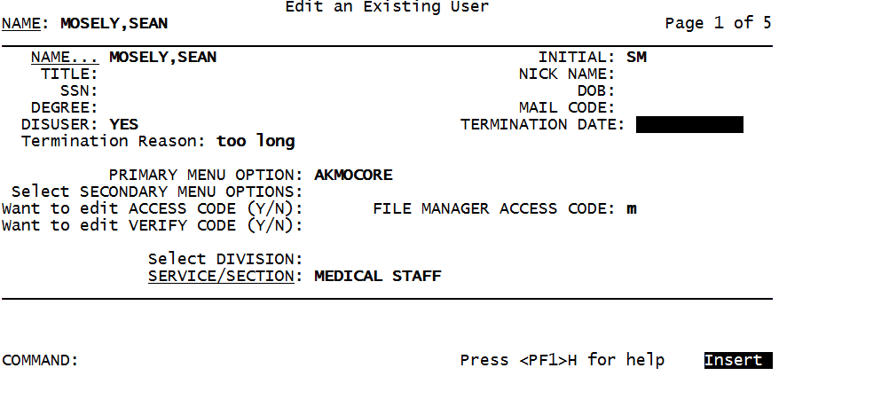
User will not be able to log into RPMS or EHR

STEP 2: Inactivating a Provider/user
Select User Management Option: AVA
Select IHS Provider/Person Add/Edit Option: INA

INACTIVATE/REACTIVATE A PERSON/PROVIDER

Use this option to enter an INACTIVE DATE for a Person or Provider. To deactivate a user, please use the option on the USER EDIT menu. To REACTIVATE a person or provider, enter an "@" at the Inactive Date prompt. Then proceed to the ADD/EDIT PROVIDERS option to insure all the data is current.

Select NEW PERSON NAME: DEMO,PHX-AO DOCTOR PDD PHYSICIAN

INACTIVE DATE: T (DEC 11, 2015)

Disabled pending intial upload.

Press RETURN to continue:

Select NEW PERSON NAME:
Select User Management Option: Deactivate a User
DEMO,PHX-AO DOCTOR PDD PHYSICIAN
View/Print User Inquiry Data? Yes//

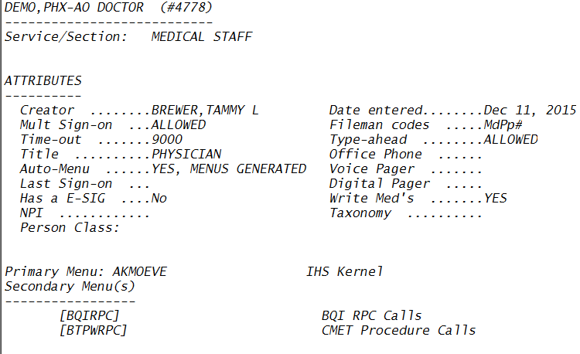

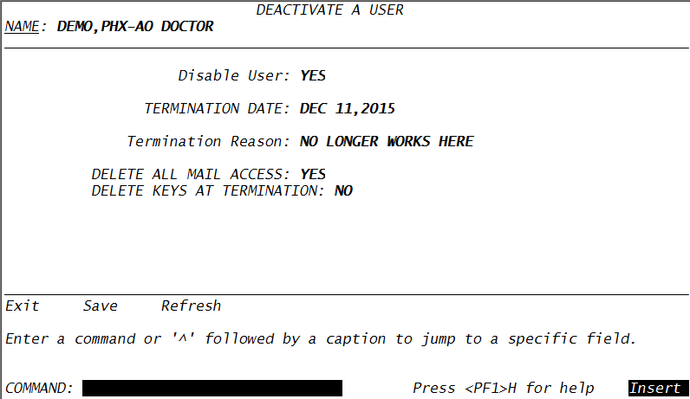
COMMAND: S and then E to Save and Exist

DEMO,PHX-AO DOCTOR will be deactivated now. Do you wish to proceed? YES//
... DONE

Step 3. Remove the User Class
***they will not be selectable as a visit provider in EHR***
Follow this menu path: Core > TIUM > TMM > UCM > UCM2

User Class Management Menu

(2014 DEMO HOSPITAL)
Select USER: DEMO,PHX

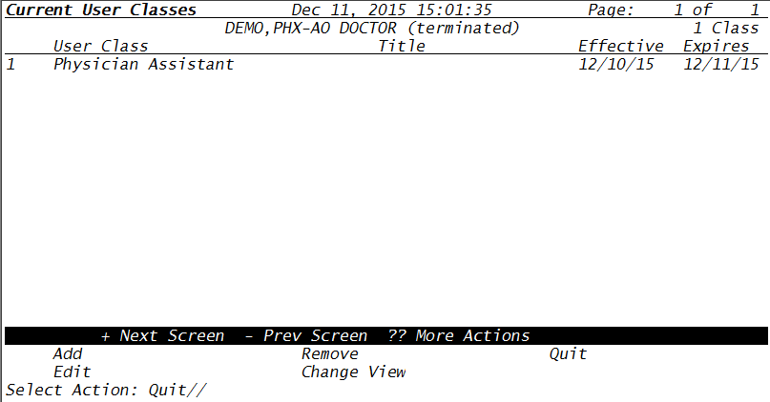
Select Action: Quit// REMOVE
Removing DEMO,PHX-AO DOCTOR from PHYSICIAN ASSISTANT
Are you SURE? NO//YES

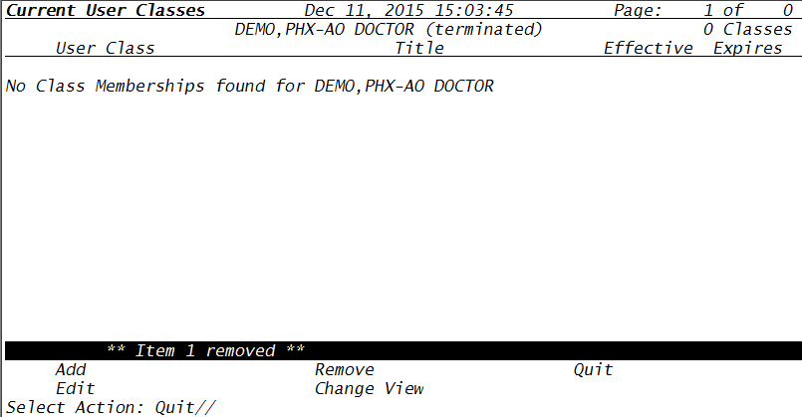

Step 4. For Provider with a scheduled clinic

Before we inactive the provider’s schedule, we need to:

- Run a report for appointment that did not get check-in or are scheduled.

***if your facility does not run this report routinely, then you may have to set the date as far back as when your provider was 1st hired. ***

AL Appointment List
AM Appointment Management
CR Chart Requests
CHK List Patient Check In Status
DA Display Patient's Appointments
MB Multiple Appointment Booking
MC Multiple Clinic Display/Book
MD Month-at-a-glance Display
PL Print Scheduling Letters
PS View Provider's Schedule
WL Waiting List Enter/Edit
PCP Primary Care Provider Menu ...
PMR Patient Mini Registration
SCR Reports Menu (Scheduling) ...
SCS Supervisor Menu (Scheduling) ...
CRA Cancel/Restore Clinic Availability
SET Set Up a Clinic

Select Scheduling Menu Option: SCR Reports Menu (Scheduling)

Select Reports Menu (Scheduling) Option: AMR Appointment Management Reports

Use this option to access reports designed to assist you in managing your appointment statuses. Workload Reports require knowing whether an appointment tool place, so each must be checked-in or marked as a no-show. One report also helps you track if all checked-in appointments are being coded in PCC.

1. Appointment Management Statistics
2. Appointments Requiring Action
3. Uncoded Checked-in Appointments
4. Eligibility Appointment List
5. Cancelled Appointment Listing
6. On-line Help (Report Descriptions)

Select REPORT: (1-6): 2

Use this report to list all appointments with no status or with a status of "No Action Taken". All Workload and statistical reports will not be accurate until these appointments have an appropriate status added.

Select one of the following:

C Clinic
P Principal Clinic
V Provider
T Team

Subtotal Report by: C Clinic
Select division: 2014 DEMO HOSPITAL// 8999
Select another division:
Would you like a preexisting Clinic Taxonomy?? NO//
Select clinic: ALL// BOOT BOOT *inactivated on JAN 19, 2016
Select another clinic: BREWER APPTS BREWER,TAMMY L
Select another clinic:
Would you like to save this clinic list as a Taxonomy?? NO//
Select First Date to Search: jan 1 1970 (JAN 01, 1970)
Select Last Date to Search: t (JAN 19, 2016)

Select one of the following:

B BROWSE ON SCREEN
P PRINT ON PAPER

PRINT MODE: BROWSE// ON SCREEN

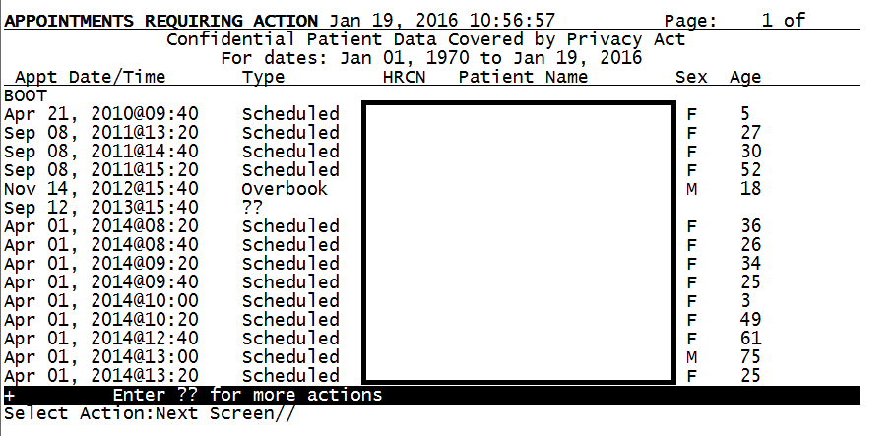

- Get provider’s clinic waitlist if any. If you inactivate the clinic before moving these patients over to a new waitlist or appointment, you will lose that data.

AL Appointment List
AM Appointment Management
CR Chart Requests
CHK List Patient Check In Status
DA Display Patient's Appointments
MB Multiple Appointment Booking
MC Multiple Clinic Display/Book
MD Month-at-a-glance Display
PL Print Scheduling Letters
PS View Provider's Schedule
WL Waiting List Enter/Edit
PCP Primary Care Provider Menu ...
PMR Patient Mini Registration
SCR Reports Menu (Scheduling) ...
SCS Supervisor Menu (Scheduling) ...
CRA Cancel/Restore Clinic Availability
SET Set Up a Clinic

Select Scheduling Menu Option: WL Waiting List Enter/Edit

Use this option to manage your waiting lists for both outpatient clinics or inpatient wards. Only application coordinators may add new clinics or wards as waiting lists. Once a list is selected, you can select how the list will be displayed. Options are Patient Name, Date Added to List, Priority, and Recall Date. From that list, you may add new patients, edit or view existing entries, remove patients from active status or request a listing of closed cases.

Select WAITING LIST CLINIC OR WARD: ?
Answer with WAITING LIST CLINIC OR WARD
Do you want the entire 55-Entry WAITING LIST List? y (Yes)
Choose from:
BOOT
BRAMER-FORTIER
BREWER APPTS

You may enter a new WAITING LIST, if you wish
Enter Clinic or Ward Name.
Answer with HOSPITAL LOCATION NAME
Do you want the entire 498-Entry HOSPITAL LOCATION List? n (No)
Select WAITING LIST CLINIC OR WARD: BOOT MOSELY,ELVIRA
...OK? Yes// (Yes)

Select one of the following:

P Patient Name
D Date Added to List
O Priority
R Recall Date

Sort By: Patient Name// Patient Name

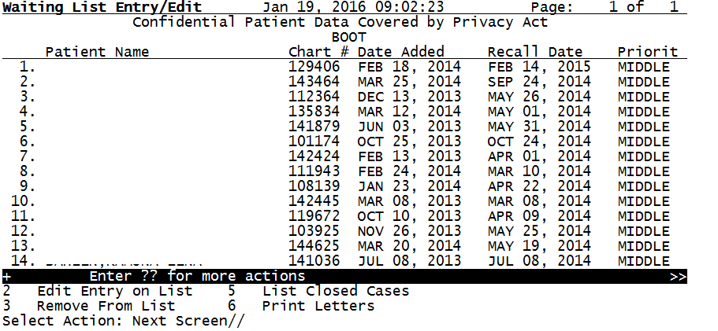

Moving patients to a new waitlist,
AD,xxxxx, GENE
DATE ADDED TO LIST: FEB 18,2014//
REASON ADDED TO LIST: F/U PATIENT; NO SCHEDULE YET
//
PRIORITY: MIDDLE// ****change priority here****
PROVIDER: BOOT,ExxxxxxTH A//
RECALL DATE: FEB 14,2015// t (JAN 19, 2016)
COMMENTS:
No existing text
Edit? NO//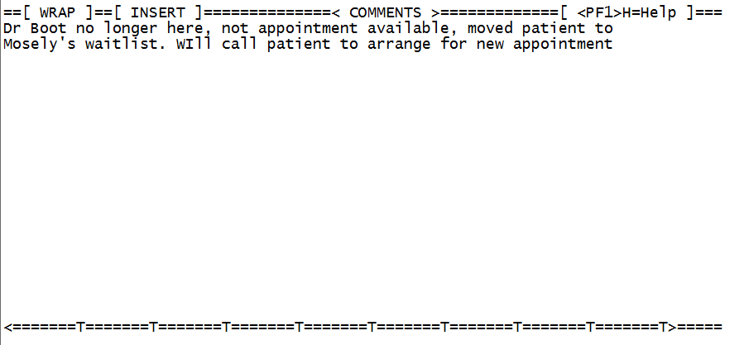

F1 key E key to save and exit
Date of Last Registration Update: MAR 25, 2014

PO BOX 891
ALB, NEW MEXICO 87119
555-555-9036 (home) (work)
Does patient's address or phone # need to be updated? NO//N **but if you enter yes, you can edit the demographic information for this patient.

Or you can remove that patient from the waitlist and give them an appointment.

*** If you need more time to move patient into the appropriate waitlist of appointment, you can cancel the availability of this clinic, this prevents users from booking appointments into this clinic,

Cancel availability so that no user can schedule an appointment with this provider while you are still working on this clinic’s waitlist and schedule appointment

ACM Application Coordinator Menu ...
CPF Clinic Profile
CRA Cancel/Restore Clinic Availability
DSU Display Scheduling User
EEL Enter/Edit Letters
IWL Wait List Activate/Inactivate
LAM List Appts Made By Clinic
MON Month-at-a-glance Display
SET Set Up a Clinic

Select Supervisor Menu (Scheduling) Option: CRA Cancel/Restore Clinic Availability

Use this option to either CANCEL or RESTORE a clinic's appointment slots.

You can CANCEL a clinic's availability for either a whole day or portion of a day. If several portions of a day are to be canceled you must cancel one portion first, then select CANCEL again to cancel the second portion, etc.

You can RESTORE the availability for a previously canceled clinic. Appointments that were rescheduled using the auto-rebook feature at the time of cancellation WILL NOT be moved to their original time slots.

Select one of the following:

C CANCEL CLINIC AVAILABILITY
R RESTORE CLINIC AVAILABILITY

Select Action: C CANCEL CLINIC AVAILABILITY
Select CLINIC NAME: BOOT
CANCEL 'BOOT' FOR WHAT BEGIN DATE: T (JAN 19, 2016)
CANCEL 'BOOT' FOR WHAT END DATE: <enter>

****Now you are ready to add that patient to a new waitlist, but remember that it is best to provide that patient with an appointment then to transfer them to another waitlist.****

Finally once you have scheduled and transfer patient to the new either waitlist or given an appointment, we can then inactivate the clinic.

SCS Supervisor Menu (Scheduling) > ACM Application Coordinator Menu

Select Application Coordinator Menu Option: IRC Inactivate/Reactivate Clinic

Choose INACTIVATE to render a clinic inactive (no activity) allowed) as of a selected date. Choose REACTIVATE to set the date from which point the inactivation of a clinic is terminated.

For INACTIVE clinics, you may want to change the clinic name, remove the abbreviation and principal clinic link. Use the Set Up A Clinic option to make those changes.

Select one of the following:

I INACTIVATE CLINIC
R REACTIVATE CLINIC

Select Action: INACTIVATE CLINIC

Select CLINIC NAME: BOOT MOSELY,ELVIRA
Enter Date Clinic is to be Inactivated: T (JAN 19, 2016)

Clinic will be inactivated effective 01/19/2016

STEP 5:
Remove them from:
- Mail groups
- PCP teams
- EHR Consult team

