Create Note Titles
Creating Note Titles consists of: (1) selecting or creating a document class and (2) creating a new Note Title in that document class.

Document Class Creation (not frequently needed)
If you are creating a new Note Title in an existing Document Class, skip to Page 3.
Go to Document Definitions menu.
--- Manager Document Definition Menu ---
1 Edit Document Definitions
2 Sort Document Definitions
3 Create Document Definitions
4 Create Objects
5 Create TIU/Health Summary Objects

Figure 1: Manager Document Definition Menu
Start with Number 3: Create Document Titles.
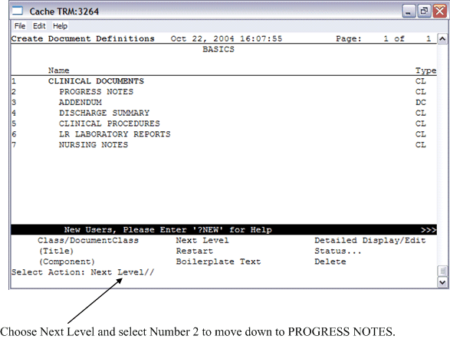
Figure 2: “Select Action: Next Level” prompt
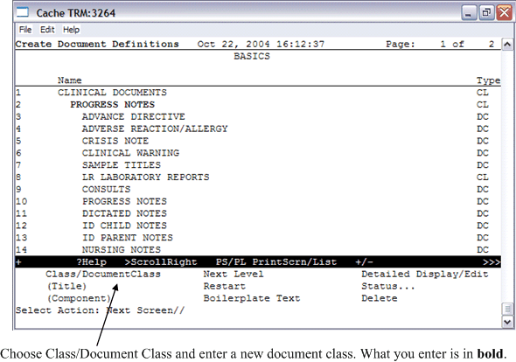
Figure 3: The Class/DocumentClass option
Enter the Name of a new PROGRESS NOTES: HAGER NOTES <- Put your name in
TYPE: (CL/DC): DC DOCUMENT CLASS
CLASS OWNER: CLINICAL COORDINATOR Replace <- Leave this
STATUS: (A/I): INACTIVE// A ACTIVE <- Make it active
SEQUENCE:
MNEMONIC:
MENU TEXT: Hager Notes//
Entry Created
If you wish, you may enter another PROGRESS NOTES:

Figure 4: Creating a Progress Note
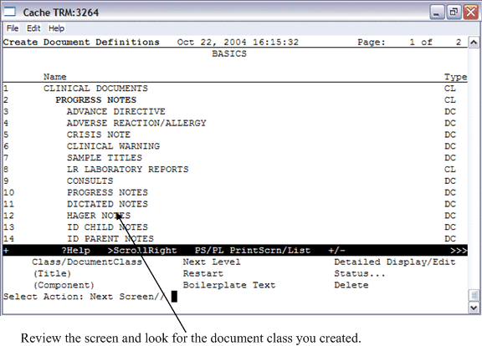
Figure 5: The new document class displays

Note Title Creation
For most new Note Titles, start here.
Now, choose Next Screen and pick the appropriate document class: (example) HAGER NOTES.
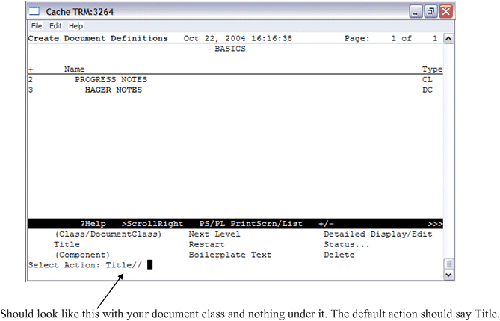
Figure 6: The “Select Action: Title” prompt
Script: Make two titles each with your name in them. What you enter is in bold.
Select Action: Title// Title
Enter the Name of a new HAGER NOTES: HAGER NURSING NOTE
CLASS OWNER: CLINICAL COORDINATOR Replace
STATUS: (A/I/T): INACTIVE// A ACTIVE
SEQUENCE:
MENU TEXT: Hager Nursing Note//
Entry Created
If you wish, you may enter another HAGER NOTES: HAGER ENCOUNTER NOTE
CLASS OWNER: CLINICAL COORDINATOR Replace
STATUS: (A/I/T): INACTIVE// A ACTIVE
SEQUENCE:
MENU TEXT: Hager Encounter Note Replace
Entry Created
Figure 7: Creating a new title
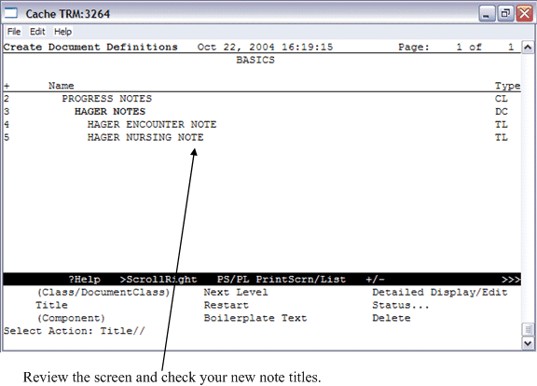
Figure 8: New note title

