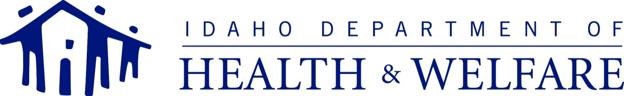
C.L. “BUTCH” OTTER – Governor  RUSSELL S. BARRON – Director |  | Matt Wimmer - Administrator  DIVISION OF MEDICAID  Post Office Box 83720  Boise, Idaho 83720-0009  PHONE: (208) 334-5747  FAX: (208) 364-1811
September 12, 2018
Dear Tribal Representative:
In accordance with section 1902(a)(73)(A) of the Social Security Act regarding the solicitation of advice prior to the submission of any Medicaid State Plan Amendment (SPA) or waiver likely to have a direct effect on Indians, Indian Health Programs, or Urban Indian Organizations, the Idaho Department of Health and Welfare (IDHW) seeks your advice on the following matter.
Idaho Medicaid intends to submit a State Plan Amendment in order to align Attachment 4.18-F of the State Plan with cost-sharing provisions in IDAPA 16.03.18.207 that are applicable to enrollees in the Medicaid SED Program (YES) serving children with Serious Emotional Disturbance. As provided in IDAPA 16.03.18.025, Native American participants are exempt from cost-sharing provisions in State administrative rule.
These State Plan changes will support the Department in charging a monthly premium to Medicaid SED Program (YES) participants whose family income is above Title XIX income limits, and will conform with the cost-sharing requirements enacted by the Idaho Legislature in Section 56-257, Idaho Code.
Anticipated Impact on Indians/Indian Health Programs/Urban Indian Organizations
Due to the cost-sharing exemptions in place, there is no significant impact anticipated with regard to Indians, Indian Health Programs, or Urban Indian Organizations.
Copy Available on Request
IDHW is in the process of completing the SPA. A draft copy can be provided upon request made to Clay Lord at (208) 364-1979 or by e-mail at Clay.Lord@dhw.idaho.gov.
Comments and Questions
IDHW would appreciate any input or concerns that Tribal representatives wish to share regarding this SPA. This request for consultation is being made under expedited circumstances. Should you have questions about the upcoming SPA, please contact Clay Lord at (208) 364-1979 or by e-mail at Clay.Lord@dhw.idaho.gov prior to October 12, 2018. Development of the SPA will be reviewed as part of the Policy Update at the next quarterly Tribal meeting.
Sincerely,
MATT WIMMER
Administrator
MW/cl

