Part I: Data Objects
There are two methods for creating TIU Data Objects. The first method is to copy an existing Data Object.
We will create a new Data Object to extract the value of the last Diabetes Self Monitoring Health Factor.
For a Health Factor, check either RPMS-EHR or RPMS roll-and-scroll to determine the exact name of the Health Factor. (Similarly if it is a Lab Data Object, you will need to determine the exact test name, or if it is an Exam Data Object you will need the Exam Code Number.)
Data Object Creation by Copy:
TIU > HIS > TMM > DDM > DDM4
Document Definitions (Manager)
(MEDSPHERE DEMO HOSPITAL)

DDM1 Edit Document Definitions
DDM2 Sort Document Definitions
DDM3 Create Document Definitions
DDM4 Create Objects
DDM5 List Object Descriptions
DDM6 Create TIU/Health Summary Objects
DDM7 Title Headers/Footers

Select Document Definitions (Manager) Option: DDM4 Create Objects

START DISPLAY WITH OBJECT: FIRST// Objects Apr 05, 2012 11:40:55 Page: 1 of 20

Objects Status

- ACTIVE MEDICATIONS A
- ACTIVE MEDS COMBINED A
- ACTIVE MEDS IN AND OUT A
- ACTIVE MEDS INPATIENT A
- ACTIVE MEDS ONE LIST A
- ACTIVE MEDS OUTPATIENT A
- ACTIVE PROBLEMS A
- ACTIVE PROBLEMS W/O DATES A
- ADDRESS-ONE LINE A
- ADMITTING DX A
- ADMITTING PROVIDER A
- ALLERGIES/ADR A
- ASTHMA REGISTRY A
- BEHDICTATE HEADER A
+ ?Help >ScrollRight PS/PL PrintScrn/List +/- >>>
Find Detailed Display/Edit Copy/Move
Change View Try Quit
Create Owner
Select Action: Next Screen//FIND

Search for: LAST HEALTH
- Locate the prototype data object to be copied using the FIND command in the Objects editor.
- Type Last Health to find the Health Factor prototype Data Object.
Objects Apr 05, 2012 11:43:23 Page: 7 of 20
Objects

+ Status
- LAST HEALTH FACTOR - SAMPLE I
- LAST HEIGHT A
- LAST HEIGHT-DETAILED A
- LAST HF ALCOHOL/DRUG A
- LAST HF CATEGORY - SAMPLE I
- LAST HT WITH CAPTION A
- LAST HT WITH DATE A
- LAST LAB ALT A
- LAST LAB AST A
- LAST LAB CBC A
- LAST LAB CHEM7 A
- LAST LAB CREATININE A
- LAST LAB DATE CHOL A
- LAST LAB GLUCOSE A
+ ?Help >ScrollRight PS/PL PrintScrn/List +/- >>>

Stop Here? Yes// <ENTER>
Find Detailed Display/Edit Copy/Move
Change View Try Quit
Create Owner
Select Action: Next Screen// COPY
Select Entry to Copy: (96-109): 100 (Your number may differ) Copy into (different) Name: LAST HF CATEGORY - SAMPLE
Replace ... <ENTER> LAST HFC DM SELF MONITOR YOURNAME Replace <ENTER> LAST HFC DM SELF MONITOR YOURNAME

OBJECT copied into File Entry #1524
Press RETURN to continue or '^' or '^^' to exit: <ENTER>
Please test the copy object and activate it when it is ready for users to embed it in boilerplate text.

Press RETURN to continue or '^' or '^^' to exit: <ENTER>

Objects Apr 05, 2012 11:52:59 Page: 7 of 20
Objects + Status

- LAST HEALTH FACTOR - SAMPLE I
- LAST HEIGHT A
- LAST HEIGHT-DETAILED A
- LAST HF ALCOHOL/DRUG A
- LAST HF CATEGORY - SAMPLE I
- LAST HFC DM SELF MONITOR PHIL I
- LAST HT WITH CAPTION A
- LAST HT WITH DATE A
- LAST LAB ALT A
- LAST LAB AST A
- LAST LAB CBC A
- LAST LAB CHEM7 A
- LAST LAB CREATININE A
- LAST LAB DATE CHOL A

+ ?Help >ScrollRight PS/PL PrintScrn/List +/- >>>
Find Detailed Display/Edit Copy/Move
Change View Try Quit
Create Owner
Select Action: Next Screen//DETAILED DISPLAY/EDIT
Select Entry: (96-109): 101 (Your number may differ)

Detailed Display Apr 05, 2012 11:54:13 Page: 1 of 1
Object LAST HF DM SELF MONITOR PHIL
Basics
Name: LAST HF DM SELF MONITOR PHIL
Abbreviation:
Print Name:
Type: OBJECT
IFN: 1524
National
Standard: NO
Status: INACTIVE
Owner: CLINICAL COORDINATOR

Technical Fields
Object Method: S X=$$LASTHFC^BTIULO7(+$G(DFN),"CATEGORY NAME",1)

Description
? Help +, - Next, Previous Screen PS/PL
Basics Find Description Edit
Technical Fields Delete
Try Quit
Select Action: Quit// TECHNICAL FIELDS
OBJECT METHOD: S X=$$LASTHFC^BTIULO7(+$G(DFN),"CATEGORY NAME",1)
Replace FACTOR NAME With DIABETES SELF MONITORING Replace <ENTER>

Detailed Display Apr 05, 2012 11:57:26 Page: 1 of 1
Object LAST HF DM SELF MONITOR PHIL
Basics
Name: LAST HF DM SELF MONITOR PHIL
Abbreviation:
Print Name:
Type: OBJECT
IFN: 1524
National
Standard: NO
Status: INACTIVE
Owner: CLINICAL COORDINATOR

Technical Fields
Object Method: S X=$$LASTHFC^BTIULO7(+$G(DFN),"DIABETES SELF MONITORING",1)

Description
? Help +, - Next, Previous Screen PS/PL
Basics Find Description Edit
Technical Fields Delete
Try Quit
Select Action: Quit// BASICS
NAME: LAST HF DM SELF MONITOR YOURNAME Replace <ENTER>
ABBREVIATION: <ENTER>
PRINT NAME: <ENTER>
CLASS OWNER: CLINICAL COORDINATOR// <ENTER>
STATUS: (A/I): INACTIVE// ACTIVE
Detailed Display Apr 05, 2012 12:02:15 Page: 1 of 1
Object LAST HF DM SELF MONITOR PHIL
Basics
Name: LAST HF DM SELF MONITOR YOURNAME
Abbreviation:
Print Name:
Type: OBJECT
IFN: 1524
National
Standard: NO
Status: ACTIVE
Owner: CLINICAL COORDINATOR

Technical Fields
Object Method: S X=$$LASTHFC^BTIULO7(+$G(DFN),"DIABETES SELF MONITORING",1)

Description
? Help +, - Next, Previous Screen PS/PL
Basics Find Description Edit
Technical Fields Delete
Try Quit
Select Action: Quit// <ENTER>

Objects Apr 05, 2012 12:03:14 Page: 7 of 20
Objects + Status

- LAST HEALTH FACTOR - SAMPLE I
- LAST HEIGHT A
- LAST HEIGHT-DETAILED A
- LAST HF ALCOHOL/DRUG A
- LAST HF CATEGORY - SAMPLE I
- LAST HF DM SELF MONITOR YOURNAME A
- LAST HT WITH CAPTION A
- LAST HT WITH DATE A
- LAST LAB ALT A
- LAST LAB AST A
- LAST LAB CBC A
- LAST LAB CHEM7 A
- LAST LAB CREATININE A
- LAST LAB DATE CHOL A
+ ?Help >ScrollRight PS/PL PrintScrn/List +/- >>>
Find Detailed Display/Edit Copy/Move
Change View Try Quit
Create Owner

Select Action: Next Screen//
You now have a New, Active Data Object to extract the value of the Last Health Factor for Diabetes Self-Monitoring. Also create data objects Lipid panel.
Use of a Data Object in a Quick Order:
MEDSPHERE DEMO HOSPITAL RPMS-EHR Management Version 1.1
Create/Modify Quick Orders
Select QUICK ORDER NAME: PSOZ ASPIRIN (EC) 81MG DAILY
NAME: PSOZ ASPIRIN (EC) 81MG DAILY Replace
DISPLAY TEXT: Aspirin (EC) 81mg DAILY Replace VERIFY ORDER: YES//
DESCRIPTION:

No existing text
Edit? NO// ENTRY ACTION:

Medication: ASPIRIN TAB,EC //
Complex dose? NO//
Dose: 81MG//
Route: ORAL//
Schedule: DAILY//
Chronic Med?//
Dispense as Written?//
Days Supply: 90//
Quantity (TAB): 90//
Refills (0-3): 3//
Pick Up: WINDOW//
Pharmacy://
SureScripts Pharmacy Information
Edit? No// (No)
APSP REFILL REQUEST entry//
Priority: ROUTINE//
Comments:
No existing text
Edit? No// YES

==[ WRAP ]==[ INSERT ]=========< Comments >========[ <PF1>H=Help ]====
|LAST LAB INR|

<=======T=======T=======T=======T=======T=======T=======T=======T>=====

Indication://
Indication ICD9://

-----------------------------------------------------------------------
Medication: ASPIRIN TAB,EC 81MG
Instructions: 81MG ORAL DAILY
Days Supply: 90
Quantity (TAB): 90
Refills (0-3): 3
Pick Up: WINDOW
Priority: ROUTINE
Comments: |LAST LAB INR|
-----------------------------------------------------------------------
(P)lace, (E)dit, or (C)ancel this quick order? PLACE// <Enter>
Auto-accept this order? NO//
Data Object Creation with a Health Summary:
- Create a VA Health Summary to output the desired data: RPT > HSM > VHA > BLD > EDT
MEDSPHERE DEMO HOSPITAL RPMS-EHR Management Version 1.1
Create/Modify Health Summary Type
Select Health Summary Type: LAST A1C AND 3 GLUCOSE

Are you adding 'LAST A1C AND 3 GLUCOSE' as
a new HEALTH SUMMARY TYPE (the 65th)? No// YES NAME: LAST A1C AND 3 GLUCOSE Replace
TITLE:
SUPPRESS PRINT OF COMPONENTS WITHOUT DATA: SUPPRESS SENSITIVE PRINT DATA:
LOCK:
OWNER: TAYLOR,PHILIP K//

Do you wish to copy COMPONENTS from an existing Health Summary Type? YES//NO
Select COMPONENT: SLT LAB TESTS SELECTED SLT
SUMMARY ORDER: 5// <ENTER>
OCCURRENCE LIMIT: 1
TIME LIMIT: 1Y
HEADER NAME: Lab Tests Selected// <ENTER>

No selection items chosen.

Select new items one at a time in the sequence you want them displayed. You may select any number of items.

Select SELECTION ITEM: HEMOGLOBIN A1C (Match to Lab Test from your site)

Searching for a LABORATORY TEST, (pointed-to by SELECTION ITEM)
Searching for a LABORATORY TEST
HEMOGLOBIN A1C
...OK? Yes// <ENTER>
Are you adding 'HEMOGLOBIN A1C' as a new SELECTION ITEM (the 1ST for this STRUCTURE)? No// YES
Select SELECTION ITEM: <ENTER>
Select COMPONENT: SCLU
SUMMARY ORDER: 10// 10 <ENTER>
OCCURRENCE LIMIT: 3
TIME LIMIT: 1Y
HEADER NAME: Lab Cum Selected// <ENTER>

No selection items chosen.

Select new items one at a time in the sequence you want them displayed. You may select any number of items.

Select SELECTION ITEM: BLOOD GLUCOSE

Searching for a LABORATORY TEST, (pointed-to by SELECTION ITEM)
Searching for a LABORATORY TEST
BLOOD GLUCOSE
...OK? Yes// (Yes)
Are you adding 'BLOOD GLUCOSE' as a new SELECTION ITEM (the 1ST for this
STRUCTURE)? No// YES

Select the tests which you wish to include, in the sequence in which you wish them to appear.

-- Glucose --

1 RANDOM GLUCOSE

Select LAB TEST(s): ALL// <ENTER>
Select SELECTION ITEM: <ENTER>
Select COMPONENT: <ENTER>

Do you wish to review the Summary Type structure before continuing? NO// YES
Type Name: LAST A1C AND 3 GLUCOSE
Title:
Owner: TAYLOR,PHILIP K SUPPRESS PRINT OF COMPONENTS WITHOUT DATA: SUPPRESS SENSITIVE PRINT DATA:

Max Hos ICD Pro CPT
Abb Ord Component Name Occ Time Loc Text Nar Mod Selection
------------------------------------------------------------------------------
SLT 5 Lab Tests Selected 1 1Y
HEMOGLOBIN A1C
SCLU 10 Lab Cum Selected 3 1Y
RANDOM GLUCOSE
* = Disabled Components
Select COMPONENT: <ENTER>

Do you wish to review the Summary Type structure before continuing? NO// <ENTER>
- Create a Health Summary Object:
BEH > TIU > HIS > TMM > DDM > DDM6
TIU Health Summary Object Apr 05, 2012 12:34:46 Page: 1 of 2

TIU Object Name Health Summary Type
- CHRONIC MEDS HS-MEDS CHRONIC
- ER FLOWSHEET ER FLOWSHEET
- FAMILY HISTORY FAMILY HISTORY
- HOSPITAL STAYS HOSPITAL STAYS
- IMMUNIZATION HISTORY IMMUNIZATION HISTORY
- LAST 5 HGBA1CS LAST 5 HGBA1CS
- LAST 5 INRS LAST 5 INRS
- LAST MAMMOGRAPHY LAST MAMMOGRAPHY
- LAST PAIN CONTRACT LAST PAIN CONTRACT
- LMRD LMRD
- MEASUREMENT PANEL MEASUREMENT PANELS
- MED RECONCILIATION MED RECONCILIATION
- MOST RECENT LABS MOST RECENT LABS
- NEW TEST NEW TEST
+ Enter ?? for more actions
Create New TIU Object Find
Detailed Display/Edit TIU Object Detailed Display/Edit HS Object Quit
Select Action: Next Screen// CREATE

--- Create TIU/Health Summary Object ---

Enter a New TIU OBJECT NAME: LAST A1C AND 3 GLUCOSE

Object Name: LAST A1C AND 3 GLUCOSE

Is this correct? YES// <ENTER>

Use a pre-existing Health Summary Object? NO// YES
Enter the name of the Health Summary Object: LAST A1C AND 3 GLUCOSE

Create a TIU Object named: LAST A1C AND 3 GLUCOSE

Ok? YES// <ENTER>

TIU Object created successfully.

Enter RETURN to continue... <ENTER>
You now have a new TIU Data Object ready to be used in a Template.

Part II: TIU Template
In this exercise we will create a template for Diabetes Training and Therapy Services that could be used for input into a Consult. The American Association of Diabetes Educators and the American Dietetic Association’s Diabetes Self-Management Education/Training and Medical Nutrition Therapy Services Order Form Revised 8/2011 was used as a resource for this exercise.
- Log on to RPMS EHR.
- Select a patient and select or create a visit. Always select a patient and visit when making TIU templates or you may get error dialogs because TIU is unable to find requested data.
- Select the Notes tab.
- Select the Options menu on the Notes component then select Edit Templates. In this exercise we are going to create our templates under My Templates to avoid conflicts. It is likely this template would actually be used under Consult Reasons for Request at an actual site.
- Ensuring that My Templates is highlighted, click New Templates.
- Type Diabetes Training and Therapy Services in the name field.
- Click Apply. We will frequently click Apply as we create this template to save our work as we go.
- Change the Template Type to Dialog.
- Add additional sub-templates to this parent dialog:
  - Ensuring that the dialog Diabetes Training and Therapy Services is highlighted, click New Template and name this template Diagnosis.
  - Repeat and name the next template Training.
  - Repeat once again and name the last template Therapy. You should have a template skeleton that looks like this:
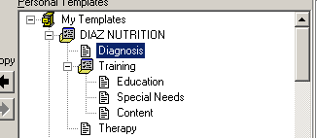

Figure 1: Template Skeleton
- Highlight the Training template and change the Template Type to Dialog.
- We are going to add more sub-templates:
  - Ensure that the Training template is highlighted. Click New Template and name this template Education.
  - Repeat and name the next template Special Needs.
  - Repeat once again and name the last template Content.
- This would be a good time to click Apply. Our template skeleton should now look like this:
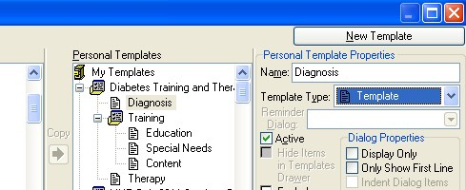
Figure 2: Template Skeleton
Now we are ready to begin adding content to these templates:
- Ensure that you have highlighted Diabetes Training and Therapy. Click inside the Template Boilerplate editing area. In this editor we will add the following text (note that text between Pipes or curly brackets is not typed, but is inserted as Data Objects or Template fields via using the right-click dropdown menu):
PATIENT INFORMATION
Last Name: |PATIENT LAST NAME| First Name: |PATIENT FIRST NAME|
Date of Birth: |PATIENT DATE OF BIRTH| Gender: |PATIENT SEX| Address: |ADDRESS-ONE LINE|
Home Phone: |PATIENT PHONE| {FLD:GEN TEXT 15}
Alternate Phone: |PATIENT OTHER PHONE| E-mail Address: {FLD:GEN TEXT 50}
- Next highlight the Diagnosis template and type the following content:
DIAGNOSIS
Diabetes Type:
Complications/Comorbidities:
Laboratory:
- We need some new template fields for this section. Click the Tools menu and select Edit Template Fields.
- Click New and name your field Yourname DM Type and complete as shown in Figure
3:
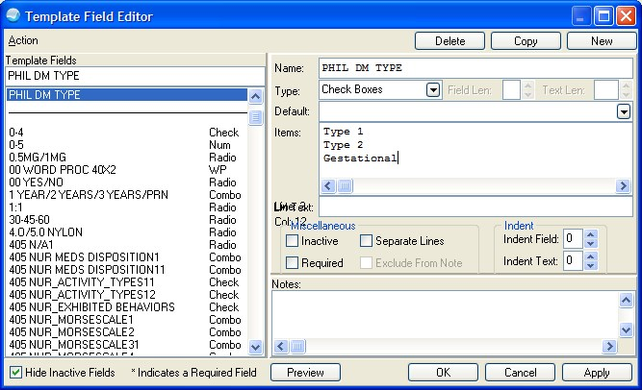
Figure 3: Template Field Editor dialog
- Create a field called Yourname DM Complications as in Figure 4.
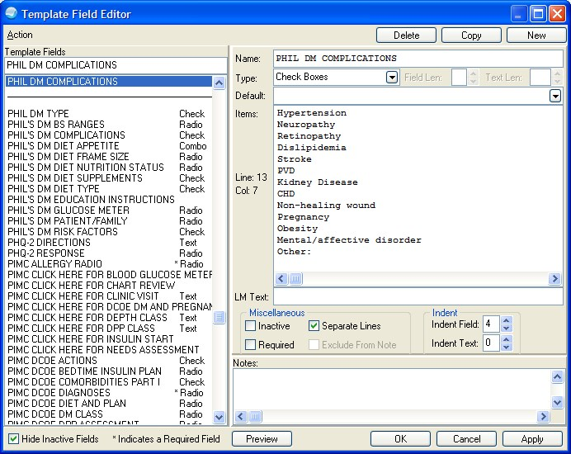
Figure 4: Template Field Editor dialog
- Select Separate Lines.
- Set Indent Field to 4.
- We can now add these new fields and the TIU/Health Summary Data Object we created at the beginning of this exercise.
DIAGNOSIS
Diabetes Type: {FLD:DIAZ DM TYPE}
Complications/Comorbidities: {FLD:DIAZ DM COMPLICATION} {FLD:GEN TEXT 15}
Laboratory: |MOS LAST LAB 90D||LAST LIPID PANEL MOS||LAST A1C AND 3 GLUCOSE|

- We are ready to move on to the next dialog, Training. In this dialog simple add the text
- Moving on the to the Education dialog, type the following text.

Diabetes Self-Management Education/Training (DSME/T)
Type:
Length:

- We need to create these fields for the Education Section:
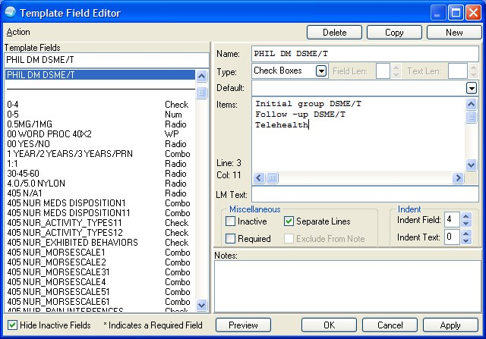
Figure 5: Template Field Editor dialog
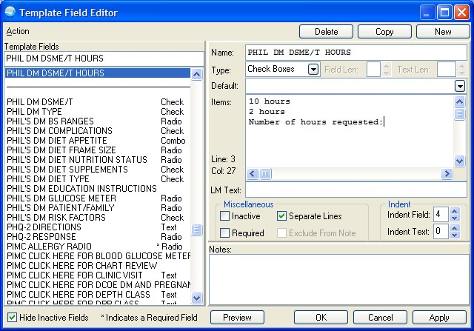
Figure 6: Template Field Editor dialog
- Now we can add our new fields to the Education dialog:
Diabetes Self-Management Education/Training (DSME/T)
Type: {FLD:DIAZ DM DSME/T}
Length: {FLD:DIAZ DM DSME/T HOURS}{FLD:GEN TEXT 15}
- Don’t forget to periodically click Apply to save your work. Next is Special Needs. We will make the following fields: *don’t forget to allow long lines*

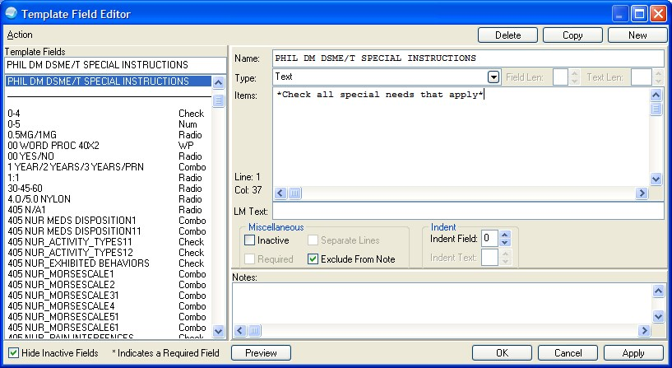
Figure 7: Template Field Editor dialog
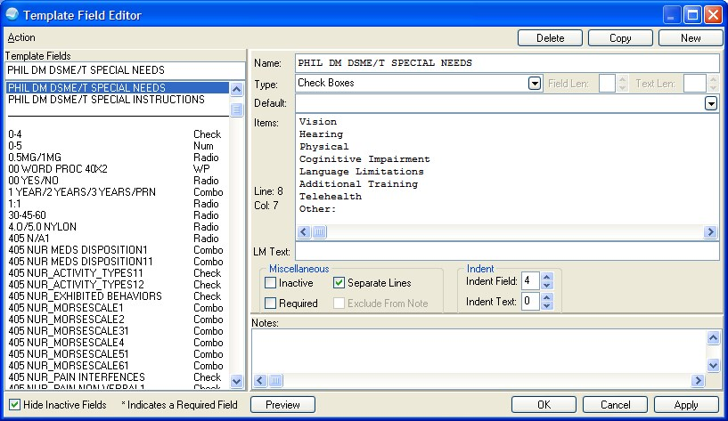
Figure 8: Template Field Editor dialog
- Now add the new fields to the Special Needs Dialog:
Figure 9: Template Field Editor dialog
Note that the text instruction field was purposely placed on the same line as the title to avoid introducing a space in the output template. Also note that it is necessary to select Allow Long Lines to do this.
- We are ready to populate Content with the following text. Let’s go ahead and create the needed field. Type “DSME/T CONTENT
DSME/T CONTENT:

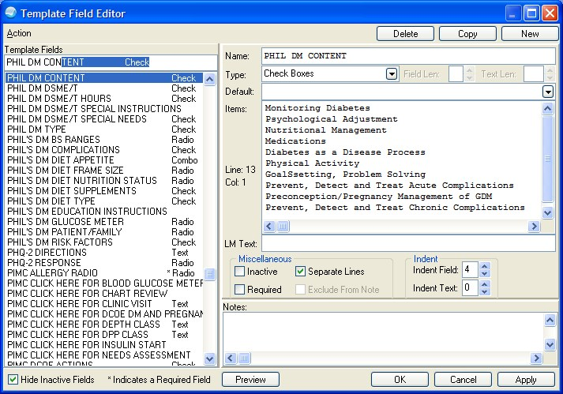
Figure 10: Template Field Editor dialog
- Add field to the content template
DSME/T CONTENT: {FLD:DIAZ DM CONTENT}

We are now ready to finish up the last template dialog, Therapy.
- Let’s make the required fields first:
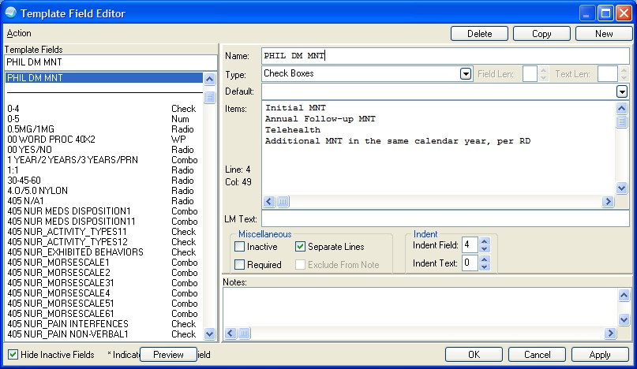
Figure 11: Template Field Editor dialog
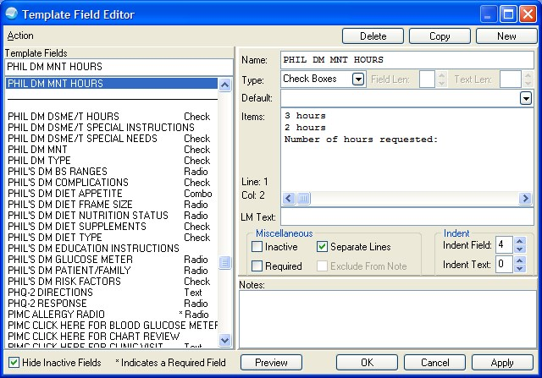
Figure 12: Template Field Editor dialog
Edit template with the following
Medical Nutrition Therapy (MNT)
Type: {FLD:DIAZ DM MNT}
Length: {FLD:DIAZ DM MNT HOURS}

We are almost done but we need to so a little formatting of the final template.
- Highlight the top level of the template, Diabetes Training and Therapy.
- Under Display Properties select Indent Dialog Items and Hide Dialog Items.
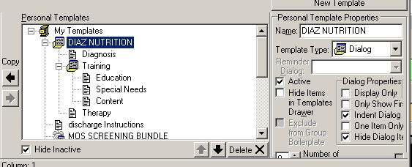
Figure 13: Template Field Editor dialog
- Highlight the Training dialog and repeat the same process as above under Dialog Properties.
- Click Apply to save your work.
To see how the template will appear, ensure that you have highlighted the top level of the template. In the Template Boilerplate editor area, right click and then click on
Preview/Print Template. (There is a bug in the Template Editor, so you may have to do this twice.)
You only see the first Patient Information section. To expand the template, check the box.
Note that the Training section shows only the title until checked. This shows it is possible to create a template that initially presents only headers that expand when checked. To accomplish this requires building templates with multiple nested sub-templates as in the example below.

