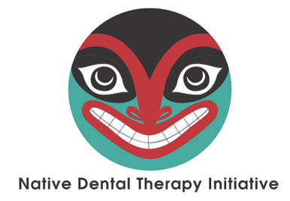
YEARLY DHAT UPDATE MEETING
Native Dental Therapy Initiative (NDTI)
Dental Health Aide Therapist (DHAT)

August 20-21, 2018 The Tulalip Resort and Casino, Tulalip, WA

Name | Click here to enter text.
Job Title | Click here to enter text.
Organization/Clinic | Click here to enter text.
Address, City, State, Zip | Click here to enter text.
Email | Click here to enter text.
Phone | Click here to enter text.
Do you want to register more attendees? | Name | Click here to enter text. | Job Title | Click here to enter text.
 | Name | Click here to enter text. | Job Title | Click here to enter text.
 | Name | Click here to enter text. | Job Title | Click here to enter text.
 | Name | Click here to enter text. | Job Title | Click here to enter text.
 | Name | Click here to enter text. | Job Title | Click here to enter text.

Click Below
Yes  ☐ | No  ☐ | I will be attending the 2018 Portland Area Dental Meeting, Sponsored by the Northwest Tribal Dental Support Center. Not mandatory, but encouraged for your new dental team members.

Meeting Location and Host Hotel:  The Tulalip Resort and Casino  10200 Quil Ceda Boulevard, Tulalip, WA 98271  https://www.tulalipresortcasino.com/ | Reservations: call 866-716-7162; or  Click here for online reservations  Mention Group code: LAH5448 for group room rate of $149/night plus tax by July 22. 72-hour cancellation policy.

Agenda-At-A-Glance
Monday 8/20: 12:00 pm – 1:00 pm Lunch Provided by NDTI
1:00 pm – 5:00 pm General Session

Tuesday 8/21: 8:00 am – 9:00 am Breakfast Provided by NDTI
8:30 am – 12 pm General Session
12:00 pm – 5:00 pm 2018 Portland Area Dental Meeting
Northwest Tribal Dental Support Center (ends 8/23)

Hotel and Registration Deadline: July 22, 2018

Please send your registration form via email to Tanya Firemoon, NPAIHB by July 22, 2018.

