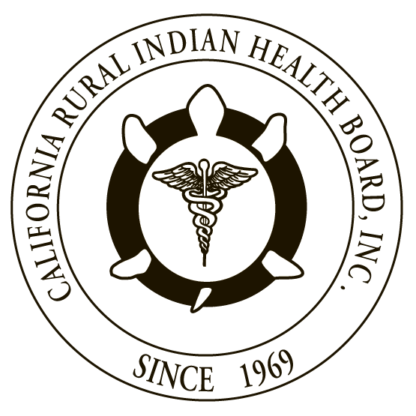

RESOLUTION # RESOLUTION #
NORTHWEST PORTLAND AREA CALIFORNIA RURAL INDIAN
INDIAN HEALTH BOARD HEALTH BOARD

JOINT RESOLUTION
REQUEST TO CENTERS FOR MEDICARE AND MEDICAID SERVICES (CMS) TO EXTEND 100% FEDERAL MEDICAL ASSISTANCE PERCENTAGE (FMAP) TO SERVICES PROVIDED BY URBAN INDIAN HEALTH PROGRAMS

WHEREAS, the Northwest Portland Area Indian Health Board (NPAIHB) is a Tribal organization under P.L. 93-638 that represents 43 federally-recognized Indian Tribes in Oregon, Washington, and Idaho and is dedicated to assisting and promoting the health needs and concerns of American Indian/Alaska Native (AI/AN) people in the Northwest; AND

WHEREAS, the California Rural Indian Health Board, Inc. (CRIHB), founded in 1969 for the purpose of bringing back health services to Indians of California, is a Tribal organization in accordance with P.L. 93-638 and is a statewide Tribal health organization representing 33 federally recognized tribes in 14 counties through its membership of 12 Tribal Health Programs throughout California’s Indian Country; AND

WHEREAS, the NPAIHB and CRIHB are dedicated to assisting and promoting the health needs and concerns of AI/AN people; AND

WHEREAS, the primary goal of the NPAIHB and CRIHB is to improve the health and quality of life of its member Tribes; AND

WHEREAS, the United States has a unique trust responsibility to provide health care to AI/AN people, founded in treaties and other historical relations with Tribes, and reflected in numerous statutes; AND

WHEREAS, the tribal 100% Federal Medical Assistance Percentage (FMAP) rule is found in Section 1905(b) of the Social Security Act (SSA), and was enacted when the IHS system was first authorized to bill the Medicaid program in 1976 in order to ensure that States did not have to bear the costs associated with such services; AND

WHEREAS, currently, if an American Indian or Alaska Native (AI/AN) Medicaid beneficiary receives services “received through” an IHS or Tribally operated health facility, CMS matches the amount paid for those services at 100% and is commonly referred to as 100% FMAP; AND

WHEREAS, the Center for Medicare and Medicaid Services’ (CMS) current interpretation of the 100% FMAP rule is that urban Indian health programs operated under the Indian Health Care Improvement Act (IHCIA) are not eligible for 100% FMAP.

THEREFORE BE IT RESOLVED, CRIHB and NPAIHB respectfully request CMS to extend 100% FMAP to services provided by urban Indian health programs funded under the Indian Health Care Improvement Act so long as they are provided to eligible beneficiaries of the Indian Health Service and that such consideration does not result in a diminution by CMS to allow the application of 100% FMAP to purchased and referred care services.

CERTIFICATION

The foregoing joint resolution was adopted at a duly called regular joint meeting of the Board of Directors of Northwest Portland Area Indian Health Board and California Rural Indian Health Board (NPAIHB vote __ For and _ Against and _ Abstain; CRIHB vote __ For and _ Against and _ Abstain) held this day of July 2017 in Canyonville, Oregon and shall remain in full force and effect until rescinded.

NORTHWEST PORTLAND AREA CALIFORNIA RURAL
INDIAN HEALTH BOARD INDIAN HEALTH BOARD
2121 SW Broadway, Suite 300 4400 Auburn Blvd, 2nd Floor
Portland, OR 97201 Sacramento, CA 95841
(503) 228-4185 (916) 929-9761

_________________________ __________________________
Chairperson of the Board Chairperson of the Board

_________________________ __________________________
Attest Attest

