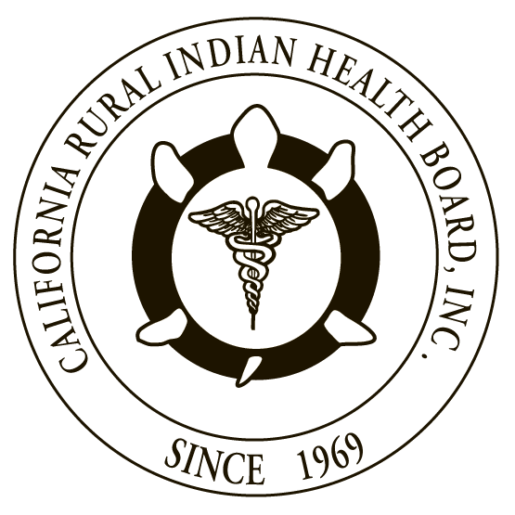

RESOLUTION # RESOLUTION #
NORTHWEST PORTLAND AREA CALIFORNIA RURAL INDIAN
INDIAN HEALTH BOARD HEALTH BOARD

JOINT RESOLUTION
Recommendations to Congress to Obtain Additional Data on IHS Health Care Facilities Construction Funding and Distribution Methodologies

WHEREAS, the Northwest Portland Area Indian Health Board (NPAIHB) is a Tribal organization under P.L. 93-638 that represents 43 federally-recognized Indian tribes in Oregon, Washington, and Idaho and is dedicated to assisting and promoting the health needs and concerns of American Indian/Alaska Native (AI/AN) people in the Northwest; AND

WHEREAS, the California Rural Indian Health Board, Inc. (CRIHB), founded in 1969 for the purpose of bringing back health services to Indians of California, is a Tribal organization in accordance with P.L. 93-638 and is a statewide Tribal health organization representing 33 federally recognized tribes in 14 counties through its membership of 12 Tribal Health Programs throughout California’s Indian Country; AND

WHEREAS, the NPAIHB and CRIHB are dedicated to assisting and promoting the health needs and concerns of AI/AN people; AND

WHEREAS, the primary goal of the NPAIHB and CRIHB is to improve the health and quality of life of its member Tribes; AND

WHEREAS, the Indian Health Care Improvement Act (IHCIA) is the legislative embodiment of the federal trust and treaty responsibilities to American Indian and Alaska Natives (AI/AN) for healthcare; AND

WHEREAS, the IHCIA was first enacted in 1976 and then permanently enacted in 2010 as part of the Patient Protection and Affordable Care Act (ACA) (P.L. 111-148); AND

WHEREAS, the IHCIA requires the Health and Human Services (HHS) Secretary to submit a report to Congress that describes the comprehensive, national, ranked list of all health care facilities’ needs for the Indian Health Service (IHS), Indian Tribes, and Tribal Organizations carrying out health programs under the IHCIA, initially by March 23, 2011, and thereafter update the report every five years; AND

WHEREAS, the IHCIA also requires the IHS to maintain a health care facility priority system which is to be developed in consultation with Indian Tribes and Tribal Organizations and serve as the basis for the HHS Secretary to submit the above referenced report to Congress; AND

WHEREAS, the initial report submitted to Congress estimated facilities needs and costs based on unfunded projects in the existing Health Care Facilities Construction Priority List (Priority List), in addition to those projects identified in Area Health Services and Facilities Master Plans (Masters Plans) developed in FY 2005 with their costs estimated by using the health care facility priority system; AND

WHEREAS, CRIHB, NPAIHB, and many other Tribes and Tribal Organizations do not feel that the report submitted to Congress was adequate to identify a national comprehensive list of facilities needs in light of the fact that the Priority List has been locked since approximately 1991 and Tribes and Tribal Organizations have not had an equitable opportunity to compete for funding in order to be placed on the list; AND

WHEREAS, the 2005 Area Master Planning process included inconsistent planning criteria (and the necessary resources to complete thorough and comparable master plans) across the entire IHS system, and neither of these two processes incorporated new authorities for health services or facility types authorized in the 2010 amendments to the IHCIA; AND

WHEREAS, the 2016 IHS/Tribal Health Care Facilities’ Needs Assessment Report to Congress stated that the current Priority List will not be complete until 2041 and at the current rate of construction appropriations and the replacement timeline, a new 2016 facility would not be replaced for 400 years; AND

WHEREAS, many Tribes and Tribal Organizations have had to assume substantial debt to build or renovate clinics for Indian people to receive IHS-funded health care.

THEREFORE BE IT RESOLVED, that CRIHB and NPAIHB urge the U.S. Congress to instruct the Government Accountability Office to review and issue a report on the IHS Facilities Construction Priority System, including historical and current funding distribution inequities; AND

BE IT FINALLY RESOLVED, that CRIHB and NPAIHB urge the U.S. Congress to increase funding to the Indian Health Facilities account in the IHS budget to provide construction, repair and improvement, equipment, and environmental health and facilities support for all IHS Areas equitably, and for Tribal governments through self-determination contracts and self-governance compacts.

CERTIFICATION

The foregoing joint resolution was adopted at a duly called regular joint meeting of the Board of Directors of Northwest Portland Area Indian Health Board and California Rural Indian Health Board (NPAIHB vote __ For and _ Against and _ Abstain; CRIHB vote __ For and _ Against and _ Abstain) held this day of July 2017 in Canyonville, Oregon and shall remain in full force and effect until rescinded.

NORTHWEST PORTLAND AREA CALIFORNIA RURAL
INDIAN HEALTH BOARD INDIAN HEALTH BOARD
2121 SW Broadway, Suite 300 4400 Auburn Blvd, 2nd Floor
Portland, OR 97201 Sacramento, CA 95841
(503) 228-4185 (916) 929-9761

_________________________ __________________________
Chairperson of the Board Chairperson of the Board

_________________________ __________________________
Attest Attest

25 USC § 1631(c)(2)(A)(ii)(I).
See “Report to Congress on Estimated Need For Tribal and Indian Health Service Health Care Facilities,” submitted by the Indian Health Service, circa March 2011.

