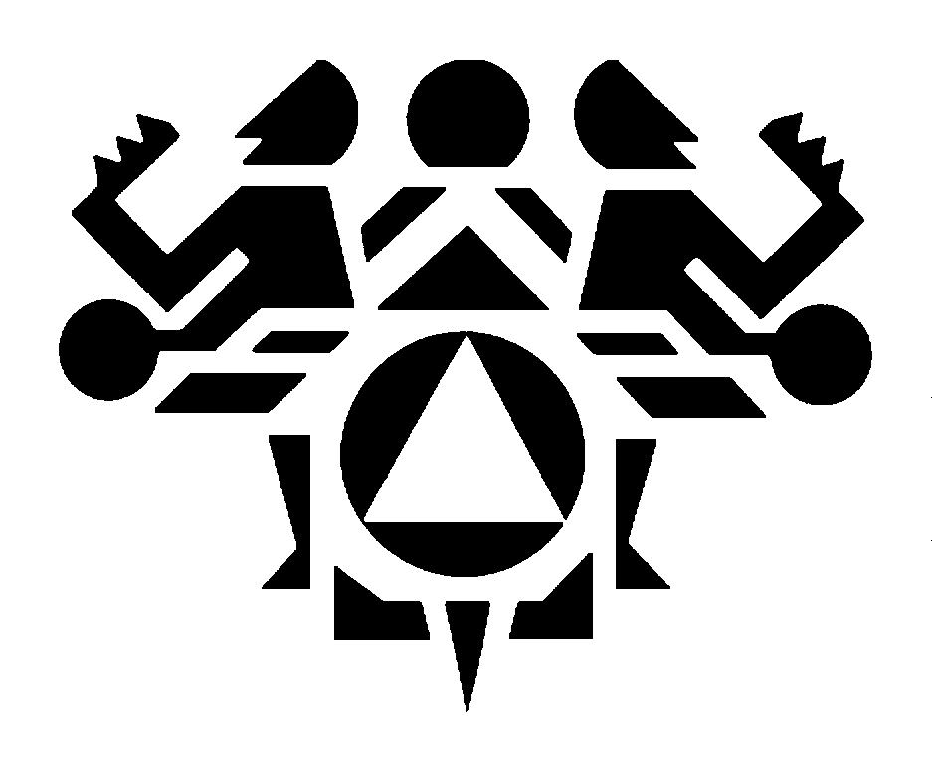
Northwest Portland Area Indian Health Board

The FY 2018 Indian Health Service Budget: Analysis and Recommendations

27th Annual Report

If you would like to make a contribution towards the production of this annual review of the Indian Health Service Budget, please make a check payable to:

NPAIHB /General Fund

Send your check to
Northwest Portland Area Indian Health Board
2121 S. W. Broadway, Suite 300
Portland, OR 97201

Or, consult our website at www.npaihb.org for information on how to donate to the Northwest Portland Area Indian Health Board.

Thank you.

TABLE OF CONTENTS

FY 2018 Indian Health Service Budget Analysis
Introduction 6
Budget Formulation: National Tribal Budget Formulation Workgroup 7
Funding True Need 7
Audience for this Analysis: Tribes, the Administration,
and the U.S. Congress 7
Acknowledgements 8
Sources 8

FY 2018 Budget Analysis and Recommendations:
The Final Enacted FY 2018 IHS Budget 9
The Budget Control Act of 2011 & the 2013 Sequester 10
Preserving the basic health program funded by the IHS budget 12
The Office of Management and Budget 12
Current Services Budget: Maintaining the Current Health
Program and the President’s Proposed FY 2018 IHS Budget 14
Justification for Estimates 14
Portland Area Recommendations for Program Increases 16
The Effect of Staffing New Facilities 18

Health Services Accounts:
The Compounding Effect of Multi-year Funding Shortfalls 19
Hospitals and Clinics 19
Epidemiology Centers 19
Permanent Funding for the Northwest Tribal Epidemiology Center
Dental Services 21
Mental Health 21
Alcohol and Substance Abuse 22
Purchased and Referred Care 23
Catastrophic Health Emergency Fund 26
Public Health Nursing 27
Health Education 27
Community Health Representatives 27
Urban Indian Health 28
Indian Health Professions 29
Tribal Management 29
Direct Operations 29
Self-Governance 30
Contract Support Costs 30
Special Funding Request: Hepatitis C Screening, Management and Treatment 31

Health Facilities Account:
Maintenance and Improvement (M&I) 31
Sanitation 32
Health Facilities Construction 32
Alternative Methods of Acquiring Health Facilities 32
Facilities, Environmental Health and Engineering Support 33
Equipment 33

Conclusion: The Purpose of this Report 34

Evaluation Based on Budget Principles 34

Grading the President’s Proposed FY 2018 IHS Budget (Back Cover)

Northwest Portland Area Indian Health Board

Introduction

This 27th Annual Northwest Portland Area Indian Health Board (NPAIHB) analysis of the President’s FY 2018 Indian Health Service (IHS) budget continues a tradition of close scrutiny of the IHS budget that began in 1989. The decrease of $300 million (6.0%) makes this proposed budgets one of the worst budgets for American Indian/Alaska Natives (AI/AN) people in recent history.

Every line item received a cut except for Direct Operations (2.7%) from the FY 2017 enacted levels. A decrease to Health Services of $120 million (3.3%) and Facilities of $98 million (18.1%) are proposed from FY 2017 enacted levels. Moreover, decreases to Maintenance and Improvements (M&I) and Sanitation Facilities are proposed at $15.8 million (21%) and $26.3 million (26%), respectively. These decreases could have dire consequences for AI/AN people both individually and on a community-wide basis as to public health practices. At a minimum, the FY 2018 IHS budget must be funded at FY 2017 enacted levels with inflation and population growth increases. In our report on the FY 2017 budget, we highlighted that there was no increase to Purchased and Referred Care (PRC) in FY 2016 and requested this amount be funded in FY 2017. This FY 2018 budget proposes to repeat that loss and to further diminish the purchasing power of Tribes to provide care to their citizens.

The federal trust responsibility for health care and the government-to-government relationship between Tribes and the federal government, by definition, requires a partnership in the development of the budget.
The President’s FY 2018 IHS budget reminds Indian country of the heavy burden of neglect the IHS has suffered over the past twenty years. Following a FY 2001 increase of 10%, from FY 2002 to FY 2008 the average IHS budget increase was less than 2.5%. A growing population and medical inflation eroded the purchasing power of Indian health programs. There is no denying that budget shortfalls resulted in greater health care disparities between Indian people and the general population over the past fifteen years. This gap was addressed in the budget increases in the past several years, but this amount was not enough and additional funding is needed for the health of AI/AN people.

The total NPAIHB recommended increase to the President’s FY 2018 budget is $769 million.. This amount includes funding at FY 2017 enacted levels (+ $301 million) and an estimated $328 million to fund pay act increases, inflation, and population growth. In addition, $140 million is needed in program increases. The President’s FY 2018 budget decrease of $301 million dollars will severely impact the Indian health system and any progress that has been made in the past several years.

The President’s total budget authority requested for FY 2018 is $4.7 billion, a 6.0% decrease over FY 2017 compared to $5 billion dollar budget that included a 4.8% increase in the IHS enacted budget for FY 2017. While the NPAIHB makes this budget recommendation for FY 2017, the NPAIHB fully supports the National Tribal Budget Formulation Workgroup’s recommendation for full funding to IHS at $32 billion implemented over a 12-year period.

It is important to note that the FY 2018 IHS Congressional Budget Justification document does not include the final numbers from the FY 2017 enacted budget which gives the false impression that the President’s FY 2018 budget increased the budget in several areas and that there was a much smaller decrease overall. This is not an accurate picture of the President’s FY 2018 budget when compared to the FY 2017 enacted levels. For the most accurate FY 2017 budget numbers see the Congressional Record, dated May 3, 2017, available at https://www.gpo.gov/fdsys/pkg/CREC-2017-05-03/html/CREC-2017-05-03-pt2-PgH3327.htm.

This NPAIHB FY 2018 budget analysis is available at (www.npaihb.org).

Budget Formulation: National Tribal Budget Formulation Workgroup

For the past eighteen years, representatives from the Portland Area have joined Tribes nationwide in the IHS budget formulation process that includes direct service Tribes, Tribally operated, and urban Indian programs. This group, commonly referred to as the National Tribal Budget Formulation Workgroup, meets annually to develop the IHS budget recommendation. The Northwest Tribes' longstanding interest and active participation in the budget process allows them to understand the complexity of developing the final appropriations. In the past, various Administrations have underestimated the need for funding the IHS. The NPAIHB supports the Workgroup’s request for full funding to IHS of $32 billion to be fully implemented over a 12-year period.

This analysis was first developed to serve as a reality check demonstrating the lack of integrity of past executive branch budgets. Tribes are not without their own interest in advocating for budget increases, but this analysis presents unbiased estimates and objective data for that cause. The analysis also establishes criteria that are used to grade the President’s budget request. These criteria are found at the end of the analysis in the form of a Report Card.

Funding True Need

The NPAIHB supports the work of both the Indian Health Service, Tribes and Tribal organizations and Urban Indian programs (I/T/U) budget formulation process and the Federal Disparities Index (FDI) Workgroup (formerly known as the Level of Need Funded). The FDI measures the proportion of funding provided to the Indian health system, relative to its actual need, by comparing healthcare costs for IHS beneficiaries in relation to beneficiaries of the Federal Employee Health Benefits (FEHB) plan. This comparison uses actuarial methods that control for age, sex, and health status.

Applying the FDI to estimate the true health care needs of Indian people results in an annual budgetary need of over $10 billion. This corroborates the long-held view that less than 50% of true need is funded by the IHS budget. If funded at $10 billion, an additional phased-in facilities cost of $10 billion would be needed to house the expanded health care services. This $20 billion is sometimes stated as the Tribal needs-based budget and has been estimated at $32 billion by the National Tribal Budget Formulation Workgroup. Either amount clearly reflects that the President’s FY 2018 budget of $4.7 billion is inadequate.

Northwest Tribes ask that the Office of Management and Budget (OMB) and HHS/IHS commit to using the same budget estimates for the IHS budget that they use for other financial and economic estimates. Medical inflation estimates are now a standard factor in budget making for the agency and the use of accurate estimates is expected and appreciated by Tribes.
Throughout the years, this analysis has sought to maintain the integrity of its estimates by not inflating amounts in the manner of conventional negotiations. Tribal leaders want information that is reliable and accurate so they can make their case to the Congress in good conscience without fear of accusations of exaggerated estimates or inflated needs. There is nothing to be gained by overestimating the funding required to meet the health care needs of Indian people. The NPAIHB invites discussion over every estimate presented in this analysis.

Audience for this Analysis: Tribes, the Administration, and Congress

NPAIHB has identified pertinent issues that impact Northwest Tribes. This information will assist leaders from each of the forty-three Portland Area Tribes in making their own analysis of the budget proposal and its impact on their respective communities. It will also serve as a useful analysis for Tribes nationwide since in nearly every case the interests of Tribes nationwide are the same as the interests of Northwest Tribes. It is only by making these views known that effective budget policy can be developed. The NPAIHB and Northwest Tribes actively participate in efforts to develop consensus positions nationally on budget priorities.

The analysis is distributed to the Administration and to Congressional committees who finalize the annual IHS budget. Although the analysis is prepared for Northwest Tribes, it is made available to Tribes throughout the country. It is distributed to all Area Health Boards within the Indian health system and to national Tribal organizations. It is posted on the NPAIHB website (at www.npaihb.org) as soon as it is published so all Tribes can consider its recommendations for their own use in the consultation process.

The Congress and the Administration have traditionally considered treaty and trust responsibilities on a non-partisan basis and have worked to maintain the purchasing power of health care resources, address unmet needs with targeted increases, and facilitate service delivery improvements that achieve health objectives while maintaining fiscal discipline.

Acknowledgements

This analysis is based on over twenty-seven years of contributions from delegates and staff of the NPAIHB including current and former Chairs: Andy Joseph Jr, Chair, Linda Holt, Pearl Capoeman-Baller, Julia Davis, and Executive Directors: Doni Wilder (1990-1998) Cheryle Kennedy (1998-2000); Ed Fox, (2000-2005; also assisting with FY 2017 analysis as a consultant); and current Director, Joe Finkbonner (2006-current); and Jim Roberts (2002-2016) and Laura Platero, Policy Analysts.

Sources:

- The House analysis is available at: https://budget.house.gov/budgets/fiscal-year-2017-budget/
- The Budget for FY 2018 is available at: http://www.whitehouse.gov/omb/budget/ is the President’s budget request of May, 2017.
- Congressional Budget Office Analysis of the President’s FY 2018 budget is available at: https://www.cbo.gov/publication/52846..
- Congressional Record Volume 163, Number 76 (May 3, 2017) available at: https://www.gpo.gov/fdsys/pkg/CREC-2017-05-03/html/CREC-2017-05-03-pt2-PgH3327.htm.
- Department of Health and Human Services Fiscal Year 2018, HHS FY 2017 Budget In Brief available at: https://www.hhs.gov/about/budget/fy2018/budget-in-brief/index.html.
- Indian Health Service, Congressional Justification of Estimates for Appropriations Committees Fiscal Year 2018 is available at: https://www.ihs.gov/budgetformulation/index.cfm/congressionaljustifications/
- The National Tribal Budget Formulation Workgroup’s Recommendations on the Indian Health Service Fiscal Year 2018 Budget available at: http://www.nihb.org.
- Additional information about the U.S. Budget is available at the Center on Budget and Policy Priorities is available at: http://www.cbpp.org/topics/federal-budget.

The FY 2018 Northwest Portland Area Indian Health Board

Budget Analysis and Recommendations

The President’s FY 2018 budget request provides $4.7 billion for the Indian Health Service (IHS), and is a $301 million decrease, 6.0%, in funding above the FY 2016 enacted level. Congress must realize that this budget violates the federal trust responsibility to provide health care to AI/AN people and must fund IHS, at a minimum, at FY 2017 enacted levels with proposed increases for inflation and population growth. From FY 2008 to FY 2017 the IHS budget has increased by over 50% thanks to bipartisan support and Presidential leadership. Tribes ask Congress to continue this trend into the future. Congress should also consider full funding for IHS at $32 billion, implemented over a 12 year period, as recommended by the Tribal Budget Formulation Workgroup is the amount that will fulfill the federal trust responsibility and the amount requested here will ensure that current services will continue.

NPAIHB estimates that it will take at least $629 million to maintain current services (funding at FY 2017 enacted level plus inflation and population growth) for IHS health programs in FY 2018 and an additional $140 million to fund program increases to address growing health needs and diminished services due to the lack of sufficient funding increases in past budgets. NPAIHB recommends a total of $769 million over the President’s FY 2018 request.

The Final Enacted FY 2017 IHS Budget

The FY 2017 enacted budget continued a positive trend for Portland Area Tribes. The 4.8% increase overall increase was a reasonable increase to allow the provision of current services.

Portland Area Tribes were pleased to see that PRC received an increase of $14.7 million (1.6%) in FY 2017 over the FY 2016 enacted level. However, flat funding for PRC in FY 2016 (same level as FY 2015) should be accounted for in the FY 2018 budget increase. Portland Area Tribes and Tribes nationally lost critical purchasing power with flat funding in FY 2016.

Other notable increases in FY 2017 were provided in Mental Health of $12 million (14.6%) and Alcohol and Substance Abuse of $13 million (6.4%). Increases were also provided to Facilities in FY 2017 of $232 thousand dollars (4.8%). Of this amount $13 million (12.3%) was allocated for Health Care Facilities Construction. As discussed in the Facilities section of this report, Portland Area Tribes do not support funding or increases to Health Care Facilities Construction.

It is worth mentioning that no area of the IHS is hurt more by the unconscionable neglect of the PRC budget than the Portland Area. At a minimum, $1.05 billion is the amount for PRC that should be approved by the Congress in FY 2018 to correct the egregious unfairness in the FY 2016 enacted budget and to ensure funding at FY 2017 levels with inflation and population growth increases. This amount is needed to maintain current services and to regain PRC purchasing power. .

Budget Control Act 2011 & 2013 Sequester
The Budget Control Act of 2011 (BCA) requires the federal deficit to be reduced by $2.3 trillion over 10 years. The BCA sets spending targets and if they are not met requires budget sequestration by the Administration to make across the board spending cuts. This is important for Indian health programs because at least $26.4 billion of the proposed cuts must be made from non-defense discretionary programs. Since the IHS appropriation comes entirely from discretionary funding, the BCA sequestration will have an adverse impact IHS programs. If Congress fails to enact legislation negating the government-wide sequestration in future years, the IHS budget will be subject to across the board spending reductions. Following the final FY 2013 sequestration, the IHS appropriation lost $175.7 million. This lost funding will take years for the Administration and Congress to address in order to make Tribal government’s health budgets whole and in turn the AI/AN people they serve.

BCA disproportionately targets discretionary spending and Tribes repeatedly inform Congress that the IHS appropriations are not “discretionary” by their mere classification in the appropriations process. IHS funding is provided in fulfillment of the United States federal trust responsibility based on treaty obligations that the United States Congress entered into with Indian Tribes. It is important that the Administration and Congress recognize that it passed a Declaration of National Indian Health Policy, in which the Congress declares it the policy of the United States—“in fulfillment of its special trust responsibilities and legal obligations to Indians—to ensure the highest possible health status for Indians and urban Indians and to provide all resources necessary to effect that policy.” To reduce IHS funding would be an abrogation of this policy passed by Congress and signed by this President.

Because of the federal trust responsibility and the chronic and severe underfunding of the Indian health system—along with the significant health disparities of Indian people—the Congress and Administration must exempt the IHS appropriation from discretionary funding budget reductions, and; enact an amendment to the Budget Control Act of 2011 to fully exempt the IHS budget from future sequestrations. A 2013 report indicates that health disparities have gotten significantly worse or have remained unchanged for AI/AN people. The nature of the federal trust responsibility makes an exemption from sequestrations a moral obligation that no budget agreement can abrogate.

FY 2018 IHS Budget
The FY 2017 budget provided $5 billion for the Indian Health Service (IHS), which was about a $232 million dollar increase from FY 2016. Simply looking at the overall increase does not take into account the net effects of including staffing for new facilities or other Congressional earmarks like new Tribes funding. Tribes understand that a budget request is not the same as an approved budget, but the hope is that needed funding to address pressing health issues is a possibility even in the politicized environment. The needs are real and the priorities of this budget are well chosen to address and justify those needs.

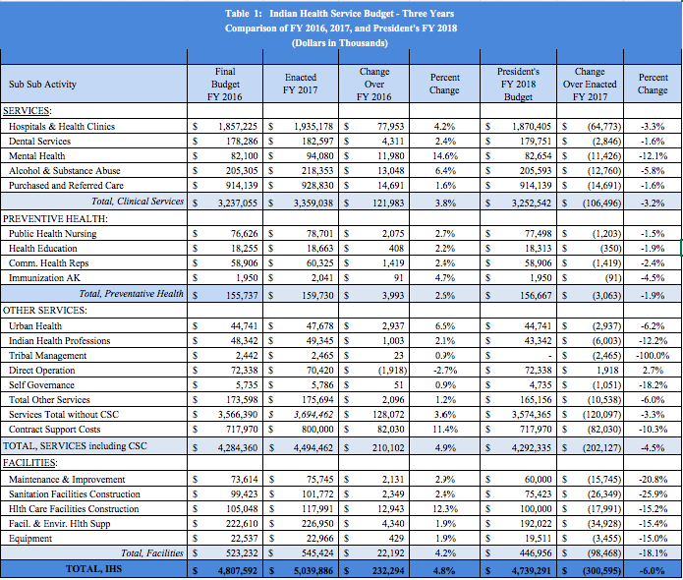

Total Budget Authority

The Health Services Account, Contract Support Costs (CSC), and Facilities are now the three components of the Total Budget Authority for the Indian Health Services Budget.

Table 2 depicts the health services budget without CSC for the years FY 2016, FY 2017, and FY 2018. CSC is now mandatory funding and is no longer included in the health services account.

Table 2: Budget Authority
Note: Health Services no longer includes Contract Support Costs
 | FY 2016 | FY 2017 | FY 2018
Health Services | $3,566,390 | $3,694,462 | $3,574,365
Facilities | $523,232 | $545,424 | $446,956
Contract Support Costs | $717,970 | $800,000 | $717,970
$4,807,592 |  | $5,039,886 | $4,739,291

Contract Support Costs (CSC)
CSC continues to be funded in FY 2017 at “such sums as may be necessary” and is maintained in a separate account. The President’s Budget estimates that CSC is $717,970,000 (CJ-147). The FY 2017 budget estimated CSC need was at $800 million; however, the amount is anticipated to be lower. In FY 2018 and beyond, the Administration proposes to reclassify CSC as a mandatory, three-year appropriation with sufficient increases year over year to fully fund the estimated need for the program, for both the IHS and the Bureau of Indian Affairs which is consistent with Tribal consultation.
Facilities
$447 million is proposed in the President’s FY 2018 budget for all Facilities line items, an 18% decrease from FY 2017 enacted level. This includes a decrease of $26 million (26%) for Sanitation Facilities Construction (26%) and a decrease of over $15 million (21%) for maintenance and improvement.
Mandatory spending for Diabetes

Mandatory spending for diabetes has been $150 million and must be increased to $250 million with inflation increases annually.

Preserving the Basic Health Program

The President’s FY 2018 IHS budget provides adequate funding to preserve existing IHS programs. A basic budget principle, Northwest Tribes have always focused on preserving the basic health care program funded by this budget. Preserving the purchasing power of the IHS base program with at least a ‘maintenance level’ budget should be the first budget principle, not an afterthought. This budget is not a “maintenance level” budget and instead decreases the FY 2017 enacted budget by 6%.

Tribes have maintained a trusting relationship, on a non-partisan basis, between Tribes who are concerned about improving the health status of their citizens, the Administration that is charged with that responsibility, and the Congress who considers the annual appropriations legislation. Tribes, IHS, and Congress must continue to focus on the goals and objectives of the IHS program and assure that the necessary resources are available to continue to make improvements in health status.

The Office of Management and Budget

The Office of Management and Budget (OMB), under President Obama, has demonstrated a new willingness to meet with Tribes. Many years ago, OMB shared a “who-struck-john” table that allowed Tribes to understand where budget cuts were made. This allowed Tribes to direct their advocacy to key decision makers by providing them with information about the funding requirements of IHS and Tribal health programs. This information became embargoed information under the Bush Administration. OMB continues to refuse to meet directly with Tribal leaders. The OMB could open the process by sharing budget information in November before final distributions are made and prior to the budget submission, typically, the first Monday in February. Tribes have specifically requested that OMB allow the Department of Health and Human Services to share the November OMB pass-back information with Tribes so they can provide their comments to the Administration and the IHS to assist in preparation of its appeal to the Department and OMB. How can Tribes effectively participate in the budget process if they are prohibited from having access to vital information in order to develop recommendations for Congress?

In the course of this budget review, the President’s budget request is evaluated, major issues and concerns are identified, and suggestions are provided that will benefit Tribes and IHS. Recommendations for funding levels are also included. Our goal is that this analysis serves as a valuable resource for the Administration, Congress, and the Congressional staff that are responsible for developing the IHS Budget.

The treaties, executive orders, and the legislation that Tribes have fought so hard to uphold with the government of the United States remain the foundation of the unique status of health care for Indian people. The promise of consultation for the FY 2019 budget suggests that treaties will be honored, promises will be kept, and the IHS will have a budget adequate to provide needed health services.

Current Services Budget: Maintaining the Current Health Program and

the President’s Proposed FY 2018 IHS Budget

Current services estimates calculate mandatory cost increases necessary to maintain the current level of services. These “mandatories” are spending increases that are due to medical and general inflation, pay costs, staff for recently constructed facilities, and population growth. The 10% increases received in FY 2001 and 2010 are the only budgets that allowed Tribes to reduce PRC denials of services. The elimination of any increase in last year’s enacted budget (FY 2017) will predictably increase the number of denials of health services. The NPAIHB estimates the current services need in FY 2018 is $629 million. This is the amount necessary to fund IHS at FY 2017 enacted levels and to fund inflation, population growth. Anything less than this amount will increase denied health care services.

There are a number of ways to compute current services. The IHS estimates pay cost increases and reports this separate from inflation. The reason has less to do with budget presentation and more with the simple fact that Congress passes a pay act each year and the service is required to include the cost in its budget. Pay cost increases are costs that are precisely computed for federal employees. The IHS has also added reasonable Tribal pay estimates and reports these in the Congressional Justification.

To reiterate, the NPAIHB estimates that in FY 2018 an increase of at least $629 million is needed to maintain current services. In addition, Portland Area Tribes recommend an additional $140 million for program enhancements to address the significant Indian health disparities and priority needs. This brings the total NPAIHB recommended amount to $769 million.

FY 2018 Justification of Estimates

In the NPAIHB proposed budget (depicted in Table 3), pay act costs are not displayed separately from general and medical inflation. Personnel inflation is a part of the overall inflation adjustment and does not need special treatment for the purposes of calculating a current services budget. The estimates presented in this analysis extrapolate medical related series of the Consumer Price Index (CPI) as they relate to IHS budget account activity. For example, inflation for the Hospital and Clinic Services is measured using the Hospital and Related Services series of the CPI, which measures inpatient and outpatient hospital related care only. Footnotes are included in the spreadsheet to indicate the CPI source that was used to measure inflation for budget sub-sub activity. Extrapolating CPI medical indices is a standard economic forecasting method that allows accurate and defensible estimates that are tied to real costs, though OMB has routinely applied non-medical related inflation rates to the IHS budget, which underestimate the true funding need for health care programs. Finally, a 1.8% rate of growth (same as the IHS rate) is used to estimate population growth.

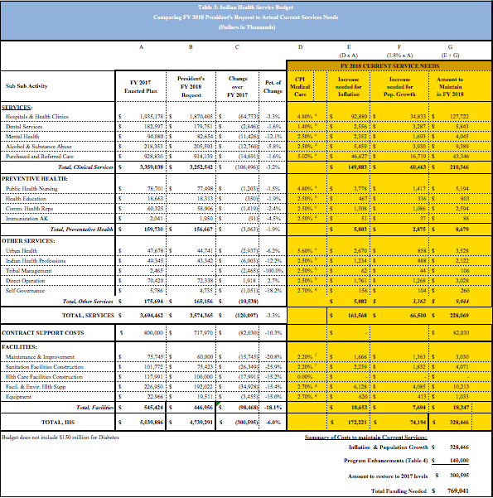

a: Inflation calculated from Consumer Price Index (CPI) data source: https://www.bls.gov/cpi/cpid1705.pdf. Average of CPI Inpatient 4.0 and Out Patient 5.6 = 4.8
b: CPI data source under Dental Services: https://www.bls.gov/cpi/cpid1705.pdf
c&d: CPI data source under Medical Care Services: https://www.bls.gov/cpi/cpid1705.pdf
e: Amount required for new and expanded Self-Determination and Self-Governance agreements.
f: CPI data source under Other Medical Professionals: https://www.bls.gov/cpi/cpid1705.pdf
g: CPI data source under Medical Care Services: https://www.bls.gov/cpi/cpid1705.pdf.

Portland Area Recommendations for Program Increases

Portland Area Tribes have considered various program increases (or program enhancements) that they feel are essential to address the desperate health disparities and high priority health needs that their programs face. In past years spirited discussions on keeping these recommendations within the bounds of political feasibility often compete with recommendations based on true need. Everyone feels the funding increases for the line items listed here are far short of what was actually needed. It was decided, however, to highlight these program increases given the significant health disparities of AI/AN people and the increased morbidity and years of productive life lost because of these disparities.

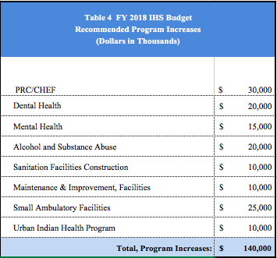

Portland Area Tribes recommend program increases of $140,000 for FY 2018. They also recommend more funding ($30 million) for the Catastrophic Health Emergency Fund (CHEF) and the PRC program in order to address the significant backlog of deferred services and the growing number of denied services and CHEF claims. Portland Area Tribes recommend a substantial increase ($20 million) to address the growing oral health needs and dental professional shortage in Indian Country. Tribal health directors stressed the importance of having good oral health; and how it is a prerequisite for making good nutritional choices that determine future health outcomes. The well-established value of dental health aide therapists is an opportunity to stretch these dental funds even more as states see the logic of extending their practice authority.

For the same reasons that IHS has recommended an additional funding for a behavioral health youth initiative, Portland Area Tribes recommend additional funding to address similar mental health and alcohol substance abuse issues for adults. The new youth behavioral initiative has been long needed; we also must do more to address similar issues for our Tribal adult population. Last year’s increases for facilities accounts, M and I was helpful, but more is needed in this long neglected line item. Portland Area Tribes insist, once again, that small ambulatory facilities have a source of funds to support the new facility construction needs of smaller Tribes who cannot compete in the current new facilities construction priority system.

Finally, the President’s FY 2018 budget proposes a 6.2% decrease to the Urban Indian Health Program (UIHP). NPAIHB once again recommends funding at FY 2017 enacted level, plus inflation and population growth increases; and an additional $10 million. The latter amount will assist UIHPs meet the growing demand for health services in urban areas across Indian Country.

Portland Area American Indian and Alaska Native Population
Portland Area’s overall American Indian and Alaska Native (AI/AN) population is 343,675 with Washington’s 196,026, Oregon’s 110,852, and Idaho’s 36,797. The American Community Survey (ACS) estimate for AI/ANs with Access to IHS is 95,113 for the Portland Area (compared to the 3-year active IHS user population of 105,000) with Washington’s estimate 54,481, Oregon’s 27,543, and Idaho’s 13,089.

The ACS estimates now contain important and timely information regarding the AI/AN population, including income and insurance status. Its annual survey, also combined to produce 5-year estimates give an accurate ‘estimate’ of income, insurance, and access to Indian Health Programs. Data released January 26, 2016 depicted a growing population (faster than general population growth) and one with increased enrollment in the Medicaid program.

The Effect of Staffing New IHS Facilities on the Budget Increase

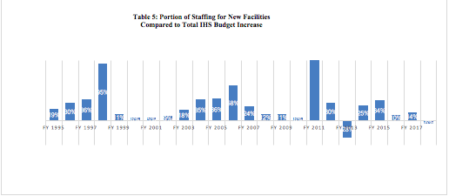

The staffing requirements for newly constructed health facilities have always been a concern for Tribes in the Portland Area and other IHS Areas that are dependent on PRC funding to provide health care. The inequity of facilities construction funding provides a disproportionate share of funding to a few select communities. The significance of facilities funding, both for construction and staffing new facilities, is that it removes funds necessary to maintain current services (pay costs, inflation, and population growth) from the IHS budget increase.

The graph above illustrates the significance of staffing new facilities on the IHS budget increase. Staffing packages for new facilities are like pay act costs in two respects:

- They come ‘off the top,’ (i.e. they are distributed before other increases), and;
- They are recurring appropriations.

Northwest Tribes frequently ask: Why did our health program receive a 1% increase in funding this year when we were told there was a 5% increase for the IHS budget? Over many years, new staffing costs have consumed over 50% of the increase.

In FY 2011, the overall IHS increase was $16.8 million, with $38 million requested for staffing, and the final operating plan amount was $25 million. In FY 2013 (year of sequester) the IHS budget was cut by $175 million, and the amount provided for staffing was $53 million. In these years, IHS cut Tribal program budgets in order to provide for funding to new facilities.

In FY 2018, $14.7 million is needed for staffing of new facilities at the Choctaw Nation and Flandreau Health Centers. These ‘new staffing packages’ become recurring appropriations.

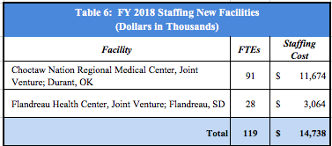

Health Services Account
The following section reviews the IHS budget at the ‘sub-sub-activity’ level for the health services account. The number in the parenthesis is the page number in the Congressional Justification for the IHS FY 2018 budget followed by the page number from the May 3, 2017, Congressional Record (CR).

Hospitals and Clinics (CJ-57; CR-H3887)

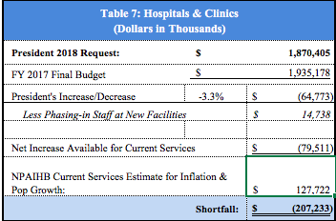

The Hospitals and Clinics (H&C) line item would receive $1.87 billion under the Administration’s request, a proposed decrease of $64.8 million or 3.3% less than the enacted FY 2017 budget. NPAIHB estimates that $127.7 million is needed to maintain current services. After the effects of staffing and program increases are factored, the President’s request will fall short by over $207.2 million.

The H&C line item supports inpatient and outpatient care, routine and emergency ambulatory care, and medical support services. In some Areas, funds that should be under contract health care are actually found in this line item. Over the last eight years this very important budget line item has been diminished due to inadequate budget increases. The Portland Area receives far less per capita than most areas from this line item that includes nearly 50% of the Health Service Account. Portland Area Tribes only receive 4% of the non-Headquarters share of H&C funding ($75 million) despite its 7% share of the IHS user population. This reflects the fact that there are no hospitals in the Portland Area.

Information Technology (CJ-72)

IT will be an important component of quality improvements and potentially cost savings so it is wise to provide a clear documentation of IHS IT activities. The IHS maintains that the current budget request ensures that the budget needs for IT are independent of direct clinical care funds. The FY 2018 budget request for IT is $182 million. The IHS information technology needs have been neglected in the budget over the last twenty years and more funding is needed, especially at P.L. 93-638 sites. It is also recognized that non-IHS information systems adopted by some programs also deserve funding support.

Epidemiology Centers: Recurring Funding Epidemiology Centers (CJ-7)

IHS proposes modest funding increases for twelve Epidemiology Centers, eleven Tribal and one urban located at the Seattle Indian Health Board.

The Northwest Tribal Epidemiology Center (The EpiCenter), is located at the NPAIHB. It was the first Tribal EpiCenter in the nation and is now a well-established part of the health research, health promotion and disease prevention efforts of Northwest Tribes. The EpiCenter provides epidemiological and programmatic assistance on a variety of health issues. The 12 Tribal EpiCenters (TECs) are:
- Northwest Tribal Epidemiology Center
- Albuquerque Area Southwest Tribal Epidemiology Center
- California Tribal Epidemiology Center (California Rural Indian Health Board)
- Alaska Native Epidemiology Center,
- Great Lakes Inter-Tribal Epidemiology Center
- Inter-Tribal Council of Arizona Tribal Epidemiology Center
- Rocky Mountain Tribal Epidemiology Center (MT-WY Tribal Leaders Council)
- Navajo Epidemiology Center (Nation Division of Health),
- Northern Plains Tribal Epidemiology Center (Great Plains Tribal Chairmen’s Health Board)
- Southern Plains Area Tribal Epidemiology Center
- United South and Eastern Tribal Epidemiology Center
- Urban Indian Health Institute Tribal Epidemiology Center

The Board recommends permanent funding for Tribal EpiCenters at a level that will enable them to be fully functional epidemiological and surveillance centers. The President’s FY 2018 request of $1.87 million ignores the fact that funding over the last ten years has remained flat. The current $380,000 per EpiCenter funding is a drastic difference when compared to the $440,000 average of 2006. In FY 2011 and FY 2012 the base budget of the Epicenters was eroded due to Congressional rescissions in the appropriations process. In FY 2013 the Epicenter budget was reduced by over $245,000 due to the Administration sequester. The large increase in FY 2014 simply restored the Epicenter budget to its original level in FY 2012 prior to the sequester.

The current level of funding does not provide an adequate increase to cover the costs of inflation, pay increases, and program growth for the EpiCenters. Tribal EpiCenters, federally recognized Public Health Authorities, conduct distinct public health functions and corresponding activities, ranging from population based public health surveillance, local, national and regional infrastructure and capacity building, to infectious disease outbreak response. In contrast to the fifty state operated public health departments, local public health departments, and federal departments, there are only 12 Tribal epidemiology centers to execute these functions for 567 Tribes, uncounted Tribal organizations, and 33 urban Indian health organizations.

Unless these programs receive adequate funding increases, they will be challenged to retain the highly skilled professionals in their programs. Previous increases have allowed the NPAIHB EpiCenter to be funded at a level that allows it to provide professional, high quality work for Indian health programs, but only because some grant funds (notably the Special Diabetes Programs for Indians funds Northwest Tribes share with the EpiCenter), have been applied to the core functions of the EpiCenter. And the center successfully competes for funds from other DHHS agencies.

In the past, the NPAIHB recommended that each Tribal EpiCenter receive at least $1 million annually in core funding from IHS funds in order to consistently provide services needed. As an alternative way to secure more funding, IHS could department from the ‘equal is equitable’ principle and provide added funding to some Epicenters to become ‘centers of excellence’ in certain aspects of Epidemiology. In order to fully handle data requests from Tribes, NPAIHB could easily use six statisticians, full time, and three additional epidemiologists. Fully funding the TECs at a reasonable rate would allow important surveillance and epidemiology work to be completed on behalf of and alongside the Tribes in each Area.

Dental Services (CJ-78; CR-H3886)

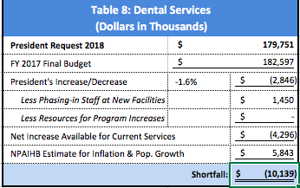

The President’s proposes a decrease for Dental Health services of $2.8 million, a 1.6% decrease compared to last year’s level. NPAIHB estimates it will take at least $5.8 million to maintain current services. The President’s request is $10.1 million less than needed to fund a maintenance budget.

The FY 2011 rescission and FY 2013 sequester have reduced the IHS dental services budget. Many Portland Area Tribes increased their dental services in FY 2015 and FY 2016, but none received increases for their increased staffing since their expansions were funded with non-IHS funds. While the ACA provides insurance coverage and Medicaid has restored dental services, many AI/AN still do not have access since the majority of dentists are not accepting Medicaid patients. The Dental Health Aide Therapist initiatives in Washington and Oregon will only partially address this need. Additional support from states in the form of Medicaid payments for DHAT services will be needed to fully take advantage of this new provider type.

Indian populations have the highest rates of oral health disease than any other population. Oral health surveys conducted by IHS indicate the following:

According to IHS (CJ-78), the demand for dental treatment remains high due to the high incidence of dental caries in AI/AN children. Over 80 percent of AI/AN children ages 6-9 years suffer from dental caries, while less than 50 percent of the U.S. population ages 6-9 years have experienced cavities. In addition to this disparity in prevalence, there is a significant disparity in severity of dental disease. AI/AN children ages 2-5 years exhibit an average of six decayed teeth, while the same age group in the U.S. population averages one decayed tooth.

In addition to the recommendation of $5.8 million to maintain current services, Northwest Tribes further recommend an additional $20 million to address the significant dental health disparities in Tribal communities. The importance of oral health is that it impacts self-esteem for children, prevents problems in eating and speaking, and results in good nutritional options for adults. On the other hand, it is now widely recognized that poor dental health leads to increase morbidity and mortality.

Mental Health (CJ-85; CR-3887)

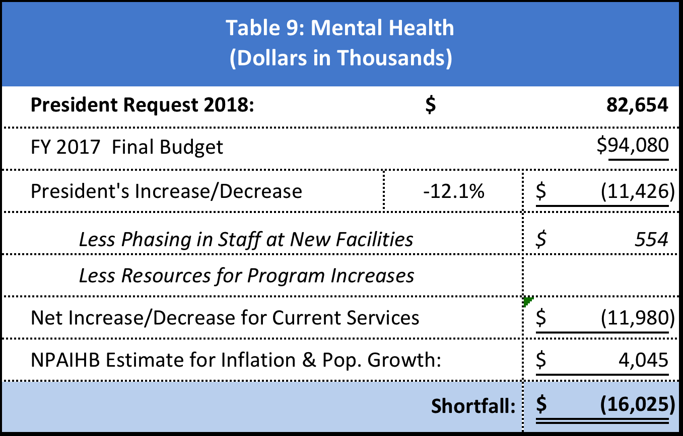

The President requests $82.6 million to cover the mental health needs of IHS and Tribal health programs. This is a decrease of $11.4 million (12.1%) over enacted FY 2017 amount. NPAIHB estimates that it will take $4 million to fund mandatory cost increases for inflation and population growth. The shortfall for mental health proposed funding to IHS is $16 million.

IHS mental health providers report that mental health needs throughout Indian Country are a growing concern. A significant investment is needed to avoid youth suicides, domestic violence, and other manifestations of mental health disparities. Violence and trauma are also reported at alarming rates in Tribal communities. The rate of violence for Indian youth aged 12-17 is 65% greater than the national average.

Among U.S. adolescents ages 12 to 20, AI/ANs had the highest major depressive episode prevalence in the past year. Among 9,464 children participating in the study, AI/AN children had the highest self-reported depression rates, and depression increased with age, peaking between 16 and 17 years of age. In the same study, race was analyzed as an independent risk factor, and results showed that simply being AI/AN, apart from any other factor, increased the rate of depression 2.6-fold.

The suicide rate among AI/AN adolescents and young adults ages 15 to 34 (31 per 100,000) is 2.5 times higher than the national average for that age group (12.2 per 100,000). These statistics are shocking and communicate the critical importance of mental health needs to be addressed in Indian Country.

Despite the need, service utilization rates for AI/ANs are low, which is likely due to a combination of factors, including stigmatization, lack of culturally trained providers, lack of services, and discrimination. Low utilization rates may also be due to a misalignment between the worldviews of AI/AN peoples and that of the behavioral health field. Anecdotal evidence suggests that when services are culturally-based (e.g., a tribal system of care), utilization increases.

Recent, congressionally-approved increases have allowed Tribes to develop innovative behavioral health projects. The NPAIHB has developed an area-wide Suicide Prevention Tribal Action Plan that is now guiding intertribal programs to prevent and treat suicidality.

The 2016 National Tribal Behavioral Health Agenda (http://store.samhsa.gov/shin/content//PEP16-NTBH-AGENDA/PEP16-NTBH-AGENDA.pdf) also offers us a landmark blueprint for improving the behavioral health of AI/ANs. The agenda was written in response to calls from tribal leaders to improve collaboration and coordination with federal agencies to address behavioral health concerns in Indian Country. Resources are now needed to bring its recommendations to fruition.

Alcohol & Substance Abuse (CJ-91; CR-3887)

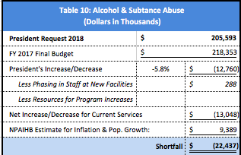

The President’s budget requests a decrease of 5.8% for Alcohol and Substance abuse programs. This is one of the larger decreases in the history of the alcohol and substance abuse program.

In FY 2018, NPAIHB estimates that it will take $9.4 million to fund current services. The President proposed decrease of $12.7 million leaving a deficit of $22.4 million still needed to fund current services and the population growth.

Alcohol and substance abuse continues to be one of the highest priorities identified by Tribal leaders and health directors during the IHS budget formulation process. The latest data available to IHS indicates that alcoholism mortality rates in Tribal communities have increased significantly since 1992 to nearly seven-times the alcoholism death rate of the overall U.S. population.

To date, there has been little attention given to the impacts of the opioid epidemic on tribal communities. Data from the NPAIHB EpiCenter indicate that AI/AN in the Northwestern states of Idaho, Oregon, and Washington and almost twice as likely to die from a prescription opioid overdose compared to Non-Hispanic Whites (NHW) in the region. AI/AN who die from opioid and drug overdoses tend to be much younger than NHW who overdose. Recent data also indicate a worrying increase in heroin overdose deaths among AI/AN, indicating a shift toward illegal and potentially more lethal substances in Indian Country. There is a need for coordination with Tribes locally, regionally and nationally, as well as state and federal agencies, to address these disturbing statistics.

The 2013 Youth Risk Behavior Survey reports that AI/AN youth had higher rates of drinking alcohol before age 13 compared to national rates (28.2 compared to 18.6 respectively). Data from the American Drug and Alcohol Survey administered to Native youth at 33 schools from 2009-2012 was compared to data from the Monitoring the Future Survey. The comparison showed much higher prevalence of drug and alcohol use amongst 8th and 10th grade Native youth in comparison to national averages. Early substance use may result from stress events, and is a clear marker of risk for prolonged and problematic use, along with lower academic achievement, academic problems, drug use, and alcoholism later in life.

By relying on Tribes to develop culturally relevant prevention and treatment programs, it is more likely that they will be effective and sustained. Northwest Tribes are developing such programs with local conditions in mind.

The 2016 National Tribal Behavioral Health Agenda (http://store.samhsa.gov/shin/content//PEP16-NTBH-AGENDA/PEP16-NTBH-AGENDA.pdf) also offers us a landmark blueprint for improving the behavioral health of AI/ANs. The agenda was written in response to calls from tribal leaders to improve collaboration and coordination with federal agencies to address behavioral health concerns in Indian Country. Resources are now needed to bring its recommendations to fruition.

Purchased and Referred Care (CJ-104)

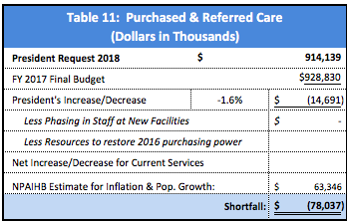

The PRC proposed decrease of $14.7 million for FY 2018 will be devastating to the Northwest and the Indian health system as any decrease reduces services to AI/AN people. There is a $78 million dollar shortfall to PRC with the President’s FY 2018 budget.

The President’s requested FY 2018 decrease of $14.7 million is will continue to erode the purchasing power of the PRC program which compounds the loss of funding in FY 2016 (no increase).

Currently, the Portland Area receives approximately 11% of the PRC funds allocated to the Areas; an estimated $100 million in FY 2018. As noted above, this compares to the Portland Area’s 4% share of the H and C budget.

PRC is the most important budget line item for Northwest Tribes. NPAIHB estimates that it will take $78 million to maintain current services in FY 2017. Otherwise, Tribes will have to absorb this amount due to funding below FY 2017 levels, and medical inflation and increases due to population growth. Another $46 million is needed to restore FY 2016 loss in purchasing power.

PRC dependent Areas lack facilities infrastructure to deliver services and have no choice but to purchase specialty care from the private sector using PRC funds. The PRC line item is subject to the same inflation rates for inpatient and outpatient services as the Hospital and Clinics line item. In fact, it could be argued that the PRC line item is subject to higher rates of inflation since it is used to purchase specialty care services. It is more expensive to purchase such services than if the services are delivered in existing facilities.

Many Tribal programs begin their new fiscal year on “Priority One” levels or in the winter instead of spring of the fiscal year. In FY 2001 and again in FY 2010, IHS received a significant CHS/PRC increase that was sufficient to fund population growth and medical inflation and for the first time since 1993 Tribes saw the level of PRC denials begin to fall (see graph). In FY 2007, the PRC program began paying Medicare-like rates for services purchased from inpatient hospitals. There was a significant decrease in deferred services resulting from implementing this new statutory requirement. The benefit of Medicare-like rates has been short-lived as PRC deferred services (within medical priorities but no funding available) are on the rise once again. In 2017 Medicare-like rates for specialists is being implemented with a great deal of uncertainty about its affect on access and rates. Tribes realize that some providers may not accept patients if only Medicare rates are paid, but hopefully providers will accept this promising and simple billing option that could lower costs for all.

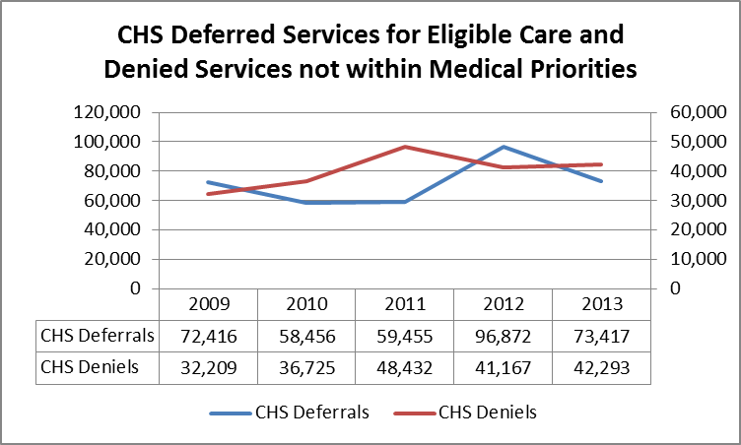

Congress should note that there is no funding associated with pay costs for the PRC program, yet the providers that Tribes purchase specialty care services from are as deserving of pay cost increases as federal workers. In many cases, increases would go to small town practitioners and rural hospitals. PRC purchases of specialty care are a very efficient method of providing health care services that contribute to rural economies. PRC is a much more efficient method of providing care than building, staffing, and maintaining new hospitals.

This year’s PRC request discontinues the recognition of the ability of a well-funded PRC program to provide efficient and effective health care services according to priorities established by Tribes themselves. The PRC appropriation is 25% of the total FY 2018 Health Services account. While small when compared to the 52% of the health services account that is in the Hospitals and Clinics line item, it is a critical component of every Indian health program, Tribally-operated or by the IHS.

In the Northwest, the PRC line item represents over 30% of the total Portland Area Office allowance. The consequence of past years of under-funded inflationary and population growth costs is degraded services for Tribes who depend upon PRC to support inpatient, outpatient, and specialty care services. IHS Areas like the Portland Area (which has no hospitals) are particularly hurt by the lack of sufficient increases to cover medical care inflation and population growth. There is only so much that can be done to restrict medical priorities. Rationing and erosion of service has been a constant problem, particularly for PRC programs.

The Portland Area strongly supports distribution of PRC dollars with a formula that recognizes that some areas are strongly dependent on this funding source. Northwest Tribes did not support the formula that was developed without consensus in 2001. Since most areas are not PRC dependent, a workgroup process runs the risk of allowing the ‘majority’ to redistribute funds from the areas who depend on a formula that accurately reflects this dependence to the ‘minority’ who are not PRC dependent. The Portland Area is not Hospitals and Clinics ‘dependent’ and does not expect to receive a share of that line item that is proportionate to the user population of the Portland Area. It is hoped that Tribes would likewise understand that their share of PRC funding is likely to be less than their user population percentage since they are not contract care dependent. The PRC program is also extremely vulnerable to inflation pressures. Between FY 1992 and FY 2018, the NPAIHB estimates that over $1.2 billion has been lost to inflation in the PRC program nationally. This number was much higher but due to the significant budget increase for PRC in FY 2001 and 2010, some funding has been restored. Unfunded medical inflation alone exceeds $597 million, while unfunded population growth totals $144 million—representing over $1.2 billion in lost purchasing power as depicted in the Table 12.

The PRC Program and Medicaid

The PRC program has been brought into closer alignment with Medicaid program increases due to the 22.8% increase received in FY 2010. Prior to this, the PRC program lagged considerably behind Medicaid program increases. The PRC program is very similar to the Medicaid program. It provides services to an underserved population that often require similar services. In fact, Congress intended the IHS and Tribal health programs to have access to Medicaid resources when in 1976, it authorized the Indian health system to be reimbursed for Medicaid related services. PRC should receive medical inflation adjustments at least equal to the Medicaid program.

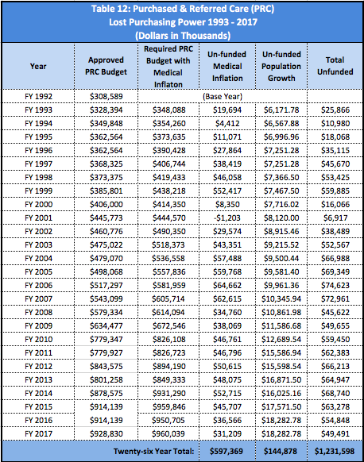

Surely no one believes that the relatively small Indian health system is able to secure better rates from providers than the Medicare and Medicaid programs. In 2003 the Medicare Modernization Act authorized Medicare-like rates for PRC programs. After a long delay, IHS funded programs gained access to Medicare-like rates in July 2007. This has moderated increases, but future increases will be somewhere between those approved by Medicare for Hospitals and those faced by all health care providers for specialty care provided outside the hospital setting. As noted above Medicare-like rate regulations covering specialist providers is being implemented with uncertain impact as to rates and impact on access to care.

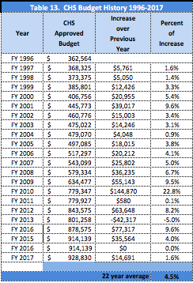

PRC Unmet Need

The IHS maintains a deferred and denied services report that is updated each year. By applying an average PRC outpatient cost to the deferred and denied services figures an estimate can be calculated for unmet PRC need. In 2013 there were 73,417 deferred services, with an estimated cost of $322 million. Deferred services are those within the PRC medical priorities (usually Priority One or Two), but for which there was not enough funding to cover the costs of care. There were an additional 42,293 denied services, estimated to cost $186 million, determined not to be within the medical priorities (Priority One).

Other types of denied services in the PRC program are also tracked in the denied service reports by the IHS. These categories represent policy and procedural decisions that typically disqualify an individual from “covered care.” They include emergency visits not reported in 72 hours, non-emergency care with no prior approval, or Indian patients that reside off the reservation. If adequate funding were available to the PRC program, these procedural denials would be covered services and should be included in projecting PRC funding shortfall.

Catastrophic Health Emergency Fund
(CJ-115)

The PRC budget includes a Catastrophic Health Emergency Fund (CHEF) which is intended to protect the daily administration of local PRC programs from expenditures for catastrophic health cases. This fund is a lifesaver for Indian health programs. Its purpose is to fund catastrophic health care cases with large expenses.

The current FY 2017 threshold before a case is considered for funding is $25,000, but could change to $19,000 under a proposed regulation. Tribal leaders voiced concern over other provisions in the regulation and the final regulation has not been issued. The Catastrophic Health Emergency Fund is an important source of funds for programs that experience high cost cases. These cases place a tremendous financial and ethical burden on a Service Unit or a Tribe if the case occurs near the end of the year after the Fund has been exhausted.

Northwest Tribes have always urged the Congress to consider fully funding CHEF since these cases are all well-documented and critical to the financial stability of the small programs that exist in the Portland Area and many other IHS Areas. In FY 2012, the CHEF was increased to $51 million. Following the Administration budget sequester it fell to $48.9 million. This year’s President’s request for CHEF is $51.5 million. The availability of cost savings with Medicare-like rates, and the vigorous application of the alternative resources (like Medicaid), CHEF funding should be available throughout the year.

Portland Area Tribes strongly urge Congress to fully fund CHEF since the impact of not funding it impacts Indian Health programs more than any other line activity in the budget.

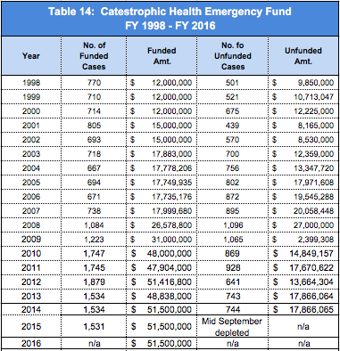

To insure that all alternative resources are accessed before any distribution of CHEF funds, alternate resources training should continue to be provided to maximize the effectiveness of this funding source.

Public Health Nursing (CJ-108)

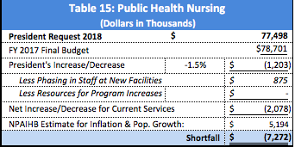

The President’s request for Public Health Nurses (PHNs) is $77.5 million, a decrease of 1.5% over last year’s amount. With $875,000 for staffing new facilities, this amount is not sufficient to fund current services. NPAIHB estimates a $7.3 million dollar shortfall to Public Health Nursing.

PHNs are at the center of many Tribal community based health services including home visits. Disease surveillance, direct therapy; and group education comprise 40% of the PHNs time. The growing elderly population has required an increase in home visits by PHNs. The increasing threats of pandemic flu and bioterrorism have also brought additional planning responsibilities for the PHN program. PHNs are vital in the emergency planning arena through health surveillance and coordination with other local health jurisdictions. It is clear that this growing need will require greater than average increases.

Another significant amount of time of PHNs is dedicated to maternal and child health promotion. The important work being done to lower infant mortality and Sudden Unexplained Infant Death Syndrome (SUIDS) cannot be maintained if funding falls below the rate of inflation. SIDS/SUIDS awareness campaigns have resulted in a lower rate of infant deaths, yet it is still the greatest cause of infant mortality among Indians, with rates that are the highest of any group in the United States. Many Tribes are now involved in focused maternal and infant health projects including an effort by Washington Tribes with support from the NPAIHB and the American Indian Health Commission for Washington State.

Health Education (CJ-110)

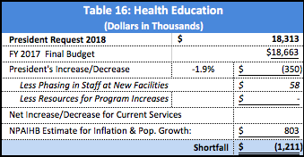

The President’s request for Health Education is $18.3 million in FY 2018, a decrease of 1.9% over last year’s amount. NPAIHB estimates a $1.2 million dollar shortfall to Health Education.

The Health Education program communicates the importance and on-going need for comprehensive clinical and community health education programs. It ensures education to patients, works with hospitals, clinics, and community education programs to integrate IHS patient education protocols and code systems. PHNs provided patient encounters for health activities and nursing services to AI/AN patients. This program continues to support national measures of maternal-child health, such as childhood immunizations, prenatal visits, postpartum visits, childhood obesity prevention through breastfeeding promotion and the Baby Friendly Hospital Initiative, as well as domestic violence screening through collaboration with related federal, state, local, and private programs.

Community Health Representatives (CJ-114)

The President’s request for the Community Health Representatives (CHRs) program is $58.9 million, a 2.4.0% decrease over last year’s level. NPAIHB estimates that it will take at least $2.6 million to maintain current services. The FY 2018 decrease of $1.4 million is not adequate to maintain the current levels of care provided by CHRs. There are no staffing or program increase requirements in the FY 2018 request. There is no coverage for inflation and population growth representing a total deficit of $4 million.

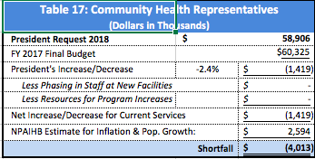

The CHR program maximizes health resources by providing basic medical knowledge about health promotion and disease prevention in the communities. Increased online training for CHRs has made them effective partners on the health care team. CHRs are at the forefront of much of the preventive health that needs to be emphasized in Indian health programs.

Urban Indian Health (CJ-123; CR-H3887)

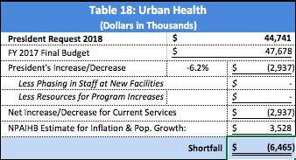
The President’s FY 2018 budget requests a decrease of 6.2% or 2.9 million.
The President proposes $44.7 million for the Urban Indian Health Program (UIHP). NPAIHB estimates that it will take $3.5 million to maintain current services in the UIHP; thus, for this year alone, funding is inadequate to maintain the current program. Accounting for inflation and growth, the UIHP will experience a $6.4 million deficit.

The UIHPs provide over 1 million health services to an eligible population of over 650,000 urban Indian people living in thirty-four locations across the United States. Many Indian people were relocated in the 1950s and 60s from reservations to cities in an attempt to assimilate them via mainstream educational and training opportunities. The basis for the provision of health services to the urban Indian population is a direct result of the federal government’s early assimilation policies.

An adequately funded UIHP helps IHS and Tribal programs. When Indian people return to reservations to receive health services, that could be secured more conveniently in UIHPs, it could actually cost the federal and state governments and Tribal health programs more money to provide needed services. Therefore, it is vital that Congress continue to support cost effective urban Indian health programs. NPAIHB recommends that the UIHPs be provided a budget increase that is not only adequate to maintain current services, but to meet the service level needs of these programs. IHS should develop reasonable estimates of this unmet need.

The President has requested legislation to extend the 100% Federal Medical Assistance Percentage to UIHPs (CJ-229). This is supported by Northwest Tribes by resolution at the Affiliated Tribes of Northwest Indians. The proposal promises to bring additional state and federal resources in support of UIHPs and should be considered and enacted by the Congress.

Indian Health Professions (CJ-142; CR-H3887)

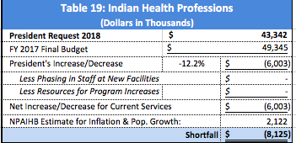

The President’s FY 2018 budget requests a decrease of 12.2% or 6 million. An additional $2.1 million is needed for inflation and population growth, leaving a deficit of over $8 million. The President’s request does not adequately fund the health professions program. Developing health professionals will be very important as the expansion of health insurance coverage due to the Affordable Care Act increases the need for health care providers. The Indian health system has high vacancies in many of its health professions and will need to begin to grow and train its work force to keep pace with the rest of the nation. Otherwise, vacancy rates will become even higher.

The Indian Health professionals program was developed to meet the critical staffing shortages of physicians, nurses, dentists, pharmacists, and other professions essential to staffing health facilities. Its purpose is to recruit Indian people into the health professions, serving as a catalyst for workforce recruitment and development for IHS and Tribal programs. NPAIHB commends the Administration for once again including a legislative proposal of tax relief for IHS Scholarship and Loan Repayment Program recipients. This is consistent with other health profession loan programs in the federal government. It is time for Congress to approve this requested legislation.

Last year’s budget was a start in the right direction, but more needs to be done in FY 2018. In addition, many believe not enough is being done to address the tremendous need for nurses, not only in the United States, but particularly in the Indian health system.

Tribal Management (CJ-133)

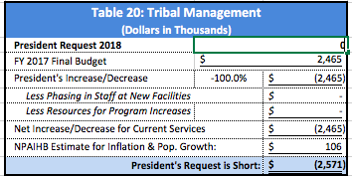

The President did not request funding for Tribal Management (zero. Funding for FY 2018 should be at least at the FY 2017 level. The President and Congress have consistently not funded any increases for this line item in a number of years with the result that it has become a program with few resources.

The Tribal Management program is an essential component of the Self-Determination program and allows Tribes to assess, evaluate, and develop their capacity to assume IHS programs. This program administers grants to Tribes and Tribal organizations that are carrying out Self-Determination programs and working to develop capacity of Indian managed programs.

Direct Operations (CJ-136; CR-H3887)

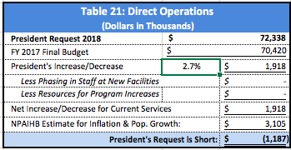

The Direct Operations line item funds the cost of management at IHS headquarters and the twelve Area Offices. This year the President’s request proposes an increase in Direct Operations funding by $1.9 million or 2.7%. NPAIHB estimates that $3.1 million will be needed to maintain current services. Thus, the President’s request falls short by $1.1 million.

The Direct Operations budget supports overall management of the IHS to ensure effective support for the IHS mission. This includes oversight of financial, human, facilities, information and support resources and systems. Recent projections by IHS indicate that a significant portion of their workforce will be eligible for retirement in the next few years. This budget line item will be important to finance succession planning activities and workforce development in order to meet the Agency’s future needs.
The IHS Congressional Justification also explains the Direct Operations budget is critical for the agency to continue to implement the Affordable Care Act (ACA) and the Indian Health Care Improvement Act (IHCIA). The past two years have seen IHS and Tribes focus on helping IHS beneficiaries during the Health Insurance Marketplace open enrollment periods and helping Tribal members who can enroll monthly throughout the entire year as a special benefit of the ACA. IHS also explains that the Direct Operation budget is critical to improving the human resources management system. These are such important functions that the IHS should receive more funding to conduct these activities.
Self-Governance (CJ 140)

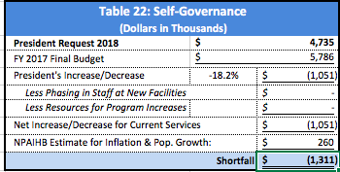

The President’s request for the Self-Governance item is $4.7 million, a 18.2% percent decrease; or $1 million less than last year’s budget. NPAIHB estimates that it will take at least an additional $260,000 over FY 2017 enacted level to maintain current services in FY 2018.. This will result in a shortfall in of $1.3 million. While this may seem like a severe cut, seven years ago, Congress reduced the Self Governance line item by $4.7 million, a loss of over 43% from the previous year. Tribes have continually recommended that this funding be restored to the FY 2002 level with appropriate adjustments to restore full funding. In FY 2002, the Self-Governance office budget was $9.8 million. Had the FY 2002 amount been maintained and received, general CPI inflation, the budget for the Self-Governance office should be at least $13.5 million in FY 2018.

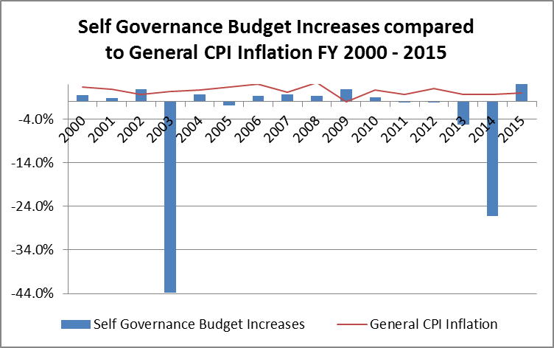

The Self-Governance office supports Tribes operating programs under the Tribal Self-Governance Amendments of 2000. The Self-Governance process serves as a model program for federal government outsourcing, which builds Tribal infrastructure and provides quality services to Indian people. Tribes operate over $3 billion of the total $5 billion IHS budget, and it is imperative that they receive the necessary resources to develop and build their administrative infrastructure and allow for new and expanded programs.

Contract Support Costs (CJ-147; CR-H3887)

The Indian Self-Determination and Education Assistance Act of 1975 authorized Tribes to enter into contracts or self-governance compacts to manage federal programs previously administered by the IHS. The well-documented achievements of the Indian self-determination policies have consistently improved service delivery, increased service levels, and strengthened Tribal governments, institutions, and services for Indian people. Every Administration since 1975 has embraced this policy and Congress has repeatedly affirmed it through extensive amendments to strengthen the Self-Determination Act in 1988 and 1994.

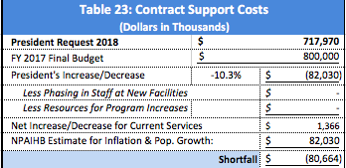

This year’s FY 2018 request of a $718 million, is a decrease of 10.3% or $82 million less than the 2017 budget. CSC is required to be funded at “such sums as necessary.”

Estimates for CSC use the IHS yearly CSC shortfall report amounts and forecasting methods that update shortfall report calculations based on actual figures provided by IHS for FY 2018. There are other CSC changes at work as well now that the Administration has agreed to fully pay CSC payments on Indian Self-Determination contracts and compacts. Under this full funding environment there will be Tribes that want to expand their self-determination contracting opportunities, as well as new Tribes that will want to enter into new self-determination agreements. There are also existing self-determination contractors that are in the process of recalculating and renegotiating their direct and indirect contracts support costs.

Special Request: Hepatitis C Screening, Management and Treatment

IHS should request special allocation of funds for Hepatitis C Virus (HCV) from Congress. Beginning at a small scale in 2014, select I/T/U facilities began treating AI/AN people for HCV with the class of Directly Acting Antivirals (DAAs) newly approved by the Food and Drug Administration. These drugs represent a breakthrough in treatment. Prior to the introduction of the new high-cost treatment therapies in January 2014, the treatments for Hepatitis C were often ineffective and presented considerable side effects to the user. By contrast, new DAAs are more effective at curing patients with HCV, present significantly fewer side effects than earlier options, and are much simpler to administer. Cure of HCV significantly decreases the risk of progression of disease to cirrhosis, liver failure, liver cancer, and death. IHS wants to ensure all AI/AN with HCV can access treatment. Similar to the recommendations from the National Academies of Sciences, Engineering and Medicine, IHS should pursue Hepatitis C Elimination.

IHS should requests similar funds to scale allocated to the Veterans Administration for HCV treatment in 2014 ($370 million) and requested for 2015-2017 ($697-660 million). IHS should be funded at $95 million in 2018, $180 million in 2019 and $170 million in 2020; projecting treatment of 1,500 people in 2018, 2,800 people in 2019 and 2,650 people in 2020, respectively. It is estimated that there are 34,000 AI/AN people with a current Hepatitis C infection, according to the National Data Warehouse.

NPAIHB and Portland Area Tribes urge the Administration to begin supporting IHS as it does VA, starting with increased funding for the FY 2018 budget.

Health Facilities Accounts (CJ-150; CR-H3887)

Maintenance and Improvement (CJ-172)

The M&I program is the primary source of funding to maintain, repair, and improve existing IHS and Tribal healthcare facilities. This infrastructure is central to the IHS mission of being able to deliver and support healthcare services to AI/AN people.

This funding is essential for the maintenance of IHS-owned and many Tribally-owned healthcare facilities.

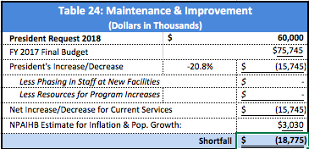
The President’s request for M&I is $60 million, a decrease of $15.7 million over last year’s enacted budget). Recognizing the serious need for M&I funds in Indian Country, NPAIHB estimates an additional $3 million to keep up with inflation and population growth. The total deficit to the 2018 budget is $18.8 million.

Sanitation (CJ-170)

The FY 2018 budget requests $75.4 million for the Sanitation facilities program. The massive 25.9% decrease in funding, following last year’s $20 million increase falls unacceptably short. Calculating for inflation and population growth, the Sanitation program faces a $30.3 million deficit that will have a significant impact on Northwest Tribes.

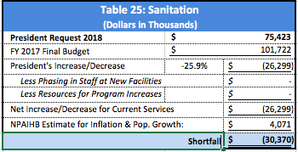

Approximately 7.5% of all AI/AN homes lack safe water in the home compared to less than 1% average nationally. Sanitation is an integral component of disease management. Many health professionals credit health status improvements due to quality water, sewage disposal facilities, development of solid waste sites, and support for Indian water and sewage programs. NPAIHB is concerned that the future of sanitation is a critical health issue for AI/AN and without adequate funding will be faced with preventable deaths.

Health Facilities Construction (CJ-175)

Northwest Tribes continue to support a moratorium on facilities construction until an equitable funding methodology can be implemented by the IHS. This position has been recommended for the past nine years so that savings from facilities construction can be redirected to the health services accounts. As noted throughout this analysis, facilities, especially hospitals are expensive to build and their staffing packages are more costly still.

The current priority list was developed in 1991 and Tribes are locked out of accessing badly needed construction dollars unless their facility is one of the facilities on the current list. The Portland Area Tribes continue to oppose any new facilities construction projects until the IHS completes its revision of the Health Facilities Construction Priority System.

The FY 2018 Health Facilities Construction budget requests $100 million for construction projects. This is a decrease of $17.9 million or 15.2%. The NPAIHB continues to request that a $25 million fund be established for small ambulatory facilities.

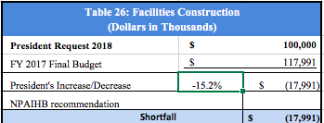

Alternative Methods of Acquiring Health Facilities

If new facilities construction dollars are included in the FY 2018 budget, some of these funds should go to alternative funding mechanisms. Northwest Tribes have long encouraged alternative methods to acquire new facilities. These alternative methods of acquiring health facilities must be supported in an effort to meet the demand for primary care. There is such an enormous need that depending exclusively upon IHS appropriations for all health facility requirements is not realistic. The IHS and Tribes have developed strategies (Joint Venture and Small Ambulatory Funding) that will greatly increase the number of new ambulatory health facilities constructed, but some IHS funding is required for this strategy of leveraging financing to work. In addition, staffing packages should be available to any new facility, regardless of how construction was funded.

The Indian Health Care Improvement Act (Section 306 of -(P.L. 102-573) authorized a grant program for the construction, expansion, and modernization of small ambulatory care facilities. This program assists Tribes to secure quality health care in isolated rural areas. In the Northwest this could mean replacing old, worn out trailers that serve as the health clinics in Tribal communities. Small modern clinic facilities assist Tribes to attract health care professionals, provide a health focus for the community, and, where Tribes are agreeable and resources available, provide health care services to underserved non-Indian individuals in the community. An investment of $20 million would support four to ten projects a year. This program has an excellent record of achievement that should be rewarded with increased appropriations.

Northwest Tribes recommend that the IHS and
Congress include appropriation language in the FY 2018 appropriation bill to allow staffing and equipment funding for the small ambulatory construction authorities (P.L. 102-573). This is necessary to realign the facilities construction program to provide consistent opportunities to address health facility construction needs throughout Indian Country. This recommendation is supported by the IHS National Budget Formulation Workgroup.

The NPAIHB has also suggested that the IHS secure authority to make loan guarantees for Tribes who are seeking outside financing for health facilities. This would create another opportunity for Tribes to build needed facilities rather than waiting for the IHS to fulfill its obligation. A loan guarantee would substantially reduce the debt service associated with financing facilities. A $25-$30 million fund (possibly funded with government bonds) could support construction of ten projects a year with Tribes repaying their loans with Medicaid collections or other sources of revenue.

Facilities and Environmental Support (CJ-183)

Northwest Tribes support the many activities of this line item that includes many public health initiatives. Some thought should be given to moving these activities out of the Facilities account into a new Public Health Account. This would align with the HHS/Centers for Disease Control and Prevention focus on improving public health under health care reform.

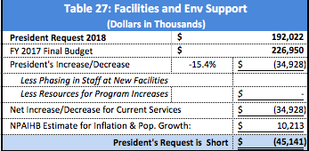

This line item consists of three subsidiary activities: facilities support, environmental health support, and the office of Environmental Health and Engineering support. The President’s request of $192 million is a 15.4% decrease or $34.9 million less than the 2017 budget. The total deficit is $45.1 million when calculated with estimates for population growth and inflation.

Equipment (CJ-171)

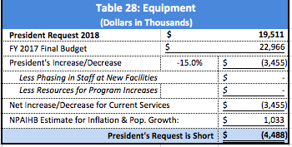

The Administration’s request of $19.5 million is a decrease of $3.4 million (15% decrease) over last year’s amount. NPAIHB estimates that it will take at least $1 million to maintain current services in the Equipment program. The President’s budget is short by $4.5 million.

IHS estimates an inventory of over $500 million in equipment with an average estimated life expectancy of six years. New facilities, including facilities built with non-IHS funds could benefit from additional funding. The equipment line item funds normal equipment replacement due to age and maintenance. A reasonable estimate is that Indian health programs will need an additional $20 million annually to cover needs for biomedical, facility and tele-communications equipment

Conclusion: The Purpose of this Report

This document and the Portland Area Tribes participation in discussion about the budget at the Affiliated Tribes of Northwest Indians, and meetings of the Northwest Portland Area Indian Health Board represents an effort by the NPAIHB to provide Tribes with an analysis of the Administration’s proposed IHS budget and is intended to identify issues that will impact or benefit all Northwest Tribes. While it is recognized that individual Tribes will have their own particular issues and projects, it is hoped that Tribes will also embrace the main budget and legislative issues identified in this document. Issues with broad support are most likely to achieve Congressional action.

Budget formulation should be a participatory process. One of the best ways to develop such participation is for Tribes and the IHS to agree on common principles and determine the cost of achieving those objectives. It is the connection between budget principles and funding that can bring Tribes and IHS together on the budget. The evaluation of this budget in Table 29 is based on these principles.

Evaluation Based on Budget Principles: Table 29

Table 29 grades the President’s FY 2018 IHS budget against criteria (or principles) that the NPAIHB has developed and applied to budget analyses over the past 26 years. It is the Northwest Tribes’ attempt to make an inherently subjective process more objective. The NPAIHB stands ready to engage in an honest discussion over each aspect of this evaluation to clarify its position in the consultation over funding Indian health programs.

As noted above, the President’s proposed FY 2019 increase for the IHS is greater than nearly every other discretionary program. Nonetheless, the obligation to fund health services is not considered discretionary by Northwest Tribes. This obligation is a long-standing legal and political responsibility embodied in the federal trust responsibility that that United States has with Indian Tribes.

 | Table 30: GRADING THE PRESIDENT’S  PROPOSED FY 2018 IHS BUDGET | President  February 2018 | Senate | House
 | Criteria or Budget Principle | FY 2018  Grade
1 | Budget Information Shared with Tribes in Consultation Sessions Prior to release date.. | D
2 | Appropriate adjustment will be made to fully cover expected inflation. | F
3 | Appropriate increases will be included to address population growth. | F
4 | Appropriate adjustments will be made to fully fund Tribal and federal employee compensation. | F
5 | The Purchased and Referred Care Budget will fully fund deferred services. | D
6 | Collection estimates are not represented as fulfilling the federal responsibility to fully fund the IHS budget. | C
7 | Increases will be provided to address the goals of the Indian Health Care Improvement Act. | D
8 | Full funding to support new facility staffing packages so they do not compete with resources to support current services or program expansion. | F
9 | The Catastrophic Health Emergency (CHEF) Fund will be budgeted at a level to cover all qualifying cases. | D
10 | Funding will be provided to cover Contract Support Costs for Tribes electing to compact or contract their health care services. | C
11 | Adequately support maintenance of IHS and Tribal health facilities. | F
12 | The public announcements relating to the budget will honestly depict what is in the budget. | D
13 | Provides adequate funding to reduce health disparities. | F
14 | Honor the federal trust responsibility to provide health care services to American Indians and Alaska Natives. | F
 | Overall Grade | D -

Department of Health and Human Services Fiscal Year 2018, HHS FY 2018 Budget In Brief, May 23, 2017 available at https://www.hhs.gov/about/budget/fy2018/budget-in-brief/index.html
National Healthcare Disparities Report 2013, Agency for Healthcare Research and Quality, available: http://www.ahrq.gov/research/findings/nhqrdr/nhqr13/index.html#
The first Monday in February is when the President is required to provide his budget to Congress.
81 Fed. Reg. 4239-4243 (Jan. 26, 2016).
Since the time of the original VA request for funds, they have received an additional $3 billion dollars for Hepatitis C.

