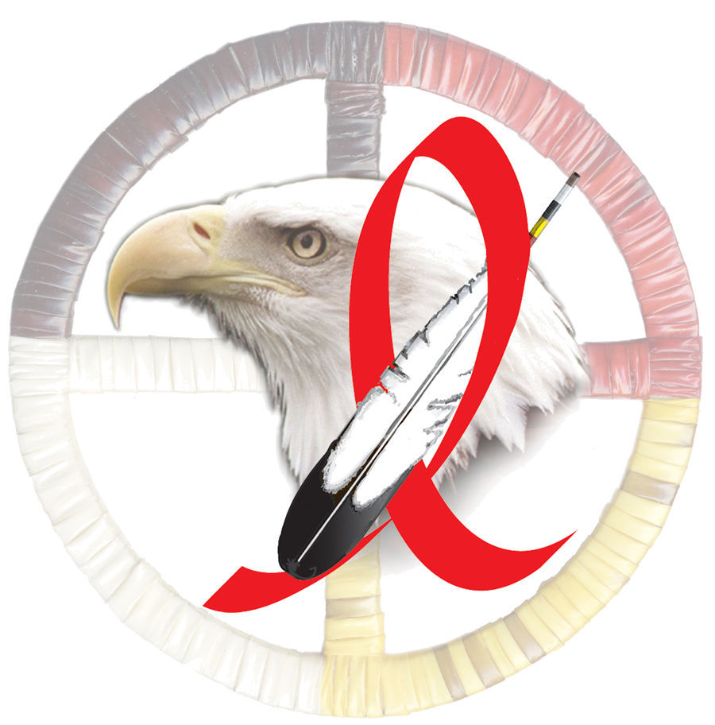
Resolution #
Support for the 2009-2011 STD/HIV Tribal Action Plan

WHEREAS, the Northwest Portland Area Indian Health Board (NPAIHB), a tribal organization under P.L. 93-638 that represents forty-three Federally-recognized Indian tribes in Oregon, Washington and Idaho on health related issues; and

WHEREAS, the NPAIHB is dedicated to assisting and promoting the health needs and concerns of Indian people; and

WHEREAS, the primary goal of the NPAIHB is to improve the health and quality of life of its member tribes; and

WHEREAS, sexually transmitted infections are rising across the nation, and our young people are most at risk. In 2004, American Indians were nearly five times more likely than whites to get chlamydia, four times more likely to get gonorrhea, and twice as likely to get syphilis. These infections hurt not only the individual, but the well being of the community as a whole; and

WHEREAS, in Oregon, Washington, and Idaho over 800 American Indian and Alaska Native youths age 10-24 years were diagnosed with chlamydia in 2005, a serious infection that can cause infertility if not properly treated; and

WHEREAS, when compared by ethnicity, American Indians and Alaska Natives continue to have the 3rd highest AIDS rate in the U.S. (at 20.8 per 100,000 for AI/AN men and 7.7 per 100,000 for AI/AN women in 2004); and

WHEREAS, sexually transmitted infections are associated with a range of considerable health outcomes, including sores, pain, infertility, cancer, and even death; and

THEREFORE BE IT RESOLVED that the Northwest Portland Area Indian Health Board endorses and encourages the adoption of the 2009-2011 STD/HIV Tribal Action Plan among its member tribes. The STD/HIV Tribal Action Plan is the product of a collaborative, inter-tribal, year-long planning process initiated by members of the Red Talon STD/HIV Coalition. The goal of the three-year Action Plan is to reduce the prevalence of STDs among American Indians and Alaska Natives living in the Pacific Northwest.

BE IT FURTHER RESOLVED that the 2009-2011 STD/HIV Tribal Action Plan will be actively used by members of the Northwest Portland Area Indian Health Board to guide program planning, support community outreach, and foster a coordinated response to STDs and HIV in our tribal communities.

