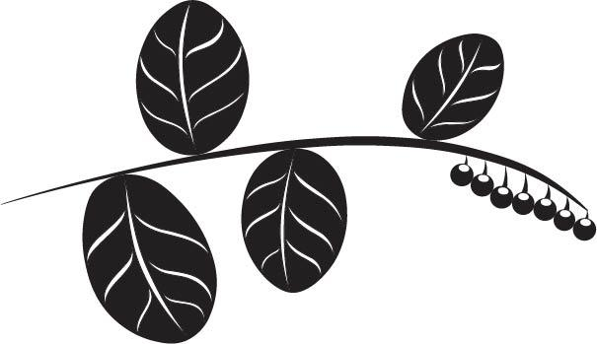
WEAVE-Northwest
Conference Agenda
Kiana Lodge, Suquamish WA

September 27th
8:30 Registration, coffee, tea, breakfast

9:00 Opening blessing, icebreaker, intro from WEAVE and coalition

9:30 Keynote presentation on community health

10:00 All Group Panel Discussion

11:00 Traditional Foods Meet and Greet

12:00 Lunch

1:00- Breakout session (3-4 sessions)

2:00-2:30 Break

2:30 Breakout session (3-4 sessions)

3:30 All group gathering – All group report back
Start Native Chopped Cookoff

4:00 Visit clam bake, salmon and wild game cooked over fire

5:00 Dinner

6:00 Closing

Notes:
Get aprons for chefs, what is prize for winning team? Who will be judges?
Bring things to share and swap including food, medicine and seeds
Invite people to come in traditional dress

Next steps:
Who is keynote?
- ideas- Robin Wall Kimmerer, Gary Ferguson, Winona LaDuke, Genie Hip, Fay Spotted Eagle-Ojibwe, Linda Black Elk, Fawn Sharp

Who is doing breakout sessions? (8 possibilities)
- Call for presenters: related to food, medicine and traditional food technologies (weaving, cooking tools, etc.)
- Should be hands-on, experiential and culturally relevant

Youth dinner or dance group? Azure will ask Suquamish singers and dancers

Storytelling?

March to do list – generate list of potential presenters- Gail, Muckleshoot-cattail, Matt Warbus, Lummi, medicine- Kris Miller, Marie

