The purpose of this exercise is to use the design mode to add a Web site to the Communications tab and add a tab and objects to the Electronic Health Record (EHR).

Accessing Design Mode
Log on to the EHR.
Right-click on the top bar and select Design Mode.
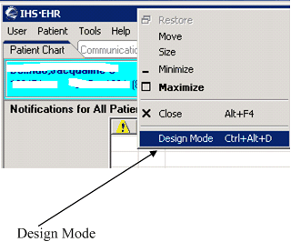
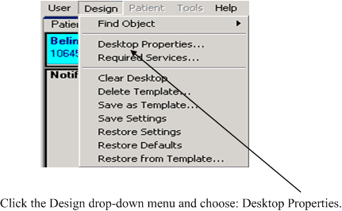

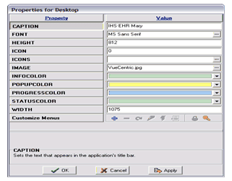 | Change the color (if you want) on one of the bars or the font on your desktop.

Add the User Name to the EHR Title Bar
EXAMPLE:
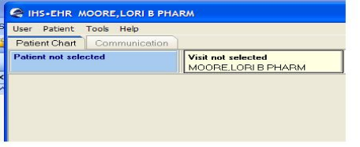
STEP 1: | STEP 1:
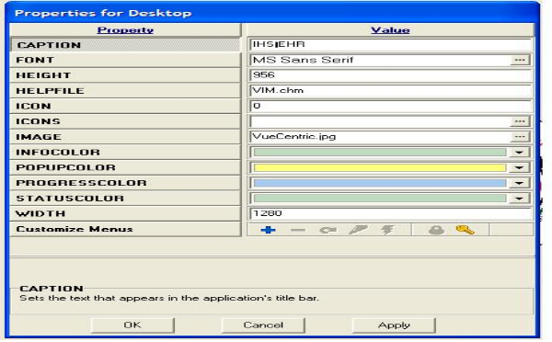 | Find the Caption Box and place your cursor beside the IHS•EHR.
STEP 2:  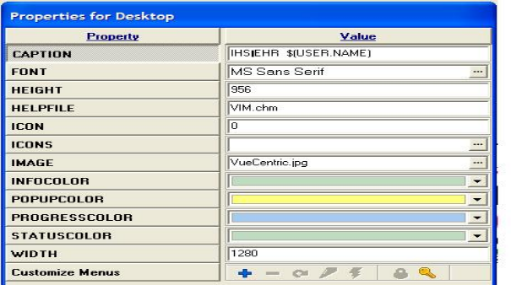 | STEP 2:  Type in the following code to add the users name to the EHR GUI Title Bar:  $(USER.NAME)

Add Facility Name to EHR Title Bar
EXAMPLE:
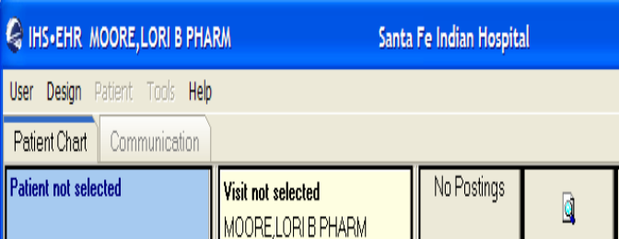
STEP 1:  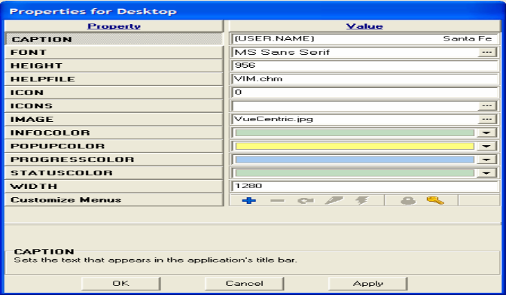 | STEP 1:  In Caption Value field, insert your facility’s name into the EHR GUI Title Bar.

Adding Refresh Button
EXAMPLE 1:  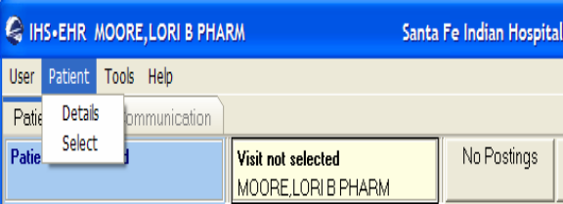 | EXAMPLE 2:  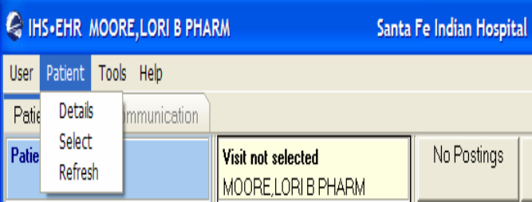
STEP 1:  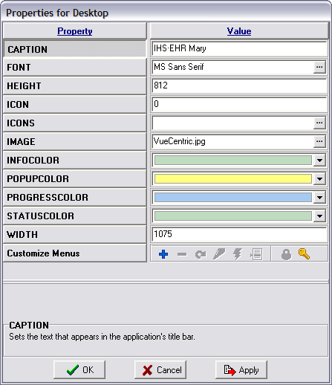 | STEP 1:  Click on Customize Menus to view the menu tree
STEP 2:  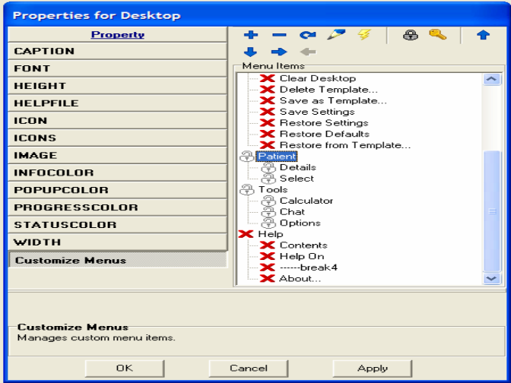 | STEP 2:  Find the Patient Header. You will see two other options under this tab (Details and Select).  This is where you are going to insert the Refresh button.
STEP 3:  Click the sign at the top of the menu to insert a new button | STEP 3:  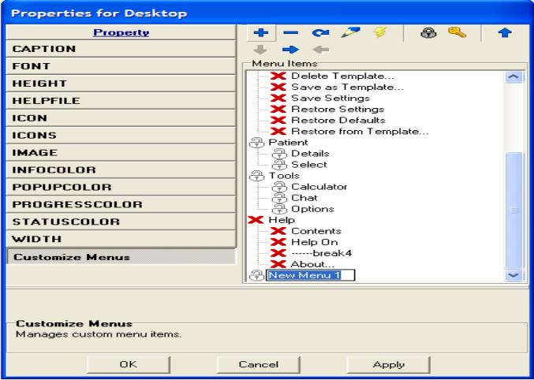
STEP 4:  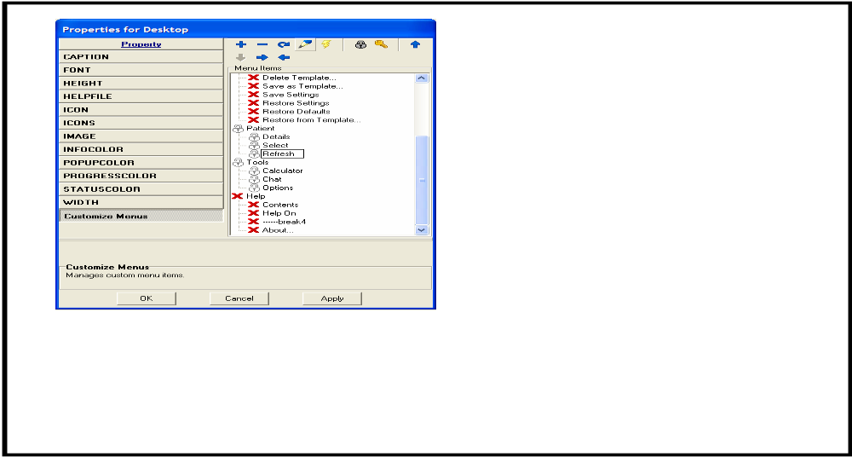 | STEP 4:  Use the to move the new button up and under the Patient Header  Use the to rename the button to Refresh.
STEP 5:  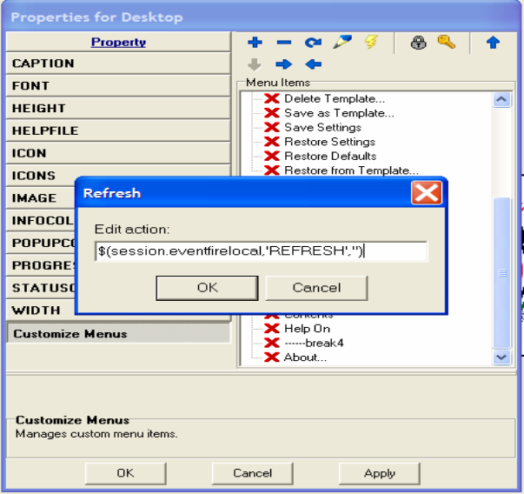 | STEP 5:  Highlight the new Refresh button and click the to insert the following code:  $(session.eventfirelocal,'REFRESH','')  Click OK and Apply to save the new feature. To test the new button, log out of Design Mode and test it.  If it works, log back into Design Mode and save it. See below for instructions on saving templates.

Adding Clear Button
EXAMPLE 1:  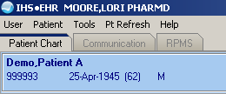 | EXAMPLE 2:  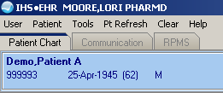
STEP 1: | STEP 1:  Click Customize Menus to view the menu tree
STEP 2: | STEP 2:  Find the Patient Header. you will see two other options under this tab (Details and Select).  This is where you will insert the Clear button.
STEP 3: | STEP 3:  Click the button at the top of the menu to insert a new button. The new menu will display at the bottom of the list highlighted in blue.
STEP 4:  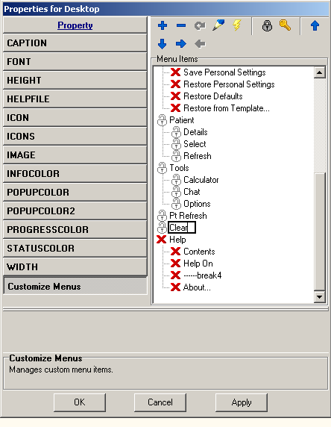 | STEP 4:  Use the and to move the new Clear button where you want it to display. I’m going to place mine above the Help menu item.  Use the to rename the button “Clear.”
STEP 5:  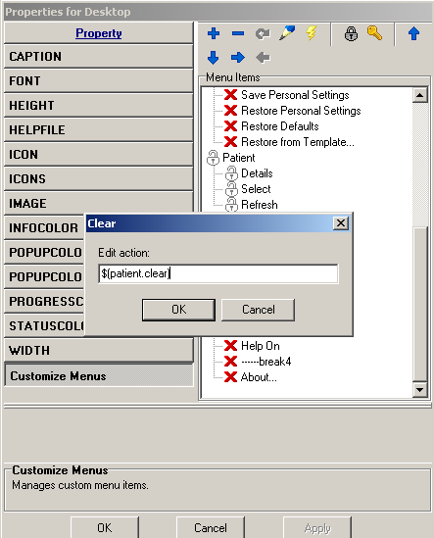 | STEP 5:  Highlight the new Clear button and click the to insert the following code:  $(patient.clear)  Click OK and Apply to save the new feature. To test the new button, log out of Design Mode and test it.  If the new Clear works, log back into Design Mode and save it. See below for instructions on saving templates.

Adding Visit Brief Button
STEP 1:  There is a new Visit Summary (Brief) Report available in Version 1.1 of the EHR. This report provides a more compact and readable alternative to the standard Visit Detail. The Visit Summary (Brief) Report can be printed for Release of Information. This report is available in the Reports window. | STEP 1:  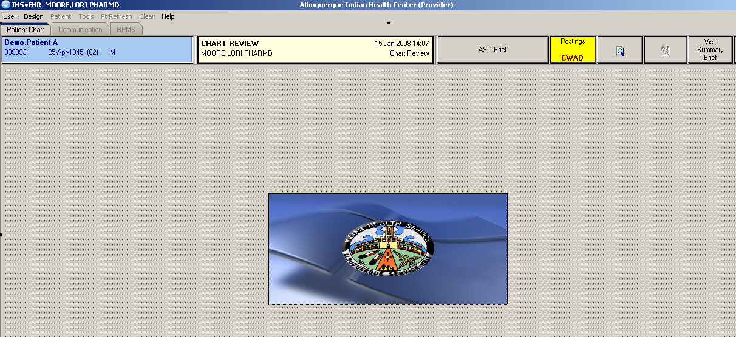
STEP 2:  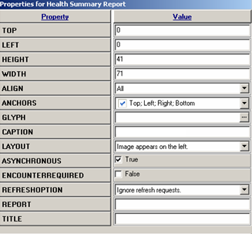 | STEP 2:  This report can be assigned to a button by following these instructions.  - In Design Mode, add the Health Summary button to the Patient/Visit tool bar.  - Right-click on the Health Summary Report button to display the Properties for Health Summary Report form
 | STEP 3:  - Enter the information from the table to the left in the Objects Properties field following information in the Value column of the Properties for Health Summary Report form  - Save the template and exit Design Mode.  - Select a patient and a visit that occurred after version 1.1 was installed.
  Property | Value
  Report | BEHOENPV:VISIT SUMMARY (BRIEF)~;;0^^1
  Caption | Visit Summary (Brief)
  Title | Visit Summary (Brief)
  Asynchronous | False
  Encounter Required | True

Adding Visit Brief Button
STEP 1:

Assigning the Health Summary to a Button - Option A
This describes how to add the IHS Health Summary button to the Patient/Visit toolbar in the EHR.
EXAMPLE:
STEP 2:  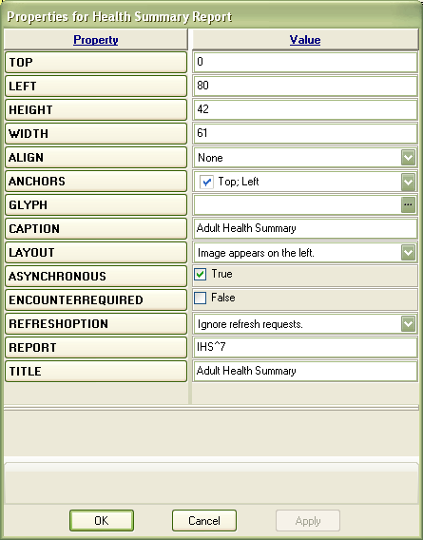 | STEP 2:  Follow these steps to assign the Health Summary to a button:  - In Design Mode, add the Health Summary button to the Patient/Visit tool bar.  - Right-click on the Health Summary Report button to display the properties.  - In the Report field, enter IHS^X, where X is the unique DFN number for the type of Health Summary you are using. In this example, you would enter IHS^7 because 7 is the DFN. If you do not know the DFN number, go to the next section to find out how to retrieve it.  - Enter the Health Summary Name in the Caption and Title fields.  - Save the template and exit Design Mode.  - Select a patient and view the health summary.

How to get the IEN Number of the Health Summary
Enter or Edit File Entries
Print File Entries
Search File Entries
Modify File Attributes
Inquire to File Entries
Utility Functions ...
Data Dictionary Utilities ...
Transfer Entries
Other Options ...
Select VA FileMan Option: print File Entries
OUTPUT FROM WHAT FILE: HEALTH SUMMARY TYPE//
SORT BY: NAME// NUMBER
START WITH NUMBER: FIRST//
WITHIN NUMBER, SORT BY:
FIRST PRINT FIELD: NAME
THEN PRINT FIELD: NUMBER
SORT BY: NAME//
START WITH NAME: FIRST//
FIRST PRINT FIELD: NUMBER
THEN PRINT FIELD: NAME
THEN PRINT FIELD:
Heading (S/C): HEALTH SUMMARY TYPE LIST Replace
DEVICE: Right Margin: 80//
HEALTH SUMMARY TYPE LIST JUL 25,2005 06:56 PAGE 1
NUMBER NAME
----------------------------------------------------------------------------
7 ADULT REGULAR
73 ALLERGIES
91 AMBULANCE

Assigning the Health Summary to a Button – Option B
This describes how to add the VA Health Summary button to the Patient/Visit toolbar in the EHR.
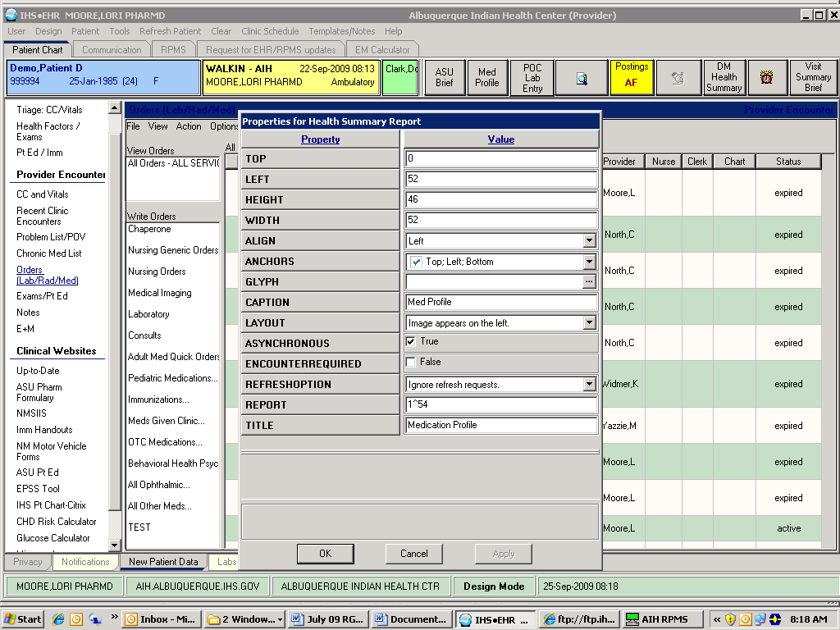

How to get the DFN Number of the Health Summary
Enter or Edit File Entries
Print File Entries
Search File Entries
Modify File Attributes
Inquire to File Entries
Utility Functions ...
Data Dictionary Utilities ...
Transfer Entries
Other Options ...
Select VA FileMan Option: PRINT File Entries
OUTPUT FROM WHAT FILE: PROVIDER// VA HEALTH SUMMARY TYPE (19 entries)
SORT BY: NAME//
START WITH NAME: FIRST//
FIRST PRINT FIELD: NUMBER
THEN PRINT FIELD: NAME
THEN PRINT FIELD:
Heading (S/C): VA HEALTH SUMMARY TYPE LIST Replace
DEVICE:
VA HEALTH SUMMARY TYPE LIST SEP 25,2009 08:26 PAGE 1
NUMBER NAME
--------------------------------------------------------------------------------
54 MEDICATION PROFILE
57 AIMS

Adding Pharm Ed Button

Medication Counseling Button Setup
The RPMS-EHR application contains the Pharmacy Refill Counseling macro, which is available to be placed on the pharmacist’s VueCentric template. The macro enables rapid visit creation and documentation of Purpose of Visit and Patient Education for high volume workflow situations, such as dispensing medication refills.
The macro is launched from the Pharmacy Ed button in the Patient-Visit Toolbar. 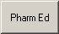
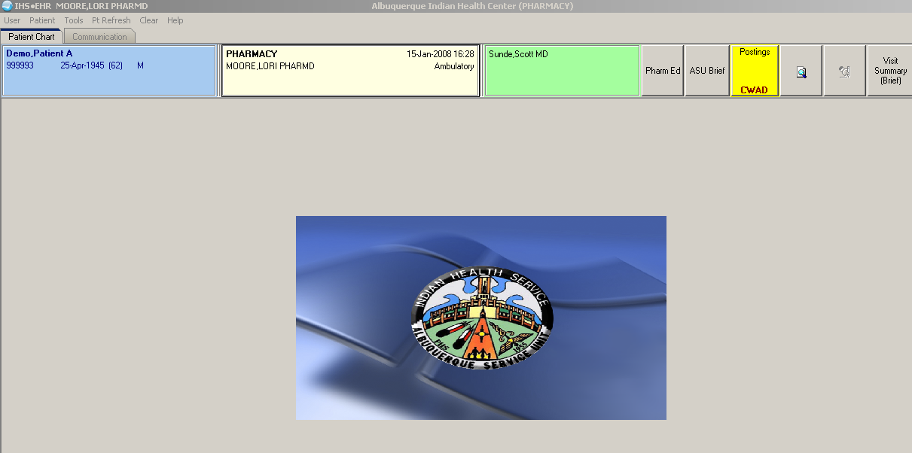
STEP 1:  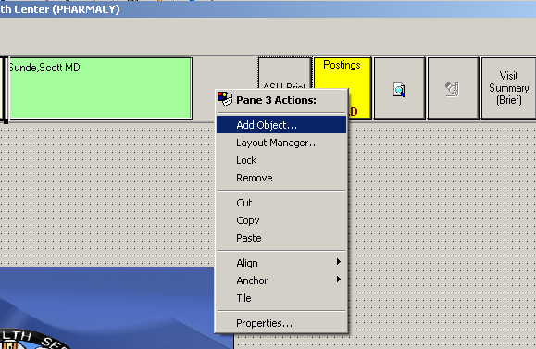 | STEP 1:  - Clear a space on the Patient/Visit toolbar for the new Pharmacy Ed button  - Right click in the blank spot and select Add Object
STEP 2:  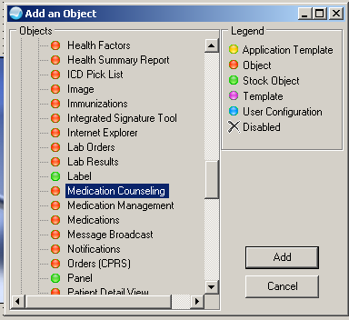 | STEP 2:  - Click the plus sign (+) in front of the name folder.  - Scroll down the list of objects until you find the “Medication Counseling” Object and then click Add.
STEP 3:  The button will display on your screen. | 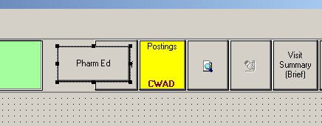
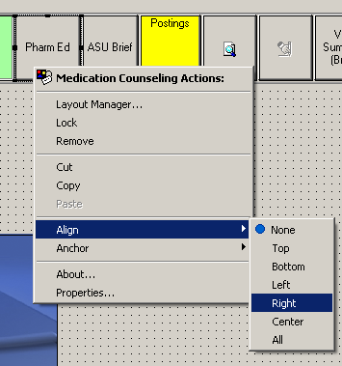 | STEP 4:  - To align to the button in the blank area, right-click and select Align.  - Another option will appear. Select the alignment that will work for your space.  - In my example, I selected Right.  - The button will fall into the space.  - Save the changes you made to the template before exiting.

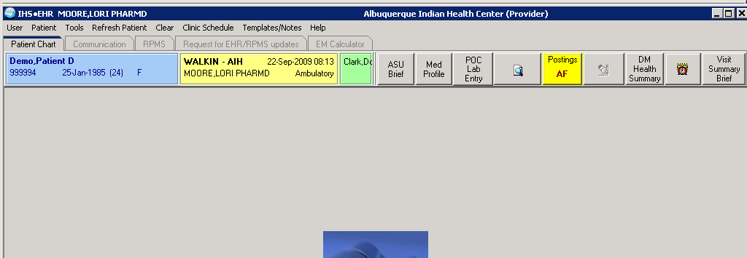

Lab Point of Care Entry Button
Use the Lab Point of Care feature by first adding the Lab Point of Care button on the toolbar. Follow these steps:
- After you access the EHR, go into Design Mode.
- Right-click in the area where you want to add the POC Entry button (somewhere in the toolbar is suggested). Select the Add an Object option in the context menu.
- The Add an Object window will display.
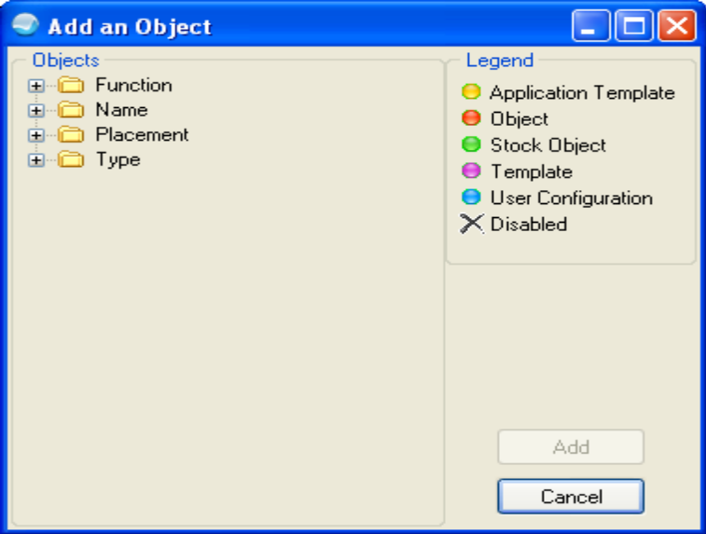
- Expand Name in the Objects group box. Select the Lab Point of Care Data Entry option. Click Add.
Setup Guide Point of Care Lab July 2009 13 Electronic Health Record (EHR) v1.1 Patch 5
- The POC Lab Entry button will display in the toolbar. Resize the button if necessary.
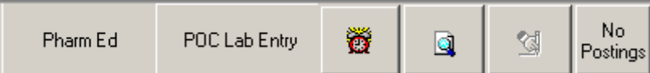
- Select Design | Save As Template.
- Save and exit from Design Mode.
The POC Lab Entry button requires that a visit and patient be selected before it becomes active.

Adding another Tab to EHR
STEP 1:  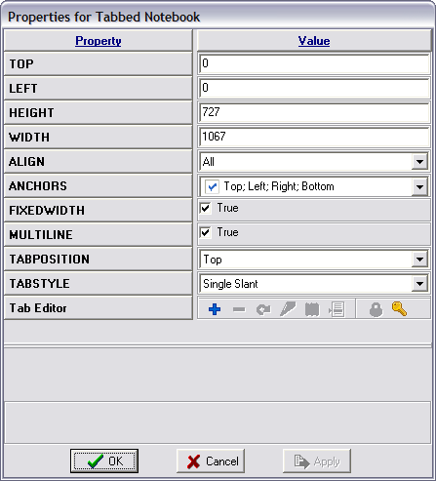 | Go to the Patient Chart tab.  Right click on any of the tabs at the bottom and bring up the dialog box.  Choose the Tab Editor Button under Properties.
STEP 2:  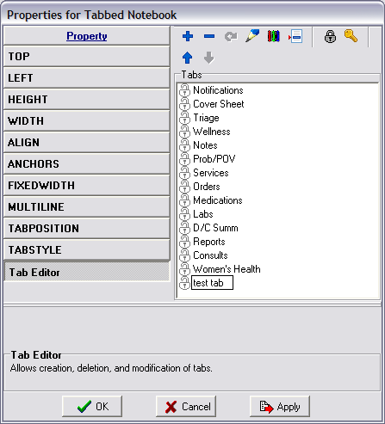 | STEP 2:  Review the tabs, and using the + to add a tab, make a tab and name it “Test Tab.”  - Add a tab  - Name it “Test Tab”  Using the and arrows to rearrange the tab order.  Use the to rename the tab.
STEP 3:  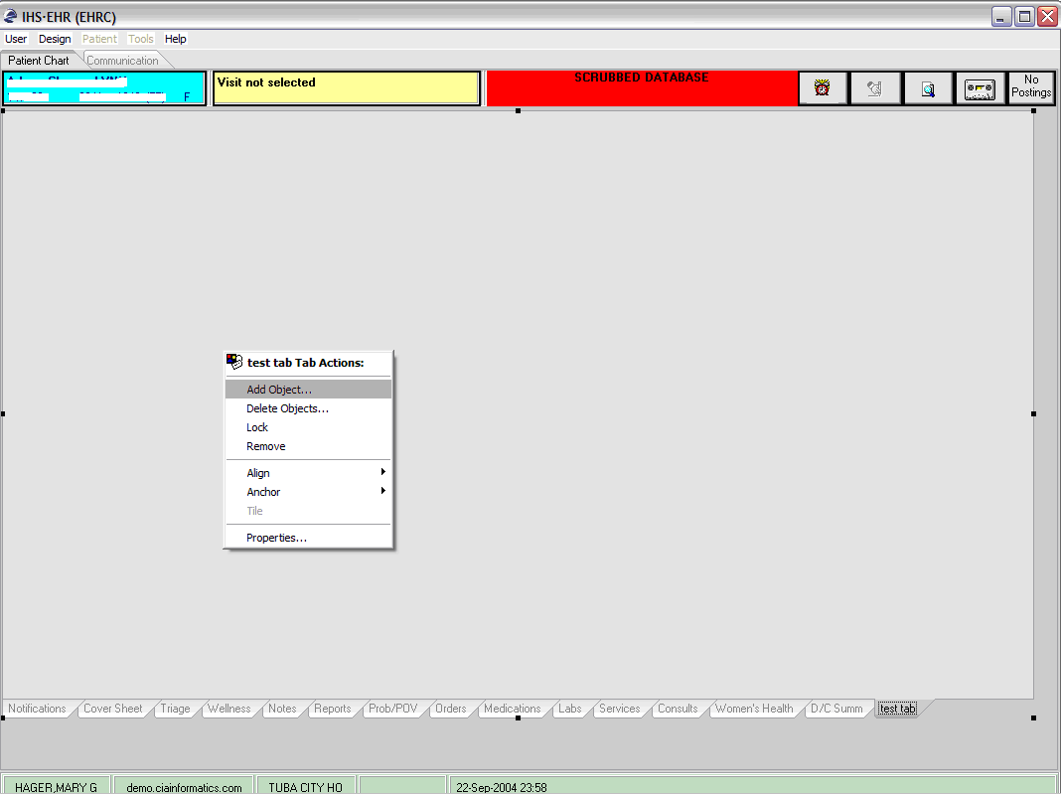 | STEP 3:  Go to the new test tab that you created.  Right-click on the middle of the tab and choose the option to add an object.  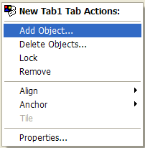
STEP 4:  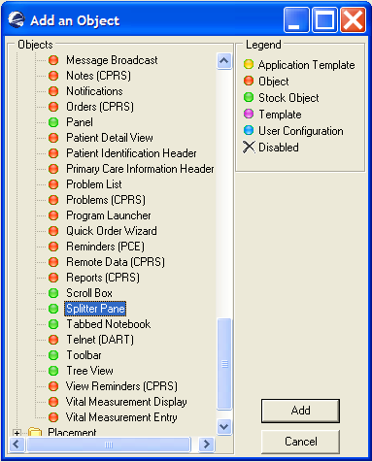 | STEP 4:  Click on the + sign beside the Name folder  Scroll down until you find the object named Splitter Pane.
STEP 5:  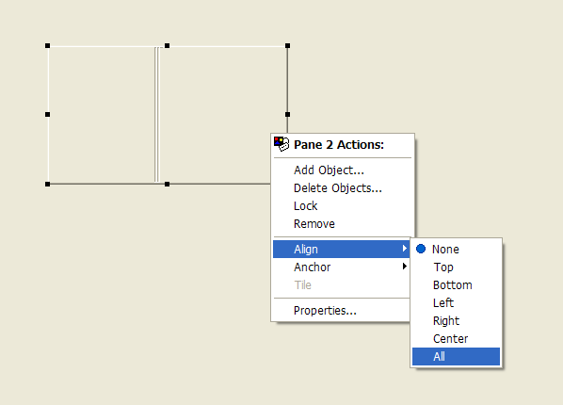 | STEP 5:  Right-click and select Align.  Click Align All.  Right-click on the splitter pane and choose Properties.
STEP 6:  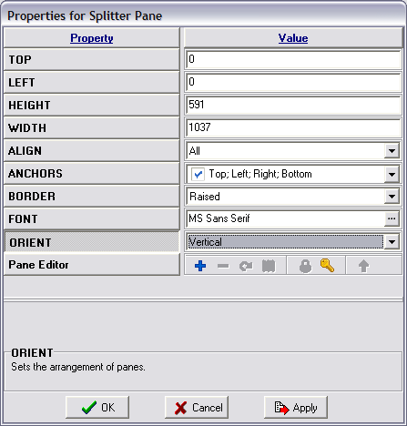 | STEP 6:  Change this splitter pane to Vertical instead of Horizontal.  Click Apply and Ok to see the changes
STEP 7:  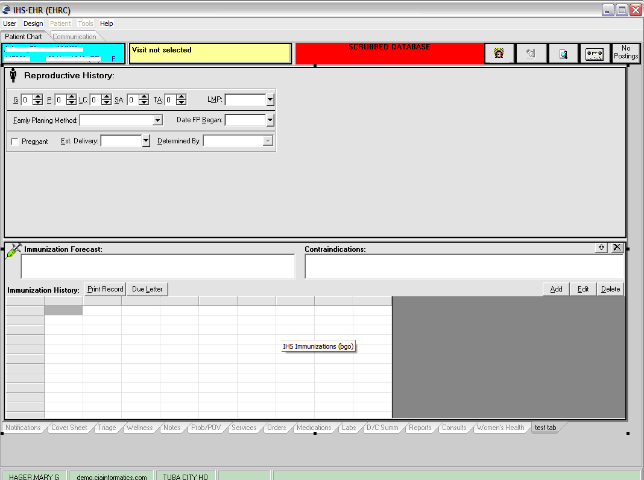 | STEP 7:  Next, right-click on the top half of the splitter screen and choose Add Object.  Add the object named Reproductive History and align it to All.  Add the object named Immunizations to the bottom half and again align it to All.

Inserting a Web Page

Option 1: Adding a Web Site to the Communications Tab.
STEP 1:  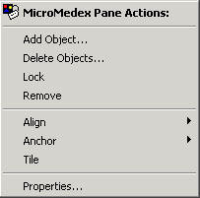 | STEP 1:  Go to the Communications tab.  Right-click on the left side that contains a list of items on the Communications tab.  Choose Properties.
STEP 2:  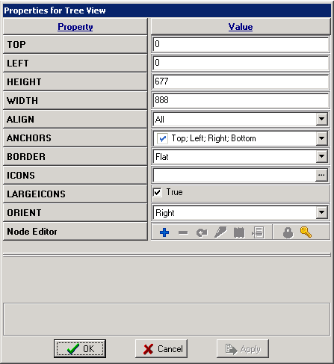 | STEP 2:  Here you can add a border, icon, and change the orientation.  Click Node Editor under Properties.
STEP 3:  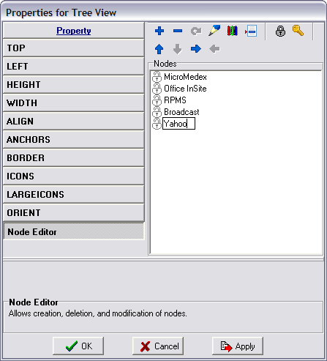 | STEP 3:  Click the + button.  Add a new tab and name it Yahoo.  Click Apply and OK to add the Web site button.
STEP 4:  Highlight the new tab and right-click on Add Object.  Add the object named Microsoft Explorer.  Click Object to add. | STEP 4:  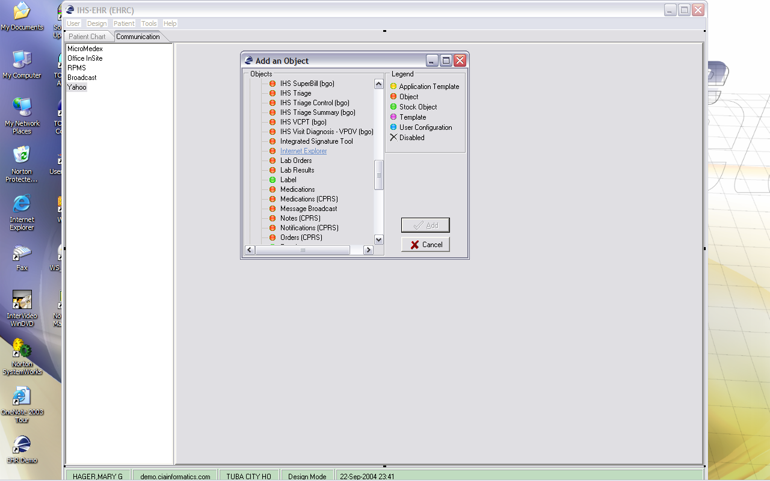
STEP 5:  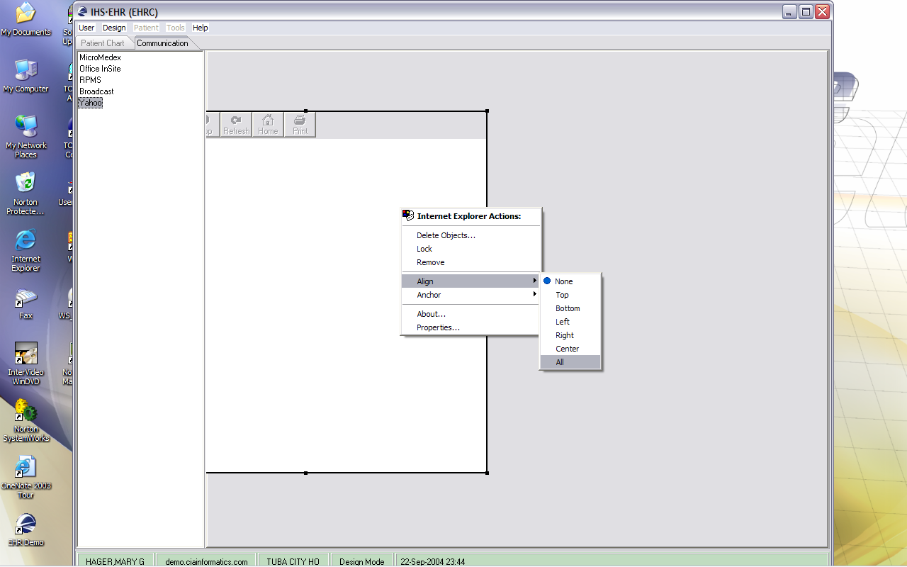 | STEP 5:  After the object is added, right-click on the object and select Align to All.
STEP 6:  Right-click in the Internet Explorer box and choose Properties.  Enter the homepage of Yahoo. | STEP 6:  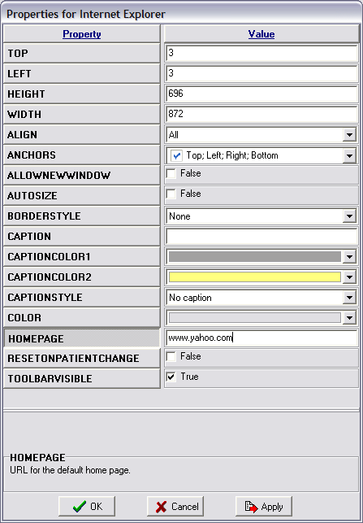

Option 2: Group Bar
EXAMPLE:
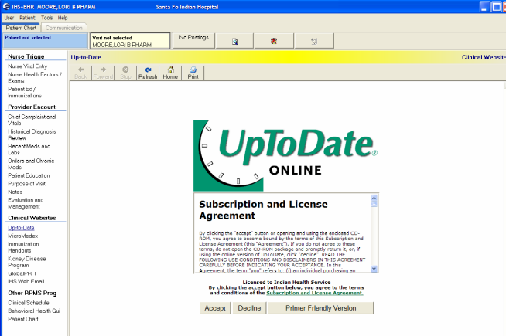
STEP 1:  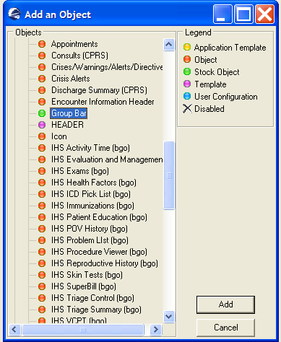 | STEP 1:  Create a blank tab.  Go to the new tab.  Right-click in the middle of the blank tab.  Click Add an Object.  Find and click the Group Bar.  Click Add.
STEP 2:  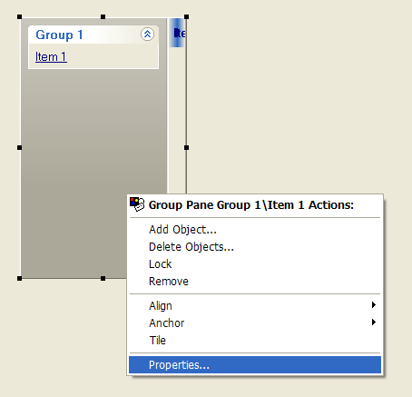 | STEP 2:  Right-click in the middle of the Group Bar.  Click Properties.
STEP 3:  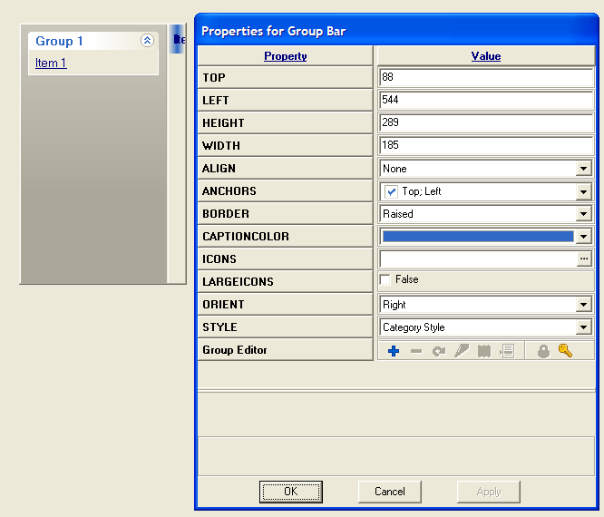 | STEP 3:  You can change the border, orientation, style, etc.
STEP 4:  Click the Group Editor under Property.  You will see the name of generic titles and links. | STEP 4:  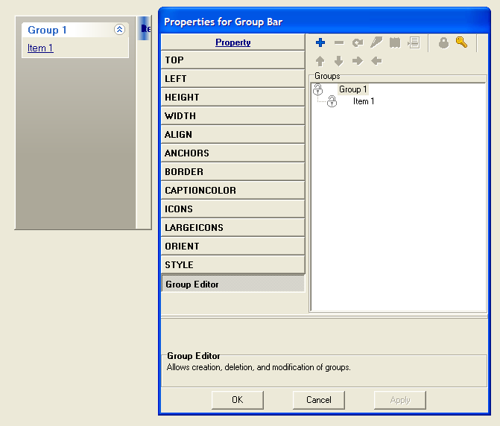
STEP 5:  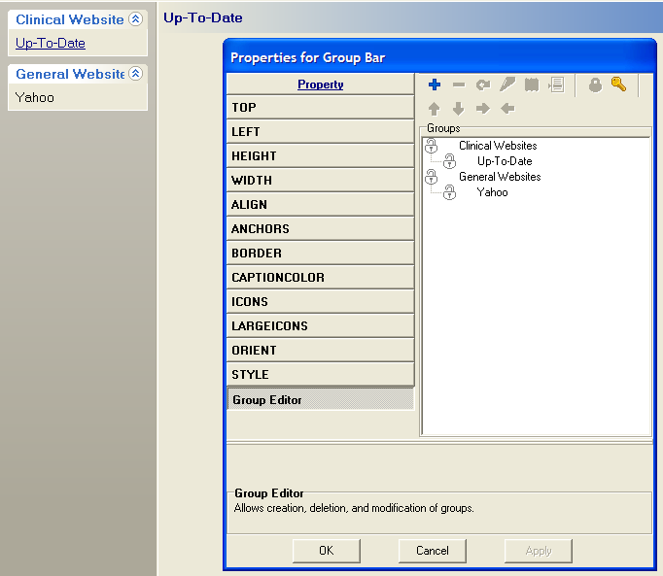 | STEP 5:  Highlight the Generic Group Name and Use the to rename the tab to Clinical Websites.  Using the and arrows to rearrange the tab order.  Click Apply and OK to make the changes.
STEP 6:  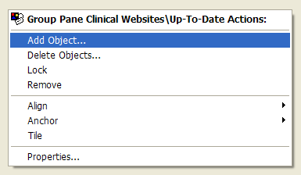 | STEP 6:  Click on the Up-to-Date Link in the Group Bar.  Right-click in the middle of the blank page and click Add Object.
STEP 7:  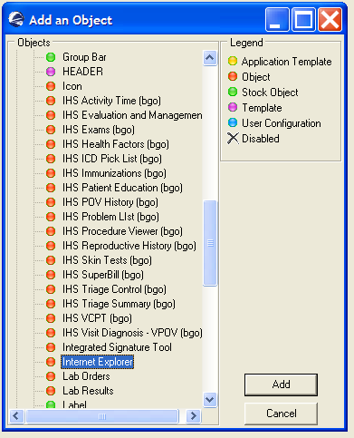 | STEP 7:  Find and Click the Internet Explorer Object.  Click Add.
STEP 8:  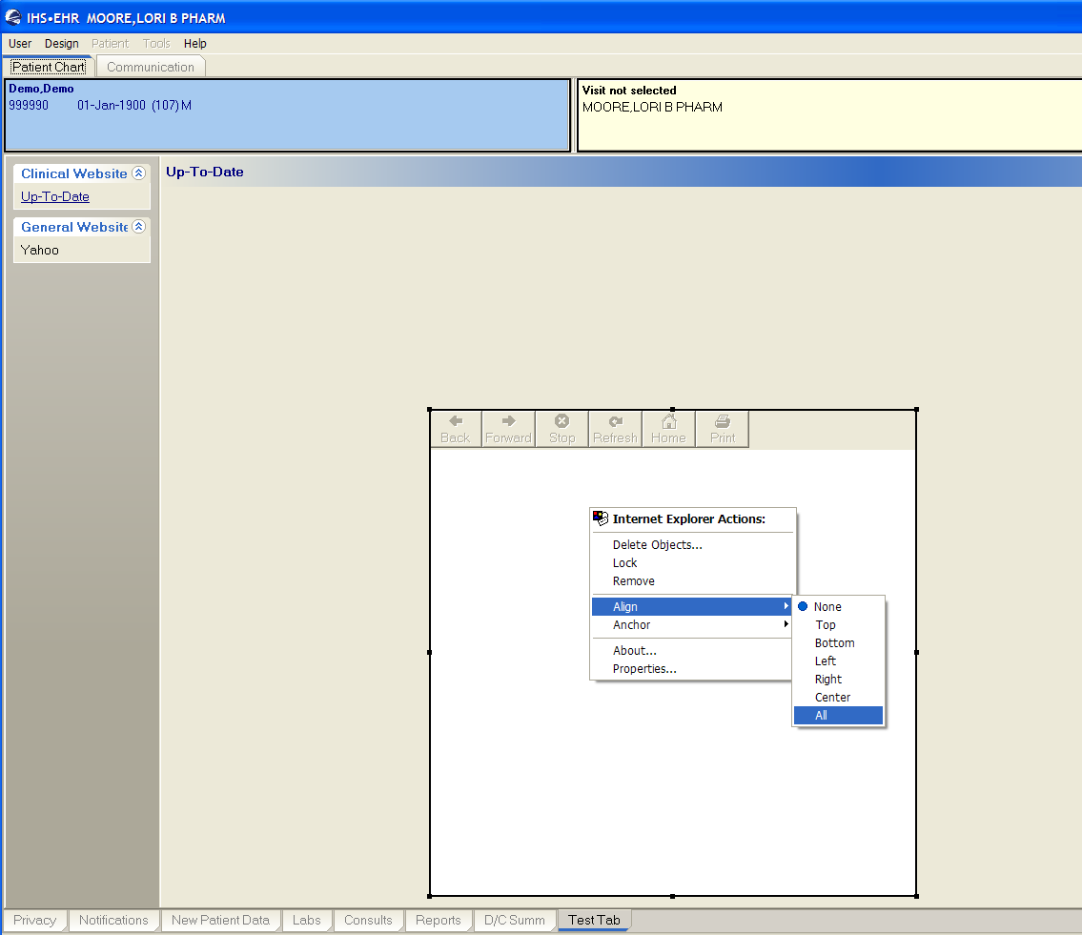 | STEP 8:  Right-Click in the middle of the Internet Explorer Object.  Select Align All.
STEP 9:  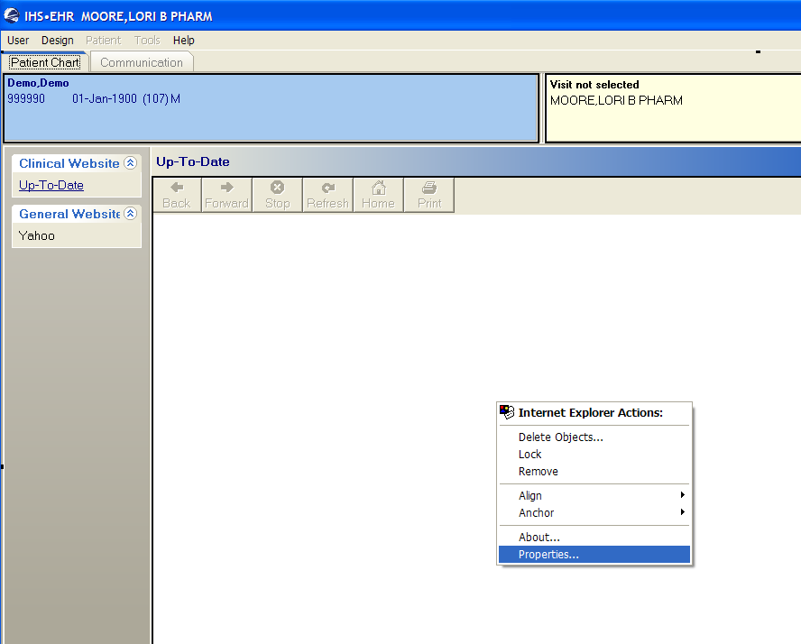 | STEP 9:  Right-cick in the middle of the Internet Explorer Object.  Click Properties.
STEP 10:  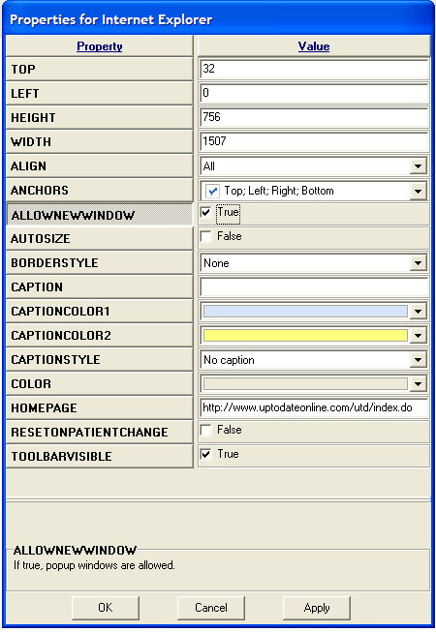 | STEP 10:  In the ALLOWNEWWINDOW, check the False box, making it True.  In the HOMEPAGE, type in the web address: http://www.uptodateonline.com/utd/index.do
STEP 11:  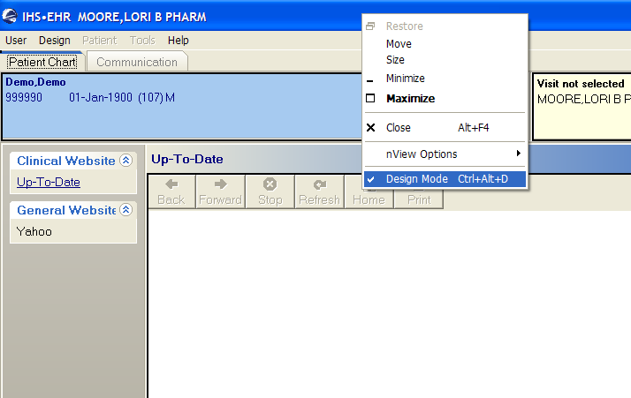 | STEP 11:  To test the Web page, exit Design Mode.  You Web page should automatically load.  You will need to log back into Design Mode to save the changes. See below for directions.

Adding Other RPMS Packages to EHR GUI
You can add other RPMS programs like Patient Chart, Behavioral Health GUI, and Clinical Scheduling GUI.
EXAMPLE:
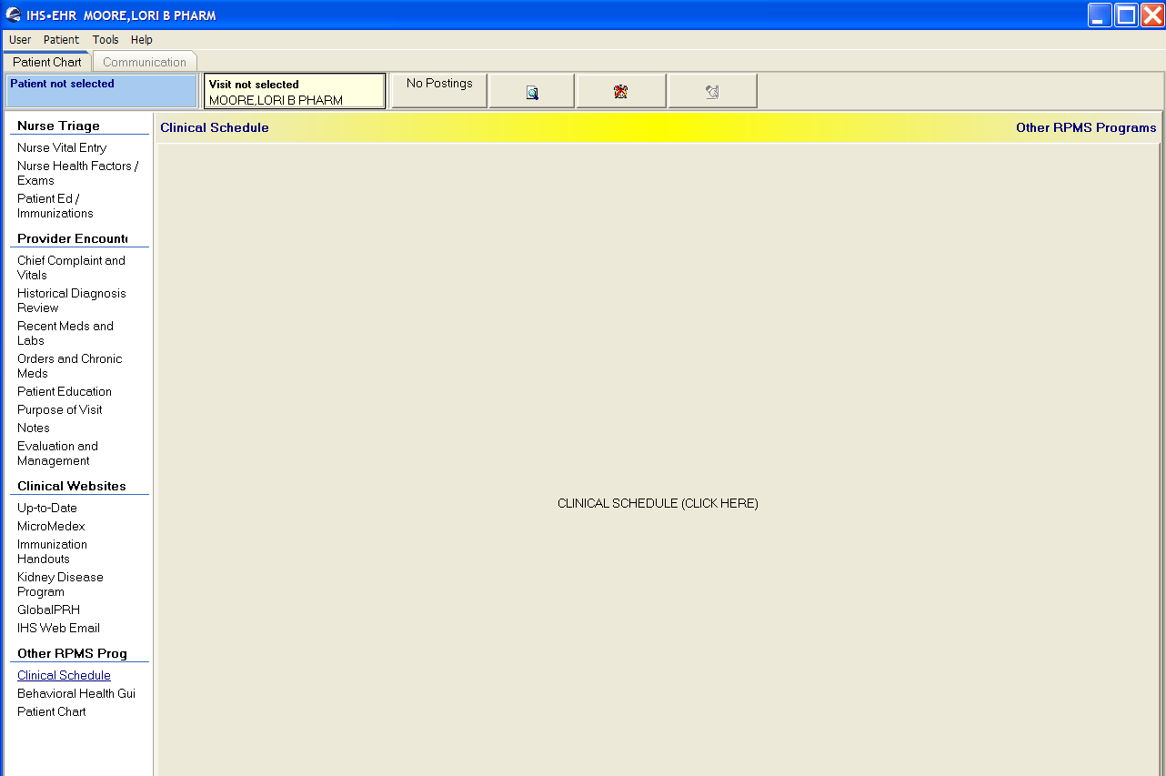
STEP 1:  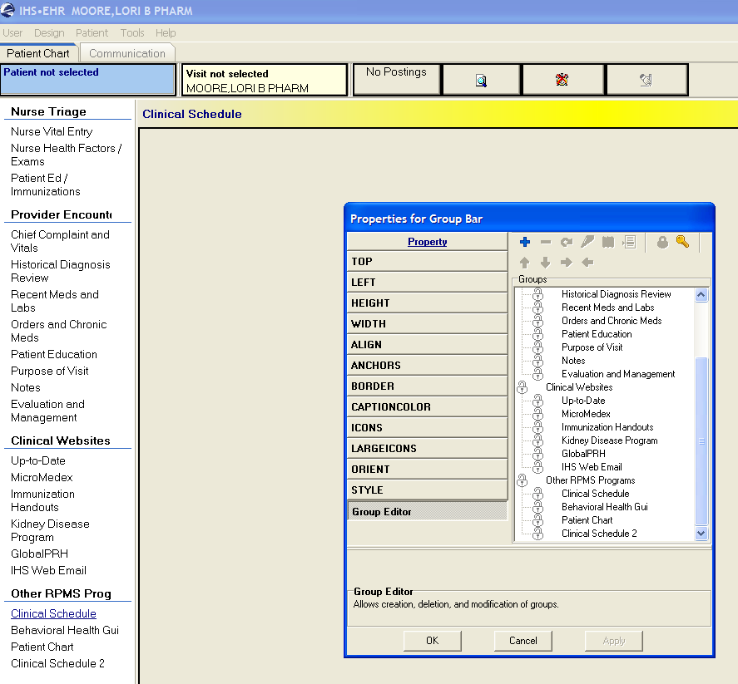 | STEP 1:  Create a new tab or a new link in the Group Bar  Name the link after the RPMS program you wish to insert (i.e. Clinical Schedule).  Click the Group Editor tab.
STEP 2:  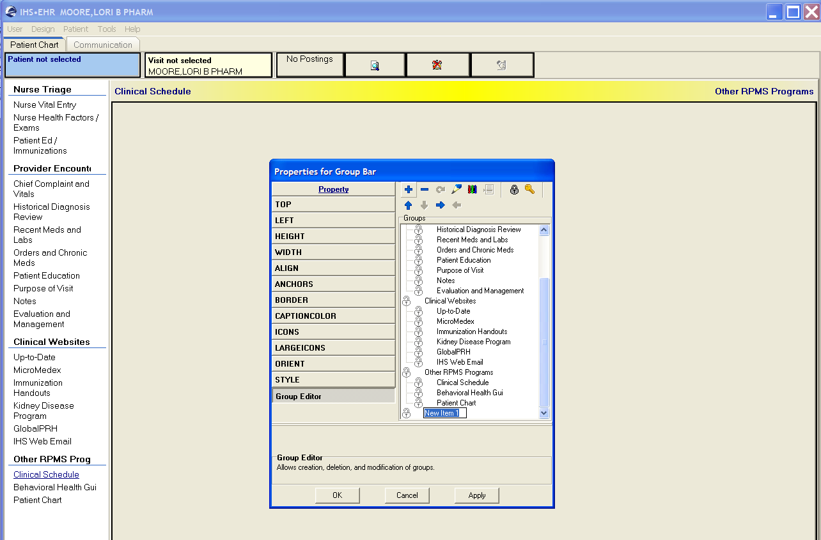 | STEP 2:  Use the to rename the tab to Clinical Web sites.  Using the and arrows to rearrange the tab order.  Click Apply and OK to make the changes.
STEP 3:  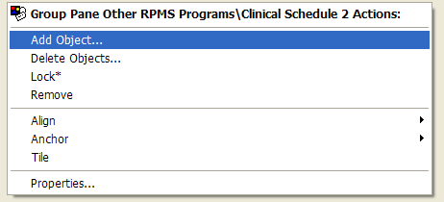 | STEP 3:  Right-click in the middle of the blank page and click Add Object.
STEP 4:  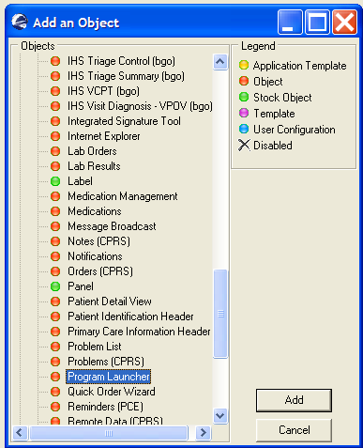 | STEP 4:  Find and click the Program Launcher Object.  Click the Add button to insert the object.
STEP 5:  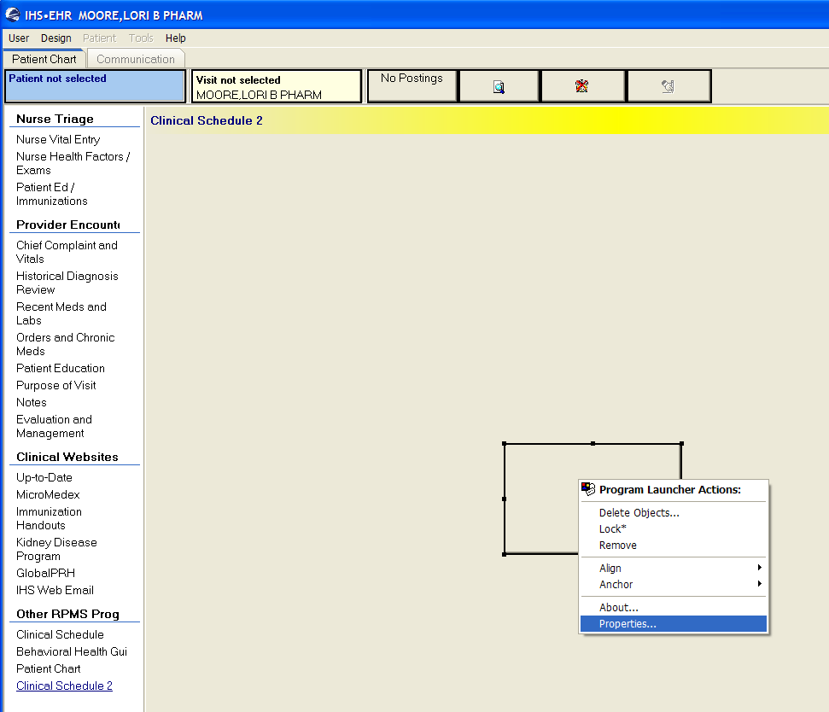 | STEP 5:  You will see a blank box in the middle of the screen.  Right-click in the middle of the box and select Properties.
STEP 6:  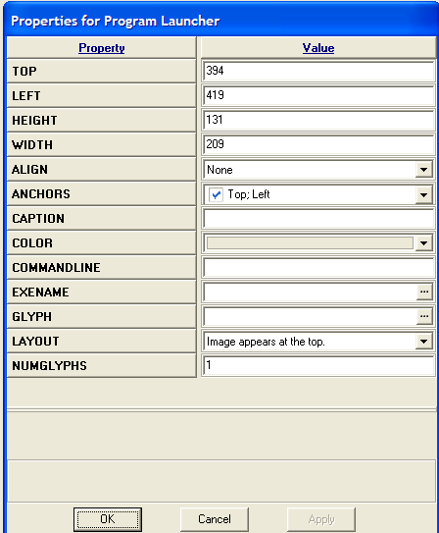 | STEP 6:  In the Properties box find the Caption Property.  Type in the name of the program.  Recommendation: Type “Click Here.”
STEP 7:  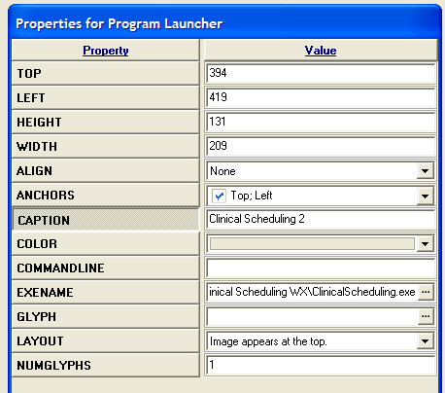 | STEP 7:  In the Properties box find the EXENAME.  Type the pathway to the RPMS program that you want to insert.  NOTE: make sure this program is installed on server.

Split Screens for Departments Using Both EHR and RPMS
(i.e. Pharmacy, Lab, Radiology, Data Entry, and Billing)

Pharmacy and Notes Tab
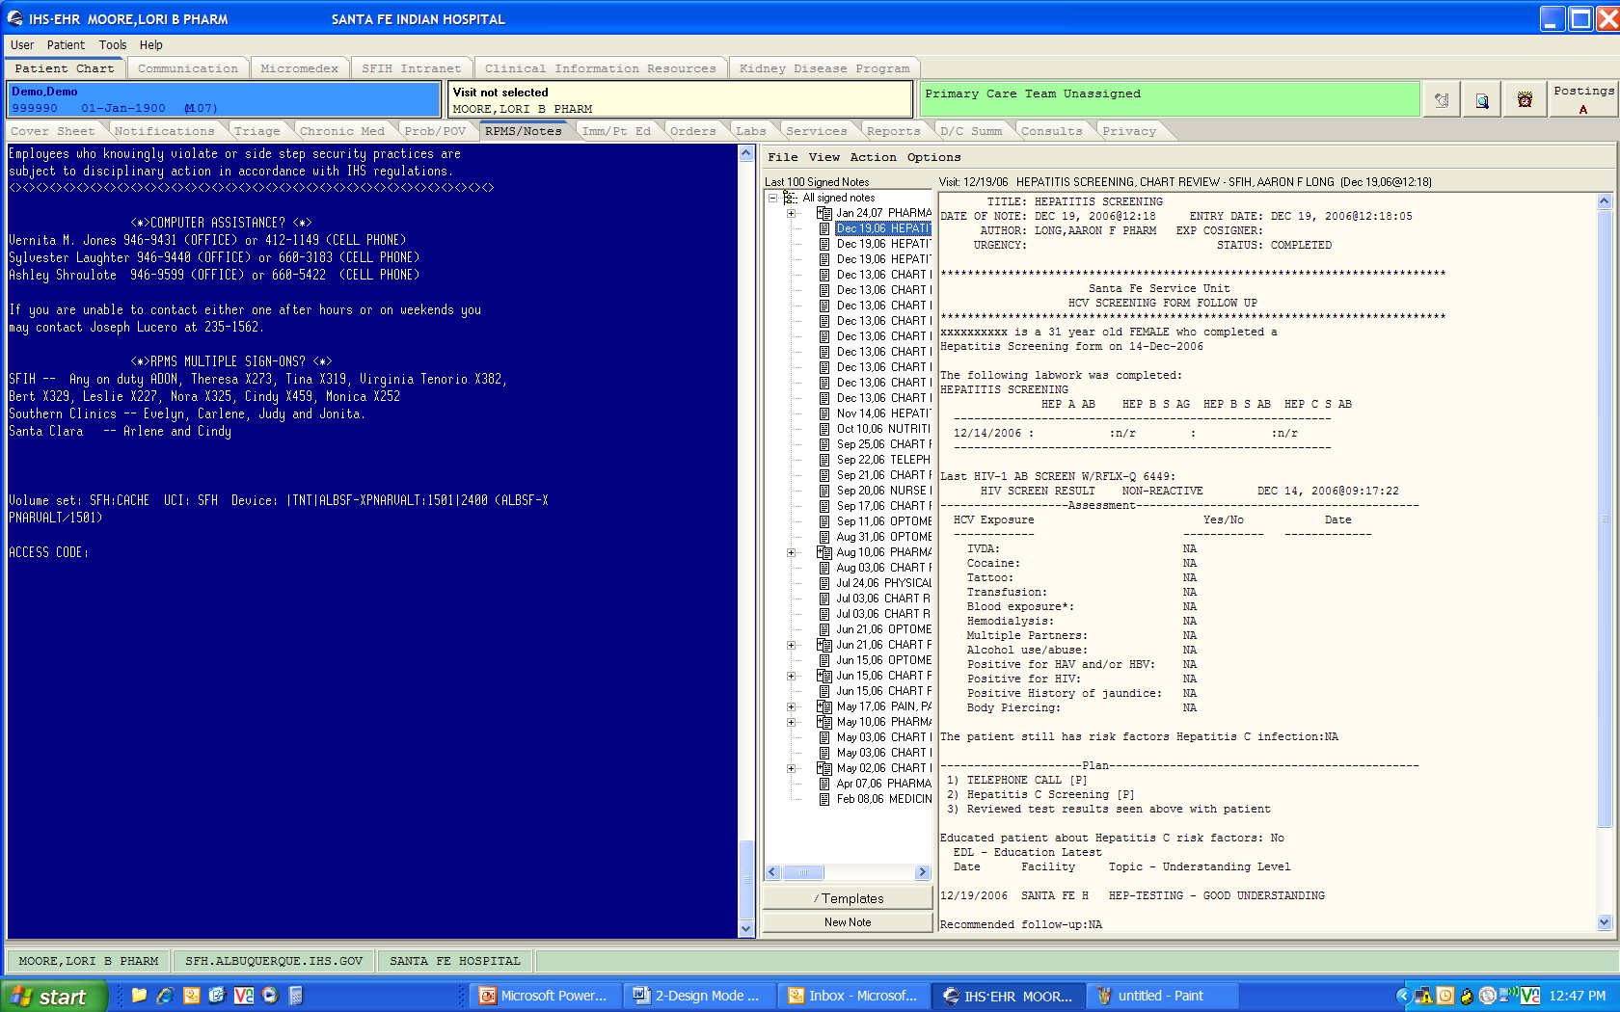

Lab and Orders Tab
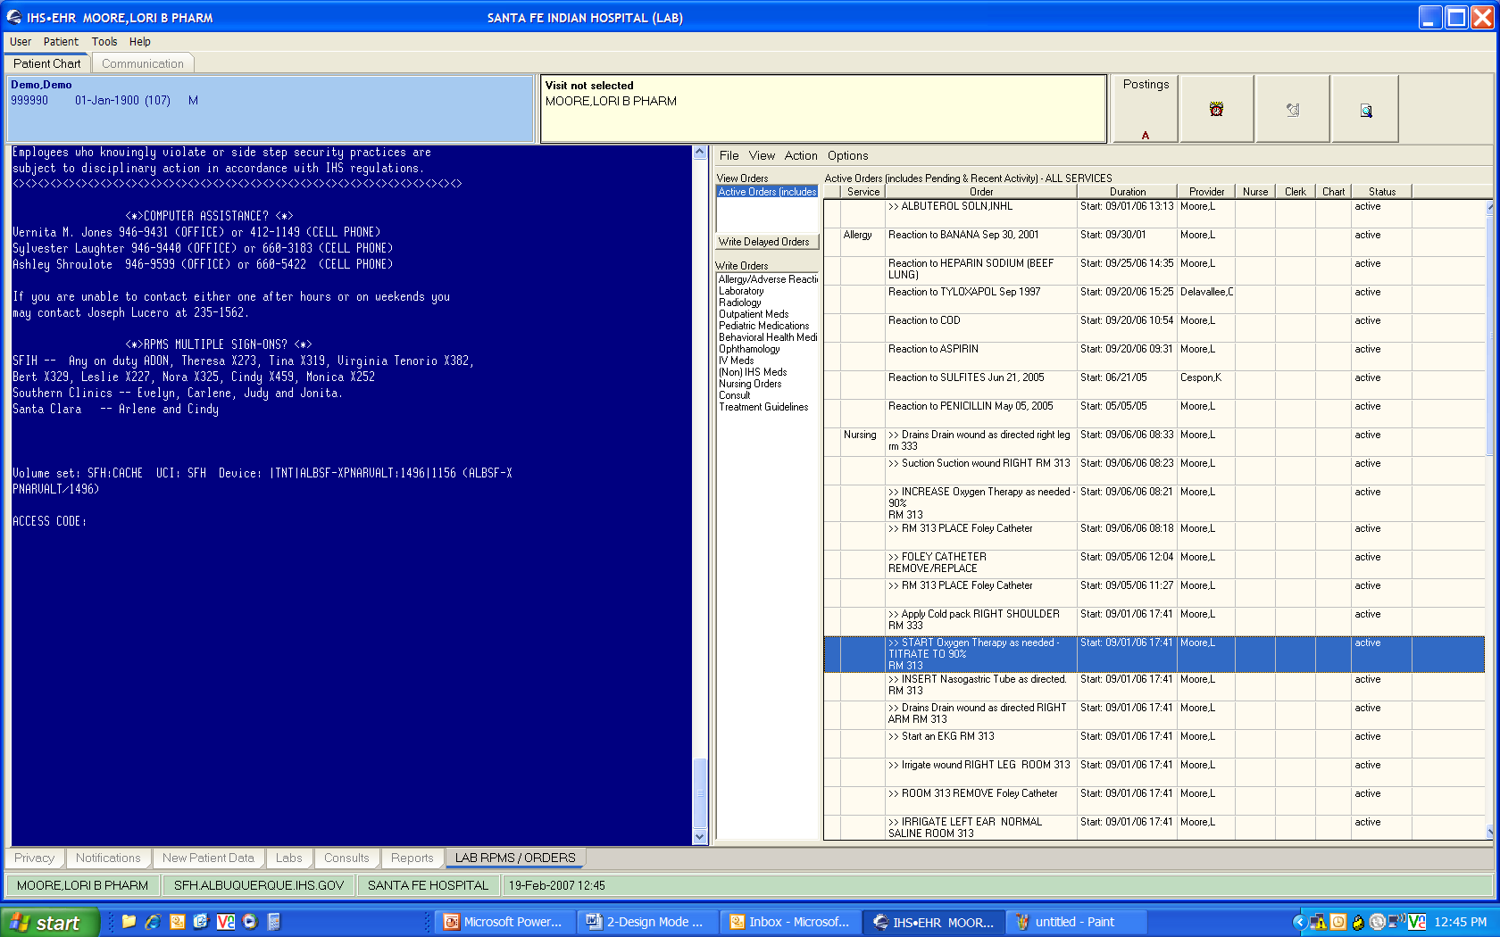

Adding Facility Logo or Other JPG Picture to EHR
EXAMPLE:
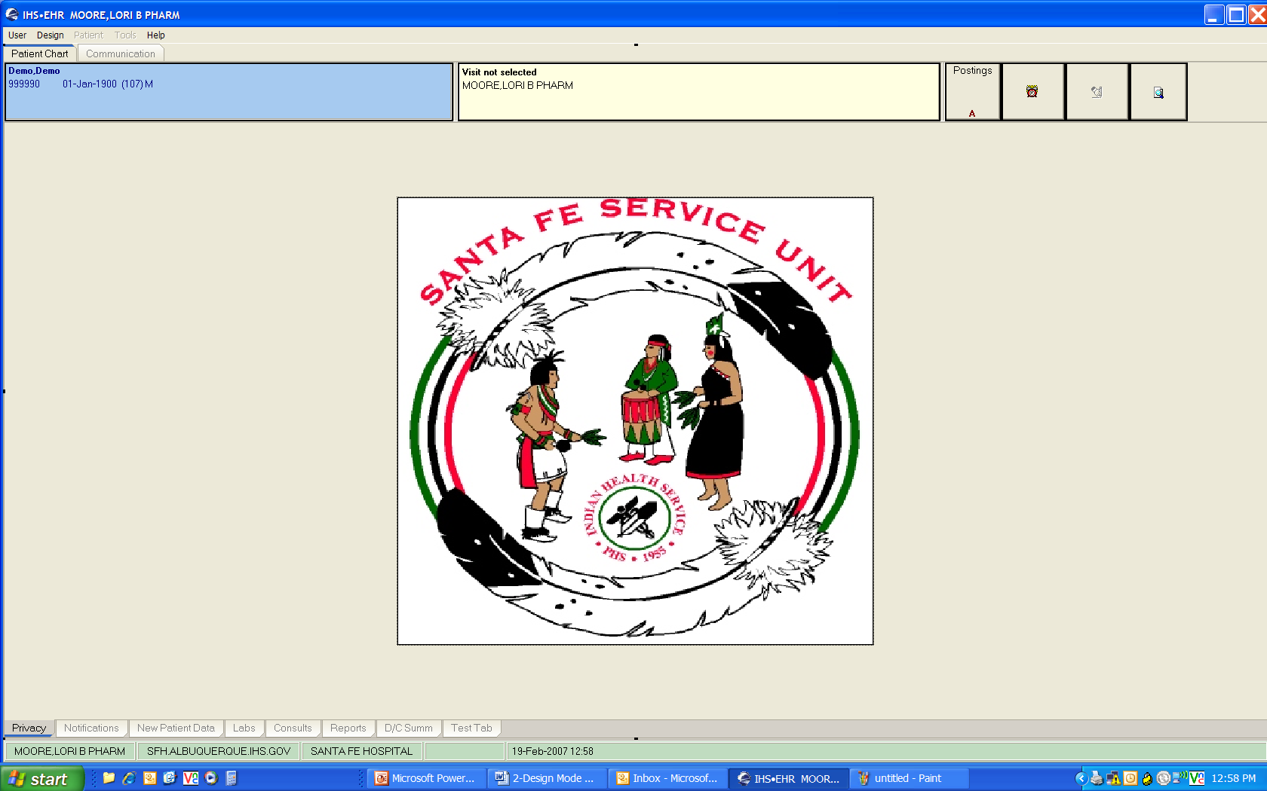
STEP 1:  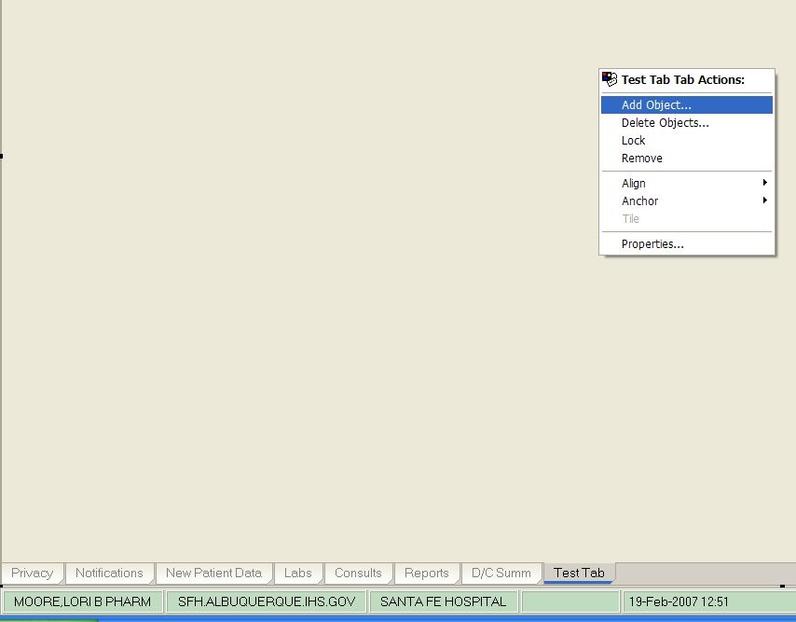 | STEP 1:  Create a new tab or use the Privacy tab to add the Icon Object.  Once tab has been created, right-click in the middle of the blank tab.  Click Add Object.  Find the object called Icon and click Add.
STEP 2:  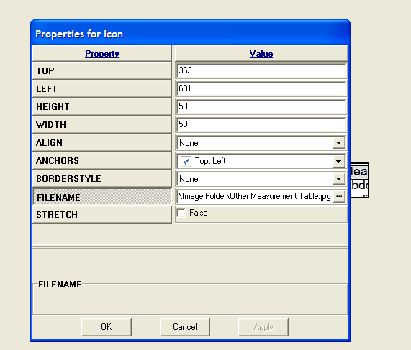 | STEP 2:  In the blank Icon Box, right-click and select Properties.  In the Properties for an icon, add the pathway for your JPG image into the file name.  NOTE: place the image on a server where it can be accessed at all times.  Click OK to insert your image onto the tab.
STEP 3:  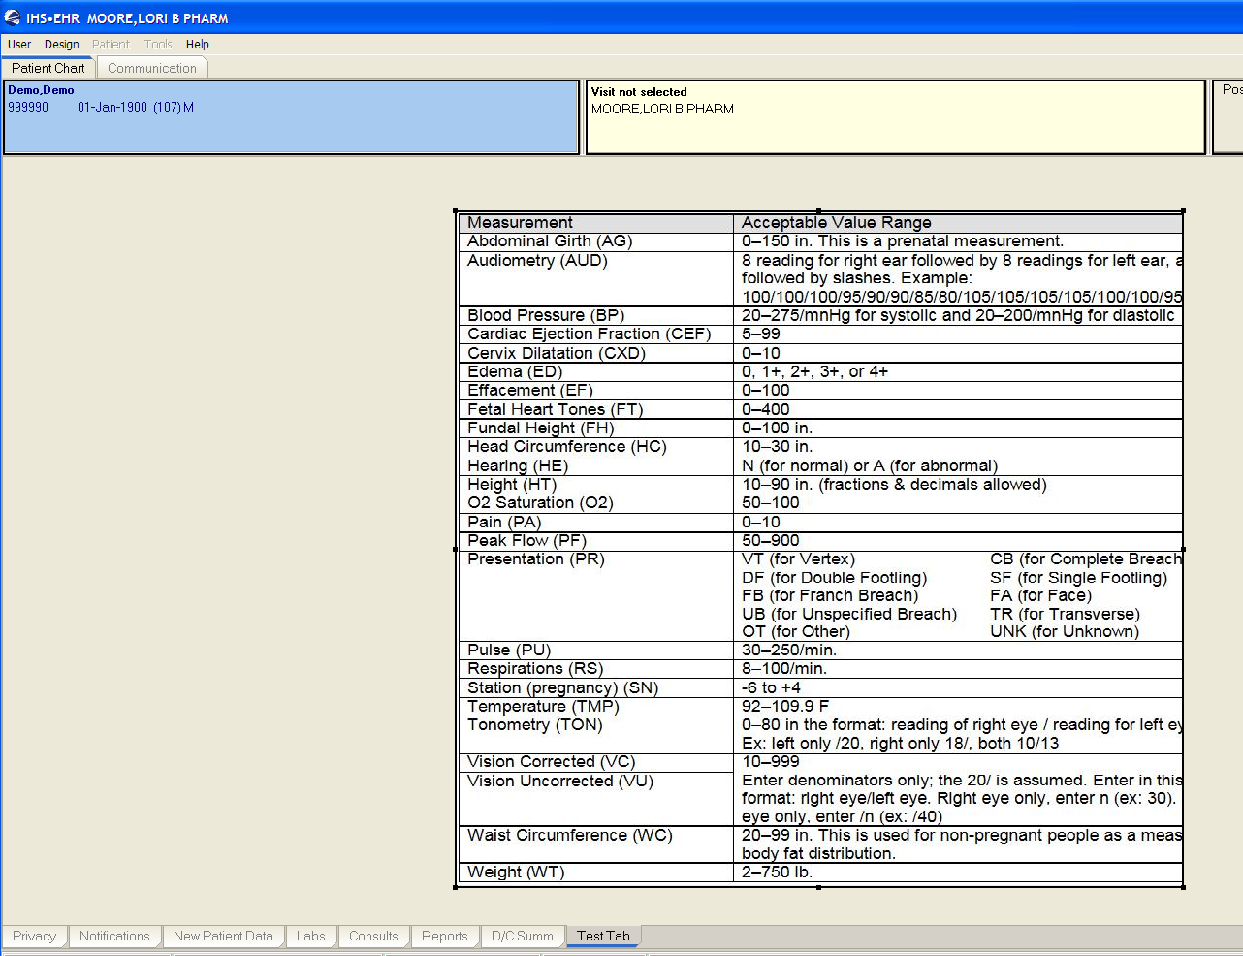 | STEP 3:  Your image may need to be resized.  Once finished, be sure to save the template. See below for instructions on saving templates.

Saving the New EHR GUI Template
Go to the Design drop-down menu and choose Save as Template.
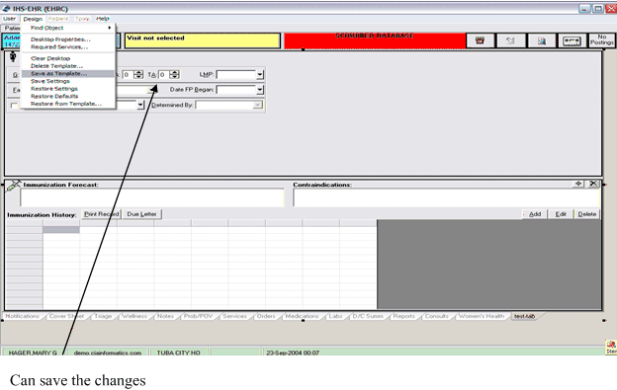
You can make a new template to be used or you can overwrite the template that you have selected.
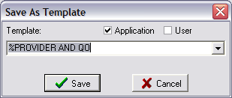
Do not overwrite the templates that come with the EHR.
Make new templates to use at your site.

Adding Quick Note to EHR
The Quick Note component can be added to an EHR template in the tool bar for access at any time. The component is called TIU Quick Note.
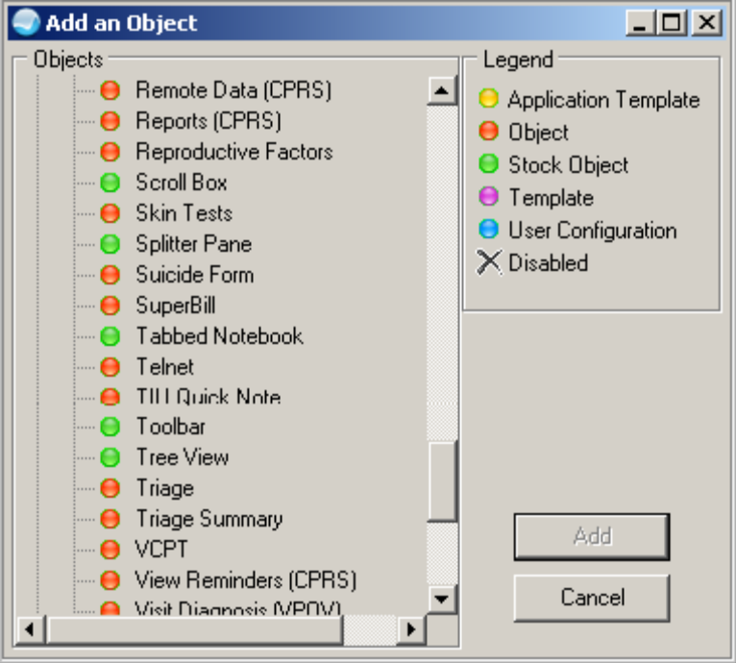

Chart Review Button:
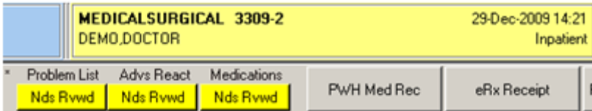

The label on the “button” area below the component (for example Nds Rvwd below Problem List) can be configured. This also applies to the hover help that displays when you run your mouse over the button area.
These features are on the Properties for Chart Review (done in Design Mode in the EHR GUI).

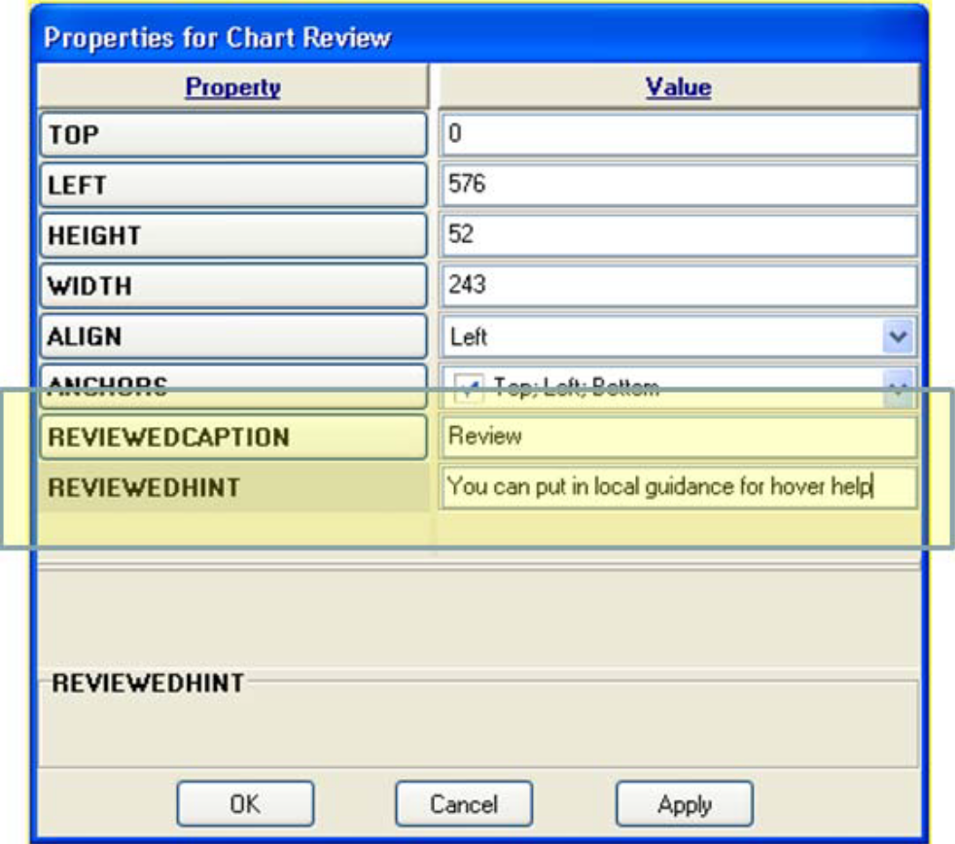

The property REVIEWEDCAPTION determines the label on the “button” area.
The property REVIEWEDHINT determines the hover help wording.
Below show the label and hover help in the application.

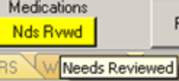

Rx Print Format (Template) Editor Set Up
Use the Rx Print Format (Template) Editor Set Up to add the Rx Template Editor to an EHR template. Follow these steps:
Select Design mode | Desktop Properties | Customize Menus
Add Menu item Rx Template Editor
Optionally, add a Print Rx menu with Rx Template Editor and Rx Print Config as submenus
Add the following in Action (lightning bolt):

$(BEHRXGENERATORSERVICE.RXGENERATOR.edittemplates)
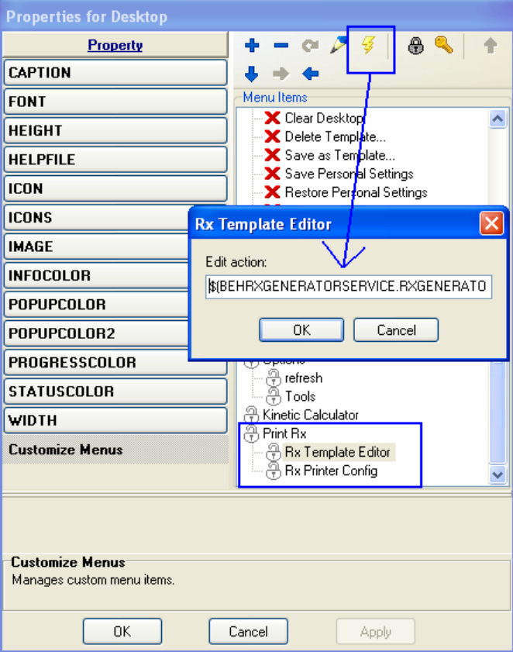

Click Apply and OK (on Properties for Desktop).
Make sure the BEH Rx Generator Service is checked under Required Services in Design Mode. Click on Design Mode | Design | Required Services.

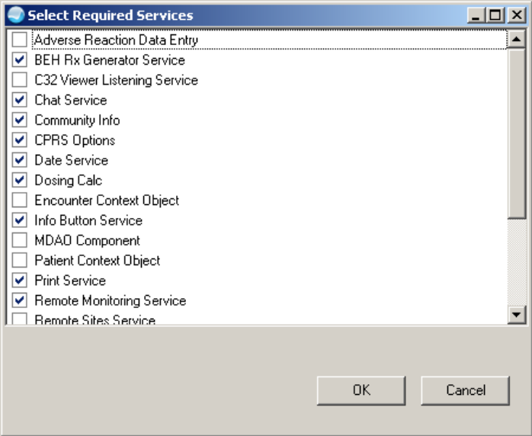

This option should only be placed on the EHR GUI template for those responsible for editing these format, for example, the CAC, and designated pharmacy personnel.

Rx Printer Preferences Editor Set up
Follow these steps:
Select Design mode | Desktop Properties | Custom Menus.
Add Menu item Rx Printer Config (Figure D- 1).
Optionally, you can add a Print Rx menu with the Rx Template Editor and Rx Printer Config as submenus

Add the following in Edit Action (lightning bolt):

$(BEHRXGENERATORSERVICE.RXGENERATOR.EditPrinterPreference)

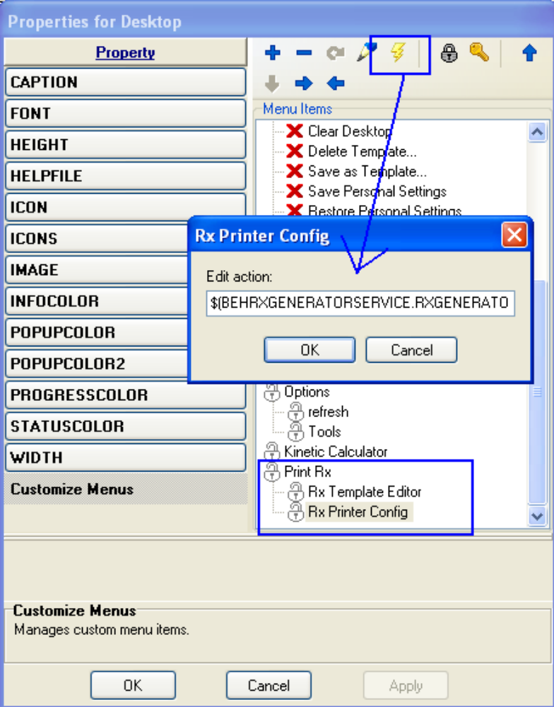

Click Apply and OK on the Properties for Desktop dialog.
Make sure to have BEH Rx Generator Service checked under Required Services.

Users without the BEHORX PRINT key will only be able to set their own defaults.

If the site does not want users to be able to set their own defaults, only add this menu option to EHR GUI templates for those users who are allowed to set this parameter.

Assign the BEHORX PRINT key for CAC/IT staff who will set Location, Division, System settings.

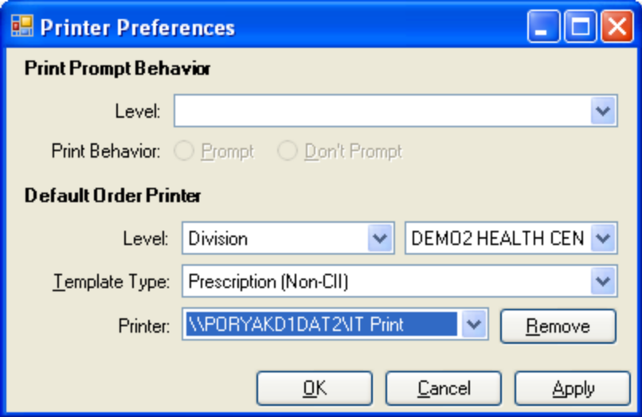

For more detail setups, please refer to EHR Patch 9 Setup Guide.

Assigning New EHR GUI Template to Users
Select IHS Core Option: ehr EHR SETUP MENU
TIU TIU Menu for Medical Records ...
BEHO IHS-EHR Configuration Master Menu ...
CON Consult Management ...
CPRS CPRS Manager Menu ...
HS Health Summary Maintenance ...
REM Reminder Managers Menu ...
TIU1 TIU Menu for Clinicians ...
VAHS Health Summary Overall Menu ...
XX General Parameter Tools ...
Select EHR SETUP MENU Option: xx General Parameter Tools
LV List Values for a Selected Parameter
LE List Values for a Selected Entity
LP List Values for a Selected Package
LT List Values for a Selected Template
EP Edit Parameter Values
ET Edit Parameter Values with Template
EK Edit Parameter Definition Keyword
Select General Parameter Tools Option: ep Edit Parameter Values
--- Edit Parameter Values ---
Select PARAMETER DEFINITION NAME: CIAVM DEF
1 CIAVM DEFAULT SOURCE Default object source path
2 CIAVM DEFAULT TARGET Default installation path
3 CIAVM DEFAULT TEMPLATE Default login template
CHOOSE 1-3: 3 CIAVM DEFAULT TEMPLATE Default login template
CIAVM DEFAULT TEMPLATE may be set for the following:
100 User USR [choose from NEW PERSON]
200 Class CLS [choose from USR CLASS]
300 Service SRV [choose from SERVICE/SECTION]
400 Location LOC [choose from HOSPITAL LOCATION]
500 Division DIV [choose from INSTITUTION]
900 Package PKG [VUECENTRIC FRAMEWORK]
Enter selection: 100 User NEW PERSON
Select NEW PERSON NAME: MOORE,LORI
1 MOORE,LORI B CLINICAL LBM 167LBM CLINICAL PHARMACIST
2 MOORE,LORI B PHARM LBM 119 109LBM PHARMACIST
CHOOSE 1-2: 2 MOORE,LORI B PHARM LBM 119 109LBM PHARMACIST
-------- Setting CIAVM DEFAULT TEMPLATE for User: MOORE,LORI B PHARM -------
Default Template: %LORI// ??
Choose from:
$1983
%AAO DEFAULT TEMPLATE
%AAO LAB TEMPLATE
%AAO PHARM TEMPLATE
%CIH PROVIDER1
%CIH PROVIDER2
%DEFAULT
%EHR_PROVIDER
%EHR_QUICK ORDER WIZARD
%LORI
%PCC OBJECTS BGO
%PROVIDER
%PROVIDER NOTE
%PROVIDER TEMPLATE
%PROVIDER TEMPLATE2
%PROVIDER3
%PROVIDER3 NURSE
%SFIH
%SFIH CAC
%SFIH LAB
%SFIH LAB 2
%SFIH MIDW 2
%SFIH NURSE
%SFIH OPT
%SFIH PHARM
%SFIH PROV 2
%SFIH PROV 2_CAC
CHOOSE 1-10: 10 %SFIH PROV 2_CAC
Select PARAMETER DEFINITION NAME: ^
LV List Values for a Selected Parameter
LE List Values for a Selected Entity
LP List Values for a Selected Package
LT List Values for a Selected Template
EP Edit Parameter Values
ET Edit Parameter Values with Template
EK Edit Parameter Definition Keyword
Select General Parameter Tools Option: LV List Values for a Selected Parameter
Select PARAMETER DEFINITION NAME: CIAVM DEFAULT TEMPLATE Default login template
Values for CIAVM DEFAULT TEMPLATE
Parameter Instance Value
----------------------------------------------------------------------------
DIV: SANTA FE HOSPITAL 1 %SFIH PROV 2
USR: DUONG,QUYNH-CHI TAN PHARM 1 %SFIH PROV 2_CAC
CLS: LABORATORY TECHNICIAN 1 %SFIH LAB 2
USR: MOORE,LORI B PHARM 1 %SFIH PROV 2_CAC
CLS: OPTOMETRIST 1 %SFIH OPT
CLS: PHARMACIST 1 %SFIH PHARM
CLS: PHARMACY STUDENT 1 %SFIH PHARM
CLS: PHARMACY TECHNICIAN 1 %SFIH PHARM
PKG: VUECENTRIC FRAMEWORK 1 %DEFAULT
CLS: CLINICAL PHARMACIST 1 %SFIH PROV 2
CLS: OPTOMETRIST TECH 1 %SFIH OPT
CLS: OPTOMETRY STUDENT 1 %SFIH OPT

Importing/Exporting EHR GUI Templates to Other Facilities
STEP 1:  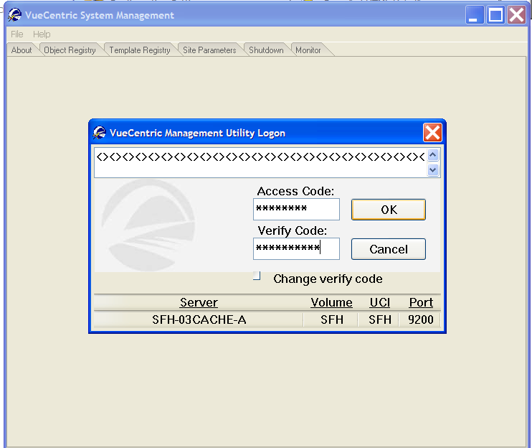 | STEP 1:  Log into VC Manager using the same access and verify code for EHR/RPMS.
STEP 2:  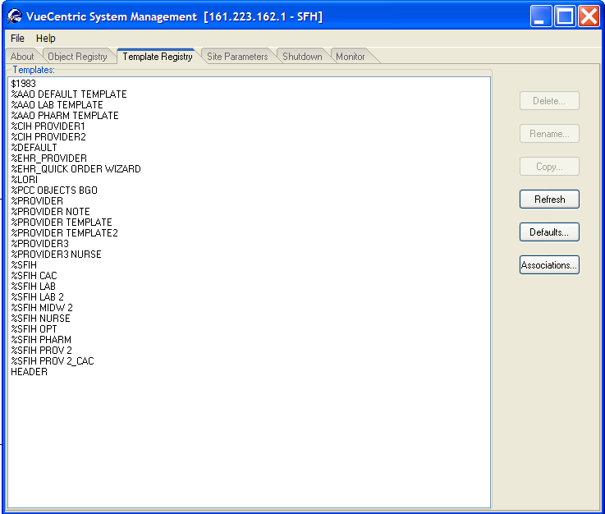 | STEP 2:  Click on the Template Registry tab.  This is a list of all the templates in your EHR.
STEP 3:  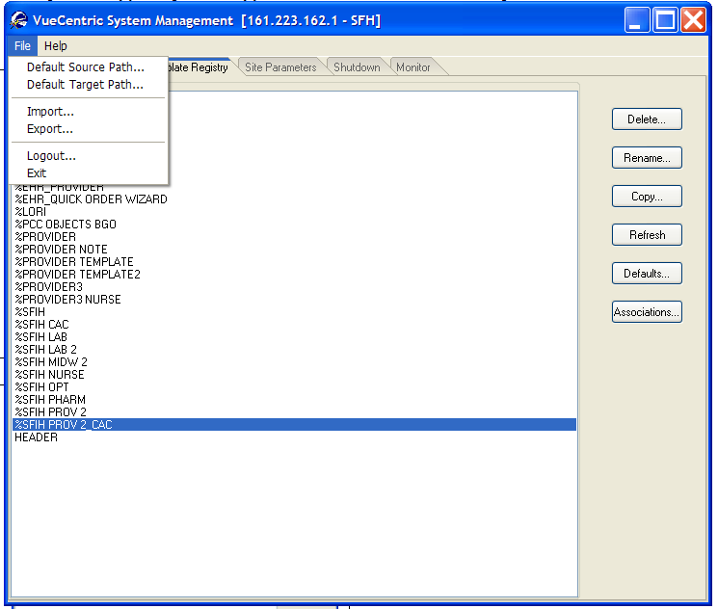 | STEP 3:  To export an EHR GUI template, click on the template that you are going to export.  Click on File and Export.
STEP 4:  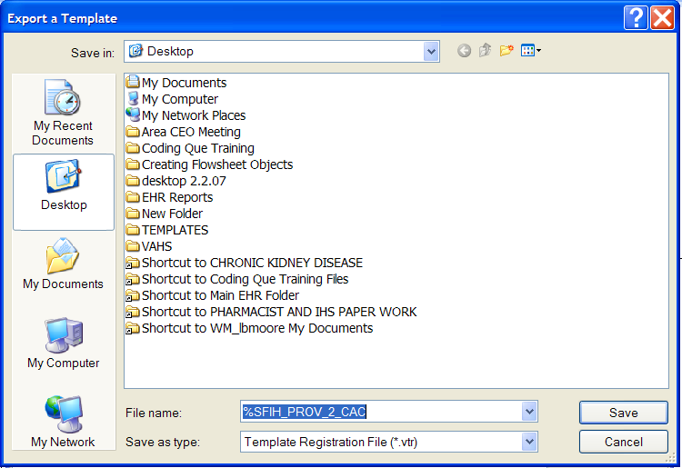 | STEP 4:  Assign the template a name and save it.  Attach file to an email and forward to another site.  To import the template, you will need to save it to your computer and import it using the same steps.

