Tribal Researchers’ Cancer  Control Fellowship Program  2021 Application | 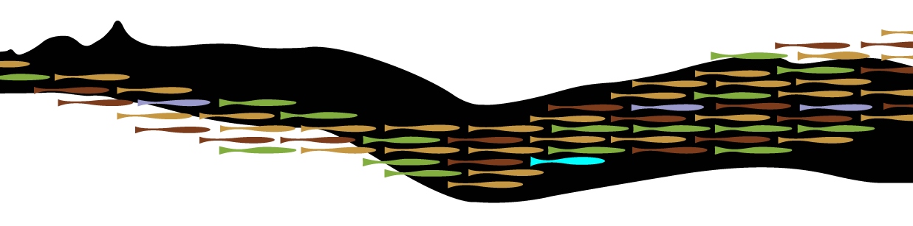

Applicant Information
Last Name |  |  | Click or tap here to enter text. |  |  |  |  |  | First | Click or tap here to enter text. |  |  |  |  |  | Date |  |  | Click or tap here to enter text.
Street Address |  |  |  | Click or tap here to enter text. |  |  |  |  |  |  |  |  |  |  |  | Apartment/Unit # |  |  |  | Click or tap here to enter text.
City |  | Click or tap here to enter text. |  |  |  |  |  |  | State | Click or tap here to enter text. |  |  |  |  |  | ZIP |  | Click or tap here to enter text.
Phone |  | Click or tap here to enter text. |  |  |  |  |  |  | E-mail Address |  |  | Click or tap here to enter text.

Education
Undergraduate Institution(s) |  |  |  |  |  | Degree(s) |  |  |  |  |  |  |  | Degree Date(s)
Click or tap here to enter text. |  |  |  |  |  | Click or tap here to enter text. |  |  |  |  |  |  |  | Click or tap here to enter text.
Click or tap here to enter text. |  |  |  |  |  | Click or tap here to enter text. |  |  |  |  |  |  |  | Click or tap here to enter text.
Graduate Institution(s)
Click or tap here to enter text. |  |  |  |  |  | Click or tap here to enter text. |  |  |  |  |  |  |  | Click or tap here to enter text.
Click or tap here to enter text. |  |  |  |  |  | Click or tap here to enter text. |  |  |  |  |  |  |  | Click or tap here to enter text.
Click or tap here to enter text. |  |  |  |  |  | Click or tap here to enter text. |  |  |  |  |  |  |  | Click or tap here to enter text.

Tribal Enrollment
Click or tap here to enter text.

Previous Professional Position(s)
1. Click or tap here to enter text.
2. Click or tap here to enter text.
3. Click or tap here to enter text.

Current Professional PositioN
Title |  |  |  |  | Click or tap here to enter text.
Organization |  |  |  |  | Click or tap here to enter text.
Street Address |  |  |  |  | Click or tap here to enter text.
City | Click or tap here to enter text. |  |  |  |  |  | State | Click or tap here to enter text. |  |  |  |  |  |  | ZIP |  | Click or tap here to enter text.
Phone | Click or tap here to enter text. |  |  |  |  |  |  |  |  |  | E-mail |  | Click or tap here to enter text.

Please briefly describe your current job responsibilities
Click or tap here to enter text.

if a fellowship in cancer control research is offered to you, how will you be able to apply this new knowledge to your community and current position? (150 word minumum)
Click or tap here to enter text.

Please include the following with your application
- A personal statement with a focus on cancer (350 word minimum)
- A copy of your CV or resume
- A copy of your Certificate of Indian Blood or Tribal ID
- A letter of support from the community or organization with which you plan to work in cancer control activities
- A brief letter from your employer ensuring that you will have time available to attend

Given the uncertainty of the COVID-19 pandemic, we do not yet know if the training will be offered in-person or virtually. In past years we offered three weeks of in-person training in Portland, OR. This year we offered two weeks of training virtually and short courses via Zoom every three weeks. We are prepared for either situation. Does that pose a problem for you?

Yes ☐
No ☐
Please feel welcome to add comments here: Click or tap here to enter text.

Please return this form and all other application materials via e-mail by March 12, 2021 to:
Ashley Thomas
E-mail: athomas@npaihb.org
Northwest Portland Area Indian Health Board
2121 SW Broadway, Suite 300
Portland, OR 97201
Phone: (503) 416-3293

