substance use
functional behavior analysis
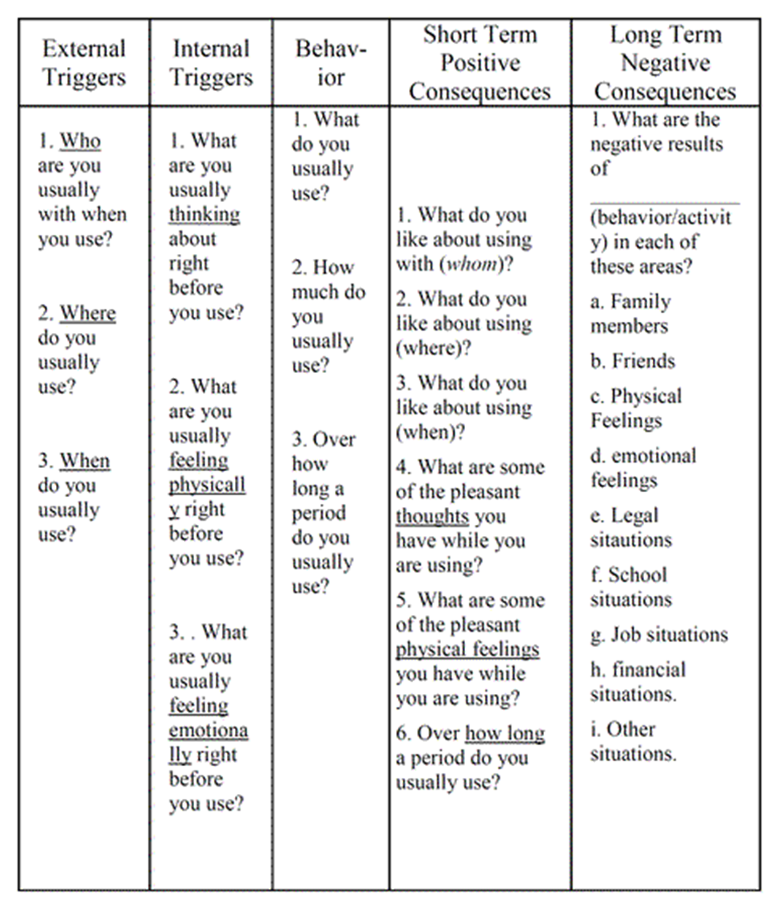

substance use
functional behavior analysis

External Triggers | Internal Triggers | Behavior | Short term Positive Consequences | Long tem Negative Consequences
Who  Where  When | Thinking  Feeling Emotionally  Feeing Pysically

