XYZ Tribe’s/Organization’s
Social Marketing & Social Media Campaign
Development Plan
May 2017 – May 2018

  - What is your campaign’s primary goal?
- Reduce underage drinking among American Indian and American Indian (AI/AN) youth.
- Reduce prescription drug abuse among young adults 12-25 years old.
- Improve cultural pride, self-esteem and resilience among AI/AN youth.
- Others:
Does your campaign have any secondary goals?
Consider other factors that are driving local prevalence.
- Change social norms surrounding house parties.
- Change social norms surrounding purchasing/serving alcohol to minors.
- Change behaviors related to prescription drug storage and disposal.
- Others:

  - Please describe your campaign’s target audience (be specific!):
Consider age, gender, location, behavior.

  - What behaviors/actions will your campaign focus on?
What barriers does your audience face when changing this behavior?

  - Who contributes to the problem and/or has the power to intervene?

  - Which community partners/stakeholders will be involved in the development of your campaign? What are their roles? How will you include them? Can they contribute any resources (time, money, expertise) to the campaign?
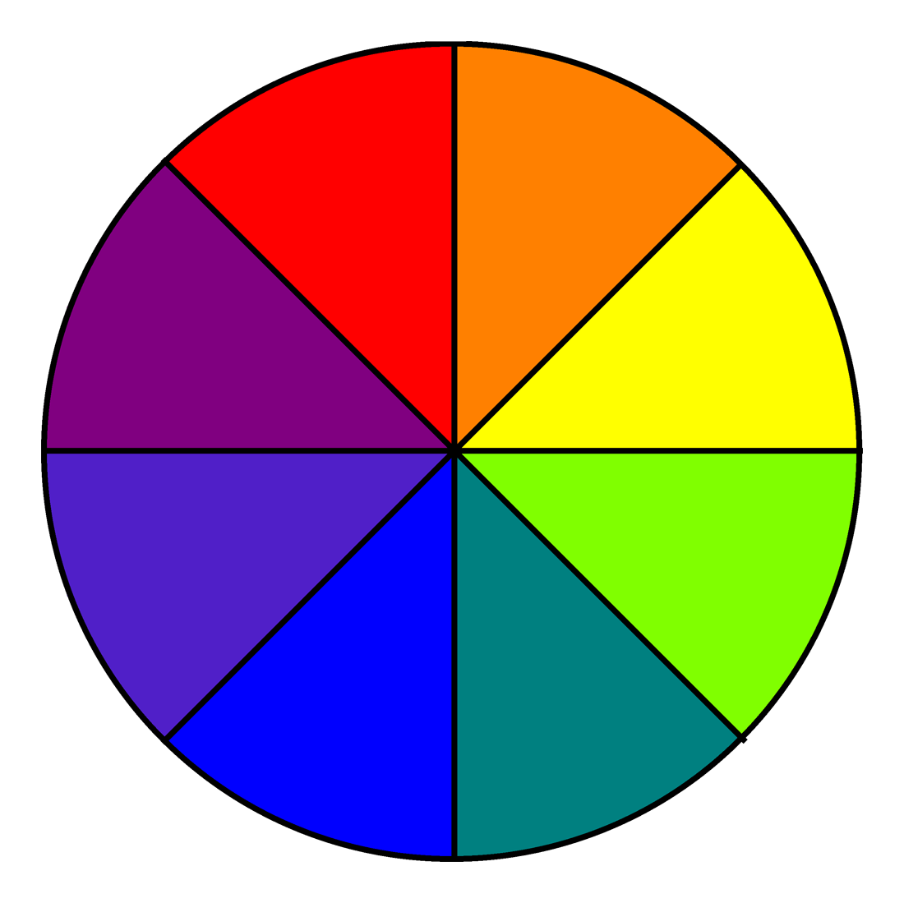
SCHOOLS
GATEKEEPERS
FAITH-BASED
ORGANIZATIONS
COMMUNITY
LEADERSHIP

LOCAL BUSINESS
NON-NATIVE
AGENCIES/
PROGRAMS
NATIVE AGENCIES/
PROGRAMS
HEALTH AGENCIES
I.H.S.

  - How will you involve the target audience in the development of your campaign?

  - What steps will you take to make sure your campaign materials meet the needs, readiness level, priorities, and preferences of your target audience? How will you identify appropriate media products and their placement?

  - What types of data will you collect to guide the development of your campaign (clinical data, surveys, focus groups, key informant interviews, discussions with stakeholders)?

  - What is your campaign’s primary message/slogan? (Culture is Prevention)

  - Which media products will you use to promote your campaign message (check all that apply):

- Posters
- Fact sheets
- Brochures
- Fliers
- Tip cards
- Newspaper, newsletter articles
- Postcards or direct mailings
- Billboard
- Video public service announcements, YouTube
- Radio public service announcements
- Social media: Facebook, Tumblr, Blogs
- A text messaging service
- Community event(s): _________________
- Other: _____________________________

  - Planning Timeline:

Activities | Specific Steps | Who is responsible? | Timeline for Completion |  |  |  |  |  |  |  |  |  |  |  |  | Budget
 |  |  | May | Jun | Jul | Aug | Sep | Oct | Nov | Dec | Jan | Feb | Mar | Apr | May
Media Training |  |  | X
Identify audience, goals, behaviors… | Consider who’s most at risk, barriers to behavior change… |  | X | X | X
Develop and test messages, slogans, campaign tone, designs… | Involve target audience. Media designers? Surveys, interviews, focus groups, informal meetings? |  |  |  | X | X | X | X
Produce materials… | Need Vendors? Designers? |  |  |  |  |  |  | X | X | X
Product 1:
Product 2:
Product 3:
Product 4:
Place materials; evaluate campaign | Consider dissemination strategies (partners, timing, location, etc.) |  |  |  |  |  |  |  |  | X | X | X | X | X | X

  - Budget: (You may also include “In-Kind” contributions, if applicable)
CATEGORY | DESCRIPTION | AMOUNT | TOTALS
Personnel | Director  Coordinator | $0,000  $0,000 | Total in Bold
Benefits | Full-time salaried @ 35%  Hourly and Part-time @20% | $0,000  $0,000 | Total in Bold
Subcontracts,  Purchased Services | Videographer  Print Designer  Photographer  T-shirt Vendor  Text Message Service  Billboard | $0,000  $0,000  $0,000  $0,000  $0,000  $0,000 | Total in Bold
Equipment, Software | Adobe InDesign  Photoshop  Color Printer | $0,000  $0,000  $0,000 | Total in Bold
Supplies,  Communication | Office Supplies (paper, pens, binders)  Postage  Meeting space rental | $0,000  $0,000  $0,000 | Total in Bold
Travel, Transportation | Staff mileage to Meeting(s)  Travel reimbursement for stakeholder feedback (bus pass, gas card, etc.) | $0,000  $0,000 | Total in Bold
Incentives | Stakeholder feedback (@ $20 per person) | $0,000 | Total in Bold
INDIRECT Rate @ 15% TOTAL: $0,000
TOTAL TOTAL: $10,000

