Prevention Social Marketing/Social Media Campaign
Organization Name - Evaluation Report
January 2018 – March 2018

Which media products did you use to promote your campaign message (check all that apply):

- Posters
- Fact sheets, brochures, fliers
- Newspaper, newsletter articles
- Postcards or direct mailings
- Billboard
- Video public service announcements, YouTube
- Radio public service announcements
- Social media: Facebook, Tumblr, Blogs
- A website
- A text messaging service
- Community event(s): _________________
- Other: _____________________________

Please fill out those sections that pertain to your campaign. Include photos or screen shots of any items that help illustrate your campaign or its reach.
Posters
Quantity Printed: Number
Placement: Where?

Fact sheets, brochures, fliers
Quantity Printed: Number
Placement: Where?
Newspaper, newsletter articles
Number of Articles: Number
Reach/Placement: Where? When? Reach – How many people read the publication?

Postcards or direct mailings
Quantity Printed: Number
Reach/Placement: Where? When? Who was your audience?

Billboard
Quantity: Number
Reach/Placement: Where? When? Who was your audience?

Radio public service announcements
Quantity: Number
Reach/Placement: Where? When? Who was your audience?

Facebook Insights
Facebook Link: Add
Your Fans: Add screenshot of your Fans - people who like you page - for example:
Health Posts: Approximate number of health posts (per day, per week, per month – as appropriate)
Overall Performance:
- Total Likes Before Campaign: Date, Number
- Total Likes After Campaign: Date, Number
  - # of unique people who like your Page

- Campaign’s Total Reach: Number - Under the “export data” tab, select the dates of your campaign and download the report. Sum up the column under “Daily Total Reach“
  - The number of people who have seen any content associated with your Page. (Unique Users)

- Campaign’s Total Impressions: Number - Under the “export data” tab, select the dates of your campaign and download the report. Sum up the column under “Daily Total Impressions“
  - The number of impressions seen of any content associated with your Page. (Total Count)

- Campaign’s Total Page Views: Number - Under the “export data” tab, select the dates of your campaign and download the report. Sum up the column under “Daily Logged-in Page Views“
  - # of unique people who have seen any contet associated with your Page (includes ads and sponsored stories)

- Campaign’s Total Daily Page Consumption: Number - Under the “export data” tab, select the dates of your campaign and download the report. Sum up the column under “Daily Page Consumption“
  - The number of clicks on any of your content. Clicks generating stories are included in "Other Clicks." Stories generated without clicks on page content (e.g., liking the page in Timeline) are not included. (Total Count)

Any Post Examples that you’d like to share: For example:

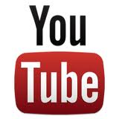
YouTube Analytics
YouTube Channel Link: Add
Your Demographics: Add screenshot of your user Demographics - for example:
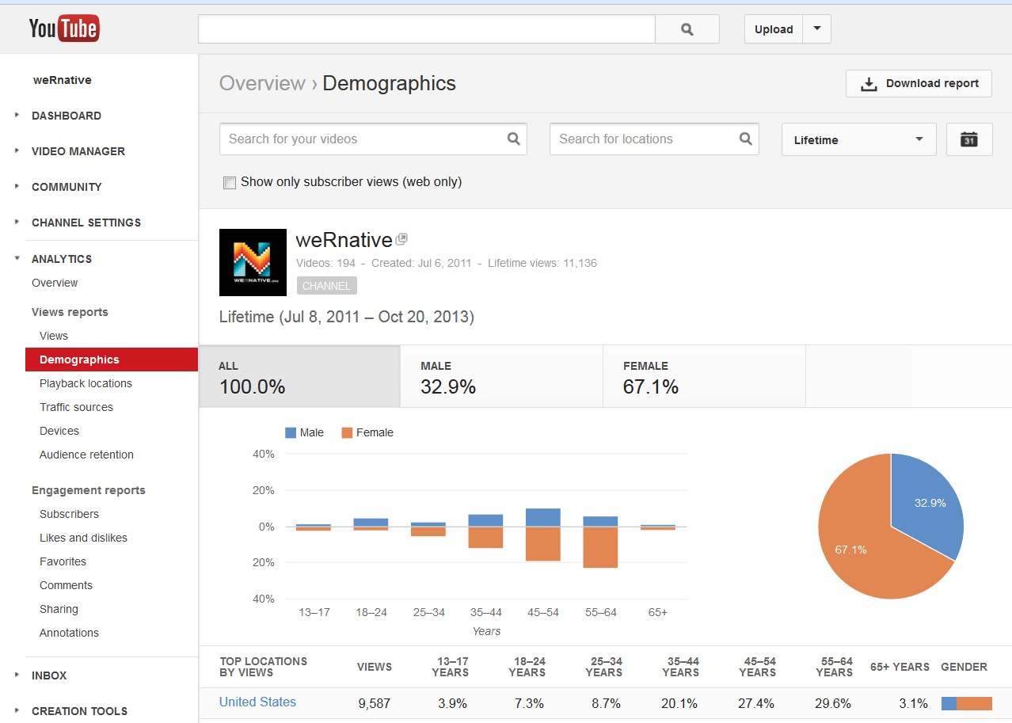

Overall Performance:
- Total Views Before Campaign: Date, Number
- Total Views After Campaign: Date, Number

- Estimated Minutes Watched Before Campaign: Date, Number
- Estimated Minutes Watched After Campaign: Date, Number

- Subscribers Before Campaign: Date, Number
- Subscribers After Campaign: Date, Number

Any Video Performance data that you’d like to share: For example:
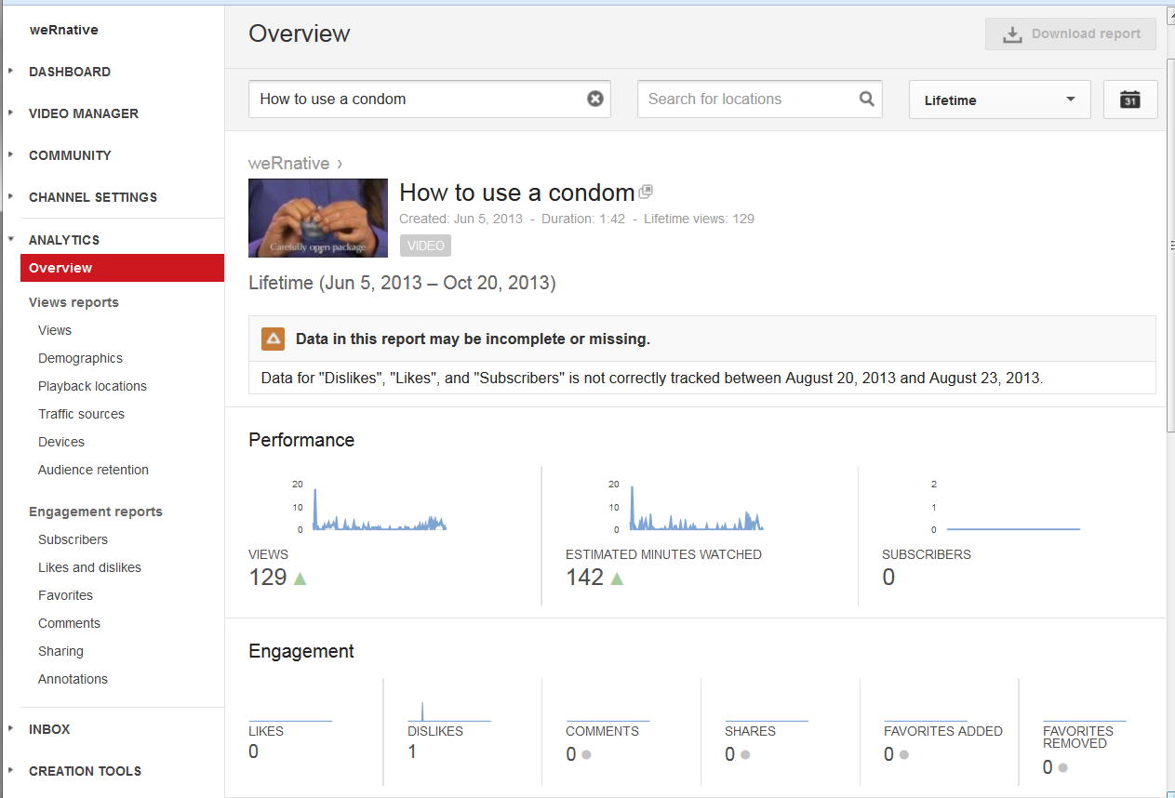

Website Analytics
Website Link: Add
User Demographics: Add screenshot of your gender, age, or geographic reach.

Website Performance:
For example: Between September 15, 2012 – March 15, 2013, our health campaign webpage had:
- Visits: 11,317
- Unique Visitors: 8,252
- Pageviews: 37,873
- Pages / Visit: 3.35
- Avg. Visit Duration: 00:03:50

Any website screen shots that you’d like to share: For example:

Community events
When: ?
Where: ?
Who attended: ?
How many attended: # of youth under 25, Number of Adults 25 and over

Other Campaign Elements

