Creating Hepatitis C reports in NextGen
No IT background required!

Step 1
With EHR open but no patient file open
Click File
Hover over Reports
Hover over Generate Report
Click By Practice

Step 2
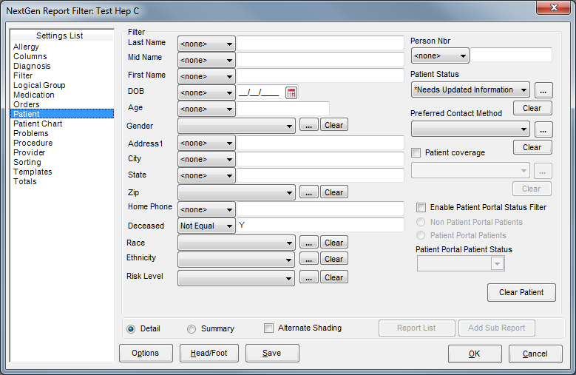
Click Patient from left-side Settings List
Change Deceased setting to Not Equal from pull-down and add a Y to the blank field as shown above. This will exclude clients who have died
Under Patient Status click on the …
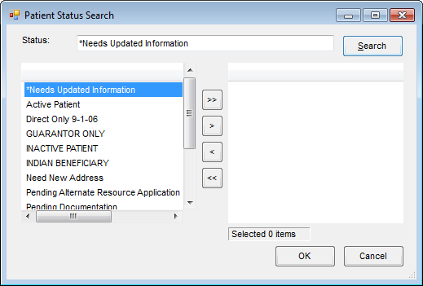
Click Search with empty status field. Highlight and click right arrow to move over any status your system uses to designate an active patient then click OK

Step 3
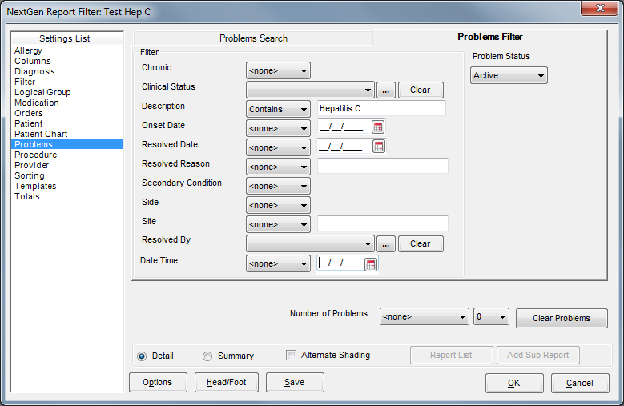
Click Problems from left-side Settings List
Select the Problems Filter tab from the main window (top right)
Under heading Description change pull down to Contains and in the box type in Hepatitis C
Set Problem Status to Active from drop down menu in the upper right

Step 4
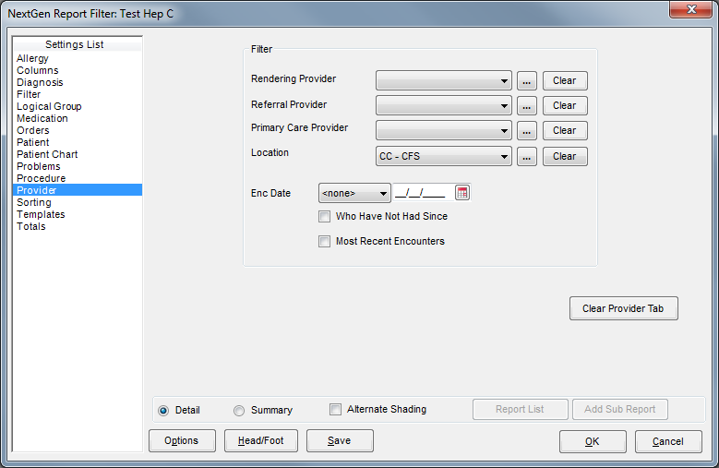
Click Provider from left-side Settings List
Under Location click the …
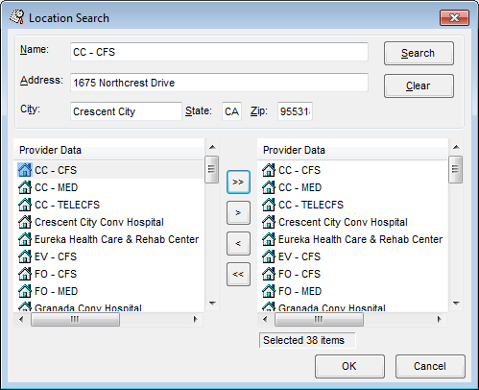
Click Search (with name field blank), then click the >> to move all locations over then hit OK

Step 5
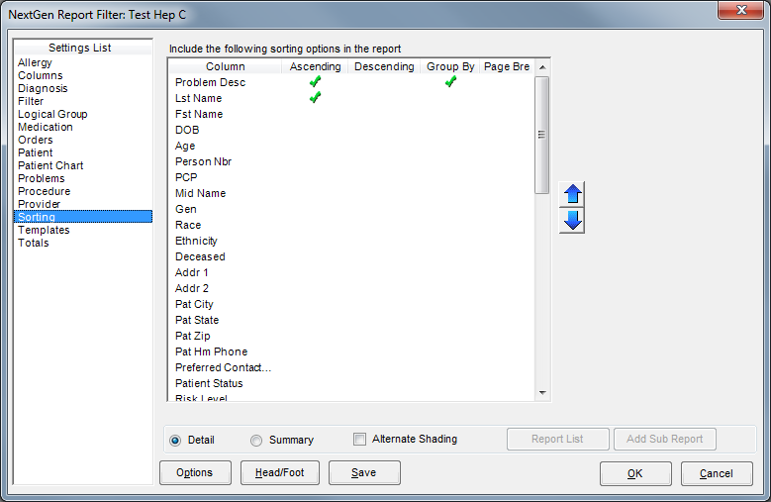
Click Sorting from left-side Settings List
For Problem Desc click to make a green arrow on Ascending and Group By
For Lst Name click to make a green arrow on Ascending

Step 6
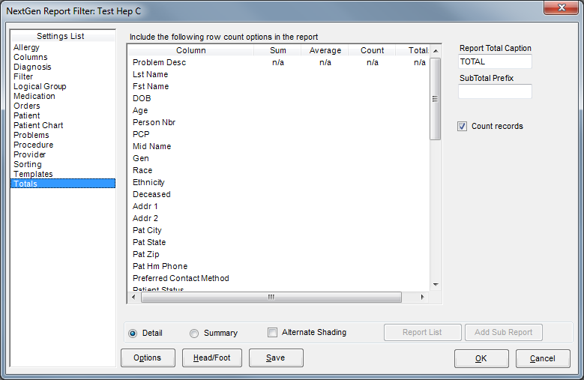
Click Totals from left-side Settings List
Check Count Records box – this will give you a total for each diagnosis

Step 7
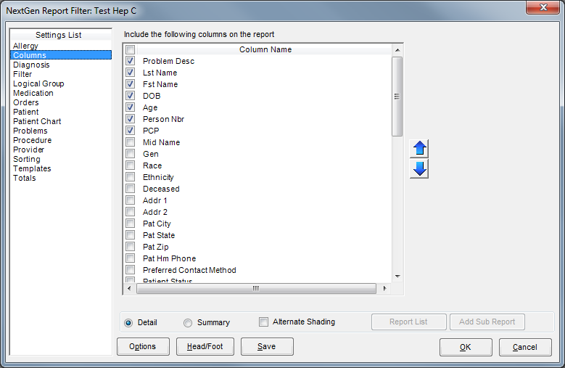

Click Columns from left-side Settings List
Check boxes shown above (they won’t be in this order, scroll to find). Use the up and down arrows to change order the columns show up on report

Step 8
Click Save on screen shown in Step 7, this will pop up
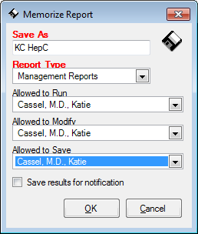
Name the file under Save As
Select a Report Type – you have to remember this report type to be able to retrieve later
Select names for Allow to fields
Click OK
This again takes you back to the Step 7 screen
Click OK – this will run the report
To save the report, I recommend using the export to excel function and saving the file

Step 9
To run your report the next time…
With EHR open but no patient file open
Click File, Hover over Reports, Click Report List
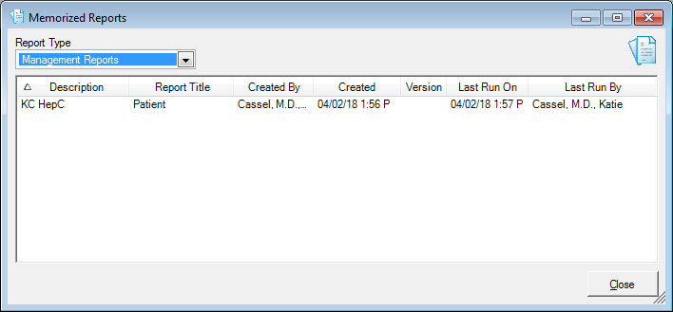
Select your Report Type (from dropdown menu) that you entered in Step 8
Double click on your saved report, this will take you back to the step 7 screen – click OK to run report
You can also make modifications to the report and save with the same name or a new name if you have need for different reports.

