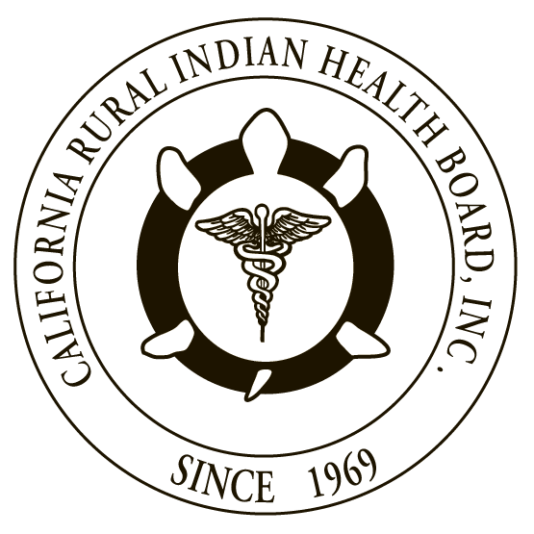
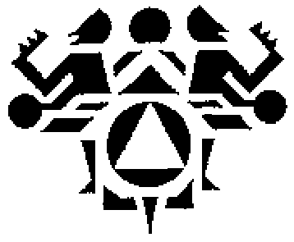

RESOLUTION # RESOLUTION #
NORTHWEST PORTLAND AREA CALIFORNIA RURAL INDIAN
INDIAN HEALTH BOARD HEALTH BOARD

JOINT RESOLUTION
Support for Dental Health Aide Therapists

WHEREAS, the Northwest Portland Area Indian Health Board (NPAIHB) is a Tribal organization under P.L. 93-638 that represents 43 federally-recognized Indian Tribes in Oregon, Washington, and Idaho and is dedicated to assisting and promoting the health needs and concerns of American Indian/Alaska Native (AI/AN) people in the Northwest; AND

WHEREAS, the California Rural Indian Health Board, Inc. (CRIHB), founded in 1969 for the purpose of bringing back health services to Indians of California, is a Tribal organization in accordance with P.L. 93-638 and is a statewide Tribal health organization representing 33 federally recognized tribes in 14 counties through its membership of 12 Tribal Health Programs throughout California’s Indian Country; AND

WHEREAS, the NPAIHB and CRIHB are dedicated to assisting and promoting the health needs and concerns of AI/AN people; AND

WHEREAS, the primary goal of the NPAIHB and CRIHB is to improve the health and quality of life of its member Tribes; AND

WHEREAS, AI/AN people have a higher prevalence of dental caries and untreated tooth decay in all age groups compared to the general United States population, with many AI/AN children experiencing dental caries before the age of two, yet there are few dental caries prevention programs that target AI/AN children and other oral health issues persist for the AI/AN population such as:
- Seventy-nine percent of AI/AN children aged 2-4 years have dental caries;
- Majority of AI/AN children have tooth decay with 78 percent of the 6-14 year olds and 91 percent of the 15-19 year olds had a history of decay;
- Despite a trend toward a reduction in tooth loss in the U.S. population, 25 percent of AI/AN people aged 35 to 44 years have fewer than 20 natural teeth;
- Among all persons aged 55 years and older, nearly 75 percent have fewer than 20 natural teeth;
- Fifty-nine percent of AI/AN adults have periodontal (gum) disease;
- Seventy-eight percent AI/AN adults 35-44 years and 98 percent of elders (55 or older) have at least one tooth removed because of decay, trauma, or gum disease; AND

WHEREAS, these disparities are directly attributed to a lack of dental health professionals in the Indian health system in which IHS dental providers have a patient load of 2,800 patients per provider, while general population providers have approximately 1,500 patients per provider and the IHS experiences a very high dental provider vacancy rate, with estimates that 26 percent of the dental positions within the IHS are vacant, which contributes to the lack of access to dental health services; AND

WHEREAS, the Alaska Native Villages determined the most expedient and successful approach to resolving their dental crisis was to send their Tribal members to New Zealand to learn how to provide dental care to their communities as DHATs over 15 years ago; AND

WHEREAS, for over 10 years, the Alaska Native Tribal Health Consortium (ANTHC) has established a successful DHAT training program; AND

WHEREAS, a newly released study of villages with DHATs providing services over the last 10 years show a 284% decrease in the number of extractions of the first four baby teeth for children under 3 and a 26% decrease in the number of extractions performed on adults over that same period as compared to villages without a DHAT; AND

WHEREAS, that same study of villages with DHATs providing services over the last 10 years shows a 75% increase in access to preventive care for the adult population and a 60% increase in access to preventive care for children as compared to villages without a DHAT; AND

WHEREAS, ANTHC has also trained Tribal members in the states of Washington and Oregon who will work in their Tribal communities in these states; AND

WHEREAS, other Tribal communities in the states of California, Idaho, Oregon and Washington are interested in having DHATs serve their communities to reduce oral health disparities among AI/AN people; AND

WHEREAS, the establishment of mid-level dental providers like DHATs would greatly increase access to dental services in Tribal communities at an economical cost and also help to address the oral health disparities for AI/AN people.

THEREFORE BE IT RESOLVED that the NPAIHB and CRIHB support the training and utilization of DHATs in Tribal communities in the states of California, Idaho, Oregon and Washington.

CERTIFICATION

The foregoing joint resolution was adopted at a duly called regular joint meeting of the Board of Directors of Northwest Portland Area Indian Health Board and California Rural Indian Health Board (NPAIHB vote __ For and _ Against and _ Abstain; CRIHB vote __ For and _ Against and _ Abstain) held this day of July 2017 in Canyonville, Oregon and shall remain in full force and effect until rescinded.

NORTHWEST PORTLAND AREA CALIFORNIA RURAL
INDIAN HEALTH BOARD INDIAN HEALTH BOARD
2121 SW Broadway, Suite 300 4400 Auburn Blvd, 2nd Floor
Portland, OR 97201 Sacramento, CA 95841
(503) 228-4185 (916) 929-9761

_________________________ __________________________
Chairperson of the Board Chairperson of the Board

_________________________ __________________________
Attest Attest

