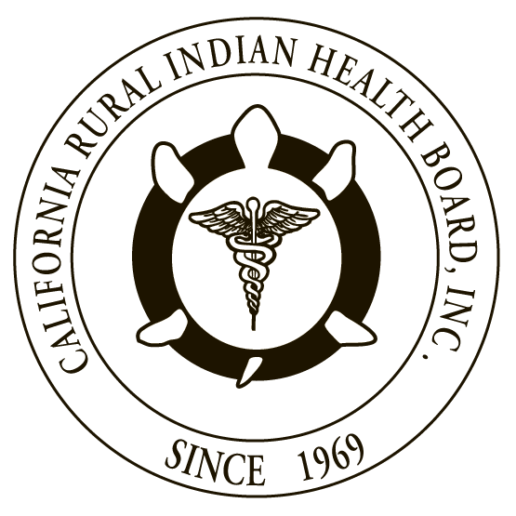
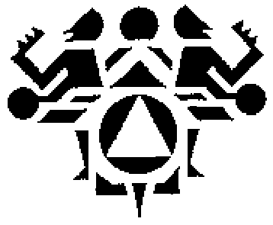

RESOLUTION # RESOLUTION #
NORTHWEST PORTLAND AREA CALIFORNIA RURAL INDIAN
INDIAN HEALTH BOARD HEALTH BOARD

JOINT RESOLUTION
Support for the Community Health Aide Program Expansion

WHEREAS, the Northwest Portland Area Indian Health Board (NPAIHB) is a Tribal organization under P.L. 93-638 that represents 43 federally-recognized Indian Tribes in Oregon, Washington, and Idaho and is dedicated to assisting and promoting the health needs and concerns of American Indian/Alaska Native (AI/AN) people in the Northwest; AND

WHEREAS, the California Rural Indian Health Board, Inc. (CRIHB), founded in 1969 for the purpose of bringing back health services to Indians of California, is a Tribal organization in accordance with P.L. 93-638 and is a statewide Tribal health organization representing 33 federally recognized tribes in 14 counties through its membership of 12 Tribal Health Programs throughout California’s Indian Country; AND

WHEREAS, the NPAIHB and CRIHB are dedicated to assisting and promoting the health needs and concerns of AI/AN people; AND

WHEREAS, the primary goal of the NPAIHB and CRIHB is to improve the health and quality of life of its member Tribes; AND

WHEREAS, AI/ANs have very limited access to health care services and are disproportionately affected by oral and behavioral health disparities and these disparities are directly attributed to the lack of health professionals in Indian communities, which has caused a serious access issue and backlog of many health services for AI/AN people; AND

WHEREAS, many of our member Tribes have great difficulty and face significant challenges in recruiting health professionals to have in their communities that results in further challenges in ensuring continuity and comprehensive healthcare for AI/AN people; AND

WHEREAS, the Alaska Community Health Aide Program (CHAP) has been in existence since 1964 as a program of the Indian Health Service (IHS); AND

WHEREAS, the federally authorized Community Health Aide Program Certification Board (CHAPCB) was established and charged with formalizing the process for maintaining the Community Health Aide/ Practitioner training and practice standards and procedures; AND

WHEREAS, CHAP has been an effective method for diminishing the health disparities of Alaska Natives for promoting access to health services for Alaska Natives residing in rural and remote communities; AND

WHEREAS, CHAP grows providers from within Tribal communities who provide patient-centered quality care that comes from providers that understand the history, culture, and language of their patients; AND

WHEREAS, CHAP provides routine, preventative, and emergent health care through Community Health Aides (CHA/Ps), Behavioral Health Aides (BHA/Ps), and Dental Health Aide Providers (DHA/Ts); AND

WHEREAS, CHAP providers provide continuity of care in communities that face recruitment and retention challenges; AND

WHEREAS, the IHS issued a Dear Tribal Leader Letter on January 4, 2017 to announce that the IHS will begin the process of developing a formal policy and implementation plan to create a national CHAP under the provisions outlined in the Indian Health Care Improvement Act as amended at 25 U.S.C. § 1616(d); AND

WHEREAS, our member Tribes would benefit from expansion of the CHAP to the Portland and California IHS Areas.

THEREFORE BE IT RESOLVED, that NPAIHB and CRIHB hereby support expansion of the CHAP nationally and in the Portland and California IHS Areas; AND

BE IT FURTHER RESOLVED, that NPAIHB and CRIHB support the development of regional certification boards with federal baseline standards for consistency of services provided by any CHAP program; AND

BE IT FINALLY RESOLVED, that NPAIHB and CRIHB support the establishment of full CHAP pilot projects in the Portland and California IHS Areas.

CERTIFICATION

The foregoing joint resolution was adopted at a duly called regular joint meeting of the Board of Directors of Northwest Portland Area Indian Health Board and California Rural Indian Health Board (NPAIHB vote __ For and _ Against and _ Abstain; CRIHB vote __ For and _ Against and _ Abstain) held this day of July 2017 in Canyonville, Oregon and shall remain in full force and effect until rescinded.

NORTHWEST PORTLAND AREA CALIFORNIA RURAL
INDIAN HEALTH BOARD INDIAN HEALTH BOARD
2121 SW Broadway, Suite 300 4400 Auburn Blvd, 2nd Floor
Portland, OR 97201 Sacramento, CA 95841
(503) 228-4185 (916) 929-9761

_________________________ __________________________
Chairperson of the Board Chairperson of the Board

_________________________ __________________________
Attest Attest

