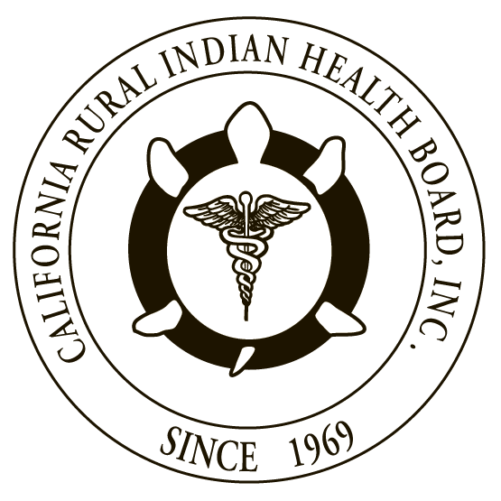

RESOLUTION # 17-04-06 RESOLUTION # 332-07-17
NORTHWEST PORTLAND AREA CALIFORNIA RURAL INDIAN
INDIAN HEALTH BOARD HEALTH BOARD

JOINT RESOLUTION
Support for Adoption of “CDC Guideline for Prescribing Opioids for Chronic Pain” by Indian Health Service facilities and Tribal Health Organizations

WHEREAS, the Northwest Portland Area Indian Health Board (NPAIHB) is a Tribal organization under P.L. 93-638 that represents 43 federally-recognized Indian Tribes in Oregon, Washington, and Idaho and is dedicated to assisting and promoting the health needs and concerns of American Indian/Alaska Native (AI/AN) people in the Northwest; AND

WHEREAS, the California Rural Indian Health Board, Inc. (CRIHB), founded in 1969 for the purpose of bringing back health services to Indians of California, is a Tribal organization in accordance with P.L. 93-638 and is a statewide Tribal health organization representing 33 federally recognized tribes in 14 counties through its membership of 12 Tribal Health Programs throughout California’s Indian Country; AND

WHEREAS, the NPAIHB and CRIHB are dedicated to assisting and promoting the health needs and concerns of AI/AN people; AND

WHEREAS, the primary goal of the NPAIHB and CRIHB is to improve the health and quality of life of its member Tribes; AND

WHEREAS, opioid prescriptions have risen dramatically over the past 15 to 20 years and the annual incidence of opioid overdose and deaths have also risen nationally; AND

WHEREAS, people in rural counties are nearly twice as likely to overdose on prescription painkillers as people in big cities and many Tribal communities are located in rural areas; AND

WHEREAS, AI/AN people are more likely to overdose on prescription painkillers; AND

WHEREAS, AI/AN people in the Northwest (Oregon, Idaho, and Washington) are two times more likely to fatally overdose on prescription painkillers compared to non-Hispanic Whites in the region; AND

WHEREAS, the California Public Health Department has identified that some of the highest rates of opioid overdose in the United States are in Northern California, with some counties’ opioid prescription death rates 2 - 3 times higher than the national average; AND

WHEREAS, the Centers for Disease Control and Prevention (CDC) developed and published the CDC Guideline for Prescribing Opioids for Chronic Pain to provide recommendations for the prescribing of opioid pain medication for patients 18 and older in primary care settings; AND

WHEREAS, adoption of the CDC Guideline for Prescribing Opioids for Chronic Pain by Indian Health Service (IHS) and Tribal Health Organizations in California, Idaho, Oregon and Washington would improve how opioids are prescribed to AI/AN patients; and ensure that AI/AN patients have access to safer, more effective chronic pain treatment, while reducing the number of AI/AN people who abuse or overdose from these drugs.

THEREFORE BE IT RESOLVED that the NPAIHB and CRIHB support adoption of the CDC Guideline for Prescribing Opioids for Chronic Pain by Indian Health Service and Tribal Health Organizations in the states of California, Idaho, Oregon and Washington to reduce opioid addiction, overdose and death of AI/AN people.

CERTIFICATION

The foregoing joint resolution was adopted at a duly called regular joint meeting of the Board of Directors of Northwest Portland Area Indian Health Board and California Rural Indian Health Board (NPAIHB vote __ For and _ Against and _ Abstain; CRIHB vote __ For and _ Against and _ Abstain) held this day of July 2017 in Canyonville, Oregon and shall remain in full force and effect until rescinded.

NORTHWEST PORTLAND AREA CALIFORNIA RURAL
INDIAN HEALTH BOARD INDIAN HEALTH BOARD
2121 SW Broadway, Suite 300 4400 Auburn Blvd, 2nd Floor
Portland, OR 97201 Sacramento, CA 95841
(503) 228-4185 (916) 929-9761

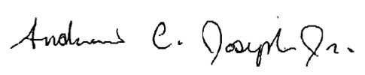
_________________________ __________________________
Chairperson of the Board Chairperson of the Board

_________________________ __________________________
Attest Attest

