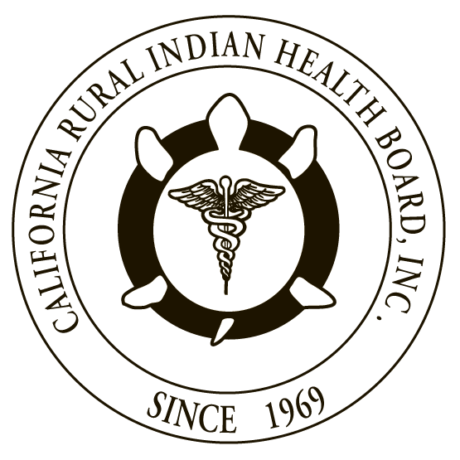
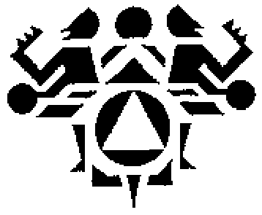

RESOLUTION # 17-04-05 RESOLUTION #
NORTHWEST PORTLAND AREA CALIFORNIA RURAL INDIAN
INDIAN HEALTH BOARD HEALTH BOARD

JOINT RESOLUTION
Preserve the Indian Health Care Improvement Act and other provisions that directly benefit the Indian health system

WHEREAS, the Northwest Portland Area Indian Health Board (NPAIHB) is a Tribal organization under P.L. 93-638 that represents 43 federally-recognized Indian Tribes in Oregon, Washington, and Idaho and is dedicated to assisting and promoting the health needs and concerns of American Indian/Alaska Native (AI/AN) people in the Northwest; AND

WHEREAS, the California Rural Indian Health Board, Inc. (CRIHB), founded in 1969 for the purpose of bringing back health services to Indians of California, is a Tribal organization in accordance with P.L. 93-638 and is a statewide Tribal health organization representing 33 federally recognized tribes in 14 counties through its membership of 12 Tribal Health Programs throughout California’s Indian Country; AND

WHEREAS, the NPAIHB and CRIHB are dedicated to assisting and promoting the health needs and concerns of AI/AN people; AND

WHEREAS, the primary goal of the NPAIHB and CRIHB is to improve the health and quality of life of its member Tribes; AND

WHEREAS, AI/ANs are experiencing vast health inequities as evidenced by high rates of cancer, diabetes, trauma, mental and substance use disorders (including suicide), and unintentional injury. Compared with all other races, AI/ANs are most likely to live in poverty (28.3% compared with 15.5% for the U.S. general population); AND

WHEREAS, the Indian Health Care Improvement Act (IHCIA) is the legislative embodiment of the federal trust and treaty responsibilities to AI/AN people for healthcare and was a result of years of negotiations, meetings, and strategy sessions between Tribes and Congress, resulting in bipartisan legislation; AND

WHEREAS, the IHCIA was first enacted in 1976 and then permanently enacted in 2010 as part of the Patient Protection and Affordable Care Act (ACA) (P.L. 111-148); AND

WHEREAS, the IHCIA states that “it is the policy of this Nation, in fulfillment of its special trust responsibilities and legal obligations to Indians -- to ensure the highest possible health status for Indians and urban Indians and to provide all resources necessary to effect that policy” and reaffirms a system for the federal government to do so; AND

WHEREAS, since 2010, the IHCIA has provided significant progress in the IHS/Tribal/Urban (I/T/U) system, such as updated and modernized health delivery services, a continuum of care through integrated behavioral health programs, and cost-saving and reimbursement provisions for IHS and Tribes; AND

WHEREAS, other provisions also exist within the ACA, separate from IHCIA, that are unrelated to the overall healthcare reform legislation. They are as follows:
- Section 2901 which states that any I/T/U must be the payer of last resort for services provided notwithstanding any federal, state, or local law to the contrary
- Section 2902 which grants I/T/U providers permanent authority to collect reimbursements for all Medicare Part B services
- Section 9021 ensures that any health benefits provided by a Tribe to its members are not included as taxable income
- Medicaid Benefits for AI/ANs. Under current law, the federal government reimburses States for 100 percent of the cost of providing Medicaid services to AI/ANs; AND

WHEREAS, repealing these provisions and the IHCIA now would have disastrous consequences for the Indian health system. I/T/Us would lose critical third party revenue, legal authorities, and life-saving programs.

THEREFORE BE IT RESOLVED, that CRIHB and NPAIHB urge the U.S. Congress to ensure that the IHCIA and Indian-specific provisions in any health care reform legislation are preserved so the Indian health system can continue to operate under a framework appropriate for 21st century healthcare delivery that honors the United States’ trust responsibility to provide healthcare to AI/ANs; AND

BE IT FINALLY RESOLVED, that any plan to change the manner in which State Medicaid costs are reimbursed by the federal government must include a carve out for services provided to AI/ANs so that the federal government’s trust responsibility is not shifted to the States.

CERTIFICATION

The foregoing joint resolution was adopted at a duly called regular joint meeting of the Board of Directors of Northwest Portland Area Indian Health Board and California Rural Indian Health Board (NPAIHB vote __ For and _ Against and _ Abstain; CRIHB vote __ For and _ Against and _ Abstain) held this day of July 2017 in Canyonville, Oregon and shall remain in full force and effect until rescinded.

NORTHWEST PORTLAND AREA CALIFORNIA RURAL
INDIAN HEALTH BOARD INDIAN HEALTH BOARD
2121 SW Broadway, Suite 300 4400 Auburn Blvd, 2nd Floor
Portland, OR 97201 Sacramento, CA 95841
(503) 228-4185 (916) 929-9761

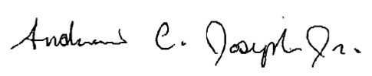
_________________________ __________________________
Chairperson of the Board Chairperson of the Board

_________________________ __________________________
Attest Attest

U.S. Census Bureau. (2015). FFF: American Indian and Alaska Native Heritage Month. Retrieved December 21, 2015, from http://www.census.gov/newsroom/facts-for-features/2015/cb15-ff22.html.
25 U.S.C. § 1602.

