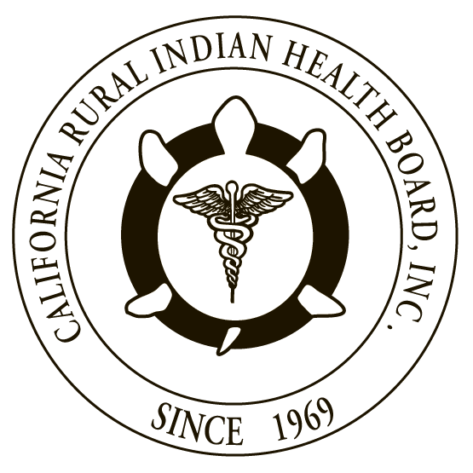

RESOLUTION # 17-04-04 RESOLUTION #
NORTHWEST PORTLAND AREA CALIFORNIA RURAL INDIAN
INDIAN HEALTH BOARD HEALTH BOARD

JOINT RESOLUTION
Request to Congress to Honor Federal Trust Responsibility and Maintain 100 Percent Federal Medical Assistance Percentage (FMAP) in Medicaid Reform

WHEREAS, the Northwest Portland Area Indian Health Board (NPAIHB) is a Tribal organization under P.L. 93-638 that represents 43 federally-recognized Indian Tribes in Oregon, Washington, and Idaho and is dedicated to assisting and promoting the health needs and concerns of American Indian/Alaska Native (AI/AN) people in the Northwest; AND

WHEREAS, the California Rural Indian Health Board, Inc. (CRIHB), founded in 1969 for the purpose of bringing back health services to Indians of California, is a Tribal organization in accordance with P.L. 93-638 and is a statewide Tribal health organization representing 33 federally recognized tribes in 14 counties through its membership of 12 Tribal Health Programs throughout California’s Indian Country; AND

WHEREAS, the NPAIHB and CRIHB are dedicated to assisting and promoting the health needs and concerns of AI/AN people; AND

WHEREAS, the primary goal of the NPAIHB and CRIHB is to improve the health and quality of life of its member Tribes; AND

WHEREAS, the United States has a unique trust responsibility to provide health care to AI/AN people, founded in treaties and other historical relations with Tribes, and reflected in numerous statutes; AND

WHEREAS, in 1976, in recognition of this federal obligation, Congress amended the Social Security Act to authorize Medicare and Medicaid reimbursement for services provided in Indian Health Service (IHS) and Tribal health organizations; AND

WHEREAS, Congress also acted to ensure that States would be reimbursed at a 100 percent federal medical assistance percentage (FMAP) for Medicaid services to AI/AN people that are received through the Indian health system; AND

WHEREAS, Medicaid reimbursements are critically important in filling the gap created by chronic underfunding of IHS, and are a critical source of funding for Tribes; AND

WHEREAS, Medicaid reimbursements received through the Indian health system only represent a fraction of one percent of total Medicaid funding; AND

WHEREAS, Congress’ maintenance of full federal funding for Medicaid services received through the Indian health system will not adversely affect the overall effort to cap and control federal Medicaid spending; AND

WHEREAS, it is critical for Congress to ensure that any Medicaid reform proposal honors the federal trust responsibility for Indian health care, rather than passing that obligation on to the states through per capita allocations, block grants or other mechanisms that may be under consideration.

THEREFORE BE IT RESOLVED that the NPAIHB and CRIHB request that Congress, in any Medicaid reform effort, honor the federal trust responsibility and maintain 100 percent FMAP reimbursement rate for Medicaid services provided to AI/AN people that are received through the Indian health system.

CERTIFICATION

The foregoing joint resolution was adopted at a duly called regular joint meeting of the Board of Directors of Northwest Portland Area Indian Health Board and California Rural Indian Health Board (NPAIHB vote __ For and _ Against and _ Abstain; CRIHB vote __ For and _ Against and _ Abstain) held this day of July 2017 in Canyonville, Oregon and shall remain in full force and effect until rescinded.

NORTHWEST PORTLAND AREA CALIFORNIA RURAL
INDIAN HEALTH BOARD INDIAN HEALTH BOARD
2121 SW Broadway, Suite 300 4400 Auburn Blvd, 2nd Floor
Portland, OR 97201 Sacramento, CA 95841
(503) 228-4185 (916) 929-9761

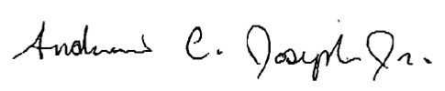
_________________________ __________________________
Chairperson of the Board Chairperson of the Board

_________________________ __________________________
Attest Attest

42 U.S.C. § 1395qq and § 1396j

