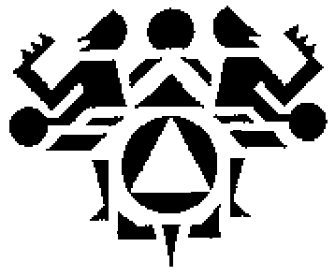
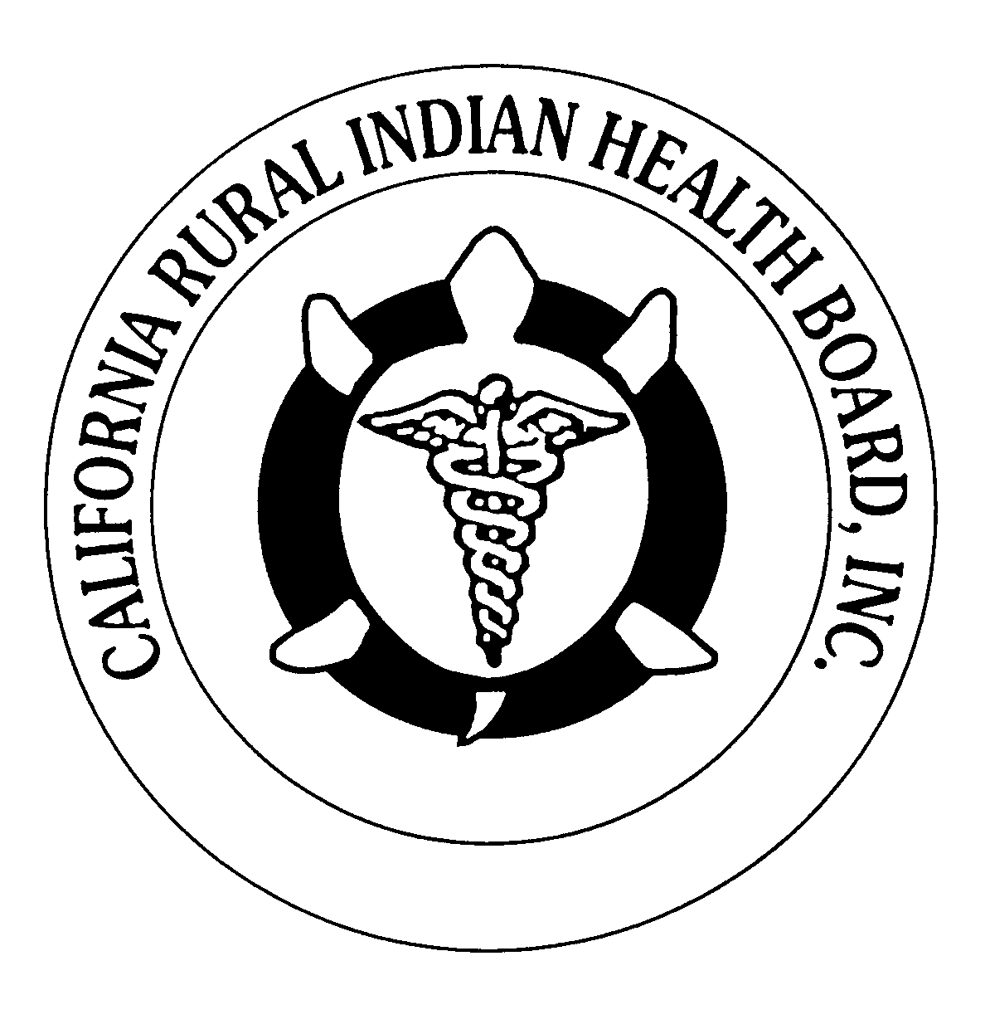

RESOLUTION # RESOLUTION # 185-07-03

NORTHWEST PORTLAND AREA CALIFORNIA RURAL
INDIAN HEALTH BOARD INDIAN HEALTH BOARD

JOINT RESOLUTION

In support of Tribes and Tribal Organizations contributing amounts equal to their tribal shares directly to NIHB to support legislative advocacy

WHEREAS, the Northwest Portland Area Indian Health Board (NPAIHB) is a tribal organization under P.L. 93-638 that represents forty-three Federally-recognized Indian tribes in Oregon, Washington and Idaho and is dedicated to assisting and promoting the health needs and concerns of Indian people in the Northwest; AND

WHEREAS, the California Rural Indian Health Board, Inc. (CRIHB), founded in 1969 for the purpose of bringing back health services to Indians of California; is a tribal organization in accordance with Public Law 93-638, is a statewide tribal health organization representing 36 Federally recognized tribes in 21 counties through it’s membership of 11 Indian Health Programs throughout California’s Indian Country; AND

WHEREAS, the NPAIHB and CRIHB are dedicated to assisting and promoting the health needs and concerns of Indian people; AND

WHEREAS, the primary goal of the NPAIHB and CRIHB is to improve the health and quality of life of its member tribes; AND

WHEREAS, the National Indian Health Board (NIHB) is the oldest national Indian health organization founded in 1985, headquarters located in Denver Colorado, to advocate for the improvement of health care services to the American and Alaska Native peoples and to serve as a forum for the development of national consensuses on Indian health policy issues and serves as the standing health committee for the National Congress of American Indians; AND

WHEREAS, core funding NIHB was provided by the Indian Health Service through the Office of Tribal Activities; AND

WHEREAS, IHS funding for the NIHB was defined as divisible and made subject to the Tribal Shares allocation formula resulting in numerous Tribes and Tribal Health Organizations exercising their option under the Indian Self Determination Act to contract directly; AND

WHEREAS, this has resulted in a reduction in core operating support for the NIHB and created a situation in which some Tribes and Tribal Organizations are in effect funding a governance structure that still equally represents all twelve areas of the IHS organizational structure and maintains its mission to all Tribes and Tribal Organizations serviced by that structure; AND

WHEREAS, the NIHB has recently relocated to the District of Columbia in order to more effectively advocate for the benefit of all American Indians and Alaska Natives and has assumed new responsibilities to advocate directly with the Congress of the United States on the behalf of all American Indians and Alaska Natives;

THEREFORE BE IT RESOLVED THAT; resolved by this body, the Northwest Portland Area Indian Health Board and the California Rural Indian Health Board meeting in joint session that all Tribes and Tribal Organizations that have contracted with the Indian Health Service for their NIHB Tribal Share amounts are urged to provide contributions in amounts equal to those tribal shares amounts directly to the NIHB to support the function of legislative advocacy which is not fundable with federal funds.

CERTIFICATION

The foregoing joint resolution was adopted at a duly called regular joint meeting of the Board of Director’s of Northwest Portland Area Indian Health Board and California Rural Indian Health Board (NPAIHB vote ___ For and_____ Against and _____ Abstain; CRIHB vote ___ For and ___ Against and ______ Abstain) held this 19th day of July 2003 in Reno, Nevada and shall remain in full force and effect until rescinded.

NORTHWEST PORTLAND AREA CALIFORNIA RURAL
INDIAN HEALTH BOARD INDIAN HEALTH BOARD
527 SW Hall, Suite 300 4400 Auburn Blvd; 2nd Floor
Portland, OR 97201 Sacramento, CA. 95841
(503) 228-4185 (916) 929-9761

________________________ _____________________
Chairperson of the Board Chairperson of the Board

________________________ _____________________
Attest Attest

