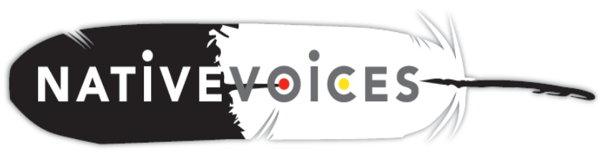

**The Native VOICES Project is housed at the Northwest Portland Area Indian Health Board, and is supported by the Indian Health Service’s Native American Research Centers for Health (NARCH) program. Results from a national effectiveness study will be available in early 2015. The video and an implementation toolkit will be available free-of-charge in January 2015.**

For more information, contact

Mattie Tomeo-Palmanteer: ph: (503) 416-3294

⬩ [mattie@npaihb.org](mailto:mattie@npaihb.org) ⬩ [native@npaihb.org](mailto:native@npaihb.org) ⬩

**An evidence-based sexual health video for**

**American Indian teens and young adults (15-24 years old)**

Native VOICES (Video Opportunities for Innovative Condom Education and Safer Sex) is a single-session, video-based intervention designed to prevent HIV and other sexually transmitted diseases. The video was adapted from VOICES, an effective behavioral HIV prevention intervention recognized by the Centers for Disease Control and Prevention. The 23-minute video was designed to encourage condom use and improve condom negotiation skills among heterosexual and LGBTQ (Lesbian, Gay, Bisexual, Trans and Queer) American Indian/Alaska Native teens and young adults 15-24 years old. The DVD also includes brief condom and dental dam demonstrations.

**Red carpet showings of the video suggest promising results!**

* Over 94% of those surveyed enjoyed the video
* 98% - found the video to be culturally appropriate for American Indian people
* 98% - felt the information could be trusted
* 82% - felt the video was better than other sexual health lessons they’d had
* 90% - felt the video showed real life situations with characters they could relate to
* 92% - indicated that the video will help them make healthy life choices
* 88% - could see themselves or their friends in the situations presented in the video
* 94% - felt that the things the actors did and said in the video about condoms and

negotiating safe sex would work for them

**After watching the video, 72% of respondents felt more likely to get tested for STDs/HIV, 65% felt more likely to use condoms, and 43% felt more likely to use dental dams.**