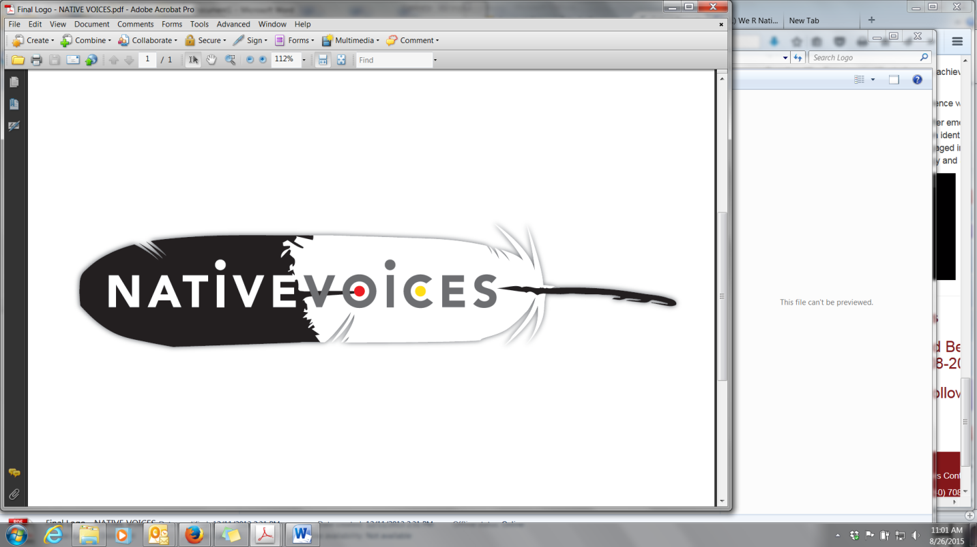

## Project Red Talon, Northwest Portland Area Indian Health Board

Background

American Indian and Alaska Native (AI/AN) youth experience disproportionate rates of sexually transmitted infections (STI). Despite their need for culturally appropriate sexual health interventions, few evidence-based programs have been designed for or rigorously evaluated with AI/AN youth. The primary goal of this study was to adapt a video-based HIV/STI intervention for AI/AN teens and young adults (15-24 years old), and evaluate its impact among Native youth living in urban and reservation settings.

Rationale

Health issues that affect teens and young adults are particularly relevant in Indian Country. Youth are torchbearers of tradition and the future leaders of our communities. They are also a relatively large portion of the American Indian and Alaska Native (AI/AN or Native) population. Notably, roughly one-third of Native persons are 18 years or younger, compared to 24% of the total U.S. population, and as of 2015, 1.5 million AI/AN youth reside across Indian Country (Office of Minority Health, 2015).

Of particular importance are inequities related to sexual health. Stemming from a younger than average sexual début and lower rates of consistent condom use (de Ravello, Tulloch, & Taylor, 2012; Hellerstedt, 2004; Kaufman, Beals, Mitchell, LeMaster, & Fickenscher, 2004), AI/AN youth experience disproportionate rates of sexually transmitted infections (de Ravello et al., 2012). In 2009, AI/ANs had the second highest rates of chlamydia reported among all races and ethnicities; with the highest rates occurring among young people 15-24 years old (CDC and IHS, 2012). Sexually active youth are particularly vulnerable to Human Immunodeficiency Virus (HIV) transmission; nearly one-quarter of new HIV infections in the U.S. occur among teens and young adults (Centers for Disease Control and Prevention, 2015).

The sexual health of Native youth is influenced by a number of socioecological factors, including high levels of poverty and substance use, insufficient sex education, poor access to reproductive health services, stigma, sexual violence, and historical trauma (de Ravello et al., 2012).

Native young people’s reproductive decisions are also shaped by social norms and sexual contexts that include both traditional and contemporary cultural values (Kaufman et al., 2007). As a result, mainstream sexual health campaigns and curricula are often inappropriate and ineffective for AI/AN youth. To meet the unique needs of AI/AN youth, sexual health programs must be tailored to reflect their cultural contexts and values (Craig Rushing & Stephens, 2011; [Gilley, 2006](#_ENREF_9" \o "Gilley, 2006 #280)).

Native VOICES Adaptation

The Native VOICES intervention was adapted from two evidence-based interventions (EBI) recognized by the Centers for Disease Control and Prevention (CDC): *Video Opportunities for Innovative Condom Education and Safer Sex* (*VOICES*) and *Safe in the City*. Given the substantial time and cost associated with designing effective interventions, the CDC strongly encourages that communities “adapt” EBIs to better reflect their own social and cultural context, without altering the intervention’s core elements (Wingood & DiClemente, 2008). Prior to this study, none of the EBIs included in the CDC’s compendium of high-impact HIV prevention interventions were designed for, or rigorously evaluated with AI/AN youth (see: [www.effectiveinterventions.org](http://www.effectiveinterventions.org)).

During the first two years of the project, the Northwest Portland Area Indian Health Board partnered with two NW Tribes and one Urban Indian clinic to carryout focus groups and key informant interviews with teens and young adults, to better understand their knowledge and attitudes towards sexual health. Young men who have sex with men (MSM) and young women who have sex with women (WSW) were also consulted, to ensure their perspectives and concerns were reflected in the video. Personnel at tribal health departments, tribal clinics, schools, and other youth-serving programs were also consulted to ensure the resultant intervention could be practically implemented and sustained over time.

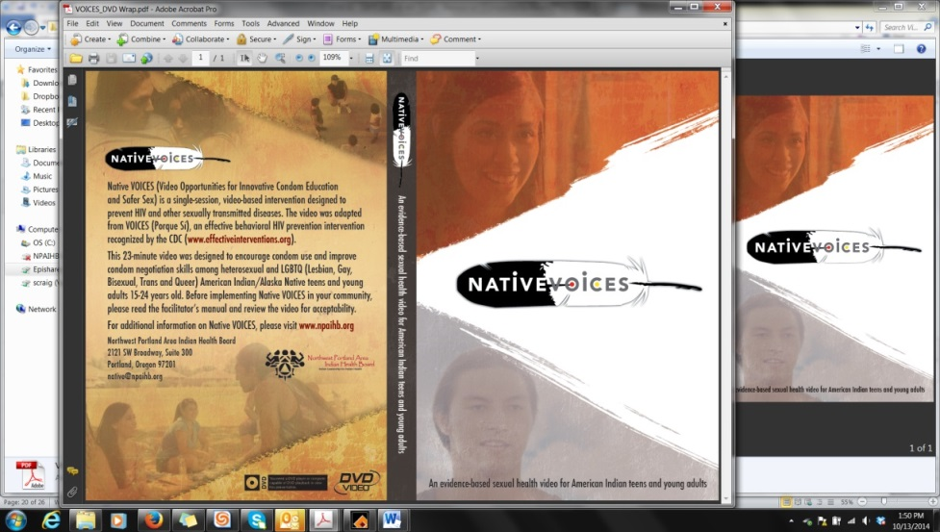During the third year of the project, AI/AN teens and young adults from across the U.S. read or reenacted iterative drafts of the adapted script, and provided feedback on the characters, scenes, tone, and dialogue. The adapted Native VOICES video was shot on location in Oklahoma City in August 2013.

The video shows Native actors in situations that AI/AN youth can find relatable – playing basketball with friends, at a party at a private home, traveling between urban and rural environments, and seeking advice from older family members and friends. The video demonstrates condom negotiation and acquisition, as well as the importance of talking about STIs with sexual partners.

Native VOICES Evaluation

In 2014, the NPAIHB partnered with nine tribes across the U.S. to evaluate the effectiveness of the Native VOICES intervention. The sites included schools, youth centers, and tribal centers in Oregon, Minnesota, California, Mississippi, Montana, Arizona, Idaho, and Washington.

The tribal sites were randomized into one of three study arms:

1. Fact sheets alone (standard of care)
2. Fact sheets plus the Native VOICES video (intervention)
3. Fact sheets plus the Native VOICES video plus a facilitated discussion (intervention+)

Together, the sites recruited and consented nearly 800 AI/AN youth 15-24 years old to participate in the Native VOICES study.

|  |  |  |  |
| --- | --- | --- | --- |
| Study Arm | Arm 1 | Arm 2 | Arm 3 |
| Intervention received | Fact sheets | Fact sheets plus the  VOICES video | Fact sheets plus the VOICES video,  with a facilitated discussion |
| Number of participants (Baseline) | 337 youth | 253 youth | 198 youth |
| Number of participants  (6-month follow-up) | 238 youth | 186 youth | 131 youth |

Changes in participant knowledge, attitude, intention and behavior were evaluated using pre-, post-, and 6 month follow-up surveys. The Native VOICES surveys included demographic questions about age, sex, race/ethnicity, and sexual orientation; knowledge questions about proper use of condoms, and STD infection and symptoms; attitude questions about using and procuring condoms and dental dams; and risk behavior questions about vaginal, oral, and anal sex.

*Power and Sample Size*

In order to achieve a balance of urban and rural sites in each arm, as well as similar numbers of participants in each arm, a block randomization strategy was employed. The nine sites in this study were randomized to three treatment arms. Each arm was limited to 300 participants, and was randomly assigned one urban site and two rural sites.

*Methods*

Confidential survey data were collected before and after the intervention for 788 AI/AN youth 15-24 years old. Participants were recruited by local site coordinators who obtained informed consent from participants. A signed consent form was also obtained from the parents of minors. A $20 cash or gift card incentive was offered to participants following completion of the post-intervention survey. IRB approval was obtained from the Portland Area Indian Health Service Institutional Review Board and other local Institutional Review Board(s).

The three study arms contained 337, 253, and 198 participants respectively. Due to the dedication and hard work of the local site coordinators, nearly 75% of the study participants completed six-month follow-up surveys.

De-identified survey responses were entered into a Microsoft Access database, and a subset of 258 surveys were double entered to check for agreement. Following double data entry, the percent disagreement was 0.8% for all entered responses. Data were exported from Access to a Stata data set for analysis.

The primary constructs measured via pre- and post-intervention surveys were knowledge, attitudes towards condoms and dental dams, and self-efficacy or intention to use condoms and dental dams. Aggregate scores were created for each construct (knowledge, condom attitudes, dental dam attitudes, condom intent, and dental dam intent) based on the number of correct or ideal answers to survey questions.

Results

**Participant Demographics**

|  |  |  |
| --- | --- | --- |
|  | Total | |
| Demographic characteristics | n | % |
|  |  |  |
| **Age** |  |  |
| 15-19 | 595 | 76.0 |
| 20-24 | 188 | 24.0 |
|  |  |  |
| **Sex** |  |  |
| Male | 305 | 44.7 |
| Female | 377 | 55.2 |
| Other | 1 | 0.2 |
|  |  |  |
| **Race/Ethnicity** |  |  |
| American Indian or Alaska Native | 516 | 75.4 |
| AI/AN and White | 45 | 6.6 |
| AI/AN and African-American | 17 | 2.5 |
| AI/AN and Hispanic or Latino | 77 | 11.3 |
| AI/AN and Asian or Pacific Islander | 2 | 0.3 |
| AI/AN and Other | 21 | 3.1 |
| AI/AN and Two or More Others | 6 | 0.9 |
|  |  |  |
| **Sexual Orientation** |  |  |
| Straight | 589 | 87.5 |
| LGBT | 84 | 12.5 |
|  |  |  |
| **Geography** |  |  |
| Rural | 460 | 67.0 |
| Urban | 227 | 33.0 |
|  |  |  |
| **Total** | **788** | **100** |
|  |  |  |

A total of 788 AI/AN youth participated in the Native VOICES baseline survey. Just over half (55%) were female; 45% were male. Nearly three-quarters (76%) were 15-19 years old; one-quarter (24%) were 20-24 years old. Two-thirds (67%) lived in rural or tribal communities, and one-third (33%) lived in urban communities. Over 12% identified as lesbian, gay, bisexual, transgender, or two spirit (LGBT-TS).

**Video Satisfaction – Arms 2 & 3 (n=443 respondents)**

**On a scale from 1-5, how much did you enjoy watching the Native VOICES video?**

**Do you think the Native VOICES video is culturally appropriate for Native people?** 93% agreed

**Were the characters in the Native VOICES video realistic?** 86% agreed

**Were the scenes and situations in the Native VOICES video realistic?** 86% agreed

**Did the Native VOICES video change your views about:**

|  |  |  |
| --- | --- | --- |
|  | n | % |
|  |  |  |
| **Using condoms?** |  |  |
| Yes, I am **more** likely to | 341 | 78.4 |
| Yes, I am **less** likely to | 12 | 2.8 |
| No, my opinion did not change | 82 | 18.9 |
|  |  |  |
| **Using dental dams?** |  |  |
| Yes, I am **more** likely to | 258 | 60.9 |
| Yes, I am **less** likely to | 21 | 5.0 |
| No, my opinion did not change | 145 | 34.2 |
|  |  |  |
| **Getting tested for STDs/HIV?** |  |  |
| Yes, I am **more** likely to | 357 | 82.3 |
| Yes, I am **less** likely to | 19 | 4.4 |
| No, my opinion did not change | 58 | 13.4 |
|  |  |  |

**Changes in STD/HIV Knowledge**

**Average Changes in Participant Knowledge, by Study Arm**

**Average Knowledge Retention, by Study Arm**

|  |  |  |  |  |  |  |  |  |  |  |
| --- | --- | --- | --- | --- | --- | --- | --- | --- | --- | --- |
| Study Arm | Pre-Intervention | | Post-Intervention | | Six Months Post-Intervention | | Pre to Post-Intervention Difference | | Pre to 6 Months Post Intervention Difference | |
| Mean Score | St Dev | Mean Score | St Dev | Mean Score | St Dev | Mean Change | p | Mean Change | p |
|  |  |  |  |  |  |  |  |  |  |  |
| 1 | 8 | 2.6 | 9.4 | 2.2 | 9.1 | 2.2 | 1.4 | **<.0001** | 1.1 | **<.0001** |
| 2 | 8.1 | 2.5 | 9.5 | 1.7 | 9.3 | 1.9 | 1.4 | **<.0001** | 1.2 | **<.0001** |
| 3 | 6.6 | 2.9 | 7.9 | 2.9 | 7.4 | 3 | 1.3 | **<.0001** | 0.8 | **0.0095** |
|  |  |  |  |  |  |  |  |  |  |  |

**Discussion**: An aggregate score for “STD/HIV knowledge” was created for each participant, based on the number of correct answers to 11 true-false survey questions [e.g. You can tell if your partner has an STD by examining him or her (*false*), Some STDs make women unable to have children (*true*), Space should be left at the tip of a condom when it is applied (*true*)].

On average, the “STD/HIV knowledge” score increased across all three study arms from pre- to post-test (p=<.0001). Notably, improvements STD/HIV knowledge were retained by all three study arms even after six months.

**Changes in Condom and Dental Dam Attitudes**

**Average Change in Condom Use Attitudes, by Study Arm**

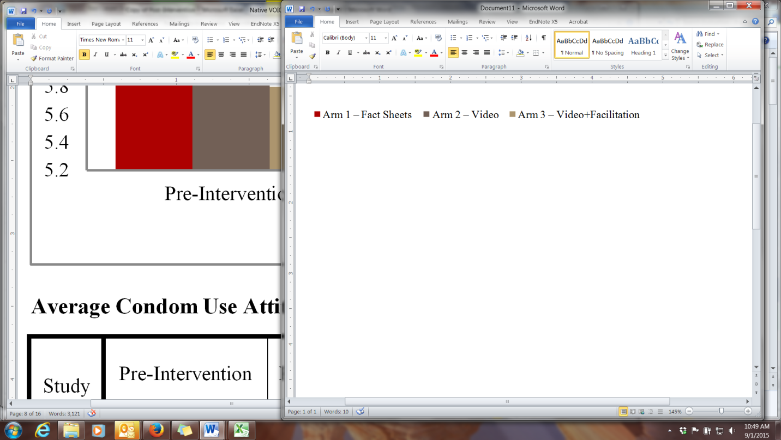

**Average Condom Use Attitude, Retention of Change, by Study Arm**

|  |  |  |  |  |  |  |  |  |  |  |
| --- | --- | --- | --- | --- | --- | --- | --- | --- | --- | --- |
| Study Arm | Pre-Intervention | | Post-Intervention | | Six Months Post-Intervention | | Pre to Post-Intervention Difference | | Pre to 6 Months Post Intervention Difference | |
| Mean Score | St Dev | Mean Score | St Dev | Mean Score | St Dev | Mean Change | p | Mean Change | p |
|  |  |  |  |  |  |  |  |  |  |  |
| 1 | 6.6 | 1.6 | 6.9 | 1.4 | 6.9 | 1.3 | 0.3 | **<.0001** | 0.3 | **0.0006** |
| 2 | 6.2 | 1.8 | 6.7 | 1.5 | 6.6 | 1.4 | 0.5 | **0.0002** | 0.4 | **0.0009** |
| 3 | 5.8 | 2.1 | 6.4 | 1.7 | 6.1 | 1.7 | 0.6 | **0.0024** | 0.3 | 0.1204 |
|  |  |  |  |  |  |  |  |  |  |  |

**Discussion**: An aggregate score for “condom attitudes” was created for each participant, based on their response to 8 agree-disagree survey questions [e.g. Condoms ruin the mood, Using a condom is too much trouble, Condoms break too often to really be safe].

On average, the “condom attitude” score improved across all three study arms from pre- to post-test, though the difference was only statistically significant in study arm 1 (p=<.0001). Improvements in condom attitudes were retained even after six months.

**Average Change in Dental Dam Use Attitudes, by Study Arm**



**Average Dental Dam Use Attitude, Retention of Change, by Study Arm**

|  |  |  |  |  |  |  |  |  |  |  |
| --- | --- | --- | --- | --- | --- | --- | --- | --- | --- | --- |
| Study Arm | Pre-Intervention | | Post-Intervention | | Six Months Post-Intervention | | Pre to Post-Intervention Difference | | Pre to 6 Months Post Intervention Difference | |
| Mean Score | St Dev | Mean Score | St Dev | Mean Score | St Dev | Mean Change | p | Mean Change | p |
|  |  |  |  |  |  |  |  |  |  |  |
| 1 | 1.4 | 2.4 | 4.8 | 2.4 | 5.5 | 2.4 | 3.4 | **<.0001** | 4.1 | **<.0001** |
| 2 | 1.6 | 2.4 | 5.2 | 2.3 | 5.7 | 2.2 | 3.6 | **<.0001** | 4.1 | **<.0001** |
| 3 | 1.3 | 2.4 | 5.7 | 2.2 | 6.4 | 2.4 | 4.4 | **<.0001** | 5.1 | **<.0001** |
|  |  |  |  |  |  |  |  |  |  |  |

**Discussion**: An aggregate score for “dental dam attitudes” was created for each participant, based on their response to 9 agree-disagree survey questions [e.g. Using a dental dam turns me off, It is easy to get dental dams, I am worried what others would think if I were to get dental dams].

On average, the “dental dam attitude” score improved dramatically across all three study arms from pre- to post-test (p=<.0001). Statistically significant improvements in youth’s attitudes towards dental dams were retained even after six months.

**Changes in Condom and Dental Dam Intentions**

**Average Change in Condom Use Intentions, by Study Arm**



**Average Condom Use Intention, Retention of Change, by Study Arm**

|  |  |  |  |  |  |  |  |  |  |  |
| --- | --- | --- | --- | --- | --- | --- | --- | --- | --- | --- |
| Study Arm | Pre-Intervention | | Post-Intervention | | Six Months Post-Intervention | | Pre to Post-Intervention Difference | | Pre to 6 Months Post Intervention Difference | |
| Mean Score | St Dev | Mean Score | St Dev | Mean Score | St Dev | Mean Change | p | Mean Change | p |
|  |  |  |  |  |  |  |  |  |  |  |
| 1 | 3.7 | 1.7 | 3.5 | 1.5 | 3.9 | 1.8 | -0.2 | 0.9998 | -3.7 | **0.0332** |
| 2 | 3.4 | 1.7 | 3.4 | 1.6 | 3.6 | 1.7 | 0 | 0.7025 | -3.4 | 0.161 |
| 3 | 3.0 | 1.9 | 3.0 | 1.8 | 3.4 | 1.9 | 0 | 0.8401 | -3 | **0.0004** |
|  |  |  |  |  |  |  |  |  |  |  |

**Discussion**: An aggregate score for “condom use intention/self-efficacy” was created for each participant, based on their response to 5 sure-not sure survey questions [e.g. How sure are you that you could tell your partner you want to start using condoms for vaginal sex? How sure are you that you could use a condom correctly? How sure are you that you could get a condom?].

On average, the post-intervention “condom use self-efficacy” score decreased slightly among those who viewed only the fact sheets, while it held steady among those who viewed the video as well. After six months, all three study arms demonstrated improvements in condom use self-efficacy, which were statistically significant in arms 1 and 3 (p=<.05).

**Average Change in Dental Dam Use Intentions, by Study Arm**



**Average Dental Dam Use Intention, Retention of Change, by Study Arm**

|  |  |  |  |  |  |  |  |  |  |  |
| --- | --- | --- | --- | --- | --- | --- | --- | --- | --- | --- |
| Study Arm | Pre-Intervention | | Post-Intervention | | Six Months Post-Intervention | | Pre to Post-Intervention Difference | | Pre to 6 Months Post Intervention Difference | |
| Mean Score | St Dev | Mean Score | St Dev | Mean Score | St Dev | Mean Change | p | Mean Change | p |
|  |  |  |  |  |  |  |  |  |  |  |
| 1 | 0.44 | 0.85 | 0.95 | 1.12 | 0.71 | 1.01 | 0.51 | **<.0001** | 0.27 | **0.0001** |
| 2 | 0.40 | 0.71 | 0.83 | 1.00 | 0.79 | 1.00 | 0.43 | **<.0001** | 0.39 | **<.0001** |
| 3 | 0.49 | 0.88 | 0.98 | 1.16 | 0.82 | 1.17 | 0.49 | **<.0001** | 0.33 | **0.0011** |
|  |  |  |  |  |  |  |  |  |  |  |

**Discussion**: An aggregate score for “dental dam intention/self-efficacy” was created for each participant, based on their response to 3 sure-not sure survey questions [e.g. How sure are you that you could tell your partner you want to start using dental dams? How sure are you that you could use a dental dam correctly? How sure are you that you could get a dental dam?].

On average, the “dental dam intention/self-efficacy” score improved dramatically across all three study arms from pre- to post-test (p=<.0001). Statistically significant improvements in youth’s intentions to use dental dams were retained even after six months.

**Baseline Behavior**

|  |  |  |  |  |  |  |
| --- | --- | --- | --- | --- | --- | --- |
|  |  | Age Group | |  | Sex | |
| Risk Behaviors in Sexually Active Respondents | Total % | 15-19 | 20-24 |  | Male | Female |
| **Ever had sexual intercourse (inclusive of vaginal, oral, and anal)** | **72.7** | **66.1** | **95.2** |  | **73.7** | **72.9** |
| Ever had vaginal sex | 67.5 | 61.3 | 86.7 |  | 68.2 | 67.5 |
| Ever had oral sex | 57.2 | 47.6 | 87.2 |  | 62.2 | 53.5 |
| Ever had anal sex | 23.2 | 18.4 | 38.0 |  | 26.1 | 21.2 |
| **Had sexual intercourse for the first time before age 13 years** | **7.8** | **8.5** | **5.9** |  | **9.8** | **6.4** |
| Had vaginal sex for the first time before 13 years | 6.2 | 6.6 | 4.8 |  | 7.5 | 5.1 |
| Had oral sex for the first time before 13 years | 4.1 | 4.4 | 3.2 |  | 6.2 | 2.5 |
| Had anal sex for the first time before 13 years | 1.6 | 1.9 | 2.7 |  | 2.7 | 1.6 |
| **Had sexual intercourse with four or more people** | **32.6** | **24.9** | **55.9** |  | **37.6** | **28.3** |
| Had vaginal sex with four or more people | 28.0 | 20.9 | 50.0 |  | 31.6 | 25.3 |
| Had oral sex with four or more people | 14.8 | 9.9 | 28.7 |  | 19.7 | 10.3 |
| Had anal sex with four or more people | 6.3 | 6.2 | 4.8 |  | 9.5 | 3.0 |

**Discussion**: At baseline, many of the youth who participated in the Native VOICES study reported behavior that could put them at-risk for STDs/HIV and teen pregnancy. Over 72% had ever had sexual intercourse (including vaginal, oral, and anal sex), over 7% reported having had sexual intercourse for the first time before age 13, and over one-quarter (28%) reported having had vaginal sex with four or more people in their lifetime.

Not surprisingly, rates of “ever having had sex” were higher among older participants (95% - 20-24 years old), than among younger participants (66% - 15-19 years old). And rates of “having had sex with 4 or more partners” were higher among the older participants (56%) than among younger participants (25%).

A greater percentage of the *younger* participants, on the other hand, reported having had vaginal sex for the first time before age 13 (6.6%), compared to the older participants (at 4.8%).

**Baseline Behavior**

|  |  |  |  |  |  |  |
| --- | --- | --- | --- | --- | --- | --- |
|  |  | Age Group | |  | Sex | |
| Risk Behaviors in Sexually Active Respondents | Total % | 15-19 | 20-24 |  | Male | Female |
| **Drank alcohol or used drugs before last vaginal sex (among those who have had vaginal sex)** | **22.7** | **21.8** | **24.7** |  | **26.3** | **19.9** |
| Drank alcohol or used drugs before last oral sex (among those who have had oral sex) | 24.2 | 20.0 | 32.3 |  | 24.9 | 23.8 |
| **Drank alcohol or used drugs before last anal sex (among those who have had anal sex)** | **18.9** | **18.9** | **19.0** |  | **24.1** | **13.8** |
| Did not use a condom during last vaginal sex (among those who have had vaginal sex) | 49.4 | 46.4 | 55.7 |  | 48.7 | 50.0 |
| **Did not use a condom during last oral sex**  **(out of those who have had oral sex)** | **84.9** | **83.7** | **87.0** |  | **84.3** | **85.5** |
| Did not use a dental dam during last oral sex  (among those who have had oral sex) | 91.9 | 90.3 | 94.6 |  | 88.8 | 95.2 |
| **Did not use a condom during last anal sex (out of those who have had anal sex)** | **66.8** | **61.9** | **74.0** |  | **60.4** | **73.0** |

**Discussion**: Two other high-risk behaviors include drinking alcohol or using drugs before sex, and not using protection (a condom for vaginal or anal sex; a condom or dental dam for oral sex). At baseline, roughly one-fifth of the participants (23%) reported drinking alcohol or using drugs before their last vaginal sex, and half (49%) reported not using a condom.

Both risky behaviors were more common among those who had had oral sex. At baseline, roughly one-quarter of the participants (24%) reported drinking alcohol or using drugs prior to oral sex, 85% did not use a condom, and 92% did not use a dental dam.

**6-Month Follow-up Behavior**

|  |  |  |  |  |  |  |
| --- | --- | --- | --- | --- | --- | --- |
|  |  | Age Group | |  | Sex | |
| Risk Behaviors in Sexually Active Respondents | Total % | 15-19 | 20-24 |  | Male | Female |
| **Had vaginal sex with at least one person in past three months** | **51** | **44.8** | **72.4** |  | **51.3** | **50.2** |
| Had oral sex with at least one person in past three months | 40.8 | 33.8 | 65.5 |  | 44.2 | 37.8 |
| **Had anal sex with at least one person in past three months** | **10.9** | **10.4** | **11.2** |  | **14.2** | **7.8** |
| Drank alcohol or used drugs before last vaginal sex (among those who have had vaginal sex) | 22.4 | 21 | 25 |  | 23.1 | 21.4 |
| **Drank alcohol or used drugs before last oral sex (among those who have had oral sex)** | **24.9** | **24.6** | **24.5** |  | **25** | **24.1** |
| Drank alcohol or used drugs before last anal sex (among those who have had anal sex) | 20.7 | 21 | 18.4 |  | 23.8 | 15.4 |
| **Did not use a condom during last vaginal sex (among those who have had vaginal sex)** | **52** | **50.5** | **55.7** |  | **49.4** | **54.3** |
| Did not use a condom during last oral sex  (out of those who have had oral sex) | 85.1 | 84 | 87.9 |  | 86 | 84.6 |
| **Did not use a dental dam during last oral sex**  **(among those who have had oral sex)** | **93.4** | **92.5** | **95.9** |  | **89.1** | **98** |
| Did not use a condom during last anal sex (out of those who have had anal sex) | 65.7 | 67.4 | 61.7 |  | 65 | 66.1 |

**Discussion**: At the 6-month follow-up, combining all three study arms, slightly fewer participants (22%) reported drinking alcohol or using drugs before their last vaginal sex, but slightly more (52%) reported not using a condom.

At the 6-month follow-up, combining all three study arms, slightly more participants (25%) reported drinking alcohol or using drugs prior to oral sex, and rates of condom and dental dam use during oral sex remained the same: 85% did not use a condom, and 93% did not use a dental dam.

**6 Month Behavior Change, By Study Arm**

**Discussion**: The most notable changes in protective behavior occurred between and within the three study arms. Additional analyses are now being conducted to correct for differences in baseline knowledge, attitude, and intention between the three arms, to more accurately quantify the impact that the Native VOICES intervention had on risk and protective behavior.

Discussion of Findings

**Demographics**: The study was able to successfully recruit a robust number of AI/AN youth, living in tribal and urban communities across the U.S. Just over half were female, and three-quarters were 15-19 years old. Over 12% identified as lesbian, gay, bisexual, transgender, or two spirit.

**Baseline Sexual Behavior**: At baseline, many of the youth who participated in the Native VOICES study reported engaging in behaviors that could put them at-risk for STDs/HIV and teen pregnancy. Over 72% had ever had sexual intercourse (including vaginal, oral, and anal sex), over 7% reported having had sexual intercourse for the first time before age 13, and over one-quarter (28%) reported having had vaginal sex with four or more people in their lifetime.

Not surprisingly, rates of “ever having had sex” were higher among those who were 20-24 years old (95%), compared to those who were 15-19 years old (66%). Rates of “having had sex with 4 or more people” were also higher among older participants (56%), compared to younger participants (25%). A greater percentage of the *younger* participants (6.6%), on the other hand, reported having had vaginal sex for the first time before age 13, compared to 4.8% of the older participants.

Two other high-risk behaviors include: drinking alcohol or using drugs before sex, and not using protection (a condom for vaginal or anal sex; or a condom or dental dam for oral sex). At baseline, roughly one-fifth of the participants (23%) reported drinking alcohol or using drugs before their last vaginal sex, and half (49%) reported not using a condom. These rates were slightly higher among those who had had oral sex. At baseline, roughly one-quarter (24%) reported drinking alcohol or using drugs prior to oral sex, 85% reported not using a condom, and 92% reported not using a dental dam.

**VOICES Intervention Satisfaction**: Participants in Arms 2 and 3 of the study (n=443 respondents) expressed high levels of satisfaction with the Native VOICES video. Over 90% felt the video was culturally appropriate for AI/AN people. Over 75% found it to be entertaining or highly entertaining. And 86% felt the characters, scenes, and situations in the video were realistic.

After watching the video, 78% of participants indicated that they were more likely to use condoms, 61% felt more likely to use dental dams, and 82% felt more likely to get tested for STDs/HIV.

**Changes in Sexual Health Knowledge, Attitudes, and Intentions:** Statistically significant improvements in sexual health knowledge, attitude, intention, and self-efficacy occurred across all three study arms, many of which were retained 6 months later.

An aggregate score for *STD/HIV knowledge* was created for each participant, based on the number of correct answers to 11 true-false survey questions [e.g. You can tell if your partner has an STD by examining him or her (*false*), Some STDs make women unable to have children (*true*), Space should be left at the tip of a condom when it is applied (*true*)]. The “STD/HIV knowledge” score improved for all three study arms from pre- to post-test (p=<.0001). These improvements were retained after six months.

An aggregate score for *attitude toward condom use* was created for each participant, based on their response to 8 agree-disagree survey questions [e.g. Condoms ruin the mood, Using a condom is too much trouble, Condoms break too often to really be safe]. The “condom attitude” score improved across all three study arms from pre- to post-test, though the difference was only statistically significant in study Arm 1 (p=<.0001). Improvements in condom attitudes were retained after six months.

An aggregate score for *attitude toward dental dams* was created for each participant, based on their response to 9 agree-disagree survey questions [e.g. Using a dental dam turns me off, It is easy to get dental dams, I am worried what others would think if I were to get dental dams]. The “dental dam attitude” score improved dramatically across all three study arms from pre- to post-test (p=<.0001). Statistically significant improvements in youth’s attitudes towards dental dams were retained even after six months.

An aggregate score for *condom use intention/self-efficacy* was created for each participant, based on their response to 5 sure-not sure survey questions [e.g. How sure are you that you could tell your partner you want to start using condoms for vaginal sex? How sure are you that you could use a condom correctly? How sure are you that you could get a condom?]. The “condom use self-efficacy” score decreased slightly immediately after the intervention among those who viewed only the fact sheets, while it held steady among those who viewed the video as well. After six months, all three study arms demonstrated improvements in condom use self-efficacy, which were statistically significant in Arms 1 and 3 (p=<.05).

**Changes in Risk and Protective Behavior**: Across all three study arms, slightly fewer participants (22%) reported drinking alcohol or using drugs before their last vaginal sex, during the 6-month follow-up survey, but slightly more (52%) reported not using a condom. Similarly, slightly more participants (25%) reported drinking alcohol or using drugs prior to oral sex at the 6-month follow-up survey, and rates of condom and dental dam use during oral sex remained the same: 85% did not use a condom, and 93% did not use a dental dam.

The most notable changes in protective behavior occurred between and within the three study arms. To quantify the impact of the Native VOICES intervention on risk and protective behavior, additional analyses are now being carried out to correct for differences in baseline knowledge, attitude, and intention that were present between the three study arms.

**Conclusion**: Native VOICES fills a significant need for evidence-based, sexual health interventions purposefully designed for heterosexual and LGBT-TS AI/AN youth living in reservation and urban communities. This randomized controlled trial demonstrated high levels of participant satisfaction with the Native VOICES intervention. Over 90% felt the video was culturally appropriate for AI/AN people, and 86% felt the video’s characters, scenes, and situations were relatable. Statistically significant improvements in sexual health knowledge, attitude, intention, and self-efficacy were demonstrated immediately after the intervention, and were retained after 6 months. Forthcoming analyses will help quantify the impact of the Native VOICES intervention on risk and protective behavior.

Resources to Support Implementation

A toolkit was designed to support the intervention’s dissemination and implementation in diverse tribal settings. The toolkit includes the Native VOICES video (23 minutes), a condom demonstration video (1:40 minutes), a dental dam demonstration video (1:08 minutes), a selection of condoms and dental dams, and a users’ guide.

While the toolkit encourages users to facilitate a 30-45 minute, small-group discussion after watching the video, the video can also be used independently in settings or situations where the small-group discussion is not practical or appropriate.

The toolkit can be ordered free of charge. Additional implementation tools are available on the NPAIHB website: www.npaihb.org/epicenter/project/native_voices_project

**Implementation Resources**

* [Native VOICES - Parent Information Letter](http://www.npaihb.org/images/epicenter_docs/PRT/VOICES/Native%20VOICES%20-%20Parent%20Information%20Letter.doc)
* [Intervention Recruitment Flyer - Template](http://www.npaihb.org/images/epicenter_docs/PRT/VOICES/Intervention%20Flyer%20Template.docx)
* [Answering Sensitive Questions - Tips for Facilitators](http://www.npaihb.org/images/epicenter_docs/PRT/VOICES/Sensitive%20questions.docx)
* [STD/HIV Fact Sheets](http://www.npaihb.org/images/epicenter_docs/PRT/VOICES/Fact%20Sheets%20-%20Plus%20Resources.pdf)
* [Viewer Satisfaction Survey Results](http://www.npaihb.org/images/epicenter_docs/PRT/VOICES/Red%20Carpet%20Results%20-%20One%20pager.docx)
* [Viewer Satisfaction Survey - Blank Template](http://www.npaihb.org/images/epicenter_docs/PRT/VOICES/VOICES%20Red%20Carpet%20Satisfaction%20Survey.docx)

Acknowledgements

We wish to thank the tribes, health departments, schools, youth programs, and young adults who contributed to this project. Their commitment to cultivating the health and well-being of Native youth is inspiring and unwavering. In particular, Stephanie Craig Rushing, Wendee Gardner, Mattie Tomeo-Palmanteer, and Lauren Adrian made significant contributions to the Native VOICES project.

**Disclosure of Funding**: This study was funded through a grant from the Native American Research Centers for Health (NARCH V U26IHS300290).

**Northwest Portland Area Indian Health Board**

**2121 SW Broadway, Suite 300 • Portland, OR 97201**

**www.npaihb.org**