A Teacher’s Guide

Native STAND is a comprehensive curriculum for training peer educators that promotes healthy decision making for Native youth. All youth—including Native youth—face extreme pressures to fit in and belong. To make the best decisions for themselves, youth need factual, science-based information delivered to them in a way they can relate to, by people who they can trust and feel comfortable talking to. Below are a few videos starring peer educators that can fill this important role.

Where to find the videos: **http://www.youtube.com/user/Nativestand7**

For more information and resources please visit: ***http://www.nativestand.com***



Students asked people their opinion about the meaning and importance of healthy relationships.

1. Healthy Relationships
2. Healthy Relationships PSA

**Discussion Questions** -What does a healthy relationship look like to you?

-Is it always clear-cut whether a relationship is healthy or not?

-What should you do if you’re not sure something is healthy?

-What does your family or tribe tell you about being in a healthy relationship?

**Healthy Relationships Activity**

Tape “Unhealthy” and “Healthy” signs on the wall, far apart. Explain to participants that you will play a video that will ask many questions about healthy relationships. Begin to play the video *Healthy Relationships*. After the first 45 seconds, present hypothetical situations based upon the questions asked in the video. After each situation has been presented, ask the participants to come stand somewhere between the two signs to indicate how “healthy” or “unhealthy” the stated situation is. Ask participants to sit down in their chosen location and lead a discussion based on the questions above. Play the remainder of the video.

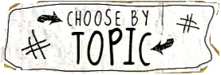



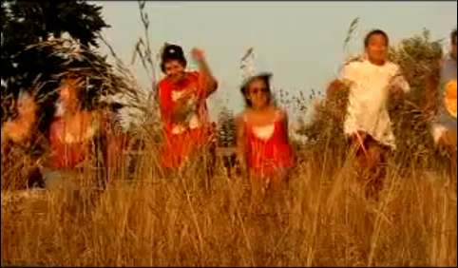

Three Public Service Announcements filmed by teens at the Native STAND conference in Chehalis, WA.

1. PSA - I Got Culture
2. PSA - It’s Always a Good Day to Be Indigenous

**Discussion Questions:** -What does the saying “I got culture” mean to you?

- What activities do you participate in that represent your culture?

-What kind of coming-of-age teachings and/or ceremonies does your family or tribe hold?

**Got Culture? Activities**

Invite a guest to lead a cultural activity for your class (e.g. bead making, language course, etc.) or go to your tribe’s website or community center to find out more about local events (e.g. powwow, canoe races, youth days, etc.). Visit [www.npaihb.org](http://www.npaihb.org) for other upcoming regional events.

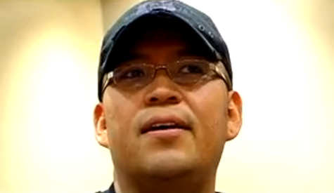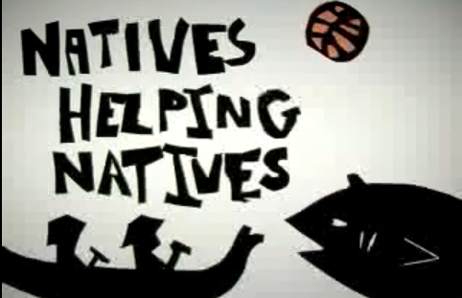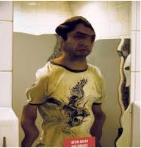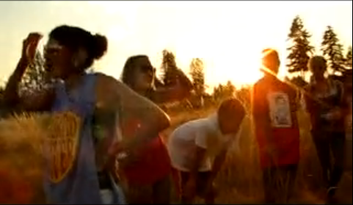

This video features two youth who share their

stories about overcoming past drug and alcohol use.

1. Drug & Alcohol-Teen Panel

**Discussion Questions:**  -Does it surprise you that people 12-20 years-old drink 11% of all alcohol consumed in the United States? Why or why not?

-What are the signs and symptoms of alcoholism?

-What are some of the reasons people use drugs and alcohol?

-What advice would you give teens in this community, if they wanted to avoid using drugs and alcohol?

-Name something you’ve done in your life that you consider an accomplishment, where you’ve met a challenge and really "lived"? Are you glad you tried it?

**Drugs and Alcohol Activity**: As a class, brainstorm a list of commonly assumed or often-heard facts relating to drug use that might be misconceptions. Then divide the class into teams and assign each team one or more "myths" to research as either true or false. Have teams report their findings back to the class.

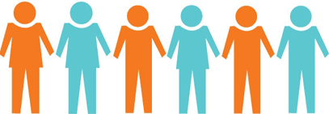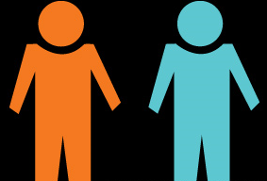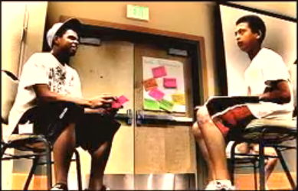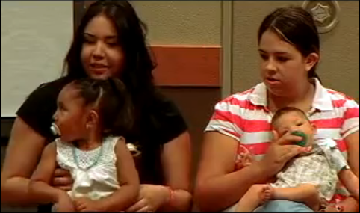



One video explains how to properly put on a condom, and assess one’s pregnancy/STD risks. In the Panel Discussion, a Native women talks about learning she’s HIV positive. In the Role-Play, a boy finds out that he is HIV positive and prepares to tell his girlfriend. These videos call upon youth to know and reduce their risks.

1. Sexual Health - Video
2. Sexual Health - Condom
3. HIV/AIDS- Panel Discussion (Part 1 & 2)
4. HIV/AIDS- Role Play
5. PSA-Animation

**Discussion Questions:** -What are some things that teens can do to reduce their risk of contracting an STD or HIV? How often do you think teens really do them?

-Describe how to properly use a condom. Where can teens go in this community to access condoms?

-What should young people consider when deciding whether or not they are ready to have sex?

**Sexual Health Activity**

The videos in this section contain several activities and role plays. Try one out with your students.

Four youth participated in a panel to share their experience as teen parents.

1. Teen Parents-Panel
2. Teen Parenting- Role Play

**Discussion Questions**

-What can teens do to prevent an unintended pregnancy?

-What do you think the hardest part would be about

being a parent right now?

**Teen Parent Activity**

After watching the teen parenting panel, ask two individuals to participate in a role play.

*“A teenage boy learns that his girlfriend is pregnant. He asks his best friend for advice.”*

Following the role play, lead a discussion based on what happened during the interaction. The role play can also be followed up with the video “Teen Parenting-Role Play”.

Further discussion questions –How do you think his friend reacted to the news about his girlfriend being pregnant? How else could he have reacted? How will the boyfriend’s life change now that his girlfriend is pregnant?