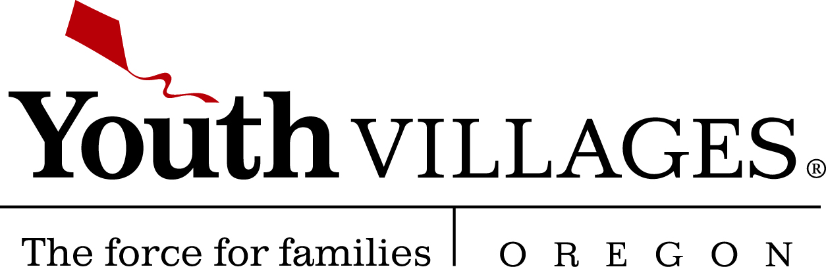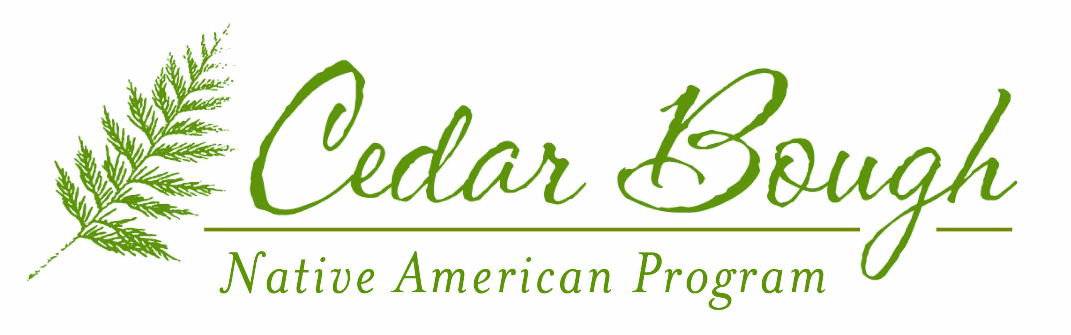

February 21st, 2014

Tribal Representative:

The mental and behavioral health conditions of American Indian and Alaska Native tribal youth is a growing concern in Indian Country. For many tribal communities the lack of access to mental health services, economic barriers, social/cultural differences and historical mistrust of institutions continue to prevent tribal youth from receiving treatment. The Cedar Bough Native American Program was established in 2007 to address these vital concerns. Cedar Bough is one of the first culturally responsive psychiatric residential treatment facilities in the nation. Through blending the most effective psychiatric treatment methods with indigenous cultural practices Cedar Bough is addressing mental and behavioral health needs of tribal communities.

Located on the Christie Campus in Marylhurst, Oregon **Cedar Bough heals tribal youth who are emotionally and behaviorally challenged through culture and tradition.** We believe cultural practices will bring the youth back into balance and harmony regarding their spiritual, emotional, mental, and physical well being. Our culturally integrated treatment practice involves: sweat lodge ceremonies, talking circles, smudging, drumming, beading, community gatherings, cultural arts & crafts, elder visits, and seasonal gatherings. Coupled with our cultural treatment is our evidence based mental health practices such as Trauma-focused Cognitive Behavior Therapy, Collaborative Problem Solving, and Equine-assisted psychotherapy. With co-occurring disorders Cedar Bough partners with the Native American Rehabilitation Association of the Northwest out of Portland, OR to assess, educate, and treat substance abuse. The common emotional and behavioral challenges we treat are: suicide ideation, depression, anxiety, post traumatic stress disorder, substance abuse, and aggressive/destructive behavior.

Additional Program Information:

* Serve tribal youth ages 11-17 that represent diverse tribal backgrounds. 133 tribal youth served to date from 34 different tribes including: the Nine Tribes of Oregon, Shoshone, Navajo, Muckleshoot, and Alaska Native tribes.
* Cultural outings that expose youth to the tribal community such as powwows.
* Educational supports: assessment, individual education plan, Cedar Bough School offers a balanced school year and curriculum incorporating Native American history, literature, and tradition.
* Program cultural content is guided by a Native American Advisory Council led by Dr. John Spence (Gros Ventre and Sioux) to ensure Cedar Bough meets the cultural needs of the tribal community.

**In most cases, youth who are Medicaid eligible can be funded for Cedar Bough if they meet criteria for this level of care.** Eligibility is determined through a psychiatric assessment we can help coordinate. Youth have also been funded through other sources including single case agreements with tribes and other entities.

If you are interested in the referral process or learning more about Cedar Bough feel free to contact us at (503) 675-2243 or at adam.becenti@youthvillages.org. We hope to hear from you!

Sincerely,



Adam Becenti (*Diné)*

Tribal Liaison/ Cultural Coordinator