Northwest Portland Area
Indian Health Board
Strategic Plan -- 2010-2015

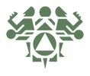

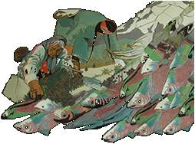

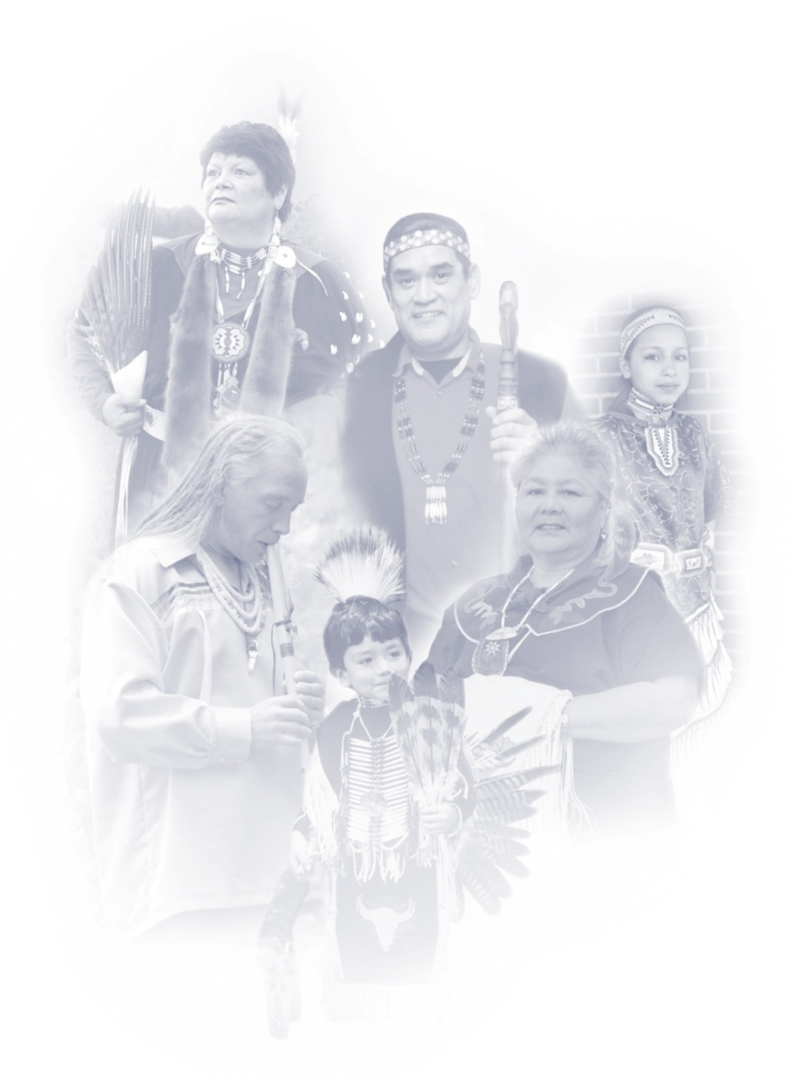
Northwest Portland Area Indian Health Board

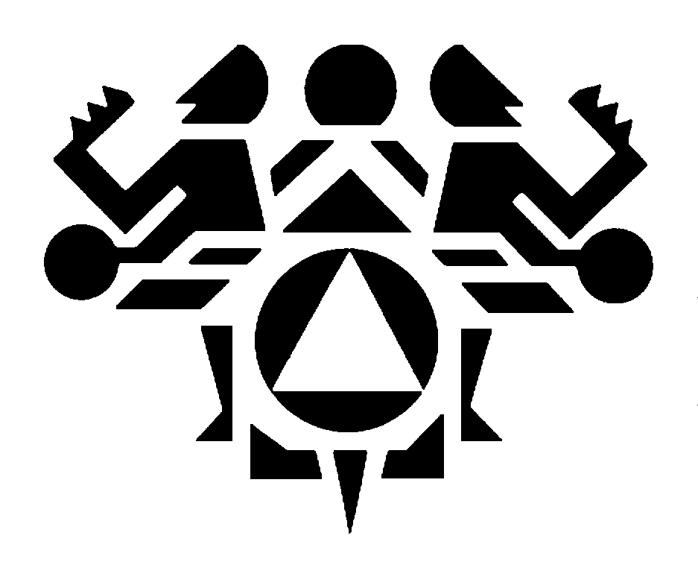

The Northwest Tribes have long recognized the need to exercise control over the design and development of health care delivery systems in their local communities. To this end, they formed the Northwest Portland Area Indian Health Board (also referred to as NPAIHB or Board) in 1972. NPAIHB is a nonprofit tribal organization that serves the forty-three federally recognized tribes of Idaho, Oregon, and Washington on health-related issues. Tribes become voting members of the Board through resolutions passed by their governing body. Each member tribe designates a delegate to serve on the NPAIHB Board of Directors.

In keeping with the Board’s strong advocacy for tribal sovereignty and control over the design and delivery of their own systems of care, Board delegates meet quarterly to provide guidance and leadership in establishing NPAIHB programs and services. Recognizing the need for accurate, culturally-relevant data, the NW Tribal EpiCenter was established in 1997 to engage the NW Tribes in public health research and surveillance. The NW Tribal EpiCenter houses the Portland Area IHS Institutional Review Board (IRB), which oversees protection of human subjects in research occurring in Northwest Indian communities. The EpiCenter now serves as an essential resource for supporting community-based, participatory data collection.

"It gives me great pleasure to provide you with the product of your thoughtful leadership. Strategic planning, while it sometimes seems like a modern business concept, is actually very much an Indian concept. When our leaders from the past contemplated decisions, it was always within the context of making life better for the seventh generation. We do not prepare a strategic plan for us, but we do so to make life better for our yet to be born Tribal members."

Joe Finkbonner, NPAIHB Executive Director

Executive Summary: 2010-2015 Strategic Plan

Organizational Values: Tribal Sovereignty, Model Leadership, Holistic Health Promotion and Disease Prevention.

Mission Statement

The mission of the Northwest Portland Area Indian Health Board is to eliminate health disparities and improve the quality of life of American Indians and Alaska Natives by supporting Northwest Tribes in their delivery of culturally appropriate, high quality healthcare.

Vision for the Seventh Generation

The old people tell us to be careful in the decisions that we make today, as they will impact the seventh generation - our grandchildren’s grandchildren. It was the spirit behind this teaching that guides our organization’s mission and goals.

The People Spoke: This is their Vision
- The seventh generation will have balanced physical, mental, emotional, and spiritual lifestyles. They will have healthy diets, be fit, active, and happy.
- The seventh generation will live in sovereign communities that are politically effective, assertive, goal-oriented, thriving economically, and run by American Indian/Alaska Native (AI/AN) people.
- The seventh generation will live in a unified and poverty-free community made up of stable, loving families living in adequate housing.
- Children born to the seventh generation will be healthy and free of chemical substances. They will experience strong parenting, mentorship, and positive role models as youth and will become involved and empowered leaders.
- The seventh generation will live in accordance with their traditional values by knowing their native languages and practicing spiritual and cultural traditions.
- The seventh generation will live in a clean environment, have access to an abundance of natural resources, respect all life, and practice sustainable and socially responsible environmental stewardship.
- Every member of the seventh generation will have access to technologically advanced and culturally appropriate healthcare that includes well-equipped clinics, wellness centers, and health education; a health care delivery system that could serve as a national model.
- The seventh generation will have adequate resources to support healthcare delivery.
- The health of the seventh generation will be a model for the general population. They will experience no preventable illness and no substance abuse or addiction. Old age will be the leading cause of death.
- The seventh generation will respect and care for their elders and celebrate as they live to 100 years or more.

Goals and Objectives

GOAL 1: The NPAIHB will build and maintain a strong organizational infrastructure supporting tribal health in the Pacific Northwest.

- NPAIHB will provide a forum for developing timely tribal consensus on healthcare issues affecting the NW Tribes by hosting productive Quarterly Board Meetings that facilitate face-to-face communication and resource sharing with state and federal programs.
Indicators for Monitoring and Evaluation: NPAIHB will conduct Quarterly Board Meetings at rotating tribal sites. Meeting content and outcomes will be documented in quarterly activity reports.

- NPAIHB will support tribal delegates in regional and national AI/AN healthcare discussions, by providing them with orientation, training, and assistance.
Indicators for Monitoring and Evaluation: NPAIHB staff will document orientation, training, and capacity building activities in monthly and quarterly activity reports. Delegate training will occur by their 3rd quarterly board meeting.

- NPAIHB will maintain effective communication channels to inform tribal delegates and tribal decision-makers about emerging public health topics.
Indicators for Monitoring and Evaluation: NPAIHB projects will post and disseminate health information on a weekly, monthly, or quarterly basis, and will use available tools to evaluate their utility and uptake, including tracking and recording web “hits” and active list-serve subscriptions.

- NPAIHB will provide the NW Tribes with capacity building assistance (including training, technical assistance, and resource development) on healthcare management principles and Information Technology.
Indicators for Monitoring and Evaluation: NPAIHB staff will document health management and IT capacity building activities in monthly and quarterly activity reports.

- The NPAIHB will actively research health-related funding opportunities, will disseminate funding announcements to member tribes, and will educate federal agencies on strategies to ensure that federal funding opportunities align with the priorities, needs, and organizational capacities of the NW Tribes.
Indicators for Monitoring and Evaluation: NPAIHB staff will produce and circulate a weekly funding report, and will provide grant-writing technical assistance upon request.

- NPAIHB will build a strong organizational infrastructure by recruiting and retaining high-quality staff, by encouraging their ongoing education and training, and by actively implementing the organization’s mission and values to provide employees with comprehensive wellness benefits.
Indicators for Monitoring and Evaluation: NPAIHB will document these policies and practices in its Program Operations manual and HR Procedures manual, and will update these documents on an annual basis.

- NPAIHB will help develop tribal youth into future leaders in healthcare by making NPAIHB meetings and trainings accessible to youth, and by offering internships to interested students. When appropriate, NPAIHB projects will integrate youth leadership training and travel opportunities into the scope of work of new projects.
Indicators for Monitoring and Evaluation: NPAIHB staff will include student interns and youth leadership activities in monthly and quarterly activity reports.

GOAL 2: The NPAIHB will strengthen regional and national partnerships to ensure tribal access to the best possible health resources and services.

- NPAIHB will build and maintain effective, collaborative relationships with current and potential partners, including the NW Tribes, the Indian Health Service, Indian organizations, Federal agencies, State Health Departments, Universities, funding agencies, community-based organizations, and other interdisciplinary social service providers that promote AI/AN health.
Indicators for Monitoring and Evaluation: NPAIHB projects will document active relationships with relevant partners, recording meetings and outcomes in monthly and quarterly activity reports.

- The NPAIHB will actively contribute to regional and national workgroups, coalitions, and committees that address priority health topics identified by the NW Tribes, and key health promotion and disease prevention workgroups.
Indicators for Monitoring and Evaluation: NPAIHB projects will document their contributions to regional and national workgroups, coalitions, and committees in monthly activity reports.

GOAL 3: The NPAIHB will maintain leadership in the analysis of health-related budgets, legislation, and policy, with the ability to facilitate consultation and advocate on behalf of member Tribes.

- The NPAIHB will facilitate communication among Tribes, Federal and State agencies, and Congress to support tribal sovereignty, promote self-determination, and ensure that government-to-government consultation occurs on health-related budgets, legislation, policies, and services.
Indicators for Monitoring and Evaluation: NPAIHB staff members will document communication activities in monthly and quarterly activity reports and in periodic QBM presentations. Pertinent meeting dates and agendas will be added to the NPAIHB online calendar.

- The NPAIHB will advocate on behalf of the NW Tribes to ensure that tribal interests are taken into account as health policy is formulated, and that Congress, State legislatures, and external agencies have a full understanding of AI/AN health needs and concerns (particularly in relation to treaty rights and healthcare in Indian Country).
Indicators for Monitoring and Evaluation: NPAIHB staff members will document their advocacy work in monthly and quarterly activity reports and in periodic QBM presentations. Pertinent meeting dates and agendas will be added to the NPAIHB online calendar.

- The NPAIHB will stay at the forefront of budgetary, legislative, and policy initiatives affecting the NW Tribes, including the President's annual budget, national healthcare reform initiatives, IHS policies and strategies, and proposed changes to Medicare and Medicaid, and will assess their impact on the Northwest Tribes.
Indicators for Monitoring and Evaluation: The NPAIHB Policy Analyst will develop and disseminate timely policy reports and budget enhancement packages using existing NPAIHB communication channels to provide a strong voice on health related issues at the state and national level, assure equitable resource allocation methodologies are in place, and improve the efficient and effective delivery of health services to AI/ANs living in the Pacific Northwest.

- The NPAIHB will analyze new and existing healthcare delivery systems and will and advocate for tribal consultation and participation in their development.
Indicators for Monitoring and Evaluation: The NPAIHB will document policy analysis and advocacy in monthly and quarterly activity reports and in periodic QBM presentations.

- The NPAIHB will evaluate the feasibility of assuming certain Portland Area Office programs, functions, services, or activities on behalf of Portland Area Tribes, and if approved and selected, will carry them out in an agreement negotiated under the Indian Self-Determination and Education Assistance Act (P.L. 93-638).
Indicators for Monitoring and Evaluation: The NPAIHB will produce a report for tribal leaders and Board delegates outlining the legal and budgetary issues associated with such an assumption, will carry out requisite planning and organizational preparation, and will apply for a planning and negotiation grant if deemed appropriate and applicable.

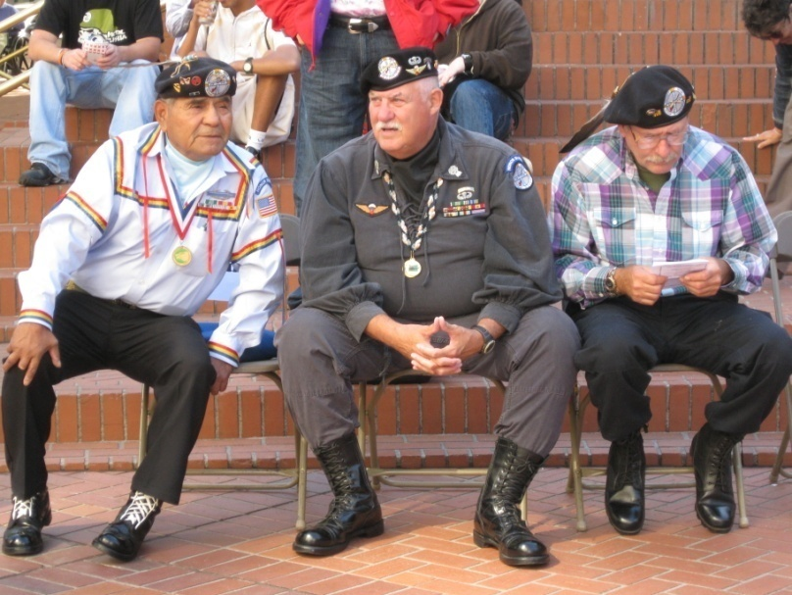
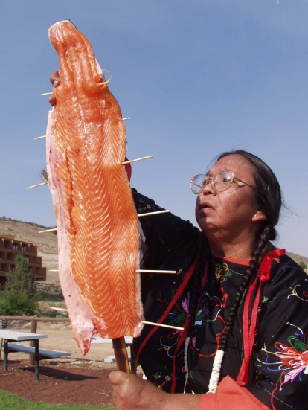
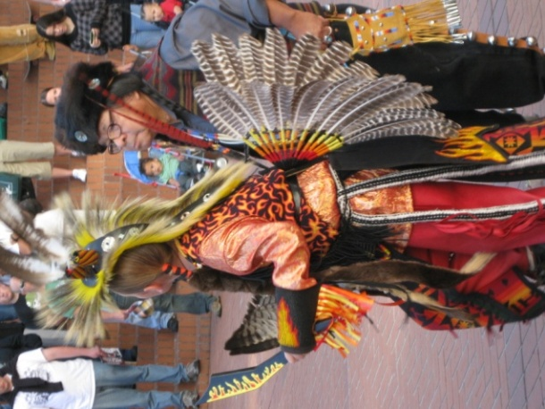

GOAL 4: The NPAIHB support health promotion and disease prevention activities occurring among the Northwest Tribes.

- The NPAIHB will focus its efforts on preventing avoidable morbidity and mortality - promoting the physical, mental, social, and spiritual health of AI/AN people throughout all phases of life.
Indicators for Monitoring and Evaluation: Priority health topics and intervention strategies will be identified on an annual basis by the NW Tribal EpiCenter, and will be considered when seeking new funds and designing new services.

- The NPAIHB will provide capacity building assistance (including training, technical assistance, and resource development) on priority health promotion and disease prevention topics and on key public health principles identified by the NW Tribes.
Indicators for Monitoring and Evaluation: NPAIHB projects will document capacity building activities in their monthly and quarterly activity reports, and in articles, newsletters, case studies, and funding reports.

- NPAIHB projects will support the development, implementation, and evaluation of culturally-rooted health promotion practices within the NW Tribes, and will adapt existing policies, educational materials, curricula, and evidence-based interventions to reflect the traditional values and teachings of the NW Tribes.
Indicators for Monitoring and Evaluation: NPAIHB projects will document these activities in monthly and quarterly activity reports, and in articles, newsletters, case studies, toolkits, and funding reports. Projects will promptly share these resources with the NW Tribes and relevant partners using existing NPAIHB communication channels.

- To improve tribal awareness about important health topics, the NPAIHB will facilitate community education and public relations efforts by developing social marketing campaigns, cultivating media contacts, and by producing press releases and “expert” health articles for placement in tribal papers.
Indicators for Monitoring and Evaluation: The NPAIHB will maintain up-to-date media contact lists, and will document the dissemination of community awareness materials in monthly and quarterly activity reports.

- NPAIHB projects will facilitate regional planning and collaboration by developing and implementing intertribal action plans that address priority health topics, and by hosting regional trainings, meetings, webinars, and conference calls that produce a coordinated, regional response to tribal health needs.
Indicators for Monitoring and Evaluation: NPAIHB projects will document regional planning activities and outcomes in their monthly and quarterly activity reports, and in articles, newsletters, case studies, and funding reports.
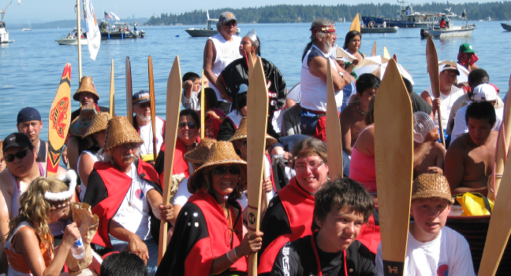

GOAL 5: The NPAIHB will support the conduct of culturally-appropriate health research and surveillance among the Northwest Tribes.

- The NW Tribal EpiCenter will respond to the needs and interests of the NW Tribes by obtaining regular feedback and guidance from tribal advisory groups, target audience members, and key personnel during all phases of the research process, and by conducting an annual survey to prioritize public health topics, capacity building needs, and research activities.
Indicators for Monitoring and Evaluation: The EpiCenter will document strategies used to obtain community input and guidance in quarterly and annual activity reports.

- The NW Tribal EpiCenter will assess the health status and health needs of the NW Tribes by conducting culturally-appropriate research and by accessing new and existing AI/AN health data.
Indicators for Monitoring and Evaluation: EpiCenter projects will document quantitative and qualitative research activities in monthly and quarterly activity reports, and will generate or locate data using data collection tools, RPMS, and state and national data sources.

- The NW Tribal EpiCenter will communicate the results of its research, surveillance, and capacity building activities to appropriate stakeholders. This information will be designed to: 1) assist the NW Tribes in their community outreach activities, public health planning, and policy advocacy; 2) share important findings across Indian Country and extend the scholarly AI/AN research agenda; and 3) increase public awareness about the function and benefits of tribal EpiCenters.
Indicators for Monitoring and Evaluation: EpiCenter projects will document research and surveillance reports, publications, presentations, and other data-sharing activities in quarterly and annual activity reports.

- The NW Tribal EpiCenter will protect the rights and wellbeing of the NW Tribes and tribal research participants by using and housing the Portland Area IHS Institutional Review Board (IRB). The IRB and EpiCenter projects will recognize tribal research methods and requirements, and will work to ensuring tribal ownership of resultant data.
Indicators for Monitoring and Evaluation: EpiCenter projects will obtain IRB approval before initiating research with the NW Tribes, and will carry out research protocols required by the IRB and the NW Tribes.

- The NW Tribal EpiCenter will provide the NW Tribes with capacity building assistance (including training, technical assistance, and resource development) on epidemiologic skills and research methods.
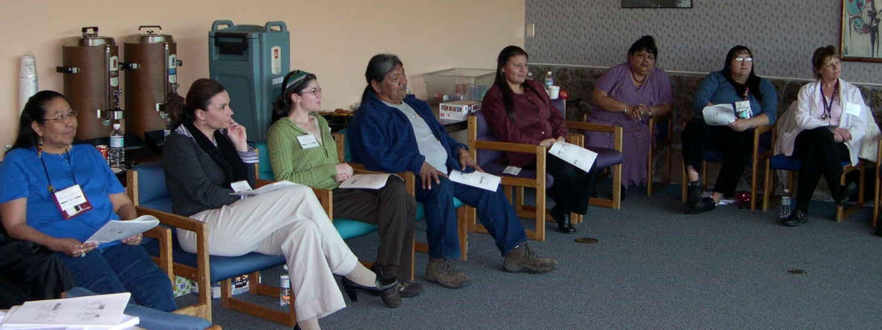
Indicators for Monitoring and Evaluation: The EpiCenter will document capacity building activities that address epidemiologic skills and research methods in monthly and quarterly activity reports.
Core Organizational Values

The Northwest Portland Area Indian Health Board:
- Is a tribally driven organization, which respects tribal leadership, recognizes the diverse needs of tribes, is inclusive and equitable, values consensus decision making, and seeks to preserve the unity of Northwest Tribes.
- Acknowledges and actively supports efforts to uphold the federal trust responsibility.
- Is a role model of holistic health (physical, mental, spiritual, and emotional), derived from traditional values – both in personal and organizational behavior.
- Respects the traditional and cultural values of all member tribes and communities.
- Strives to provide service to member tribes at the highest possible standard in the quality of work performed.
- Models leadership, which is visionary, courageous, progressive, hard working, dedicated, resilient, committed, knowledgeable, creative, respectful, and trusting.
- Provides Northwest Tribes with influential and effective advocacy, which supports tribal sovereignty and strong government-to-government relations.
- Believes in and promotes community education, health promotion and disease prevention.
- Is a credible resource for health-related technical assistance, education, information, and coordination.
- Is family centered and provides for work-family-community balance.
- Acknowledges, respects, and values the wisdom of our tribal elders.

1978 Articles of Incorporation

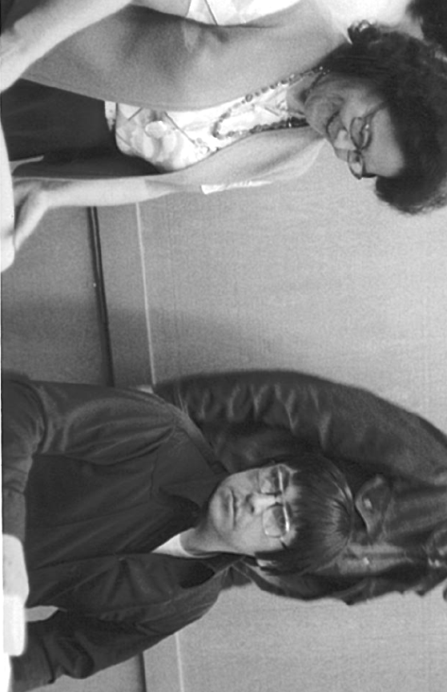
This organization was formed as a result of the President’s desire to promote self-determination of Indian people. Its purpose is to advise Indian Health Service in the development and implementation of health care and delivery to Indians in the tri-state area of Washington, Oregon and Idaho. It provides resource help and training to Indian Community Health Representatives, health education designed to promote Indian community development and conducts research activities designed to evaluate current government programs and to suggest areas of improvement in current programs of Indian reservations as well as the development of new programs. We are currently providing a monthly Health Newsletter designed to foster inter-tribal communications between the tribes in the Northwest. On-going training is developed in health related areas. Research at the present involves the evaluation of the Indian Health Service Contract Health Service System. We also carry out a counseling and recruitment program for Indian students preparing for health related careers.

Signed by: Delbert Frank Jr., Violet Hillaire, & Melvin Sampson

